Dear Girls, Life Is Too Short for Crappy Friends

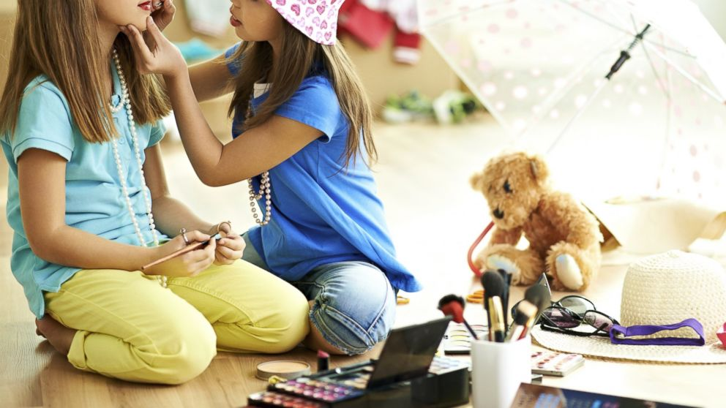

Editor's note: This article originally appeared on Babble.com and has been reprinted here with permission. Disney is the parent company of both Babble and ABC News.

Dear lovely girls,
I have a secret. Being popular, liked and included by your peers is totally overrated. I can see your eyes are glazing over. Hold on, let me put on a One-Direction T-shirt so I can get your attention. OK, let’s try that again.
Don’t get me wrong, friends are important. We are wired to long for community. You’ll desperately want to be in one when you’re in school. I hope you develop friendships that allow you to be your true self. Friends who care for you, support you and make you feel good about who you are. But if you can’t find these special friends, don’t panic. And please don’t get desperate.
There isn’t much I’m going to say here that you’ll probably believe. Hearing someone say popularity is overrated when you’re in the lonely abyss of being unpopular is like me telling you that one day you might be a little embarrassed by your Justin Bieber bed sheets. Right now, your Bieber Fever won’t allow you to hear me. I understand.
Let me just tell you what I know to be true. Maybe someday when you feel sad, lonely, jealous or excluded, you’ll remember little snippets of what I said and take courage.
Life is way too short for crappy friends.
We just don’t have time for that nonsense. Each one of us has a purpose for being here. Some might tell you that it’s all random and you have as much eternal relevance as a cup of dirt, so just have fun while you can. But I hope you won’t believe them. You have gifts and talents, activities you enjoy and fill you up. Maybe you like to draw or write stories. Maybe you can sing or play an instrument. Perhaps you’re a wiz at math and love architecture.
Maybe it’s none of those things, but there’s something. I know it.
Now is a wonderful time to cultivate these talents. To practice, play and explore everything that lights you up; all the gifts you can give to make the world a better place. Now is the perfect time to start to discover who you really are.
A good friend worth keeping will support you and what you love to do. They’ll celebrate your talents and they may even share them. A good friend brings out the best in you, loves you and even forgives you when you’re in a real salty mood and tell them their artistic portrayal of Katy Perry on the back of their Five Star notebook looks like the school librarian with a lazy eye.
You’re only human. You probably didn’t mean librarian with a lazy eye in a bad way, necessarily. Just be sure to say sorry, though, just in case.
Our desire to be liked (or have our selfies literally liked on Facebook) is normal, but it can outweigh our desire to truly be ourselves. This is where the real trouble begins.
If we live our life seeking other people’s approval, we’ll never actually live our life. And we only have one shot at this, so let’s not screw this part up.
There are obvious signs you might be in a friendship you shouldn’t be in. Obvious signs could include that the person makes you feel bad about yourself, you’re constantly paranoid about losing the friendship or the person blatantly uses you and may even be mean and verbally abusive toward you from time to time.
Aug 28, 2014, 12:05 PM ET
By ANNA LIND THOMAS, Babble.com
http://abcnews.go.com/Lifestyle/dear-girls-life-short-crappy-friends/story?id=25158996

