Thanksgiving Day (in 2010 - November 25).
It has a very interesting history. Its origin can be traced back to the 16th century when the first thanksgiving dinner is said to have taken place.
Thanksgiving Day is celebrated with lot of joy and enthusiasm not only in US but other countries as well. It symbolises the feeling of gratitude, people feel towards God.
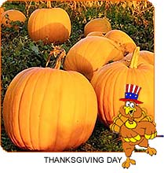
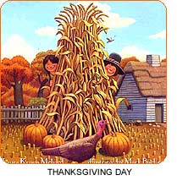
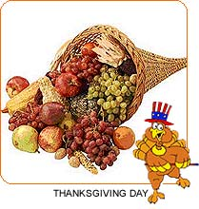
More commonly it is celebrated to thank God for the bounty of autumn harvest.
The official Thanksgiving day is celebrated on the fourth Thursday of November every year. It is generally a "four-day" weekend in the United States. Friday right after Thanksgiving is popularly known as 'Black Friday'. It is the official beginning of Christmas season and is marked with the highest retail volume sales in USA. The day got its name from the standard accounting practice of marking profits in black ink in the US.
Thanksgiving is traditionally celebrated with the customary 'feast' shared among friends and family. It is an important family gathering, and people often travel far distances to be with family members for the celebration. The traditional turkey is the most important dish cooked in every house as part of the feast. Pumpkin pie, cranberry sauce and corn dishes also form a part of the family dinner. American football and parade is a yearly feature to mark the celebration of thanksgiving.
In a nutshell, Thanksgiving is all about loving, caring, sharing and communal harmony. It is all about being grateful to not only God but also your fellowmen. It is also about reaping the benefits of the year long hard work and struggle.
Origin – происхождение feast – пир corn - кукуруза
Gratitude – благодарность turkey – индейка In a nutshell – кратко
autumn harvest – осенний урожай pumpkin -тыква
profit – прибыль, выгода cranberry - клюква
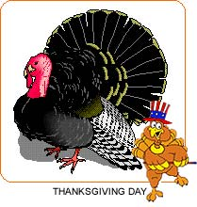
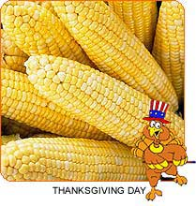
Thanksgiving Day Jokes.
(Шутки в День благодарения).
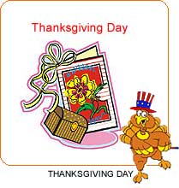
Q: Why did the turkey cross the road?
A: It was the chicken's day off.
----------------------------------------------------------------------
Q: Why do turkeys always go, "gobble, gobble"?
A: Because they never learned good table manners!
----------------------------------------------------------------------
Q: Why did the police arrest the turkey?
A: They suspected it of fowl play.
----------------------------------------------------------------------------
Q: Why did the Indian chief wear so many feathers?
A: To keep his wig warm.
----------------------------------------------------------------------------
Q: Why did they let the turkey join the band?
A: Because he had the drumsticks.
----------------------------------------------------------------------------
Q: What happened to the Pilgrim who was shot at by an Indian?
A: He had an arrow escape.
----------------------------------------------------------------------------
Asked to write a composition entitled, "What I'm thankful for on Thanksgiving," a student wrote , "I am thankful that I'm not a turkey."

