Year 3
Topic : “FOOD”
Lesson 10.
OBJECTIVES.
- to revise the vocabulary on the topic;
- to develop the pupils’ speaking skills on the basis of reading for general understanding
- to make the pupils aware of why it’s not good to eat the junk food,
what food is good for life,
what rules to follow to choose only healthy food
MATERIALS:
- pictures of different products;
- audiocassette;
- magneto phone;
- cards with gapped sentences
- cards with the plan for the story “Eat to Live, not Live to Eat”
- evaluation cards
- course book by I.N.Vereschagina, T.A.Pritykina “English 3” (for the 3d form)

TECHNIQUES:
- predicting
- reading
- group work
- filling in the gaps

ACTIVITY 1. PREDICTING.
What can’t people live without?
1. 2. 3.
A.R
W...R
F...D

Why can’t people live without food and water?
  - give energy
  - give vitamins
  - give strength
So, what shall we speak about today?
- find out why it’s not good to eat the junk food
- decide what food is good for life
- make out the rules what food to eat to be healthy
You are good eaters, aren’t you? What is your favourite food?

ACTIVITY 2. POEM “WHO LIKES WHAT?” (◘ 25)
Listen to the poem and name the products that some people like to eat.
(white and brown bread
a lot of meat
apples
juice
many sweets)
Do you think it’s good to eat a lot of apples (drink juice)? Why?
Is it right to eat a lot of bread? Why? Can you get fat if you eat a lot of white bread?

ACTIVITY 3. INTRODUCE THE NEW WORDS. (toothache, stomachache)
Do you know what happens if you eat a lot of sweets and other sweet food?
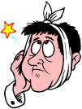
You can have a toothache:
- a toothache [‘ tu:o,eIk]

If you eat a lot you can have a stomachache.
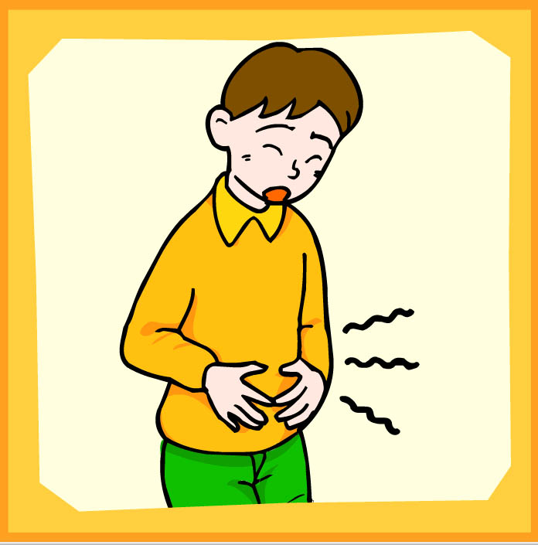

- a stomachache [‘stΛmәk,eIk]

Look at the pictures. What’s the matter with these children? What did they eat?
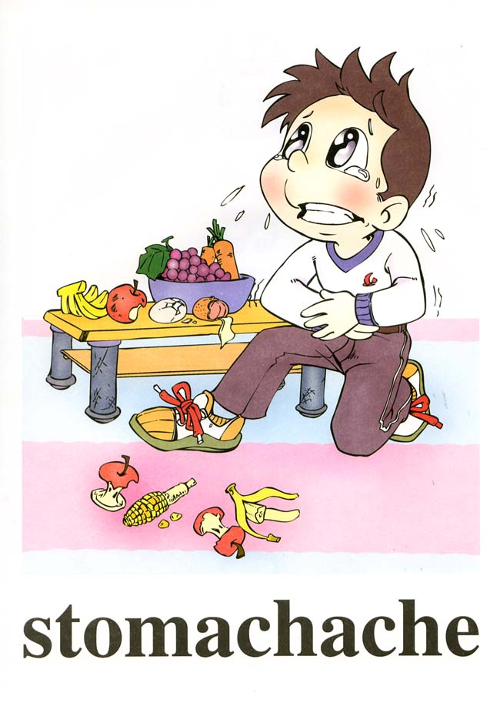
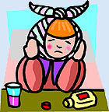
1. 2.

What about you, do you sometimes have a stomachache or a toothache?
Do you think people always eat the right food? Why do thy do it?
  - it’s tasty
  - it looks nice
  - it’s tempting

ACTIVITY 4. GROUP WORK.
Work in groups and divide these products into 2 groups: 1.healthy food and 2.junk food
(each group has 10 cads (5 with junk food and 5 with the right food)

ACTIVITY 5. DISCUSSION “THE RIGHT AND WRONG FOOD”
Think why some food is good and the other food is called junk food, use these expressions:

I think - healthy food
I believe that ….. is/are because…..
I’m sure - junk(unhealthy) food

So what is the result of eating junk food?
- getting fat
- falling ill (having a stomachache/a toothache)

ACTIVITY 6. READING THE TEXT “THE LAST TOOTH”. (p. 70 ex.9)
I know a boy. He doesn’t always eat the right food, that’s why he has problems with health.
Let me introduce Tom to you.

Do you think he is a good eater?
What did he eat and drink yesterday?
Read the text and answer the questions:
- Did Tom eat the right food?
- What food did he like to eat?
- Did he have a sweet tooth?
- What happened to him one day?
So not to have problems with health we are to eat only healthy food, do you agree?

ACTIVITY 7. FILLING IN THE GAPS.
Let’s make the rules that will help us to choose only the right food. These cards will help you. Read the sentences and fill in the missing words so that we can read the rules:

Fill in the words (Вставьте слова):
junk, fruit, sweets, right, vegetables, day

- Don’t eat a lot of ___________ food.
- Don’t eat many _____________, they are bad for your teeth.
- Eat three or four times a __________ .
- Eat a lot of ________ and ____________ .
- It’s good to eat the _____________ food.

Can you think of any more rules?

ACTIVITY 8. TALK ON THE PROVERBS.
Do you know any proverbs about products?
An apple a day keeps the doctor away.
And here’s one more proverb:
Eat to live, not live to eat.
How do you understand it?

ACTIVITY 9. EVALUATION.
We’ve talked a lot about food today, what you have learnt.
What did you like most of all?
Look at these cards and try to remember everything we did.

- CAN YOU LIVE WITHOUT FOOD?
+ | -

- 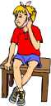 AND

- WHAT TO DO TO BE HEALTHY?
- AN APPLE A DAY KEEPS THE DOCTOR AWAY.
EAT TO LIVE NOT LIVE TO EAT.

HOMETASK. PREPARE A STORY “Eat to live, not live to eat.”
The plan will help you:
Eat To Live Not Live To Eat.
- People can’t live without food.
- Not all food is healthy.
- Eating junk food usually has bad results.
- What to eat to be healthy.
- Eat to live, not live to eat.

