МОУ «Ромодановская средняя общеобразовательная школа №1»

Внеклассное мероприятие
по английскому языку

в III классе
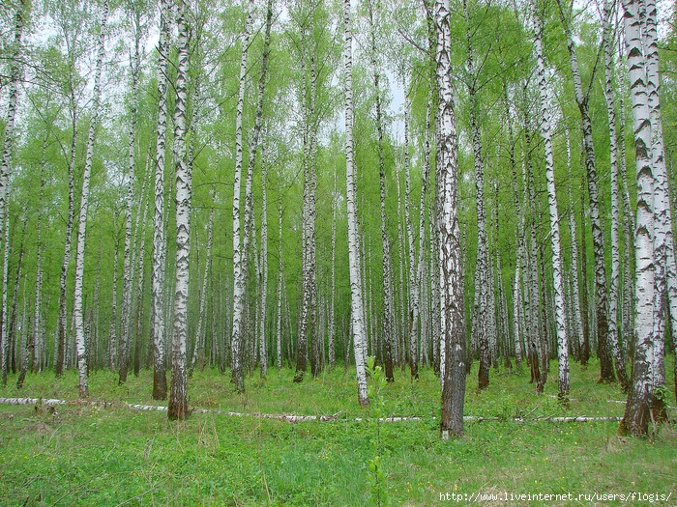
Разработала и провела:
учитель английского языка
Горюнова И.В.

Ромоданово 2010 г.
Цели: тренировка лексических навыков по темам «Природа» и «Времена года»; совершенствование навыков аудирования и монологической речи; активизация фонетических и грамматических навыков.
Оборудование: карточки c названием месяцев и времён года, картинки по темам «Природа» и «Времена года»; жетоны в форме листочков; учебный электронный ресурс, компьютерные презентации.
ТСО: компьютер, мультемедийный проектор.
Ход мероприятия
Т e a c h e r. Good afternoon everybody! Today we are going to speak about the seasons of the year.
Все поют песню «Seasons»
Look at this picture and answer my questions: What season is it?
Children. It is spring.
March . In the spring, in the spring
Sweet and fresh is everything.
April. April weather,
Rain and sunshine both together.
M a y . In the spring, in the spring
Sweet and fresh is everything.
Т e a c h e r. What holidays do you know in spring?
Children. The 8th of March - Mother's Day, The 1 st of May - May Day,
The 9th of May - Victory Day.
звучит музыка П. И. Чайковcкoгo «Временa года»
Т e a c h e r. What season comes after spring?
Children. Summer comes after spring.
June. Come, my children, come away,
For the sun shines bright today.
Little children, come with me,
Birds and trees and flowers to see. July. Get your hats and come away
For it is a pleasant day.
August. Let us make a merry ring,
Talk and laugh, and dance, and sing. Quickly, quickly, come away, For it is a pleasant day.
Three month all together.
We like flowers that are bright,
We like flowers that are white,
We like flowers that are blue, .
We like red and yellow too.
Teacher . Now we come to autumn. September, October and November, come up here.
September. Autumn is the season,
When apples are sweet.
It is the season,
When school friends meet, When noisy and gay,
And browned by the sun With their books and bags To school they run.
October. «Come little leaves», said the wind one day,
«Come over the meadows with me and play,
Put on your dresses of red and gold
For summer is gone and the days are cold».
November. Dancing and whirling the little leaves went
Winter called them, and they were content. Soon, fast asleep in their earthy beds, The snow laid a coverlet over their heads.
Teacher . Which is the coldest season?
Pupils. It is winter.
Teacher . Let us talk about winter.
December. This is the season
When children ski,
And old Father Frost
Brings the New Year tree.
January. The windows are blue at night, But in the morning they are white, And snowflakes are falling.
Come out», they are calling.
February. Get out of bed and take your sled This cold and frosty day;
The sun is bright, the snow is right For outdoor winter play.
Teacher. Now I see that you know all the seasons of the year. And now let's complete. You are divided into 2 teams.
Competitions
The first task for you is to listen to my poems and name the season. Учитель
зачитывает загадки o различных временах года и предлагает учащимся отгадать их. Жетон получает ученик, быстро и правильно отгадавший загадку.
Загадки o временах года
1. This is the season
When fruit is sweet,
This is the season
When school-friends meet. (Autumn.)
- This is the season
When children ski
And Grandfather Frost
Brings the New Year Tree. (Winter.)
- This is the season
When snowdrops bloom
When nobody likes
To stay in the room.
This is the season
When birds make their nests,
This is the season
We all like best. (Spring.)
- This is the season
When vegetables grow,
I come to the garden
And make water flow. (Summer.)
- This is the season
When nights are short
And children have plenty
Of fun and sport.
Boating, swimming
All the day, with a merry song
On a sunny day. (Summer.)
2. Now it's time to read the transcriptions of the months.
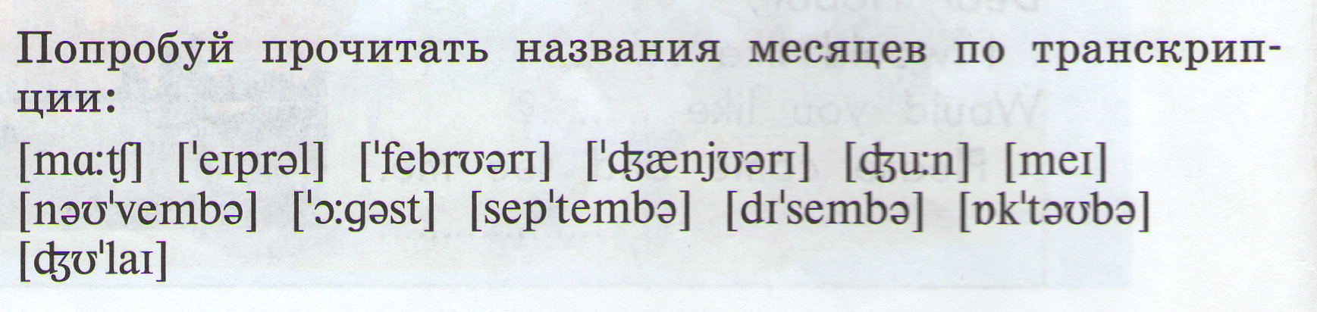
3. Fill the Crossword Puzzle.
1. осень
2
1
5
4
3
6
2. лето
3. весна
4. зима
5. сентябрь
6. декабрь

4. Now it's time to distribute the months into the seasons.
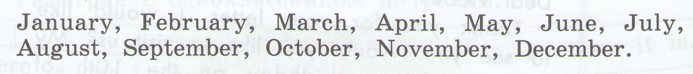

5.Make up sentences.

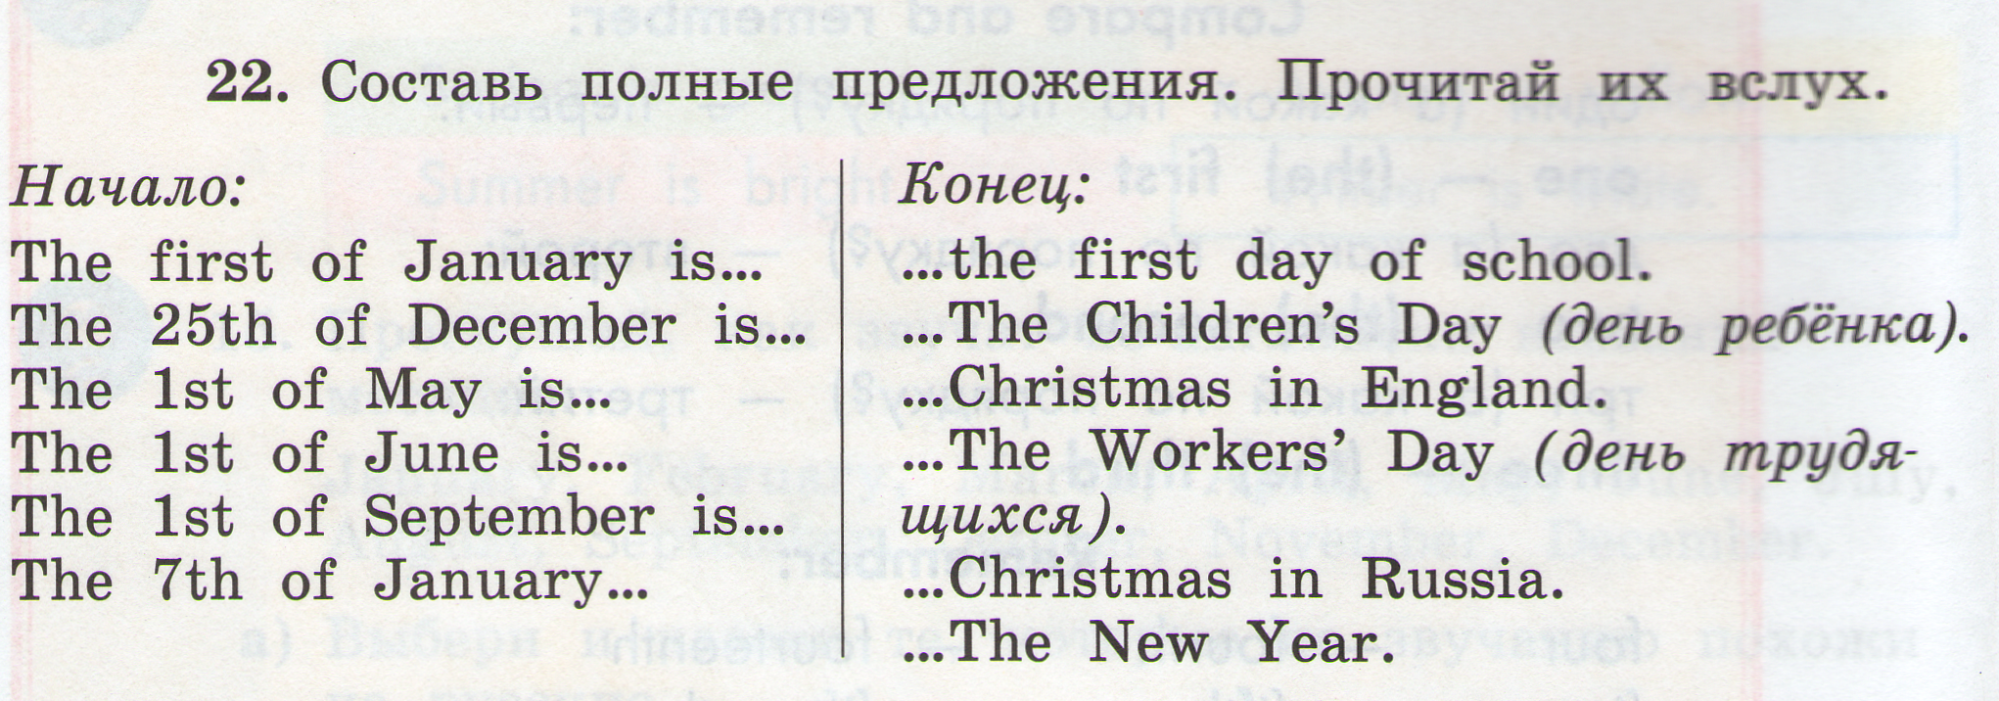 Thank you for your work. I can see you like nature and know many poems and songs about it. Now it's time to finish our work. It is interesting to know who is the winner today. Sasha and Lena are the best pupils. Let's clap our hands. Will you stand up, please.
Ученики подсчитывают количество набранных жетонов и поздравляют победителей. Учитель благодарит детей за работу.

