Мыторова Надежда Борисовна, МОУ «Кугесьский лицей», п.Кугеси, Чебоксарского р-на, Чувашской республики.

Сценарий праздника «Хелоуин»
Hallowe’en Party

The Main Witch: Hello, children! I am the Main Witch and I want to tell you about the history of the Hallowe’en.
Hallowe’en was first celebrated many centuries ago in Ireland and Scotland by Celtic priests called Druids. They observed the end of the autumn and the beginning of winter. The Druids thought that Hallowe’en was the night when the witches came out. As they were afraid of the witches they put on different clothes and painted their faces to deceive the evil spirits. They also placed food and small gifts near the doors of their houses for the witches. This was, as they say now, the beginning of the expression “trick or treat” (meaning “give me something or I’ll play a trick on you”).
The Small witch: On the 31 of October in Great Britain there is a nice holiday for children – Hallowe’en. People put pumpkins on the windows. They cut out eyes, noses, and mouths on the pumpkins and put candles into them. So the pumpkin looks like a face. They call them Jack-o-lanterns. Children dress up in funny clothes. They go from house to house and say: “trick or treat”. People give them sweets, fruit, cakes, cookies or money. This is a nice, funny and “tasty” holiday, isn’t it?
Koshey Bessmertny: Hello, children! I am Koshey Bessmertny. I am from Russia. I am 300 years old. I am very bad and fierce. I don’t like good boys and girls. I like when you are naughty and sad. My favourites are pirates, goblins, devils and witches.
Witches: We like you too! Let’s sing a song! (All sing and dance Hooky-Boocky)
1)You put your right hand in 2)You put your left hand in…
You put your right hand out 3)You put your right foot in…
In, out, in, out and shake it all about 4)You put your left foot in…
You do the Hooky-Boocky 5)You put your head in…
And turn yourself around 6)You put yourself in…
That’s what it’s all about!
The Main Witch: And now I want you to read poems about autumn or fall as Americans say.
Children recite poems:

Put on your jackets and jeans for fall,
Now it’s cold to play football.
Leaves turn orange, red and brown,
And they all are falling down.
Winter, spring, summer, fall,
I like fall best of all!

The month is amber, Great V’s of geese
gold and brown. Honk over head
Blue ghosts of smoke And maples turn
Float through the town. A fiery red.

Frost bites the lawn, At last, small witches, Their costumes hinged
The stars are slits Goblins, hags, On safety pins,
In a black cat’s eye And pirates armed Go haunt a night
Before she spits. With paper bags. Of pumpkins grins.

Now listen to a letter from Great Britain (children listen to the tape and look at the screen).Then answer the question: Do all people give children a treat?

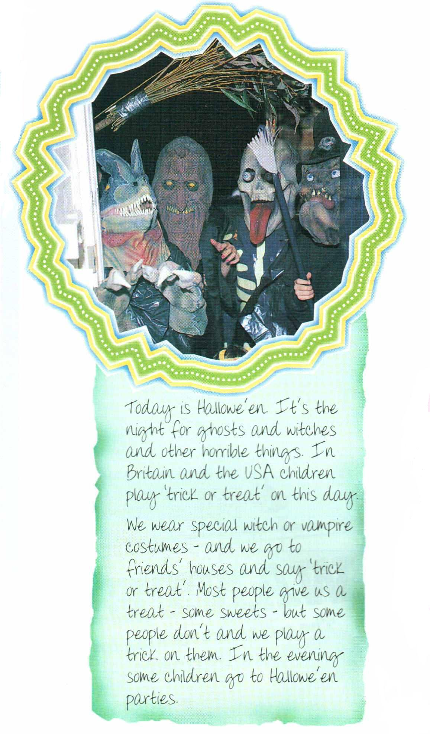
Number the pictures. 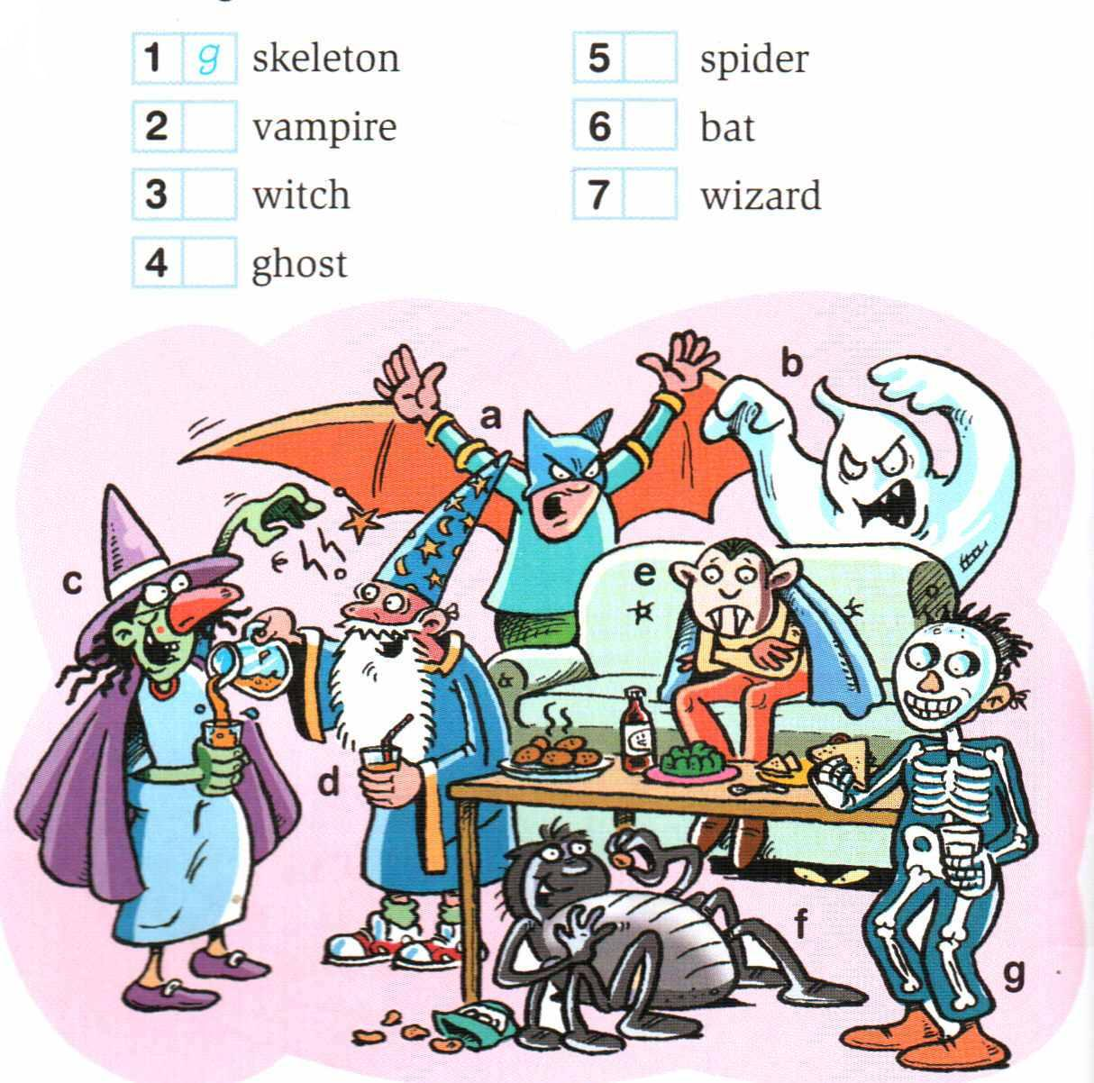

Listen to the horror story and check.

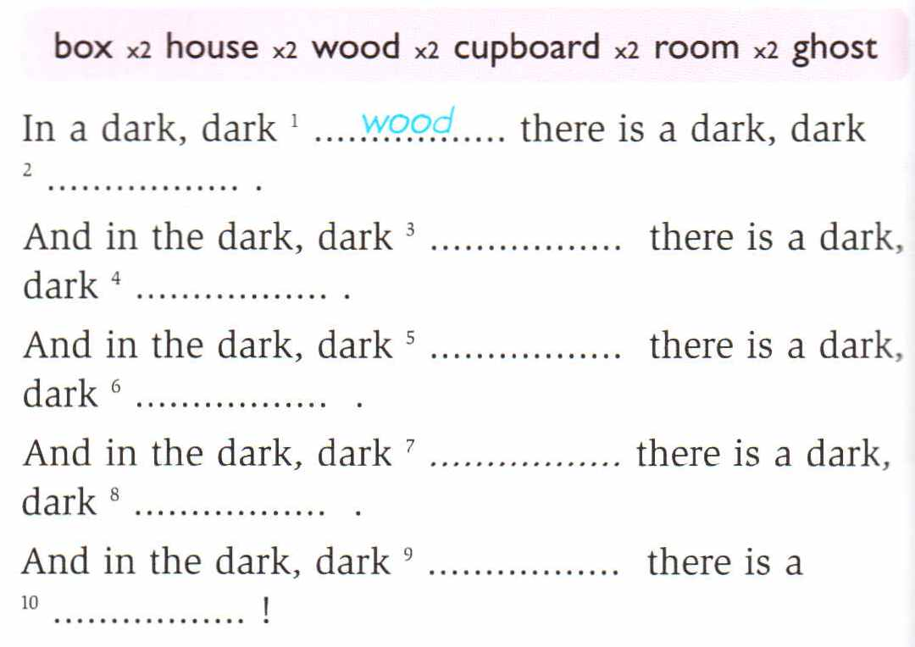

The small witch: We invite you to take part in our games (children play the games Pin the Tail on the Donkey and Shoering Chairs)!

The witches also want to play and Koshey Bessmertny blames them.

The witches: We want to play too!
Koshey Bessmertny: What? You must not play! You are not merry and good.
The witches: But we want. It’s our holiday today. We will not quarrel. Let’s dance around the Fortune Tree (all dance and guess their fortunes).

1 Let’s dance around the birch-tree,
the birch-tree, the birch-tree.
Let’s dance around the birch-tree,
White and strait and tall.
2 Let’s dance around the oak-tree,
the oak-tree, the oak-tree.
Let’s dance around the oak-tree,
Where all the acorns fall.
3 Let’s dance around the apple-tree,
the apple-tree, the apple-tree.
Let’s dance around the apple-tree,
Where all the apples fall.
4 Let’s dance around the Fortune tree,
the Fortune tree, the Fortune tree.
Let’s dance around the Fortune tree,
Which is the best of all.

The Main Witch: It’s high time to give a prize for the best Jack-o-lantern. Here you are! (The winner gets a prize). And now, let’s have a feast. What treats have you got? (Children happily lay the table and have a wonderful feast).
