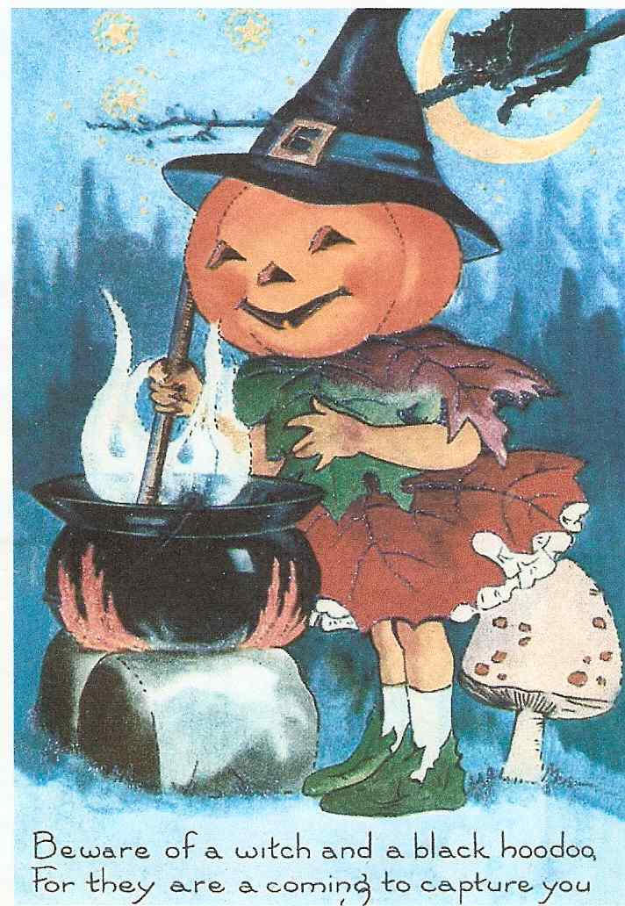

Сценарий праздника “HALLOWEEN ON PARADE”
Балаганская Анна Леонтьевна
Педагог дополнительного образования, руководитель Клуба Английского Языка
Муниципальное Образовательное Учреждение Дополнительного Образования Детей, Центр Научно-Технического Творчества Учащихся,
Г. Яровое, Алтайский край

I Условия проведения праздника
Мероприятию предшествовало знакомство с историей праздника, традициями и символами, костюмами и играми. В проведении праздника приняли участие члены Клуба Английского Языка, учащиеся 8-11 классов. В ходе подготовки к празднику они готовили костюмы, заучивали стихи, песни, рисовали плакаты, готовили тыквы-фонари, эмблемки с символами праздника (для гостей), подбирали музыку.

II Цель
Создание условий для развития кросс-культурной компетенции, для формирования у учащихся интереса к культуре и традициям стран изучаемого языка.

III Задачи

Познавательный аспект:
формировать умение говорить на английском языке, читать стихи, петь песни;

Развивающий аспект:
развивать самостоятельность;
расширять и углублять культурологические знания;
повышать общую культуру общения;

Воспитывающий аспект:
воспитывать у учащихся ответственность за порученное дело;
умение и желание работать в коллективе;
уважение к культуре другого народа.

IV Оборудование:
Плакаты (луна, ведьмы на метлах и т.д.), фонари из тыкв, вырезанные в форме Jack-o’-lantern, импровизированный котел для ведьминого зелья, эмблемы с символами праздника (для гостей), пригласительные билеты, магнитофон, кассеты с записями музыки и песен.

V Сценарий праздника
В зале, оформленном плакатами с изображением символов праздника, собираются участники «парада» в костюмах привидений, вампиров, ведьм и т. д. и гости. Звучит песня “Halloween’s on Parade”. Ведущие праздника – учащиеся 11 класса – The Halloween Lady (HL) and The Count Dracula (CD).
HL: It’s Halloween! It’s Halloween!
The moon is full and bright
And we shall see what can’t be seen
On any other night.
CD: Skeletons and ghosts and ghouls,
Grinning goblins fighting duels,
Werewolves rising from their tombs,
Witches on their magic brooms.
Together: In masks and gowns we haunt the street
And knock on doors for trick or treat.
Tonight we are the King and Queen,
For…oh!...tonight it’s Halloween!
HL: The stars are shining,
The leaves fall down,
The Moon is huge,
The trees are brown.
I see the party of evil spirits
And I can’t study
Because I feel it.
CD: I see a pumpkin,
A cat, a spider.
They all are jumping,
They all are biting.
I see the witches
I make a decision:
Let’s have a Party
Or just some vision.
HL: Dear Ladies and Gentlemen! Let us introduce ourselves. This is the Count Dracula.
CD: And this is the Halloween Lady.
HL: Welcome to our party!
CD: Don’t be afraid if you see ghosts, goblins and black cats today at our party. It’s a Halloween Party!
HL: Late Halloween night
When the moon is high
Creep out of your house
And you will spy
Witches and devils
And ghosts in the shade,
Waiting to march
In the Haunted Parade!
CD: Garish ghouls giggle,
Wicked witches wiggle,
Daring devils dance,
Gruesome goblins glance,
Mangy monsters moan,
Ghastly ghosts groan,
Jack-o’-Lanterns jeer,
While chuckling children cheer,
Together: Oh, the fun!
Oh, the fright!
Oh, the sheer delight
To parade
On Halloween night!
HL: To begin our Halloween Party we should be sure that we have got Jack-o’-Lanterns in the room. It’s necessary, because they will help us to keep evil spirits away.

CARVING «JACK – O’ – LANTERN»
Student1: The tradition of carving Jack-o’-lanterns began in medieval Ireland. According to an old legend a man, named Jack was too mean to go to heaven. He was sent to the Devil. But he also was condemned to walk the earth forever carrying a lantern to light his way, waiting for Judgment Day.
Jack-o’-lantern 1: Wise Jack-o’-lanterns who have seen
The haunting horrors of Halloween
Force smiles, while peering through scared eyes
To look on beasts that terrorize.
Jack-o’-lantern 2: While witches brew with monkey brains,
Huge spiders fight for scarce remains.
Ghosts and goblins start the dance
That puts weird zombies in a trance.
Jack-o’-lantern 3: So, trick-or-treaters, listen well
This warning jack-o’-lanterns tell:
If THEY come, just run home quick!
With these wild guys it’s Trick-or Treat!
Jack-o’-lantern 4: They dance the famous Monsters Mash
All acting tough and talking trash.
Then mold into a crowd so mean
It’s just gets worse each Halloween.
Student 2:Jack-o’-lanterns are an important part of Halloween. The pumpkin is hollowed out and then carved, usually with a funny face. On the night of Halloween jack-o’-lanterns can be seen looking out of the windows of many houses and flats after dark. People believed that jack-o’-lanterns frightened away evil spirits. Sometimes they show that children are waited here for trick-or-treating.
Student 1. And now a few words of carving a jack-o’-lantern: Take a pumpkin, cut an opening in the top. (Shows how to do it).Then you may draw a funny face on it and cut it out. Instead of cutting around the pumpkin’s stem to create a lid, cut a hole in its base and remove the strings and seeds through the bottom. Then use a base as the candle holder, and set your pumpkin down on top. You’ll see that in the dark the “face” of your pumpkin will glow. (Lights up the candles inside the pumpkin.)
CD: OK. Now we have got a very nice jack-o’-lantern. We shall put it here, with these pretty jack-o’-lanterns for the jury to decide: which one is the best. (On the table there are jack-o’-lanterns, made by the students at home.)
HL: Can we go on now? Is everything ready for a Halloween Parade?
CD: Oh, no, of course not! Not all our people have something scary on them. Have a look! These charming ladies and a noble gentleman have no charms on them! They are not protected from the evil spirits! What shall we do?
HL: We shall present them our protection. Dear ladies! Dear Sir! Would you put this on? These magic things will help you to stay alive during the Halloween night! (The Count Dracula and The Halloween Lady hand in “emblems” to the jury and to the guests.)
CD: And what are those ladies doing? Are they cooking?
HL: Oh, yes! They are witches, and they are cooking their famous “witches’ brew”!
Witch 1: Dead leaves, seaweed, rotten eggs, too
Stir them in my witches’ brew.
I got magic, ala-ka-zama-ka-zoo.
Witch 2: Spider web, moldy bread, mucky mud, too
Stir them in my witches’ brew.
I got magic, ala-ka-zama-ka-zoo
Together: Oh, my witches’ brew!
Ooh! What’s it gonna do to you? Boo!
Witch 3: Floor wax, thumbtacks, purple paint, too.
Stir them in my witches’ brew.
I got magic, ala-ka-zama-ka-zoo.
Witch 4: Fingernails, lunch pails, apple cores, too
Stir them in my witches’ brew.
I got magic, ala-ka-zama-ka-zoo.
Together: Oh, my witches’ brew!
Ooh! What’s it gonna do to you? Boo!
Witch 1: Ooh! We are too old for such job! It’s time to make younger witches learn how to cook witches’ brew! We have forgotten practically all the recipes! Oh! Have a look at them!!! They are…playing!!!
Two young witches (they are dancing and singing)
-Two little witches pranced in the garden
Two little witches danced from the moon;
-One wore a wishing hat
One held a pussy cat
And whispered a tune.
-Out flew an owl who glared at the kitten
Out flew an owl who stared at the rest.
-Dancing with haughty nose
Each on the other’s toes,
-Down past the pumpkin rows
Under the nest.
-Two little witches flew on their broomsticks
Two little witches flew to their queen.
-Over the windy glen into the night… But then
They will be back again next Halloween!
(Then all the witches –old and young ones sing a song “Witches’ Brew”)
(Spiders appear)
HL: Oh, my! Have a look! Spiders!
Spider 1: A dark, dark forest!
A mystery, mystery road!
A big, big spider
In a grey, grey spider’s web.
Spider 2: Gloomy, gloomy castle!
An open door!
One lit the candle
On the window.
Together: Sit at home on this ghost night
CD: Oh, Your Majesty! Are you afraid of spiders? And I know a very nice song about them. Let’s sing it together! (All the participants of the party are singing the song “The Spider on the Floor”)
HL: Thank you, dear ladies and gentlemen! That was wonderful!
(Ghosts, vampires, cats and others appear)
Ghost 1: Who-o-o-o-oo am I?
A flash of white in the evening dark
A creak and a groan, a squeak and a moan…
I am a ghost!
Ghost 2: A cold, cold night,
A brown, brown owl,
A grey, grey wolf,
A red, red howl.
Ghost 3: Down, down, down
Down the stairs and out,
Stay in bed tonight
There is a ghost about!
Ghost 4: A big, big house
In a black, black street
An open door
Two white, white feet.
CD: Do you think our Halloween Parade has already begun?
HL: Of course, it has! Well, have a look! Vampires!

Vampire 1: The night is still and somber
And in the murky gloom
Arisen from his slumber,
The Vampire leaves his tomb.
Vampire2: His eyes are pools of fire,
His skin is icy white,
And BLOOD his one desire
This woe begotten night.
Vampire 3: I want the gore, I see the fright
That fills each street on this dark night.
The shadows move, then screams and sighs.
Vampires bring blood curdling cries.
Ghost 5: The moon is full and bright
For Halloween is tonight.
Ghosts are howling,
Jack-o’-lanterns are glowing
You should feel such a fright
For Halloween is tonight!
Ghost 6: Gigantic zombies are chasing you
They are big and you are small. Watch out!
Bats and black cats are staring at you
Skeletons and werewolves are out!
HL: Oh, isn’t it Freddy?
CD: I think it’s him!
Freddy: On Halloween when all through the town
Some horrible creatures
Were stalking around
From inside a grave
In the land of the dead
Out stepped the bones
Of a man once named FRED!
HL: So strange cats I see! One is black, the other one is white. Saying something… let’s listen to them!
Black cat: Hey! Cackle! Hey!
Let’s have fun today!
All shoelaces will have knots.
No knots will untie.
Every glass of milk will spill.
Nothing wet will dry.
White cat: Every pencil point will break
And everywhere in town
Peanut-buttered bread will drop
Upside down!
Hey, hey, hey! Have a pleasant day!
CD: And where are these cats going? May be trick-or-treating?
Cat 3: Soul, soul, an apple or two,
If you haven’t an apple, a pear will do
An apple or a pear, or a plum, or a cherry,
Any good thing to make us merry.
Cat 4: One for Peter, two for Paul,
Three for the Man who made us all.
Up with the kettle, down with the pan
Give us good alms and we’ll be gone.
HL: Well, all children like to go trick-or-treating. It’s really a great fun!
Devil 1: Trick-or-treat! Trick-or-treat!
Give us something good to eat.
Give us candy, give us cake,
Give us something sweet to take!
Devil 2: Give us cookies, fruit and gum,
Hurry up and give us some.
You had better do it quick
Or we’ll surely play a trick!
Together: Trick-or-treat, trick-or-treat!
Give us something good to eat!
HL: Mister Dracula! I’m a bit tired.
CD: Me too.
HL: What shall we do to have a rest?
CD: Let’s ask our friends Lanterns to arrange playing Halloween games. While our guests are playing, we’ll take breath.
A game “Bobbing For Apples”
Jack-or-lantern 1:Watch us bobbing for an apple,
For an apple, for an apple
But no apple, no apple.
Not an apple can I get.
Jack-or-lantern 2: Oh, I cannot catch an apple
Not one apple, not one apple
Though my sister got an apple
All I got was soaking wet.
Jack-or-lantern 1: There is a big bowl with water in it. Let’s put an apple there. Now you must keep your hands behind your back and try to take an apple out of the water with the help of your teeth.
(The participants and guests are playing “Bobbing for apples”)
CD: While our judges are deciding on the best costume, jack-o’-lantern, and recipe of the witches’ brew, our witches will ask you some Halloween Questions.
Test “Do you know what it is?”
1. She is a Halloween Lady. She always creates something new for her evil friends; she knows how to scare children. She is also a good cook. She likes brew. (A witch)
2. It is neither a bird, nor a rat, that’s why it appears on Halloween. It’s black and you can’t easily see it, that’s why it scares you flying out of the dark. (A bat)
3. A very noisy fellow. Always rattles his bones. He is never fatty. He can’t move quietly and scares children and adults. (Skeleton)
4. He is the King of Halloween. He is as huge as the Moon on Halloween night. He lights the way for strangers and scares evil spirits. (Jack-o’-lantern)
5. He is very scary to look at! He has got a disgusting grin, the sharpest teeth and glittering eyes, longing for a victim. He is blood-scary! (A Vampire)
6. The spirit of a dead person which appears again. Usually dressed in white. (A Ghost)
7. A large, orange vegetable in the squash family associated with Halloween, (A Pumpkin)
8. The bone structure of a body without the flesh. (A Skeleton)
9. A saying used by children when they are going from house to house asking for candies. (Trick-or-treating)
10. A woman with magic powers. (A Witch)
CD: And now we’ll ask our honorable jury to say their word
(The judges name the best costumes, recipes of the witches’ brew, jack-o’-lanterns.)
HL: And now let’s sing a nice Halloween song together! (“Halloween’s on Parade”)
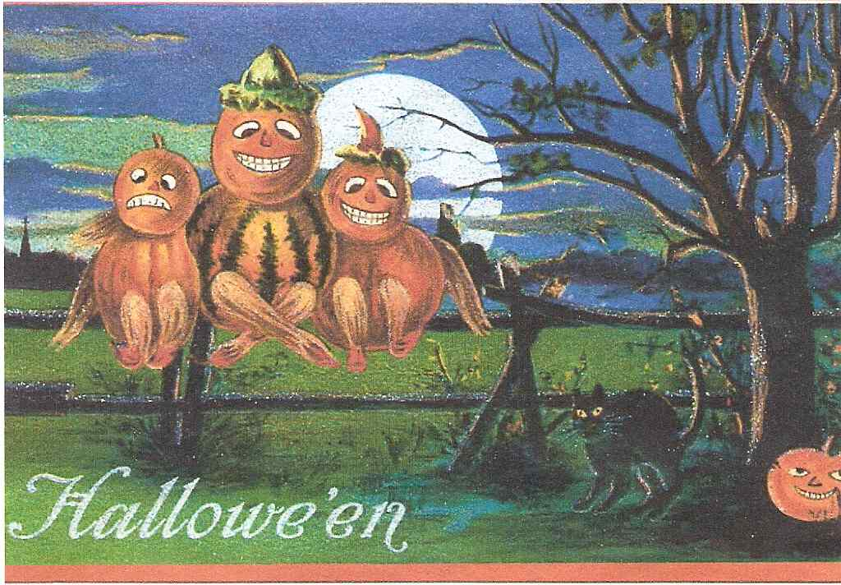

If You Like Ghosts and Witches,
Black Cats and Werewolves,
Please Come to our Horror Party.
It will be Exciting. I Think it will be
Your First and Last Horror Party…
ЛИТЕРАТУРА
1. Holidays Go Round And Round. Kathleen Carroll, Marina Novikova. St. Petersburg.
2.”English” Приложение к газете «Первое сентября» Английский язык:
№№ 37, 38 1993г. / №№41-42 1993 / № 40 1995г. / № 40 1996г. / № 40 1998г. / №45 1999г. / №40 2000г. / №39 2003г. / № 40 2003г.

