Сценарий литературно-музыкальной композиции
«Бородинская Битва 1812»
ГБОУ СОШ 1381

Тынянская Ксения Владимировна
Учитель иностранного языка
ГБОУ СОШ 1381

Memory – What do you keep inside your mind?
Memory? - Could you remind of something kind?
Who of you.. - Can understand the only thing
All the wars - Come to the people like a ring
Devil’s ring - Terrible look the lands became
While - Little monster wanted to own them

We are proud of the theme we have chosen to perform

Happy life can be destroyed if we forget the Russian history, the strength of Russian Army, the energy of its generals, officers and soldiers

and the devotion of all the people, who helped the Army to defeat French enemies in 1812.

Russian poet Mikhail Lermontov romanticized the battle in his poem “Borodino” in the following way:

You tell me, uncle, don’t you know
Why was Moskva that had to grow
Once given to Frenchmen?

They said you thought, the fight was fatal
And people’s soul turned into metal
In fact the Russians understand
You had to show them!

There were some people in my time
Not that, the current race, don’t mind
They couldn’t stand just feeling fine
What heroes – not you!

They had to share their fortunes badly
And from the fields returning hardly
If only Lord in fact wished battles
We wouldn’t give Moskva!

We had a long and silent retreat
The Frenchmen, are they undefeated?
The old men grumbled “Shame”

If they were able to lead, commanders
And change French uniforms in Russian
With our bayonets.

I wanted to present a dinner
Let’s make at once them getting thinner
Misyl! You’d better wait!

I thought another charge
Because I had to do so much
Because we had to stand the head
Of our Motherland!

Those were two days of firefighting
But what was good in trinkets finding?
We waited for the third…

And everywhere you could hear talking:
“It’s time to get the grape for shooting …”
And to the meadows and valleys
With night were coming birds.

And only sky was getting clearer
We heard some noises coming nearer
Some flashes from the guns.

The commander could watch the borders
Servant of king, Father of soldiers
We followed him and much was done
He sleeps somewhere, has gone.

Well, what a day! Through smoke and clouds
French people moved to us with sounds
And all to our redoubt…

So, dancers, clothes – full of colours.
So, Dragoons made a lot of fires
I had a look at Russian soldiers,
All they were killed, don’t look!

Have ever seen you any battles?
Where banners floated like shadows
In smoke the fire shone

The buckshot screamed and damask’s sounds
The fighters’ bodies hurt around
And bloody hills were built
By death who came to kill.

French people didn’t like “the dishes”
For Russians then they were delicious
With hands we tried to win.

The ground cried from our breathing
The day and night were tired of missing
With shots of thousands of weapons
The soldiers had to deal.

That dusk. And now I remember
With hands and bodies even trembling
We stood until the end.

Some noise of cracking drums appeared
Frenchmen retreated to the hill
Then we began to count wounds
To think of killed comrades

There were some people in my time
Not that, the current race, don’t mind
They couldn’t stand just feeling fine
What heroes – not you!
They had to share their fortunes badly
And from the fields returning hardly
If only Lord in fact wished battles
Wouldn’t you live, would you?

The writer described the events so well, the magic of the words came through my soul and my mind and caused a lot of feelings.

But what are these dolls, these pretty ballet-dancers? They are old-fashioned, but nice, aren’t they?

Танец фарфоровой куклы и оловянного солдатика

С двух сторон выносят портреты Наполеона и Кутузова
The battle of 1812
Napoleon
And Kutuzov
One was a real Frenchman?
Another was a real Russian

One was a soldier who became an emperor and dictator of France

Another was Suvorov’s pupil, the Commander of the Russian Army
One wanted to own all the world
Another didn’t let him make it

One thought he would never be arrested and die on the Island of St.Helen

Another won a lot of battles in Izmail, Austria and Western Europe

Napoleon Bonaparte was the name of the first one

Mikhail Kutuzov was the name of the Russian general
The first one lived for 52 years
The second one – about 68 years
What was the result of the Borodino Battle?
The result was awfully sad…

Dead people, soldiers and officers

Ruined homes, buildings, churches

Hunger, poverty, destruction

Tears, cries. Prays

Diseases, death, orphans

No children coming from those who were killed or died during that time

На сцене появляется девушка для исполнения романса Б. Окуджавы «Кавалергарды»

My officers, the life is not long
That’s why you take it all In all
The tube is singing honest gold song
You hear somewhere swords’ ding-ing-don
The voice is coming from the saddle
And the commander’s still alive
But don’t you promise to a maiden
That you would love her all your life.
You won’t forget your peaceful laughing
If eve breaking into tears
You never find the world of lying
As long as blood is poured on fears.
No matter faces having shadows
The sun – the moon – you are the both
But you don’t promise to a maiden
An everlasting love on earth.
Champagne is flowing like a river
The face is pale, the eyes aren’t clear
Hands up and all seems to be clever
And all the friends seem to be near
The iron cross you chose wooden
Appears on horse-guard’s chest and falls
But don’t you promise to young maiden
An everlasting love on earth?

Versleichen wir zwei Kriege: Franzosen und Russen, Deutschen und Russen. Wer begann den Krieg?

Warum versuchte Europa immer unser Land zu erobern? Warum träumten Diktatoren Napoleon und Hietler Russland sich zu bemächtigen?

Der Hauptgedanke war verrückt – so ein großes Territorium wie Russland zu haben

und alle russische Menschen Sklaven zu machen.

Aber die Russen ergaben sich nichts. Wir sind kräftig und verlieren wir den Mut nicht.

Wir sind Patrioten von unserer Heimat.

The French “Grande Armee” began its invasion of Russia in June 16, 1812.

The Russian troops under the command of Count Michael Barclay de Tolly had to face the “Grande Armee” at Vilnius region,

the remaining troops under general Pyotr Bagration would launch the attack to the French southern flank and rear.The enormous “Grande Armee” was more than enough to separate and crush both Russian armies at the same time.

Kutuzov organized a strong regular army under the command of general Konovsytsyn, and then ordered the Russian army to prepare for an incoming battle.

A defensive line was established in the best available position before reaching Moscow near the village of Borodino.

Kutuzov strengthened the line with the Raevski redoubt and with “Bagration fleches”

French and Russian units moved forward into impenetrable smoke. Infantry and cavalrymen had difficulty maneuvering over the heaps of corpses and masses of wounded.

Saxon cuirassiers and Polish lancers clashed with Russian cuirassiers, French and Russian cavalry clashed behind the Raevski redoubt.

The fall of Raevski redoubt didn’t have much meaning. Napoleon himself ordered his troops to retreat to the starting line.
Kutuzov understood that the Russian people never wanted to abandon Moscow, the city which was regarded as Russia’s “second capital”.

Taken as a one-day battle. This was the bloodiest battle of these series of conflicts and also the bloodiest battle since people used gunpowder in battlefields.

Have you ever visited a huge panorama representing the battle near Poklonnaya Hill? If not, you certainly do it.

In Russia, the Battle of Borodino is reenacted yearly on the first Sunday of September.

A commemorative one-ruble coin was released to the 175th anniversary of the Battle.

A minor planet 3544 Borodino discovered by Soviet astronomer Chernyakh in 1977 was named after the village Borodino.

Исполнение песни «Героям 1812 года»
Вы, чьи широкие шинели,
Напоминали паруса,
Чьи шпоры весело звенели
И голоса, и голоса…
И чьи глаза как бриллианты
На сердце оставляли след,
Очаровательные франты,
Очаровательные франты
Минувших лет…

Поклон.

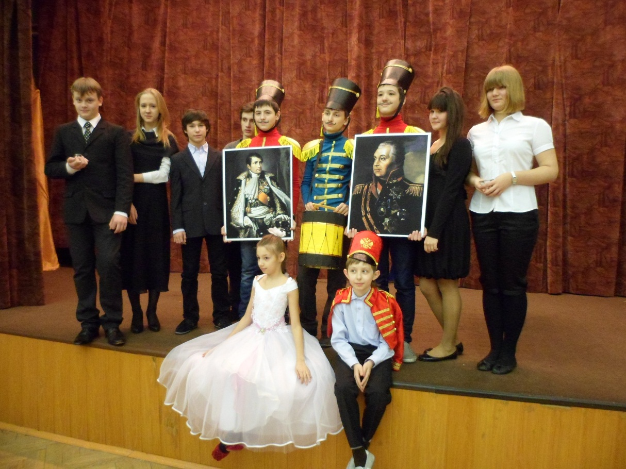

Действующие лица:
- Чтец 1 -
- Чтец 2 -
- Чтец 3 -
- Бывалый солдат -
- Гусар 1 -
- Гусар 2 -
- Школьник -
- Девушка - исполнительница романсов -
- Фарфоровая кукла (танцор) -
- Оловянный солдатик (танцор) -

Москва 2012

