Конспект урока по теме: “Достопримечательности Лондона” учителя английского языка МОУ Ржаксинской сош №1 им.Н.М.Фролова Андреевой Елены Евгеньевны.

УМК «Новый курс английского языка для российских школ» О.В.Афанасьева, И.В.Михеева
Класс -7
Тип урока: комбинированный
Цель – иметь представление о культурном наследии англоговорящих стран.
Задачи:
Обучающие: формирование лингвистической компетенции – знакомство с культурой изучаемого языка, обучение аудированию, устной речи;
Развивающие: развитие лингвистической догадки, повышение мотивации к изучению иностранного языка;
Воспитательные: формирование уважения к другим народам, их традициям, привитие навыков работы в малых и больших группах.
Оборудование: учебник, книга для учителя, раздаточный материал, фотографии достопримечательностей Лондона, компьютер, проектор, презентация.

Ход урока.
1.Введение
T: Good morning. Тhe theme of our lesson is "London, the capital of the UK of Great Britain and Northern Ireland”. (Слайд №1) As you know London is one of the most beautiful cities in the world. It has a lot of interesting historical and modern places to visit. Today we are going to visit some interesting places in London. You can see these places, listen to the information about them and do some tasks. But first let’s see what you know about London. Please, write down as much facts or words connected with London. For example, famous people, interesting places, historical events and so on.
P. (Trafalgar Square,Big Ben,Westminster Abbey,The Houses of Parliament,
The Tower of London,Tower Bridge,Buckingham Palace,Tate Galery,St Paul’s Cathedral,Hyde Park,St James’s Park,Regent’s Park,Kensington Gardens)

T: Well, I am glad that you know so much about the places of interest in London.
2.Основная часть
I.Речевая зарядка
T: And I offer you to continue our lesson with the task "Discovering Places”. I’ll give you some short descriptions of famous places. Your task will be to guess what places are they.
(Приложение № 1)
(По истечении времени дети читают свой текст)
II.Развитие навыков аудирования.
T: Very good. Well, London is famous all over the world. It is not only the capital of Great Britain but also a city which is visited by thousands of tourists. Now let’s listen to the dialogue between a tourist and his British friend. You should say the places mentioned in the dialogue. The dialogue is about sights of London.
(Приложение №2)
T:Well, could you name the places mentioned in the dialogue?
(Pupils: Westminster, BigBen ,The Bloody Tower, The Museum of the Moving Image, Hyde Park ,Regent’s Park ,St James’s Park ,Kensington Gardens )
In the dialogue you have heard about some places we haven't spoken about yet. What are they? (Дети называют Madam Tussaud's Museum, MOMI, Hyde Park, Regent's Park, St James's Park and Kensington Gardens.) Yes, you're right. There are a lot of museum, parks and art galleries in London. Now, let's listen to the dialogue once more. Name the places which Tanya has already visited. What places hasn't she visited yet?. (Диалог прослушивается еще раз для понимания детальной информации.)
ІII.Развитие навыков письменной речи.
Well, we continue our tour with the Tower of London. (Слайд №2)As you know it is one of the oldest places in London and is famous all over world. I’ll give you short pieces of information. But each text has some gaps. Fill in the gaps with the proper words and tell the class your information about the Tower of London. (Обучающимся раздаётся текст с пропусками).
(Приложение №3)
IV.Развитие навыков устной речи.
Very nice. Let’s go on. All tourists always want to visit Westminster Abbey.
(Слайд №3) What do you know about Westminster Abbey?
Now, please take the task.
(Приложение № 4)
V.Развитие навыков диалогической речи.
The next two places we are going to visit today are the Houses of Parliament and Big Ben.(Слайд №4) What do you know about them? To continue the tour you should do a little task. I’ll give you a dialogue but all phrases in it are mixed. You should make up the dialogue from these phrases.
(Приложение № 5)
VІ.Самостоятельная работа.
Very good. Now we can go. It’s Buckingham Palace. It’s the home of the Royal family. You can see the Changing of the Guard every day outside Buckingham Palace.(Слайд №5)
And the next task for you is also connected with different places in London. Please, complete the sentences.(Раздать обучающимся карточки с заданиями)
Write your answers on the back side of the backboard.
(Приложение №6)
VIІ.Развитие навыков монологической речи.
Well, we have already visited some famous places. And now I invite you to visit the Tate Gallery. (Слайд №6) What do you know about the Tate Gallery?
So, we have visited today a lot of interesting places in London. Which of them do you like most? What would you like to visit? And why?
Use the following phrases to express your opinion, please:
As for me,…
In my opinion, …
Personally I …
First of all I would visit …
Of course, …

3.Заключение .
Well, pupils. Let’s do the conclusion. Today we have learnt a lot. We talked and listened about London – the treasure of Great Britain. You have done a lot of exercises tests, listened classmates and worked with the texts. I hope you’ve enjoyed our lesson and learned a lot of interesting information about London. Many thanks for your work.
The marks are:
The lesson is over.
Мультимедийное сопровождение к уроку.

Слайд № 1 | Слайд № 2
London, the capital of the United Kingdom  of Great Britain and Nothern Ireland.  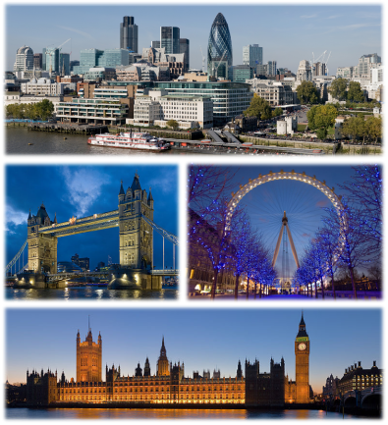 | The Tower of London  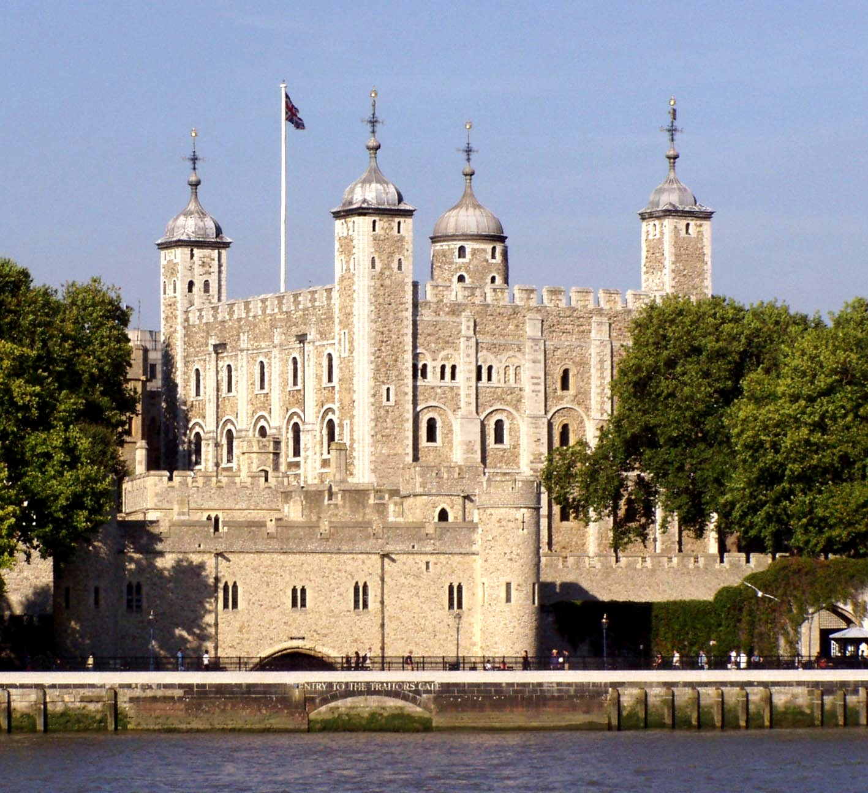
Слайд № 3 | Слайд № 4
Westminster Abbey  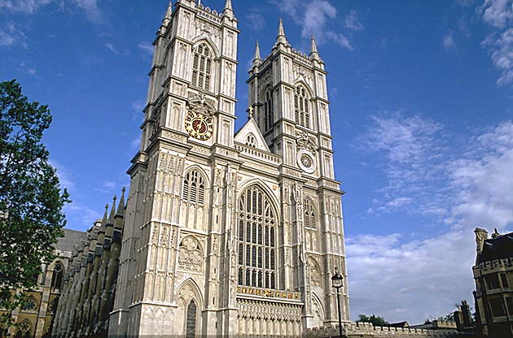 | The Houses of Parliament and Big Ben  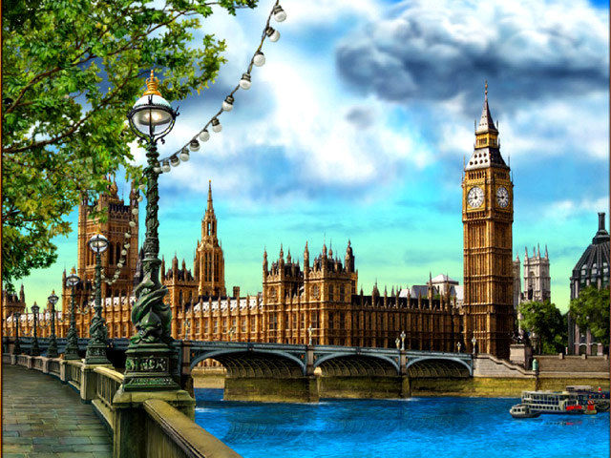
Слайд № 5 | Слайд № 6
BuckinghamPalace 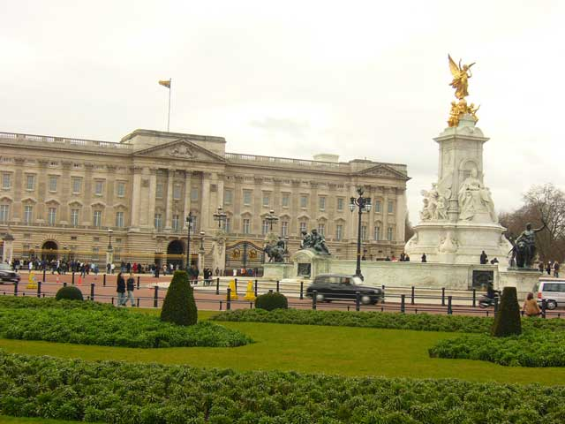 | Tate Galery

Список использованной литературы:
1.http://pedsovet.
2. УМК. «Новый курс английского языка для российских школ» О.В.Афанасьева, И.В.Михеева
3.Книга для учителя.
4. Организация классных часов на английском языке А.В.Конышева.
5.Внеклассные мероприятия по английскому языку 5-8 классы М.А.Трофимова.
Приложение №1
"Discovering Places”
Descriptions
1. It’s a clock in the tower and it’s a big bell. You can hear it every hour.
2. You can see it from the river Thames. It is very old and has a long history. In different times it was used as a fortress, a prison and a palace, now it is a museum. It is not just one building. It has several towers, for example, the White Tower and the Bloody tower.
3. It is a symbol of England. The coronation of all British Kings and Queens took place there. Some famous people are also buried.
4. It is a place where the British Government sits. It is situated not far from Westminster Abbey.
5. It is a famous bridge across the Thames.
6. It is the central square of London and it is famous all over the world.
7. It is a palace where the Queen lives when she is in London.

Ответы:
1.Big Ben
2.The Tower of London
3.Westminster Abbey
4.The Houses of Parliament
5.Tower Bridge
6.Trafalgar Square
7.Buckingham Palace

Приложение № 2.
Dialogue:
—Olga, how do you like London?
— Oh, it's very beautiful. I have already visited some famous places and I was very impressed.
— What places have you visited?
— I've already visited Westminster and saw Big Ben. I always wanted to see Big Ben because I've read a lot about it. I think it's the most beautiful clock I have ever seen.
— And have you visited the Tower of London?
— Yes, yesterday we went on the excursion to the Tower. We knew a lot of interesting facts about the history of the Tower. For example, I didn't know about the Bloody Tower. The guide told us that it has really bloody history because many men, women and even children were killed there.
—- Yes, the Tower is one of the most interesting places in London. And have you visited any museums?
— Not yet. Could you tell me something about them?
— Oh, yes, it's famous all over the world. It's the famous waxworks museum, which has one of the largest collections of wax models in the world. You can meet there great characters of history and art, film stars, pop-singers sportsmen and even the Royal family.
— You know, I've heard something about MOMI. What's this?
— It is the Museum of the Moving Image. I would recommend you to visit it. In MOMI the history and magic of cinema and TV is explained. You can also act in a Hollywood Western, select a film to watch, or even draw your own cartoon film.
— Oh, it's great. I think I'll go there tomorrow. I'm very interested in cinema. Let's go together?
— OK. And after visiting MOMI we can visit some park, for example, Hyde Park, Regent’s Park or Kensington Gardens. They are all very beautiful.
— It would be great. The see you tomorrow.
— Bye.

Приложение №3
Тексты
1. It is situated on the bank of the T_ _ _ _s, so you can see it from the river and from the Tower.
B_ _ _ _e. It is very old and has a long history. It was built in the 11th century. In the past it was used as a fortress, a p_ _ _ _e and a state p_ _ _ _ n.
(пропущенные слова:Thames, Bridge, palace, prison)
2. It is not just one building. The tall building is the White T_ _ _ r, the oldest part of the Tower of L_ _ _ _n. The B_ _ _ _ y Tower is near the river. You do not see blood there today. But the Bloody Tower has a h_ _ _ _ y of blood – the blood of men, women and even children.
( пропущенные слова Tower, London, Bloody, history)

Приложение №4
Chose the word that doesn’t belong to the group.
1. Westminster Abbey, the Houses of Parliament, the Thames, the Tower of London.
2. Museum, flag, gallery, palace.
3. Regent’s Park, Kensington Gardens, Hyde Park, MOMI.
4. The Tate Gallery, the Tretyakov Gallery, the National Gallery.

Приложение №5.
-Hello. I’m your guide. I’ll show you around London today. Where would you like to go first?
-Hello. We would like to visit the Tower.
-Okay. It’s not far from here.
-How can we get there?
-We can get there by bus or just walk.
-What would you advise?
-You will enjoy our walk.
-OK. Let’s go.

Приложение № 6
1. Big Ben is:
-a palace;
-a bell;
-a square.
2. The Queen lives in:
-the Tower of London;
- Buckingham Palace;
- Westminster Abbey.
3. The Bloody Tower is in:
- The Tower of London;
- The Houses of Parliament;
- Westminster Abbey.
4. The country’s leaders speak in:
- The Houses of Parliament;
- Big Ben:
- Buckingham Palace.

