МБОУ СОШ № 5 «Многопрофильная»
Учитель английского языка Чернова Валентина Анатольевна
Урок английского языка в 6 классе (второй год обучения)

Тема урока: «Электронное письмо как новое средство общения»

Цели урока

- развитие коммуникативных умений обучающихся в четырех основных видах речевой деятельности (говорении, аудировании, чтении, письме);
- дальнейшее развитие общих и специальных учебных умений; ознакомление с различными способами и приемами самостоятельного изучения языков и культур, в том числе с использованием новых информационных технологий;
- развитие и воспитание у школьников понимания важности изучения иностранного языка в современном мире и потребности пользоваться им как средством общения, стремления к взаимопониманию между людьми разных сообществ, толерантного отношения к проявлениям иной культуры;

Оборудование и цифровые образовательные ресурсы:

- персональные компьютеры школьного кабинета информатики
- мультимедийный проектор
- электронный учебник Британского издательства «Longman»
«New Opportunities. Beginner»
- совместный блог «Russian and Danish pen friends» (Россия – Дания)
< http://teddybearfriends.blogspot.com >

ХОД УРОКА

- Сообщение темы, цели и плана урока
Hello my dear students! I’m glad to see you again!
Well, the theme of our lesson is “An e-mail as the means of communication”.
Today we are going to speak about our Danish friends and send them our new e-mails. So, look at the plan of our lesson:
- Warming up
- Listening to Gabriela’s letter
- Playing a computer game
- Working in the blog

- Речевая разминка
Well, we have been learning English for a year and a half. We know and can do a lot. So, please, answer my questions:
- How are you?
- Can you speak English?
- Can you read English?
- Can you write English?
- Can you ride a bike?
- Can you ride a horse?
- Can you drive a car?
- Can you play football?
- Can you play the piano?
- Can you use a computer?
- Can you write e-mails?

- Do you like to read books?
- Do you like to watch television?
- Do you like to listen to music?
- Do you like to play computer games?
- Do you like to play sports?
- Do you like English?
- Do you like to write e-mails?

- Do you have a brother or a sister?
- Do you have a dog or a cat?
- Do you have a computer at home?
- Do you have many friends at school?
- Do you have a pen friend?
- Where is your pen friend from?

- Аудирование письма другу по переписке «Gabriela’s letter» и работа с ним
(использование электронного учебника “New Opportunities. Beginner”)

  - аудирование текста письма и выполнение заданий к нему.
I see you like English and you can do a lot. Let’s listen to an e-mail and try to understand it. Work using your individual answer-sheets. Fill in the necessary words:
- Gabriela is Sue’s …
- Gabriela is from Rosario in …
- Now she is in Cambridge in …
- Tobey Maguire is her favourite … star.
- He’s from the …
- Jennifer Lopez is a film star and a … star.
- Gabriela’s favourite sports star … from America.
- Her favourite … star is Russian.
- … is your favourite star?
- What … is he or she from?

  - повторное слушание письма с опорой на текст «Gabriela’s letter»
Let’s listen to the letter again using the script.

«Hi, Sue!
My name is Gabriela Fernandes. I’m your new pen friend. I’m from
Rosario in Argentina. Now I’m in Cambridge in England. It’s great!
My favourite film star is from the States. His name is Tobey Maguire. And
he is great!
My favourite pop star is Jennifer Lopez. She is American. She’s a film star
and a pop star.
My favourite sports star isn’t American. She is from Russia. Her name is
Maria Sharrapova.
Who is your favourite star? Is he or she from the United States?
Write soon!
Gabriela.»

  - самопроверка правильности выполнения заданий и
самостоятельное выставление оценок за этот вид работы в индивидуальном листе оценивания;
Please, check your answers and give a mark to yourself.

- Закрепление страноведческой лексики в игре на компьютере.
(использование электронного учебника “New Opportunities. Beginner”)

  - игра на нахождение известных лексических единиц (работа в парах)

Students of our school have a lot of pen friends in different countries: in Argentina, in Japan, in Great Britain. Do you know the names of many countries? What nationalities do you know? Let’s play the computer game “Ten countries and nationalities”.

(каждому обучающемуся предоставляется индивидуальный вариант
игры и 2 минуты игрового времени;
The words to be found: Argentinean, British, Italian, Polish, Russian,
Australia, Brazil, Denmark, France, Turkey)

  - взаимопроверка выполнения задания и выставление оценок друг
другу в индивидуальный лист оценивания;
Please, check your friends’ words and give marks to each other.

- Работа в блоге «Russian and Danish pen friends» (Россия – Дания)

a) просмотр и выборочное чтение писем от друзей по переписке из Дании

All of you have your pen friends in Denmark and we work in the blog
together with our Danish partners. Let’s read some of the letters from your
friends. Please, show us the picture of your friend, tell us his or her name and
read any e-mail you like.

b) размещение в блоге собственных электронных писем друзьям в Данию

Thank you! The letters are so interesting! But your home task was to write
your own e-mails to your pen friends. So let’s add them to the blog now.
Please, remember the steps of working in the blog. Your answer sheet
can help you. Follow the instructions:
- New Post
- Title: To …… from …...
- Copy and put your letter into the blog
- Publish Post
- View Blog

c) просмотр и выборочное чтение отправленных писем из блога;

I see a lot of new e-mails have just appeared in our blog. Who wants to read
the letters? I think we can add some pictures taken during our lesson, too. It
will be interesting for our friends to watch them.

- Подведение итогов урока.
We have done a lot today! Do you agree? You’ve worked hard and I’m very pleased with you! Please, watch the blog from your home computers and be ready with your new ideas and letters!

Источники материалов

- Собственный учебный блог класса <http://teddybearfriends.blogspot.com>
- Учебник английского языка для 6 класса (2-ой год обучения) авторы: О. В. Афанасьева, И. В. Михеева,
«Просвещение», 2008 г.
- Электронный учебник «New Opportunities. Beginner», издательство «Longman», 2007 г.

Приложения

- Образцы писем друзей по переписке из Дании и России

To Olga from Peter  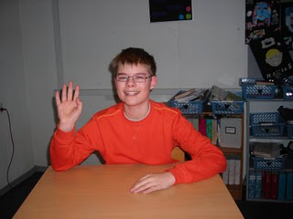  Dear Olga,  Thank you very much for all the nice presents. Is it the year of the cow now? Well, here in Denmark we have had winter holiday. Now we´re back at school. It was impossible to get up the first morning after the holiday, but now it's normal.  Best wishes,  Peter |  | To Ann, Alexander, Kate, Yana A. and Olga from Mette  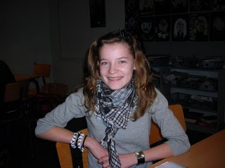  Hi, Ann, Alexander, Kate, Yana A. and Olga!  It was very nice to hear from you. In Denmark we’ve had Christmas the 24th of December and it was very nice. And I got a lot of great gifts.  I am doing lots of gymnastics. In the new year our whole class is going to confirm that we are Christians in the church. It’s like saying yes to our christening. And then we are going to have a big party with gifts and decorations and everything.  Thank you so much for the gifts which were in your parcel. They are very sweet. I hope that you also liked my gifts.  Best wishes from Mette
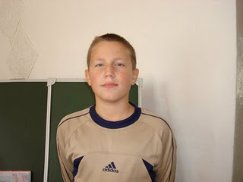  To Tobias from Misha  Hello Tobias!  I’m pleased with your present. Thank you very much!  I had my birthday on March 6. Now I’m twelve years old.  I’m from Moshkovo. Moshkovo is a small town.  My town is green and nice. My street is green too. I live at 3, Gagarin Street.  I live with my parents and my brother.  Best wishes from Michael. | To Victoria from Alberte  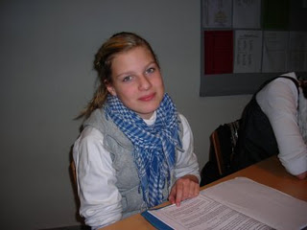  Hello Victoria.  Thank you very much for your gift. I am very happy for it and I like it very much! The chocolate you gave me was very special. It was nice to taste. Thank you!  I hope that you like my gift too!  Wishes from Alberte
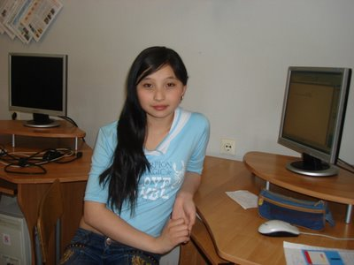  To Philip from Akku  Hello Philip!!!  Thank you for your present! How are you?  Tell me something about yourself? What do you like to do in your leisure time? When do you have you birthday? Do you like to go in for spots? I shall be glad to read about you!  According to the Chinese and Japanese calendar the year 2009 is the year of a Bull. Sometimes people in Russia pay attention to it. So we give small presents with a bull or a cow to each other.  Bye-bye!!!  Akku. | 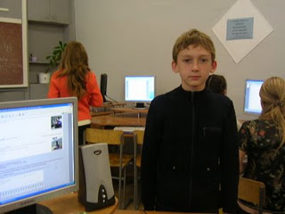  To Christoffer from Alexey  Hello Christoffer!  It’s me, Alexey. Thank you very much for your letter! I want to tell you about my day.  I get up early in the morning. I have breakfast at seven thirty and go to school. We usually have six or seven classes. I always have lunch at school. At school we often play volleyball or basketball. At two thirty I go home. After school I play computer games or watch television.  Please, tell me about your day!  Best wishes from Alexey.

- Фотографии с урока

