автор Удинцева Светлана Анатольевна, учитель английского языка,
ГБОУ ОШ-интернат №11 с углубленным
изучением китайского языка.
Topic of the lesson: Mouse, come out of the house!
(Before the lesson not to tell them the title of the topic and pointing to the picture:
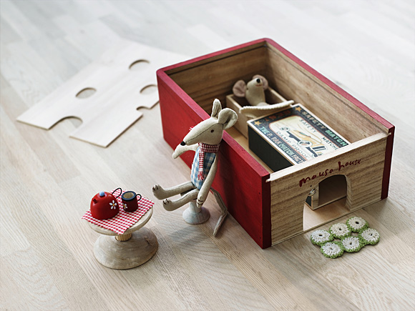
,with the question:Who is this?-однако, напомнив, что животные в английском языке- неодушевленные;
And to the picture:
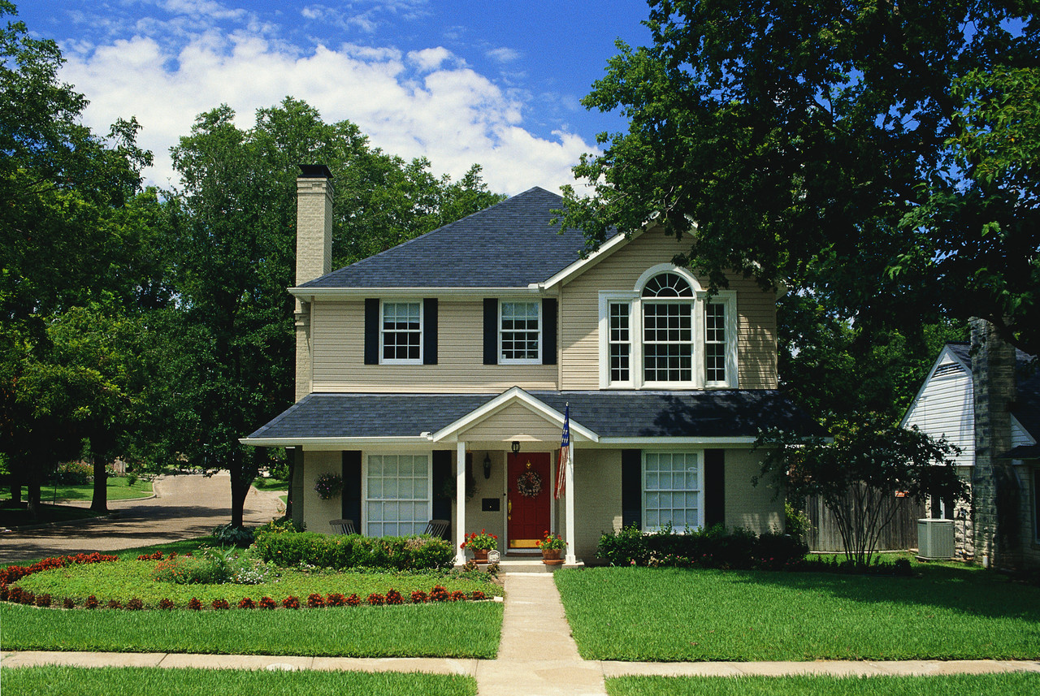
With the question :What is this?, Tell them: This (a mouse) “выйди” of that(a house). So, they have to call the topic themselves.
Task1. Children have to be split up into 2 teams, each team gets marked stickers of the parts of the house, and they should place them correctly on the poster with the picture of the house outside, with all necessary facilities and things in the yard.
The list of the words:
Roof, fence, pavement, chimney, upstairs, downstairs, balcony, basement, attic, mailbox, garden, lawn, pool, garage, tree, bush, flowers, tool shed, gates, window, door, doorsteps.
In 2 minutes the results have to be compared for determination of the winner team.
Task 3. Children have to listen to a song. They are divided into 3 groups,given an envelope of furniture items and some things of interior . In the song they will hear some known items of the furniture, should pick them up out of all the things given and place them in the correct order. Later ,after checking them up, they are shown the text of the song, and are to sing the song, translate it and while singing dance with some miming movements.
There’s a room in my house .
1.There’s a room in my house , it’s a very fine room, it’s a very fine room, indeed.
There’s a room in my house , it’s a very fine room, it’s a very fine room, indeed.
2.There’s a bed in a room ,in a room in my house, it’s a very fine bed, indeed.
There’s a bed in a room ,in a room in my house, it’s a very fine bed, indeed.
3.There’s a lamp by the bed in a room in my house, it’s a very fine lamp , indeed.
There’s a lamp by the bed in a room in my house, it’s a very fine lamp , indeed.

4.There’s a cupboard by the lamp by the bed in a room in my house, it’s a very fine cupboard , indeed.
There’s a cupboard by the lamp by the bed in a room in my house, it’s a very fine cupboard , indeed.
5.There’s a table by the cupboard by the lamp by the bed in a room in my house, it’s a very fine table , indeed.
There’s a table by the cupboard by the lamp by the bed in a room in my house, it’s a very fine table , indeed.
There’s a table by the cupboard by the lamp by the bed in a room in my house, it’s a very fine table , indeed.

6.There’s a chair by the table by the cupboard by the lamp by the bed in a room in my house, it’s a very fine chair , indeed.
There’s a chair by the table by the cupboard by the lamp by the bed in a room in my house, it’s a very fine chair , indeed.
There’s a chair by the table by the cupboard by the lamp by the bed in a room in my house, it’s a very fine chair , indeed.
7.There’s a person on the chair by the table by the cupboard by the lamp by the bed in a room in my house, it’s a very fine person , indeed.
There’s a person on the chair by the table by the cupboard by the lamp by the bed in a room in my house, it’s a very fine person , indeed.
There’s a person on the chair by the table by the cupboard by the lamp by the bed in a room in my house, it’s a very fine person , indeed.
There’s a person on the chair by the table by the cupboard by the lamp by the bed in a room in my house, this person on the chair is me.
Task 3. Children are to be divided into 3 teams, and given a file with an empty room, with some location of the door and the window , and with the pictures of some furniture.They should do the next task:
Moving the furniture around the house.
What room is this?
Please, put a bed in the middle of the room next to the wall under the window, put a radio on the bed , two carpets on the floor on the left and on the right of the bed, put a chest on the right of the bed. Put a lamp on the chest. Put a wardrobe on the right of the door in the corner, opposite the chest. Put a mirror on the wall into the left corner, opposite the door. Put a table under the mirror. Put a chair in front of the table.
After they have the task done, the teacher have to check up ,if the location of the furniture and ask the pupils, what room it is. Then show the image of the room in the puzzle:
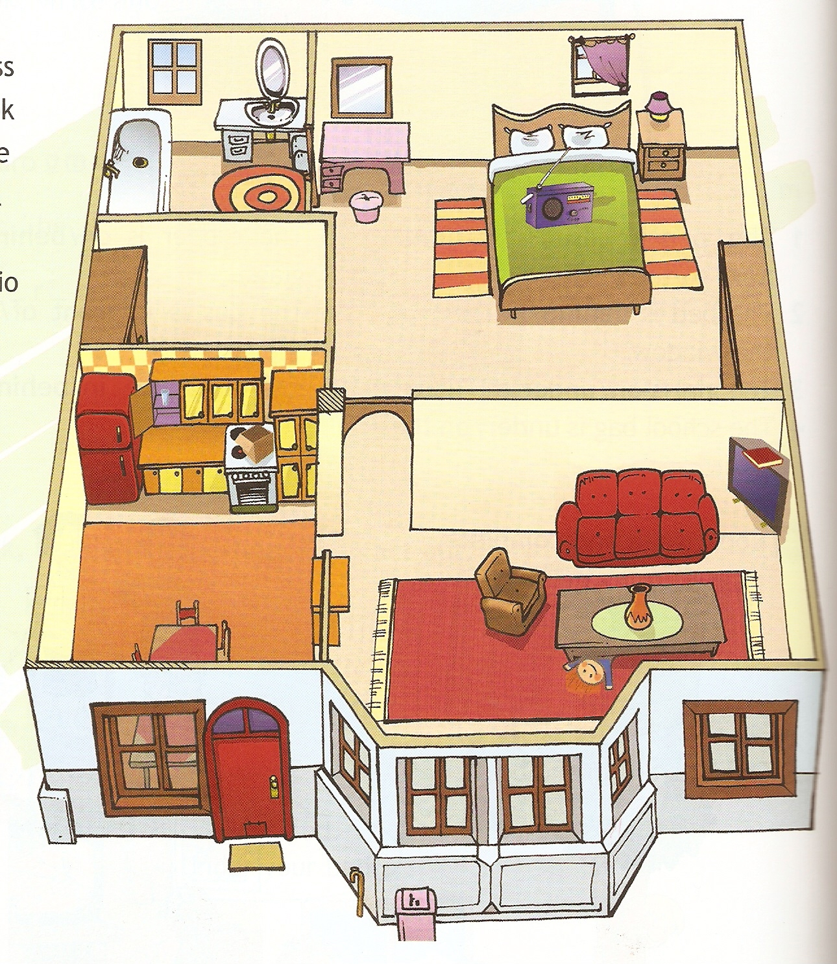
Task 4.Read , role-play the dialogue, answer the questions in a written way and orally:
A Mouse in the House.
Mrs Brown: (shouting loudly) I’ve found a mouse!
Mr Brown: Oh! You’re shouting too loudly. Sit down and don’t shout.
Mrs Brown: (sitting down) I’ve found a mouse in the house.
Mr Brown: A brown mouse?
Mrs Brown : Yes. A little round mouse . It’s running around in the house.
Mr Brown: On the ground?
Mrs Brown: Yes, under the sofa now.
Mr Brown: Well, get it out.
Mrs Brown: How?
Mr Brown: Turn the sofa upside –down. Get it out somehow. We don’t want a mouse in our house. Ours is the cleanest house in the town!

I’ve found=I have found- я нашла;
Shout- кричать;
Too loudly-слишком громко
Around- вокруг
Turn upside-down- перевернуть

- Where are Mr and Mrs Brown? Whose house is it?
- What did Mrs Brown find?
- What is the mouse doing?
- Is the mouse behind the window? Is it on the table? Where is it?
- Mr Brown
- gives a hand to his wife
- says her to calm down
- gives her some advice
- says that their clock is very expensive
- Why doesn’t he want a mouse in the house?
Task 5.Read the poems of the house and learn at home by heart.
- Little mouse,little mouse,
Will you come out of your house?
Thank you, Pussy! Says the Mouse
I won’t leave my little house!

Leave a house=come out of my house
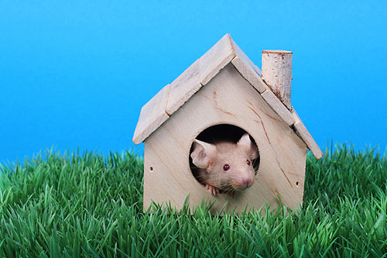
2.
Kitty’s home is in the country,
Betty’s home’s in the city,
Kitty likes to stay with Betty,
Betty likes to stay with Kitty.
Betty likes the country best
Kitty likes the busy city,
That is quite a lucky thing
For Betty and for Kitty.
to stay- ходить в гости; гостить у….
lucky thing-удача

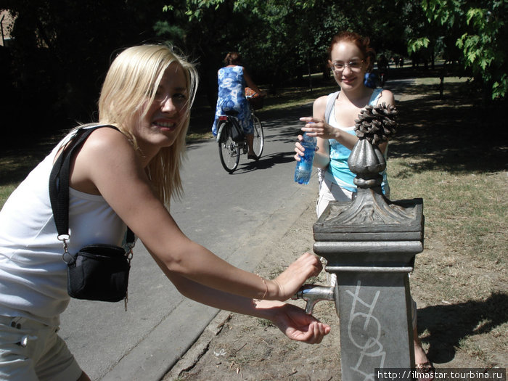

Task 6.Read the proverbs .Which of them are about the house?Why?
- a) East or West, Home is best.
В гостях хорошо, а дома лучше.
b) Great boast, small roast.
Много слов, да мало дела. ; Boast- хвастать, Roast- готовить, делать
c) It is the early bird that catches the worm.
Кто рано встает, тому бог дает. ;early bird- ранняя птица; сatches the worm- ловит червячка
d) The work shows the workman.
Дело мастера боится.
e) A bird in the hand is worth two in the bush.
Лучше синица в небе, чем журавль в небе.;
Is worth- стóит
f) Every country has its customs.
Что город, то норов.
Сustoms- обычаи
g) A wonder lasts but nine days.
Ничто не вечно под луной.
Wonder lasts- чудо длится
h) He laughs best who laughs last.
Смеется тот, кто смеется последний
- What’s done cannot be undone.
Слово не воробей- вылетит, не поймаешь!
Is done- сделано;Undone- не сделано
j)Burn not your house to rid it of a mouse.
Пытаясь избавиться от мыши, не сожги свой дом.
To rid of- избавляться
k)Man proposes, God disposes.
Человек предполагает, а бог располагает.
l)As you sow you shall mow.
Что посеешь, то и пожнешь.
Sow- сеять; mow-пожинать
m)There is no place ,like home.
В мире места лучше дома нет.
Task 7. Tell of your country house(as it was your home assignment),using the presentation.
Showing the presentation “My country house”, and children tell about their country houses.

Использованные источники и интернет ресурсы- в плане урока и в презентации:

1.Колыхалова О.А., Махмурян К.С., Учитесь говорить по-английски. Фонетический практикум. Владос, Москва, 1998.
2. www.timastar.tourbina.ru
http://images.propertyshowrooms.com
www.flickr.com/photos/ironrodart
http://media.tumblr.com/tumblr_
http://littleblacksheep.wordpress.com
www.eons.com/images/members
http://www.mixei.ru
www.lady-uspech.ru
http://www.liveinternet.ru/tags/%F6%E2%E5%F2%EE%F7%ED%FB%E9+%F1%E0%E4/
www.domidea.ru

