Серова Елене Михайловна
Учитель английского языка
МАОУ «СОШ №56 УИМ»
г. Магнитогорска
Конспект урока английского языка
«It’s the Thing You Need»
Цели:
познавательный аспект — знакомство с рекламой на предметы повседневного спроса;
развивающий аспект — развитие умения работать со словарем, способности к анализу, классификации, способности осуществлять продуктивные речевые действия, воображения;
воспитательный аспект — воспитание чувства гордости за свою культуру, страну, производящую продукцию высокого качества;
учебный аспект — формирование лексических навыков говорения;
сопутствующая задача — развитие умения читать/понимать речь на слух с разными стратегиями.
Речевой материал:
продуктивный: to operate, a waste of time, to brighten, automatic, compact, essential;
рецептивный: built-in-flash, film loading, film advance, to assemble, safe, luxury.

Ход урока:
1.
Teacher: Hello, boys and girls! We continue talking about technologies and today we are going today to discuss the way these technologies get into our life. But first of all let’s revise the names of modern inventions that have changed our life. What inventions are the most important for you?
P1, P2, P3, P4

2.
Teacher: but can we say that all the inventions are rather useful? Can you name the things you can sacrifice without reluctance?
P1, P2, P3

Teacher: Right now, we are going to read some articles about some inventions and after reading try to explain whether you would like to use it and why.

Text 1
Bow-wow!
Have you ever wondered what your dog is really thinking? Takara, a Japanese toymaker, has invented a gadget which translates dog barks into human words! Depending on your dog barks and growls, this gadget-called the Bowlingual — “translates” them into phrases like “I can’t stand it,” “How boring,” and “I’m lonely. Play with me, please.”

Text 2
Car of the Future
What will the car of the future look like? This one has no engine. It doesn’t need petrol. There isn’t even a steering wheel. Best of all, it doesn’t pollute the air! Unlike today’s cars, the Hy-wire, designed by General Motors, doesn’t give off any harmful gases into the air. It is powered by chemical reactions between oxygen and water. The only thing this car releases is water vapour. General Motors says the Hy-wire court be on the road by 2010 —just in time for you to drive!
Text 3
Wearable Computers
If you are hooked on the computer and can’t tear yourself from it, don’t worry. Soon you’ll be able to wear it- on your wrist, in your glasses and even in your earrings. The fist wearable computers are already on sale though they are probably a bit bulgy right now.
Don’t be surprised if in a few yeas you’ll be putting on your socks and your computer each morning before going to work. Of course, you might not even have to leave the house. Scientists predict that in the future most of us will work from home!

Text 4
At Your Service
If you are sick and tired of helping your parents about the house, then a new robot could be the answer.
Wakamaru, made by Mitsubishi, has been designed to make people’s life easier. This bright yellow robot with beady eyes can do different jobs for you and help you remember things you have to do. Here are some things Wakamaru can say: “Let me search the Internet!”, “What time will you be back?”
If Wakamaru is on its own and something seems wrong. it can e-mail its owner to let them know there is a problem.
It’s so clever that when its batteries run out Wakamaru knows that it needs to recharge itself, so it does!

(учащиеся читают тексты и высказывают свою точку зрения, в менее подготовленном классе можно воспользоваться схемами со страницы 222 упражнение 2.1-3)

3.
Teacher: But I wonder how these modern gadget and machines get into our life, who can advise you to choose this or that thing?
P1: my parents
P2: my friends
P3: advertisement

Teacher: Yes, TV, radio, magazines and newspapers advertise a lot of products. Can you guess the things are being advertised in the following exercise?
Ex 1.1 p 224
(Возможен следующий порядок работы:
— такой, как в Учебнике;
— учащиеся просматривают первую рекламу и отвечают на вопрос, приводя аргументы, затем — вторую рекламу и отвечают на тот же вопрос;
— одна группа работает с первой рекламой, другая — со второй. На подготовку ответов отводится 4—5 минут на каждую рекламу. Учащиеся могут обращаться к словарю)

Teacher: Would you like to buy these goods? What arguments do you think the most convincing? Why do people like to have modern appliances in their everyday life?
(работа с таблицей упражнения 1.2 страница 225)

P1, P2, P3, P4

4.
Teacher: Which characteristic should you highlight in the commercial if you want to sell the thing? Listen to the commercial and make notes.
Ex 1.4 p 226

5.
Teacher: let’s see if you could be a good salesperson. Each group will get some photos of the latest modern inventions. Present these inventions imagining that you are the inventors of these gadgets. During the presentation other pupils will be making notes.

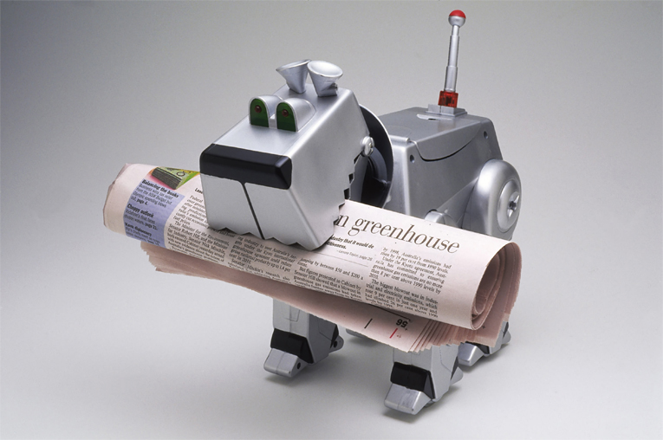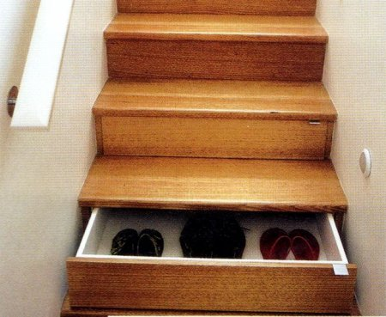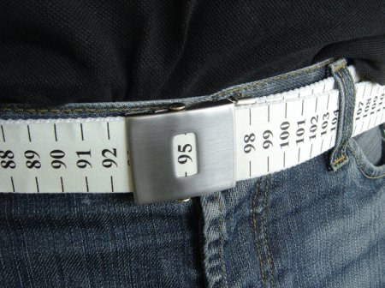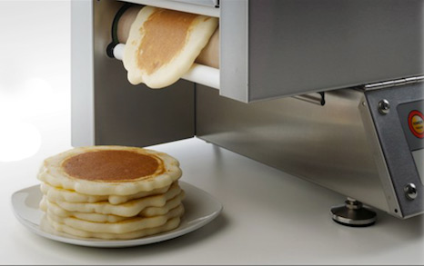

Фото взяты с http://crazy.werd.ru/index.php?newsid=30922

6.
Teacher: Thank you for your cooperation, it was nice to work with you today. Do you like our lesoon? Why?
At home I ask you to do ex 5 and 6 on page 226 and 227 in your Student’s Book. Don’t forget to give the examples in your answer.

