

Надежда Михайловна Стеклова, учитель английского языка МОУ «СОШ № 35 с углубленным изучением отдельных предметов г. Чебоксары».
C УМК “Spotlight” работаю пятый год. Особенно нравится то, что в начальных классах в него включено много красивых, ярких песенок и рифмовок, которые оживляют урок и дают определённую психологическую разгрузку детям. Ученики с удовольствием поют их при игре в настольные игры в рабочих тетрадях. Кроме запоминания лексики и грамматических структур, дети узнают в них много материала страноведческого характера, тем самым, расширяют свой кругозор. Наш интерес к песням вылился во внеклассное мероприятие, которое мы назвали “ If You Feel Like Singing”и я предлагаю его вашему вниманию. Мероприятие для учащихся среднего звена.

If you feel like singing.

1.
Hello, everyone. Nice to see you. Our activity is called “If you feel like singing” and we shall enjoy singing today. First lets remember the song “Billy Boy” (песню выучили на предыдущих мероприятиях . Вот ссылка этой песни в You Tube: http://www.youtube.com/watch?v=lr2f-SJss4g )

Billy Boy.
(D) Where have you been Billy Boy, Billy Boy
Where have you been charming (A7) Billy?
I have been to seek a wife
She's the (D) joy of my life
She's a (A7) young thing
and cannot leave her (D) mother
Did she bid you come in Billy Boy, Billy Boy
Did she bid you come in charming (A7) Billy?
Yes she bade me come in
There's a (D) dimple in her chin
She's a (A7) young thing a
and cannot leave her (D) mother
Can she make a cherry pie Billy Boy, Billy Boy
Can she make a cherry pie charming (A7) Billy?
She can make a cherry pie
Quick's a (D) cat can wink its eye
She's a (A7) young thing
and cannot leave her (D) mother
Oh oh where have you been Billy Boy, Billy Boy
Where have you been charming (A7) Billy?
I have been to seek a wife
She's the (D) joy of my life
She's a (A7) young thing
and cannot leave her (D) mother

Thank you very much! You are great singers!

2.
Now we are going to learn a new song. It’s a folk song. It’s called “A Bicycle Built for Two”
The characters of the song are Daisy and Patrick. By the way, do you know that “daisy” is a flower too? Here they are:
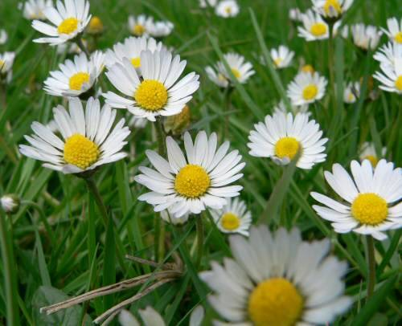

And here is a Bicycle Built for Two:

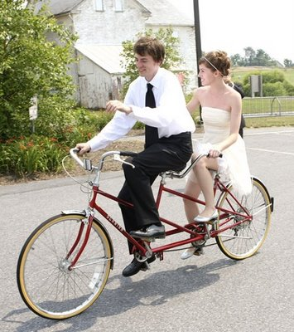

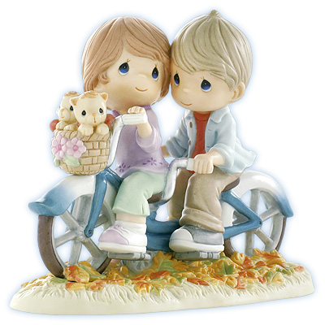

You’ll hear a street organ (a barrel organ) – a musical instrument. Here it is:

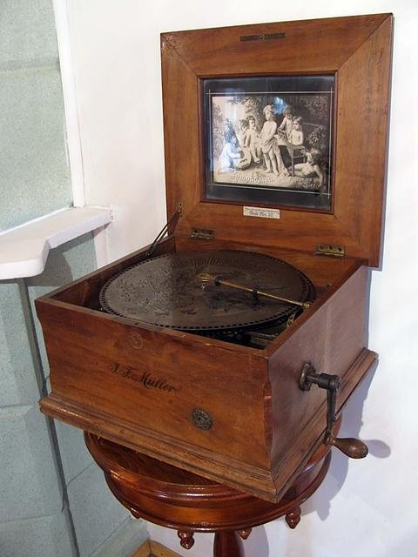

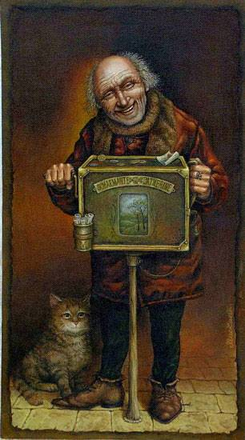

3.
Now let’s listen to the song.

--- Lyrics ----
A Bicycle built for two

Daisy, Daisy,
Give me your answer, do!
I'm half crazy,
All for the love of you!
It won't be a stylish marriage,
I can't afford a carriage
But you'll look sweet upon the seat
Of a bicycle made for two.
Patrick, Patrick, here is your answer true!
I know that trick, and it will never do.
If you can`t afford a carriage,
Then there will be no marriage,
For I insist I won’t be kissed
In a bicycle built for two.
http://www.youtube.com/watch?v=DF-VwjPNL

4.
The song’s Background.

Bicycle riding became very popular in 1890-s in England and other countries. Harry Dacre, a songwriter from London, wrote a waltz about an imaginary romantic problem with a bicycle built for two. It was immediate success. When a bicycle craze (boom) was over? People have continued to sing about Daisy, and even have added to the story.
In the 1970-s bicycles once again became fashionable for adult riders all over the world.
Daisy’s answer to Patrick was written by an American teacher, Garry Gabriel? During a seminar for teachers of English in Yugoslavia in 1972.

5.
Please pay attention to the next words and expressions from the song:

- marriage - when a young man and a girl become a wife and a husband
- carriage - a car, some kind of transport
- Daisy
- to marry – to become a wife or a husband
- do - here: please
- half crazy – 50% fool
- all for the love of you – because I love you
- stylish marriage – a fashionable marriage, a marriage in the latest style
- to afford a carriage – to have enough money to pay for a carriage ( a car)
- to look sweet – to look very beautiful
- Patrick – a boy’s name
- here is your answer true – here: yes, I’ll look sweet
- I know that trick – you are sly, cunning –хитрый
- it will never do – I will never agree with it
- for I insist – I am very serious
- I won’t be kissed – I will not marry
Repeat them after me and read again

6.
Now we are going to do some activities with the words from the song.
Let’s solve the crossword puzzle.
Using clues given fill in the missing words. There is one space for each letter. 1- across has been done as an example.
Across:
1. A girl’s name.
3. The pronoun used to refer to a bicycle.
- Also called a “bike”
- In the alphabet, the letters that come right before and after “m”
- The pronoun used to a trick
- People sometimes take _______ to learn how to ride a bike.
11. Pronoun referring to Daisy.

Down:
2. Fashionable.
3. Not well; sick.
4. Campers and soldiers sleep in them.
5. Found on a bicycle and at the door of the house.
8. A finger on your foot.
10. Abbreviation for “steamship”.

Crossword Puzzle

1D | a | i | 2 S | y
 |  |  | t |  | 3 I | 4T
5B | i | c | y | c | l | e
e |  |  | l |  | 6L | n
l |  |  | 7 I | 8T |  | t
9L | e | 10S | s | o | n | s
 |  | 11S | h | e

7.
Fill the gaps with the words and expressions.

Daisy, Daisy,
Give me your answer, do!
I'm ---- -----,
All for the love of you!
It won't be a ------- marriage,
I can't afford a --------
But you'll look sweet upon the seat
Of a ------- made for two.
Patrick, Patrick, here is your answer true!
I know that trick, and it will never do.
If you can`t afford a carriage,
Then there will be no --------,
For I insist I won’t be kissed
On a bicycle ----- for two.

8.
If you feel like singing – let’s do it.

It was really great! Thank you!

Источники материалов:
2009. daisy swayze. Lovely and warm.
http://www.fragrantica.com/perfume/Anna-Sui/Sui-Dreams-2087.html
All for the Love of You On A Bicycle Built For Two.
http://www.countrynmoregifts.com/Love-63.html

A Bicycle Built For Two.
http://joannagoddard.blogspot.com/2008_09_01_archive.html
Young Couple Riding on a Bicycle Built for Two clipart.
http://mobile.clipartguide.com/_search_terms/bicycle.html
Покручу я вам шарманку, не теряйте время...
http://www.chitalnya.ru/work/180162/
Шарманка Культура и Искусство в...
http://art16.ru/gallery2/v/tatarstan/elabuga/durova/IMG_7862.jpg.html

