ПЛАН – конспект УРОКА АНГЛИЙСКОГО ЯЗЫКА.

Учитель: Жидкова Е.В.
Класс: 7
Тема: «Праздники в США»
Тип: систематизации изученного материала.
Вид: командное соревнование
Цель: создание условий для закрепления и контроля знаний по теме.
Задачи:
- Контроль знания лексики.
- Контроль навыков монологического высказывания и диалогической речи.
- Расширение страноведческого кругозора.
Методические приемы: игра, аудирование, работа с наглядным материалом, инсценировка.
Формы организации деятельности: групповая, фронтальная, индивидуальная.
Дидактическое обеспечение: картинки, раздаточный материал, костюмы, рисунки, кроссворды, ребусы.
Планируемый результат: 1) учащиеся владеют лексикой по теме; 2) учащиеся могут выразить свою точку зрения, а так же вступают в диалог со сверстниками и учителем.

ХОД УРОКА:
- Организационный этап.
Приветствие и объявление темы и цели урока.
Hallo, boys and girls! Today we are going to speak about American Holidays. But, first of all, what American holidays do you remember? (Учащиеся называют праздники.)
- Фонетическая зарядка.

Repeat after me:
New Year’s Day
Last night, while we were fast asleep,
The old year went away.
It can’t come back again because
A new one’s come to stay.
Where is the woman of my dreams? -
So I asked boiling streams.
Think of family, my dear -
Answered the river, calm and clear.

Как вариант
Возможно прослушивание нескольких отрывков стихов, а затем назвать о каких праздниках шла речь в стихотворениях.

- Соревновательный этап
Урок включает подготовительный этап. Учащимся предлагалось заранее разделиться на 2 группы. Каждая группа должна была подготовить сценку. Каждый учащийся оформил либо кроссворд, либо ребус, либо поздравительную открытку. Творческие работы могут быть использованы для оформления кабинета. Необходимо обязательно отметить лучшие работы.

1 task (по группам):  Choose the correct answer.  ( на доске находятся 14 закрытых карточек)  e.g. 1) Jack-o-lantern is  - a) a pumpkin  - b) a toy | 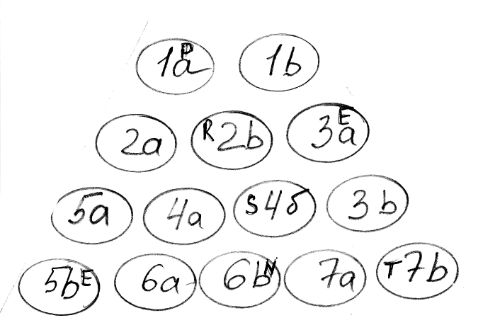
- Halloween is  - a) only an American holiday  - b) both an American and a British holiday  - St. Valentine is  - a) a funny card  - b) a toy  - Abraham Lincoln is  - a) the 1st president  - b) the 16th president. | - on Halloween children go from house to house and shout:  - a) Steady. Ready. Go!  - b) Trick or treat!  - The 4th of June is called  - a) Thanksgiving day  - b) Independence day  - Thanksgiving day is celebrated on the  - a) 1st Thursday of November  - b) 4th Thursday of November

We opened the word “present”.
What a nice word it is.
Now answer my question/ what presents do children get on different holidays.
(possible answers)
- Moms get roses on Mother’s day
- Children get chocolate eggs and rabbits on Easter
- Boys and girls get Valentines on St. Valentine’s Day
- Children get sweets and toys on Christmas
…
And the best present of all times is a greeting card, especially if it is hand – made.

2 task Show your greeting cards to us and we’ll choose the best one.

3 task the next task is the crossword puzzle. Look at the blackboard.
- A special day for Mom.  - The scariest day of the year.  - Americans celebrate Independence day during this month.  - Martin Luther King Jr. fought against racial ____________.  - He visits children on Christmas Eve.  - Americans wear this colour on St. Patrick’s Day.  - The first president of the USA.  - The celebration of this holiday begins on December, 31st.  - He discovered America.  - Everyone is ____________ on St. Patrick’s Day. | 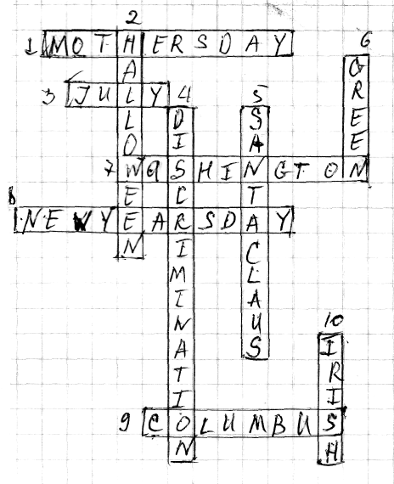

4 task
At home you were to make up a story, where smth is wrong. The first team you are welcome and the second team try to guess what is wrong.
(примерные диалоги)
1 team
A group of pupils dressed in green (except one) meets at school.  - Hi!  - Hallo!  - How do you do!  - are you ready to have fun?  - look! What a nice sweater I have!  - And I’ve bought a new green tie for the party!  - And why are you in red?  - Don’t you remember that today is Halloween? And everybody wears green on this day.  - Because everybody is Irish on Halloween!  - Sorry. I’ve clean forgotten about it!  - take my cap.  - Thank you.  - Look! I have a present for all of us!  - A green shamrock? Are you kidding?  - No! A green fur-tree! Now we shall decorate it with pumpkins…  - And have a nice party.  (Children decorate the fur-tree, stand round it and sing “Happy Birthday!”)  - It’s a fine funny party!  - Now… let’s go outdoors and congratulate people with Halloween!  (Children go out shouting “Dance or sing!”) | Wrong things:  - on Halloween children do not wear in green? They dress up like ghosts and witches.  - Everybody is Irish on St.Patrick’s day.  - Shamrock is a present on St.Patrick’s day.  - They do not decorate fur-tree with pumpkins/  - They do not usually have nice? Funny parties? But parties of horror.  - They do not congratulate people with Halloween, they frighten people.  - They do not shout “Dance or sing!”? they shout “trick or treat!”

2 team
A group of children celebrates Christmas.  - Happy Christmas! - says a boy dressed like a ghost.  - Happy Christmas! – says a girl, dressed like a witch.  - Hallo! How are you? Where is the main symbol of Christmas?  - What do you mean?  - A pumpkin, of course!  - Are you crazy? Pumpkin is a symbol of Thanksgiving day. And the symbol of Christmas is a green shamrock-tree.  - Of course you are right!  - Let’s decorate it!  (Suddenly a Christmas Bunny comes!)  - Hallo, boys and girls! I have some presents for you!  - Hurray! We are glad to see you!  - Now we shall play “trick or treat” if you choose trick? I’ll make you laugh, if you choose treat, I’ll give you a sweet present.  - Treat! Treat!  - O’K, O’K. Take your presents. Have fun! And I must go. There are a lot of other children waiting for me. Good-bye…  - see you! | Wrong things  - on Christmas people usually say “Merry Christmas1”  - They do not dress like ghosts and witches  - Pumpkin is a symbol of Halloween  - And the symbol of Christmas is a fur tree.  - Bunny comes on Easter.  - They don’t play “trick or treat” on Christmas.

5 task
Now teams, the last task. You are to make up a story about your favourite holiday.
Here’s the plan to help you.

the plan of the story..
  - What is your favourite holiday?
  - When is it celebrated?
  - How did it begin?
  - What are the main traditions?
  - What do the people do on this holiday?
  - What presents do they get?

4. Подведение итогов.

- выявить победителя.
- выставить оценки.
- рефлексия: что понравилось, что нет, добились ли поставленной цели, что получилось, что нет, почему?
- домашнее задание.

