UNIT II
WHAT ARE YOU LIKE?
TEST

I. LISTENING COMPREHENSION
1. How do the children apologize and reply? Tick. You’ll hear the conversation twice.

A. a) I’m so sorry! B. a) That’s OK!
b) I’m very sorry! b) Don’t worry!
c) Sorry! c) That’s all right!

2. Choose a picture that matches the conversation. Write out the correct letter.
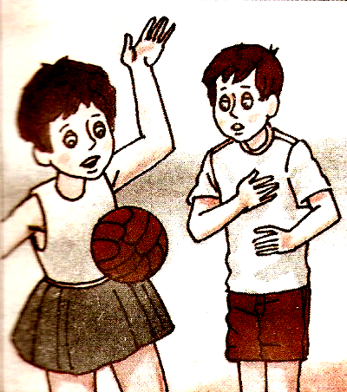
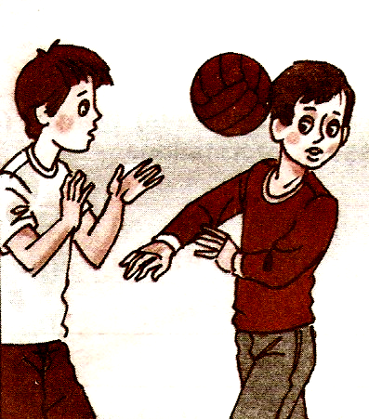
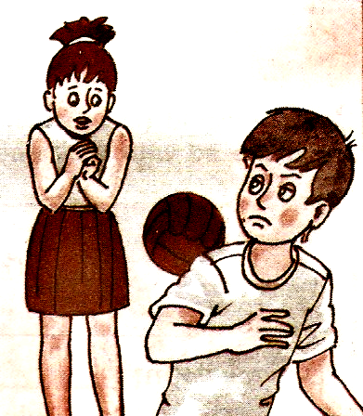
A. B. C.

II. READING COMPREHENSION
Read a story about animals at London Zoo.

LONDON ZOO
London Zoo wants everyone to adopt (взять под опеку) one of its animals, to raise money to look after them. When you “adopt” an animal, you are sponsoring it for a year.
You can adopt an animal for one year on your own, with your family or with your school or group. The cheapest are tiny (крошечные) things such as ants, beetles, butterflies and small fishes. The most expensive animal is an Asian elephant.
What do you get for your money? An Adoption Certificate, a photo of your animal and a free entrance ticket.
You can also have your name on a sign near your animal’s cage.
London Zoo has over five thousand animals.

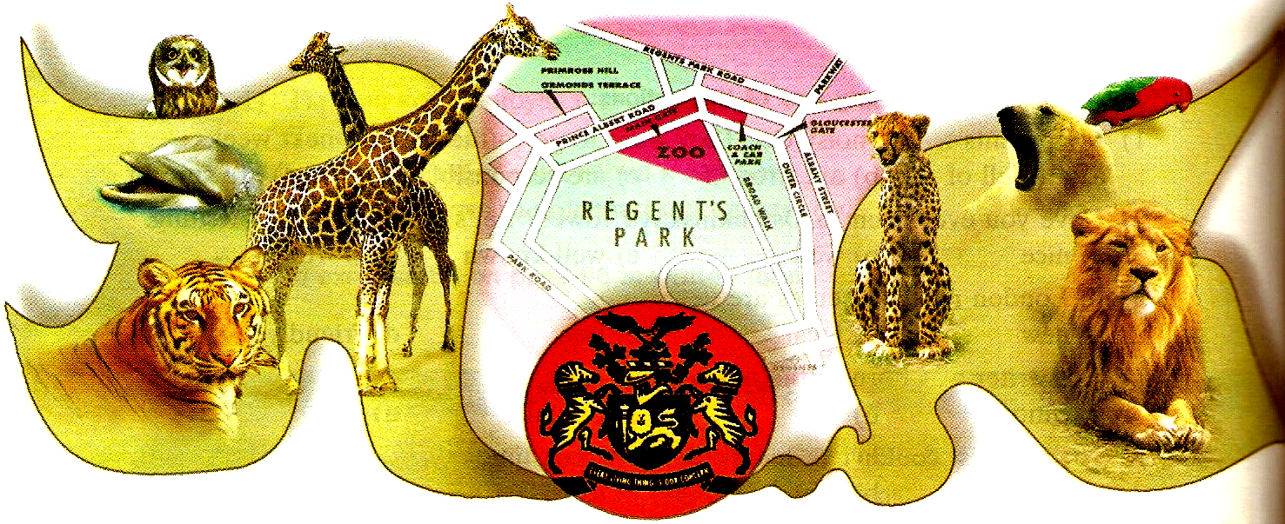
Choose the correct answers:
1). London Zoo wants people to adopt animals…
a) to raise money
b) to get rid of them
c) to help animals
2). “To adopt” an animal means you are sponsoring it…
a) for a month
b) for six months
c) for a year
3). London Zoo has…
a) 1000 animals
b) 3000 animals
c) 5000 animals.
III. USE OF ENGLISH (GRAMMAR/VOCABULARY)
1. Bill is talking about his family and friends.
Fill in the gaps with suitable words. One word in each group is extra.

- My sister is (0) sociable. But she is sometimes (1)_____. /shy, clever, sociable/
- My brother is (2) _____. He has a (3)_____smile for everybody. /friendly, talkative, cheerful/
- My mother likes to chat over the telephone. She is very (4) _____. But she is (5) _____. /polite, talkative, bossy/
- My Dad is a bit (6) _____. He isn’t (7) _____. /strong, helpful, lazy/
- My best friend is (8) _____ math. He is very (9) _____. /clever, brave, good at/

2. At weekends Paul and his family do various things.
What are Paul and his family doing now? What do they usually do? Choose the correct verb form.

Paul’s mother usually (0) (goes/is going) shopping on Saturdays, but now she (1) (does not go/isn’t going) shopping. She (2) (reads/is reading) a tale for my little brother. But I (3) (play/am playing) chess with my father. At the moment my sister (4) (helps/is helping) mother to prepare chips for dinner. We always (5) (watch/are watching) our favourite films on Sundays.

3. It is 5 p.m. Bill’s family is at home.
Fill in the gaps with the verbs in the correct verb form.

Bill (0) is watching (watch) the horror film. Kate and Helen (1) _____ (not watch) this film. They (2) _____ (not like) horror films. Bill’s mother (3) _____ (prepare) supper. His father (4) _____ (read) the newspaper at the moment. He (5) _____ (like) to read after work.

IV. CULTURAL AWARENESS
How well do you know British and American culture?
Write the letter T if the sentences are TRUE and F if they are FALSE.

1). The Scout law in Britain has 12 points.____
2). American children of your age elect a class president.____
3). “Just Seventeen” is a magazine for small children.____
4). When British people apologize, they say ‘Excuse me’.____
5). Yo-yo is a ball game.____

V. WRITING (HOMETASK)

