Карнавал сказочных героев

Звучит музыка, на сцену выбегают дети в карнавальных костюмах под музыку «We wish you a Merry Christmas» и рассказывают стих

It is December the thirty-first
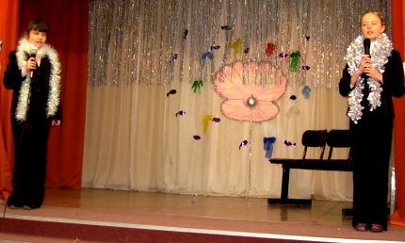
Something is about to burst.
The 31st of December is the day,
When we have a great holiday.
The New Year usually comes at midnight
And brings us presents so sweet and bright.

Merry Christmas
Merry Christmas happy day
We all dance and sing and say
Merry Christmas, happy day.

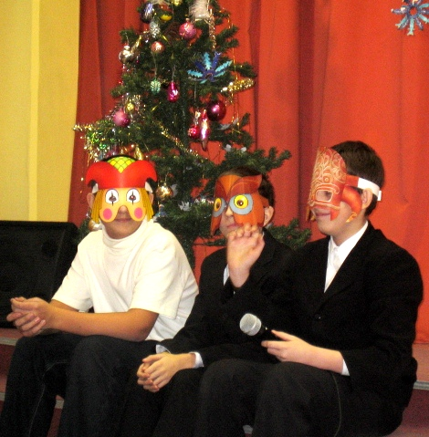
Звучит музыка “We wish you a Merry Christmas” , на сцену выходят ведущие и садятся вокруг ёлки.

P1- You know, It’s New Year’s Eve in Russia
and Merry Christmas in Britain and the USA.
P2- Yes, it’s really great time with lots of presents…
P3- …. And wonderful stories. Let’s tell the stories about Christmas
and New Year. We have some time before 12 o’clock.

P1- Let I tell you “The story of Santa Claus”.

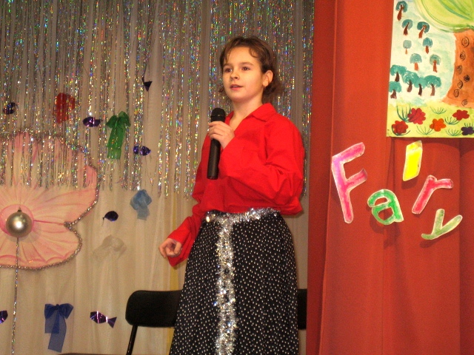
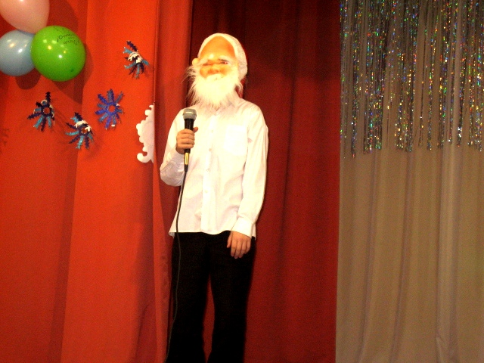

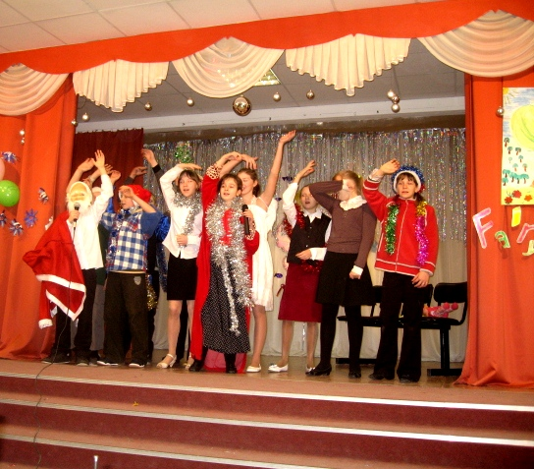

P1,3- What a wonderful story.
P3- But I know what happens further. Let I tell you “The Story of Merry Christmas”.

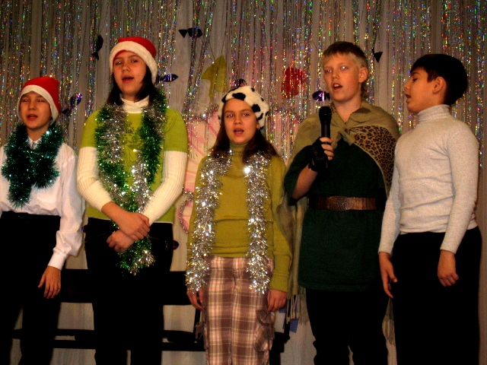

P1- Oh, thank you.
P2- I like it too. So, sit around our Christmas tree. Now is my turn. I want to tell you fairy tale about Little Red Ridding Hood.
P1,3- We are listening!!!
P2- Long time ago when there were only fairy tales on the Earth Christmas time came and everybody wanted to celebrate this holiday. All fairy persons gave presents to each other. So this is story of “Little Red Riding Hood”.
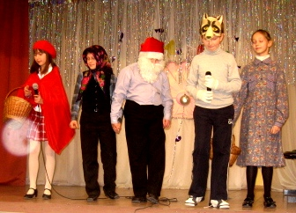

P1,3- Thank you. It was very nice story.

Knock. Knock. Knock.

P3- Somebody’s knocking at the door.

Ps- Merry Christmas and Happy New Year.

P3- Hello! Hello!
P5- We see you’re having some kind of party. Can we join you. We have some wonderful poems with us.
P1,2,3- Yes, It’s really nice when your house is full of good people.
P5,6,7- We want to tell you poems about Santa Claus or Father Christmas.

P5- It is winter, it is cold.
Father Frost is very old.
But he is full of joy,
And glad to give me a nice toy.

P6- This is the season
When children ski,
And Father Frost brings
The bright New Year Tree.

P7- You are very nice! I want to tell you.
Happy New Year, my friends!
Happy New Year today!
Let us dance hands in hands,
I will show you the way!

P8,9- But What a wonderful Christmas Tree you’ve got.

P8- It is winter, it is Christmas!
Look at our Christmas Tree!
There are big balls, there are nice dolls,
Many candies you can see.

P9- There are flags, there are ribbons,
Little bells and bright stars, too.
Red and orange, green and yellow,
Pink and purple, violet and blue.

P8,9-We have a fir-tree in the hall.
It is so beautiful and tall!
Around it we dance and play
Because it is a New Year Day.

P1- Thank you very much. But it seems that little children also want to join us.
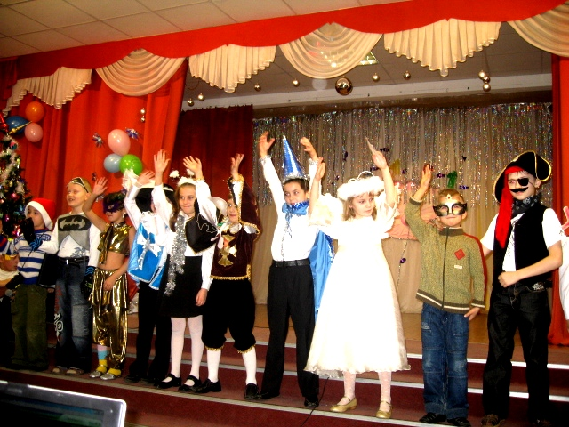
На сцену выходят первоклассники

- Santa Claus lives in England.
- He is funny and merry.
- His cheeks are like roses.
- His nose is like a cheery
- With a branch of green holy
- And robin, his friends
- To all English children
- New Wishes he sends.
- Happy New Year.

Все дети хором – Happy New Year.

P3- Let show our little guests one more fairy tale.

P2- What a wonderful fairy tales we’ve watched. I think we have the most wonderful party for ever.

P3- Look at the clock. It’s 5 to 12!!!!

На сцену выходит Санта Клаус.

S.Cl.- Ho, ho, ho!!!! I’ve heard you have a wonderful party here. So I’m glad for you. I wish everybody happiness, good health, excellent marks and always bring joy to your parents!!!!!!

The clock strikes 12.

Все участники карнавала выходят на сцену и поют финальную песню – ABBA “Happy New Year”.
