TEST

“HOW DIFFERENT THE WORLD IS!”

I. LISTENING COMPREHENSION
You will hear the information about national parks.
For questions 1-6, write down the missing information

- Yellowstone was _____ American National Park.
- Yellowstone National Park was established in _____.
- Yellowstone National Park had an area of _____ acres.
- In the 1980s, the National Park System included about _____ different areas.
- _____, the Everglades, and the Sequoia National Parks are just some of the best-known national areas.
- The System of National Parks and National Reserves has an area of over _____ square miles.

II. READING COMPREHENSION
Read an article from the Newsweek magazine.
1. Decide which title A, B, or C is the best one for the article
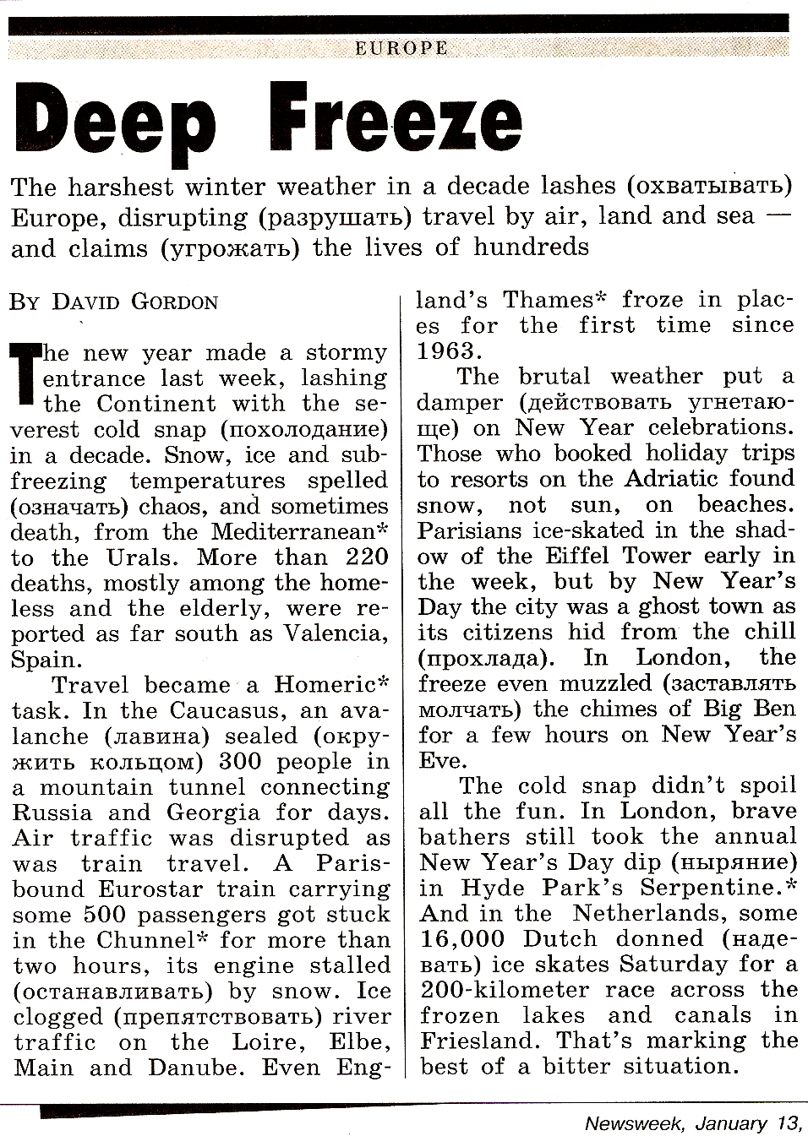
 A.

B.
DEEP FREEZE

C.

2. For statements 1-5, decide which of them are TRUE and which are FALSE. Tick (√) the necessary box

 | TRUE | FALSE
- The harshest winter weather claims the lives of hundreds.
- They report about death among animals.
- Notwithstanding the severest cold snap the Thames didn’t freeze.
- By New Year’s Day Parisians ice-skated in the shadow of the Eiffel Tower.
- In London, brave bathers took the annual New Year’s Day dip.

III. USE OF ENGLISH (GRAMMAR/VOCABULARY)
1. A tourist is traveling around the USA.
Complete the questions (1-5) he is going to ask. There is an example at the beginning (0)

0. - I want to visit the Bronx Zoo.
Do you know where the Bronx Zoo is?
1. – I’d like to visit Central Park.
Could you tell me, how far ___________?
2. – I want to see the Statue of Liberty.
Could you tell me, what transport __________?
3. – I’d love to go on an excursion to Yellowstone.
How much __________?
4. – I want to buy a souvenir.
Could you tell me, where ___________?
5. – I’d like to have a snack.
Where __________?

2. Below is a short article about tourism in Britain.
Form a word that fits in the blank space from the word in capitals. Fill in each gap with the new word. There is an example at the beginning (0)

- I think these were really (EXCITEMENT) exciting holidays.
- Every year more than eleven million tourists visit Britain, in fact, tourism is an (IMPORTANCE) _______ industry, employing thousands of people.
- Most (VISIT) _______ come in summer months when they can expect good weather.
- Tourists (USUAL) _______ spend a few days in London, then go on to other well-known cities.
- Perhaps the least visited places in England are old (INDUSTRY) _______ towns.
- But many people think that nineteenth-century cities show the (REAL) _______ of Britain.

IV. CULTURAL AWARENESS
What do you know about the geographical position and the life of the people in the USA, the UK, Australia and Russia?
For statements 1-5, decide which country the following information is related to. Tick (√) the country

 | RUSSIA | USA | UK | AUSTRALIA
- It’s sometimes called the Land Down Under.
- It’s known for the frontier experience.
- It’s situated in two continents.
- No place in it is more than 120 kilometres from the sea.
- Many people live in the outback there.

