The Turnip

(The Russian tale)
Story-teller: Once upon a time there lived an old man and an old woman. They were poor and could hardly make ends meet. One
day the old man planted a turnip in his kitchen garden. The turnip was growing and growing and grew very, very big.

Old man: Wow! Have a look at this! The turnip is huge!

Have you ever seen anything like this before? I am going to
pull it out.
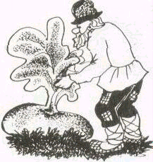

Story-teller: So. the old man grasped the turnip leaves and he
pulled, and he pulled but he couldn't pull it out. It didn't budge at all.

Old man: Oh-oh ... Keep smiling when the chips are down, I have to ask my old lady to help me. Wife, wife, come and help me! Where are you? Oh, I should shout louder. She is deaf in one ear. Hello! Come
on! Help me!

Old woman: Why are you shouting? You get on my nerves. I'm not deaf. If you scream any more I'll take my broom and ...Oh, I can hardly believe my eyes. What is it?

Old man: You are not deaf. You are blind. It's a turnip! Come on! Give me a hand with this thing.
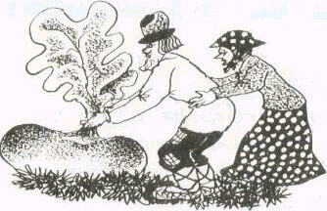
Story-teller: The old man took hold of the turnip, and the old woman took hold of the old man, and they pulled, and they pulled but they couldn't pull it out. So they arrived at a decision to call their granddaughter.

Old woman: Honey, come here and help us!
Granddaughter: Me? You want me to pull this giant thing out? Are you kidding? This whole idea is making me mad!

Old man: Don't start a quarrel! You should be ashamed of yourself. Come on, let's do it. Each family member must do his bit.

Granddaughter: You always find fault with me, I'll help you. 0. K.

Story-teller: So, the old man took hold of the turnip, and the old woman look hold of the old man, and the granddaughter took hold of the old woman, and they pulled, and they pulled but they couldn't pull it out.
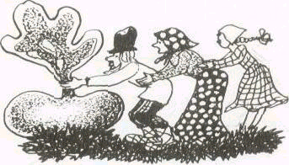

Granddaughter: Oh dear! Pulling this turnip out is no picnic. We can't do it without my dog. Come here, doggy!

Dog: What's up? •

Granddaughter: We need your help.

Old woman: Help us pull this turnip out.

Dog: Sure. No problem.

Story-teller: The old man took hold of the turnip, and the old woman took hold of the old man, and the granddaughter took hold
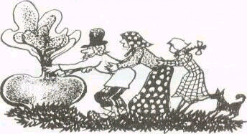
of the old woman, and the dog took hold of the granddaughter, and they pulled, and they pulled but they couldn't pull it out.

Dog: What have you grown, old man? It isn't a turnip, it's just a monster.

Granddaughter: So what? Any ideas? I'll go nuts if we don't pull it out!
Dog: Let's call the cat. Maybe he can help us. Come here, puss.

Cat: Mew-mew. Did you call me?

Dog: Look. We have to pull this turnip out. Will you help us?

Cat: I’ll help if you give me milk and sour-cream and ..

Old woman: No help -- no food. O. K.?

Cat: I was kidding. You can count on my help.

Story- teller: So, the old man took hold of the turnip, and the old woman took hold of the old man, and the granddaughter took hold of the old woman, and the dog took hold of the granddaughter, and the cat took hold of the dog, and they started pulling. It was too hard to pull out. They tied again, - no way.

Old man: It’s incredible! I think its turnip is one for The Guinness Book of Records. It’ll bring us a lot of money if we pull it out.

Old woman: That’s it, “If…”

Mouse: Hi! I see you in trouble, guys. Can I help you?

Cat: Look at this big shot. She wants to help us! Don’t you see how huge the turnip is?!

Mouse: Big deal! We’ll cope with it if we are together.

Old woman: O.K. Let’s get down to business then.

Story- teller: So, the old man took hold of the turnip, and the old woman took hold of the old man, and the granddaughter took hold of the old woman, and the dog took hold of the granddaughter, and the cat took hold of the dog, and the mouse took hold of the cat, and they pulled, and they pulled, and they pulled it out.

All: It’s fantastic! It’s great! It’s cool!

