Сычева Марина Васильевна

МАОУ СШ №1 г.Михайловска Свердловской области,
учитель английского языка

Серия «LEARNING THE WORLD”

Тип работы: материал к уроку или внеурочной деятельности для 8-11 классов

Цель: создание условий для формирования интереса к культуре и традициям изучаемого языка.
Задачи:
1.контроль лексических знаний
2.совершенствовать коммуникативные умения диалогической речи
3.расширить лингвистический кругозор обучающихся
4.воспитывать уважение к традициям других народов

2014г

Test «What do you know about Scotland»

1.Complete the beginning of the phrase with its ending.

1The Edinburgh military tattoo is a festival of performances that started in 1947

2 . The Royal Mile is a show that takes place five or six nights

3. the Cannon gate is the oldest part of Edinburgh

4. The Holyrood house is a line of streets that connects the castle and Hollyrood Palace

5.Glasgow is a royal palace

6. The Castle is an industrial centre of Scotland

7.Princes Street is connected with the name of Walter Scott

8.the Edinburgh festival is the most picturesque part of the Royal Mile

2.Answer questions
- What parts is Scotland divided into?
- What big river flows across the country?
- What are the two largest cities in Scotland?
- Which city has a longer history?
- What is Scotland washed by?
- Who is its patron?
- What is a national symbol of the country?
- What is its capital?
- What lake is situated there?

3. Read sentences and fill in the gaps. Match the pictures to these phrases.

1 … is the capital of Scotland
2 The family groups of Scotland are called ……
3 A ball game which began in Scotland is ……
4. Scotland is the part of ……
5.The northern hills of Scotland are called ….
6. The most famous poet of Scotland is …..
7.The skirts worn by Scottish men and women are called….
8.The traditional instrument is
9 .The Scottish …is called Saltire and is a white ..on the …background.
10 The highest top in Scotland is ….

A B
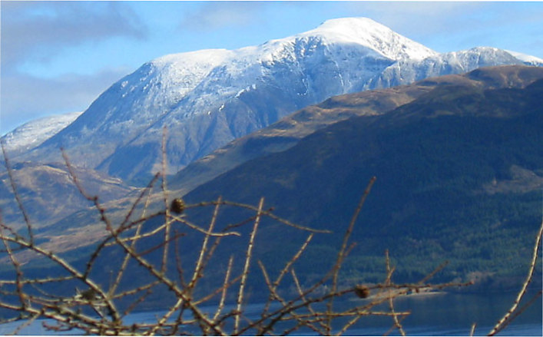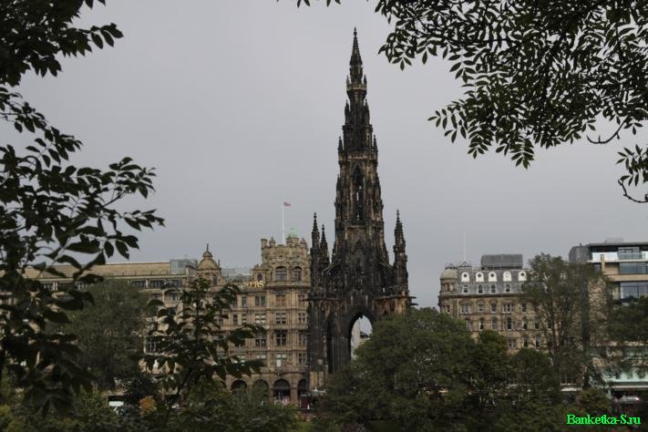
C D H
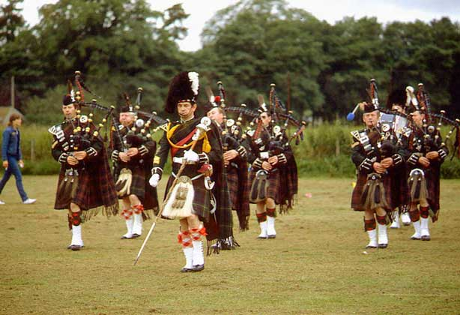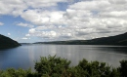

E F G
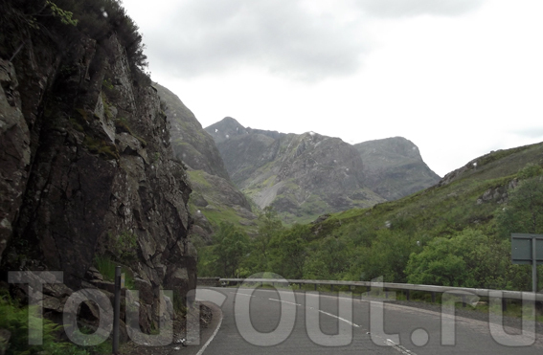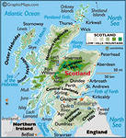

I J

