School № 204 by ALTYNSARIN

DEMONSTRATIVE LESSON

''English - around us ''

Grade: 9 “A,B,G”
Date: 22.11.2013
Prepared by: Urazova Gulbakyt
Teacher of English

2013-2014

Бекітемін :
Subject: English
Grade: 9 “a,b,g”
Date: 22.11.2013
The theme: “English around us”
The aims:
educational: to introduce the pupils with today’s theme to repeat all grammar
to teach them to make up sentences in English
B)developing: to develop their speaking ,reading ,writing , to read the poets
expressively and to develop their lexicon and abilities of
creativity
C) cultural: to teach them to respect Kazakh language and their creative works to
teach them to be patriots of their nation , motherland
The type of the lesson: Mixed lesson
The kind of the lesson: competition
Teaching methods: brainstorming, vocabulary method, method of explanation,,
completing, question - responsible
Visual aids: Interactive board , books, placards
The plan of the lesson
I. Organization moment
1.1. Greeting
1.2. Explaining the new information
II. Explanation of the new lesson ( material )
2.1. introduce yourself
2.2. All about grammar
2.3. UK or USA ?
2.4 Poetry life
2.5 Championship
2.6. Test work
IV. Concluding the lesson

The outline of the lesson
I. Organization moment
1.1. Greeting
Teacher: - -Good morning ! How are you?
Teacher: - What day is it today?
-What date is it today?
P: -Today is Friday
-Today is the 22nd of November
Today’s lesson is competition lesson .for today’s lesson participate students of 3 classes 9 “a,b,g”
The first group is : “Friendship”

Participants Umirzak Gulzat
Rzakulova Gulzhanat
Zhuman Gulzat
Serik Daulet
Marat Galia

The 2nd group is The best of the best

Srajadinova Arailym
Romankul Laura
Kuandikova Alya
Zhubantai Gulfarizat
Sahijan Gulzhazira

The 3rd group is” The Ones

Bekmirza Aktoty
Isa Maira
Zhubandyk Gaziza
Temirbay Meruert
Rash Bakutgul

2.1. introduce yourself
The 1st team :
• We are “….” • I am the captain. • My name is….
• We like/enjoy….. • We don’t like/enjoy…..
• We are good at… • We are……( clever, happy, friendly…)

The 2nd team
The 3rd team
2.2. All about grammar
The 1st team :

Переведите на английский язык:
1,Меня зовут Катя.
2. Мой любимый вид спорта - теннис.
3. Мой любимый предмет - английский язык.
4. Мы всегда заняты, но мы очень счастливы быть вместе.
5. Чья это ручка? - Это моя ручка.
6. Это тетрадь твоего брата? - Нет, это моя тетрадь.
7. Где твоя тетрадь? - Она на столе.
8. Где твоя мама? - Она на работе.
9. Где твой брат? - Он в школе.
10. Где твоя сестра? - Она дома.

The 2nd team

Translate the sentences into Russian:
1. She has come home.
2. He has a large family.
3. We have to leave home early in the morning.
4. He had the letter in his pocket.
5. He has dinner at home.
6. They had to complete their work on Monday.
7. We shall have plenty of fruit in the autumn.
8. We shall have read the story by ten o’clock.
9. Jane has got a beautiful garden.
10. Have a good time!

Translate the sentences into Russian:
1. У меня нет ее адреса.
2. У меня был вчера очень интересный разговор с профессором.
3. У него есть очень интересные книги по электронике.
4. Я должен буду пойти туда еще раз.
5. У нас завтра будет собрание.
6. Я должен вставать теперь очень рано.
7. Вы вчера обедали в ресторане?
8. Есть ли у вас красный карандаш?
9. У меня не было времени
навестить его вчера.
10. Мы вынуждены обратиться к врачу.

The 3rd team
- 1. My friend enjoys do sports. My friend enjoys doing sports.
- 2. Bob said Tom that he had a new phone. 2. Bob told Tom that he had
a new phone.
- 100 years ago children used to played with hoops and spinning tops.
100 years ago children used to play with hoops and spinning tops.
- 4. Polly have never been to London Polly has never been to London.
- We have been learning English for 2004. . We have been learning English since 2004
- I am good in mathematics. I am good at mathematics
- If the weather will fine, we will have a picnic . If the weather is fine, we will have a picnic.
- Joe has just breaked the window . Joe has just broken the window
- . They can’t to swim because the water is not warm enough.
They can’t swim because the water is not warm enough.
10.I have never was to London. I have never been to London

2) Make question or negative sentences:
1. Denise is always patient with her students.
2. Sveta and I are friends.
3. Sasha plays chess and checkers.
4. I speak French and German.
5. The weather is beautiful today.
6. My car is red.
7. Tess is a journalist
2.3.UK or USA?
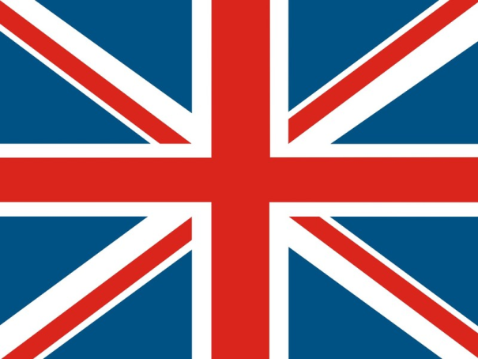 What’s the nickname of this flag? 

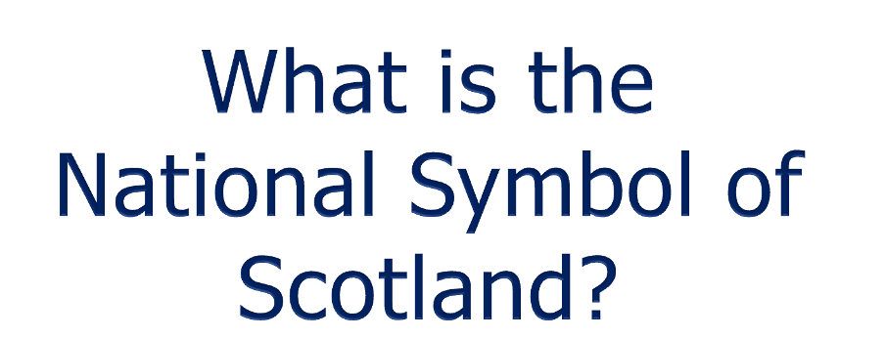 a thistle

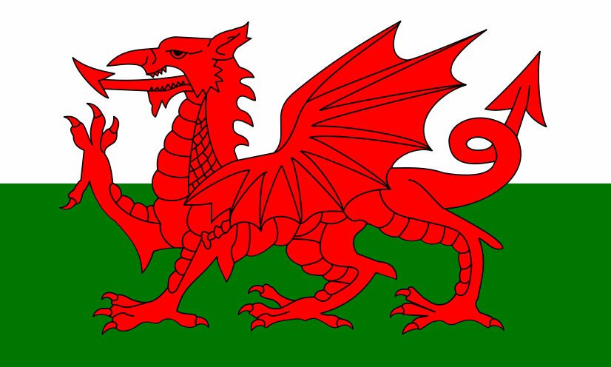 Wales
Which is the oldest and the largest museum in London? The British Museum
What building has Big Ben? Westminster Palace
It was built in the 11th century by William the Conqueror as a fortress and a royal palace.
(The Tower of London )
This is a royal church. This is where the coronation takes place. Westminster
Abbey
What is the name of Shakespeare’s famous theatre? A Globe
Who wrote 75 detective stories? Agatha Christie
These are the symbols of a spring holiday. Which one? Happy Easter
This holyday is celebrated on the 14th of February as a day of love and friendship (St. Valentine’s day)
What is Jack-o’-lantern made out of ? Pumpkin
How does Santa Claus get into the house? He gets down the chimney
What river does London stand on? The Thames
What is the most famous lake in Scotland? Loch Ness
What is the longest river in Great Britain? The Severn
What is the name of high London buses? Double-decker
What’s the nickname of London’s the Underground? The Tube
How many population had USA and its capital?
Who discovered America?
USA’s 1st president?
Where president had his meeting?
How many states had America?
2.4 Poetry life
1.Who is Shakespeare?
2.What do you know about GEOFFREY CHAUCER?
3.Who is Rudyard Kipling?
4.who is the author of fairy tale Alice is wonderland?
5.Music pause
6. Oliver Twist’s birthday?
7. Tell us Kazakh poets
8.What do you know about Abay Kunanbaev?
9.how many words had Abay?
10.Music pause
11.Whose poem is Akkular uiktafanda?
12.Where and when was born Daniel Defoe?
13.How many sonnets had Shakespeare?
14.Robinson Crusoe whose poem whose book?
15.Music pause
2.5 Championship competition between captains. They ask questions to other group.

2.6. Test work
1.The UK is…
1. Constitutional monarchy
2. Parliamentary democracy
3. Absolutely monarchy

2.Where is the flag of the UK?
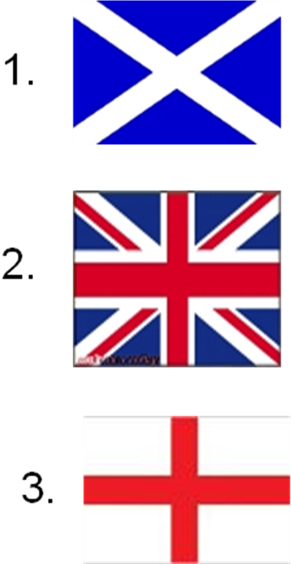
3.Whose symbol is it? 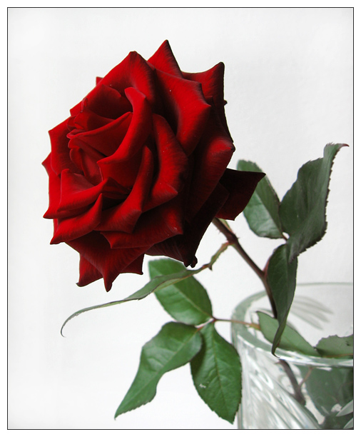
1. Wales
2. Scotland
3. England
4. Whose flag is it? 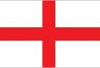
1. Scotland
2. Wales
3. England

5. What is the capital of Wales?
1. Cardiff
2. Edinburgh
3. Belfast
6.What separates the UK from Europe?
1. The Pacific Ocean
2. The English Channel
3. The Atlantic Ocean

7. What is the Severn?
1. City
2. Mountain
3. River
8.What countries does the UK consist of?
1. Ireland , England, Scotland, Wales
2. Northern Ireland, England, Scotland, Wales
3. Britain , England, Wales, Scotland
9.USA’s 1st president?
1.Obama
2.Lincoln
3.Wasnington
10.How many stars in USA’s flags?
1.23
2.54
3.50
IV. Concluding the lesson
Determine the winning team and give them Diplomas

