WHAT DO YOU KNOW ABOUT THE UK AND THE USA?
Брейн- ринг проводится на одном из последних уроков английского языка в 9 классе по окончании курса основной школы.

Оборудование: часы, звонки или молоточки, фотографии достопримечательностей.
На доске таблица
1 | 2 | 3 | 4 | 5 | 6 | 7 | 8 | 9 | 10
11 | 12 | 13 | 14 | 15 | 16 | 17 | 18 | 19 | 20
21 | 22 | 23 | 24 | 25 | 26 | 27 | 28 | 29 | 30
31 | 32 | 33 | 34 | 35 | 36 | 37 | 38 | 39 | 40
41 | 42 | 43 | 44 | 45 | 46 | 47 | 48 | 49 | 50
51 | 52
Участники:2 команды.
Методика проведения: Учитель читает один из вопросов . Учащиеся в течение 30 секунд готовят ответ. Команда, у которой готов ответ, подает сигнал звонком или молоточком.
Команда, давшая правильный ответ, выбирает номер вопроса. Номера вопросов даны в таблице.

GEOGRAPHY.
1.Great Britain consists of (states, parts, republics).
2.The USA consists of (states, parts, republics).
3.The capital of GB is (Cardiff, London, New York). .
4.The capital of the USA is (New York, Atlanta, Washington) .
5.The biggest river of the USA is (Mississippi, Hudson, Thames).
6.London is situated on the (Potomac, Thames, Hudson) river .
7.Washington is located on the (Potomac, Hudson, Mississippi) river.
8.New York is located on the (Thames, Hudson, Nile) river .
9.Atlanta is a capital of the state (Alaska, Georgia, Washington).
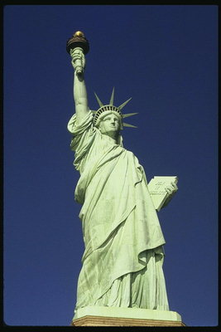 CITIES AND SIGHTS 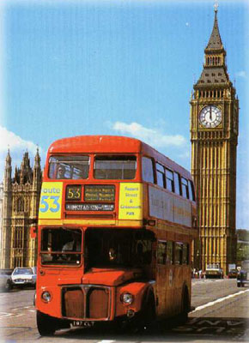
10.What city is more than 2000years old ?(Washington, Atlanta, London)
11.What city is famous for its magnolia trees ?(New York, Cardiff, Atlanta)
12.What is a nickname of New York ? (Small Apple, Big Apple, Large Apple)
13.What building does the president of the USA live and work?(The White House, the Capitol, Scitrek)
14.Which building is the oldest in Washington D,C.?(The Capitol, the White House, the Metropolitan Art Museum)
15.Where is the largest library of the world?(London, Atlanta, Washington)
16.What famous company is there in Atlanta?(BBC, CNN, NTV)
17.What is it? (Big Ben, Westminster Abbey, Broadway)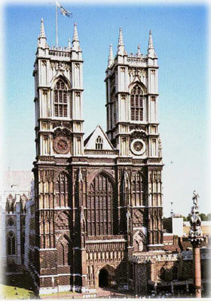
18What is Big Ben?(a park, a clock, a bus)
19.What is Westminster Abbey?(The royal church, the museum, the park)
20.What is the London home of the Queen?(The Tower of London, Buckingham Palace, Westminster Abbey)
21.Where can tourists see Big Ben?(Boston, London, Liverpool)
22.Where can tourists see SciTreck?(London, Alpharetta, Atlanta)
23.Where can tourists see Baker Street?(Manchester, Cardiff, London)
24.Where can tourist see the Tower?(Boston, London, Cardiff)
25.Where can tourists see a statue of Admiral Nelson?(Broadway, Piccadilly, Trafalgar Square)
26.Where is a Statue of Liberty?(Boston, New York, Washington)
27.Here there are more than 30theatres. What is it?(Baker Street, Broadway, Piccadilly)
28.What is Scitrek?(History Museum, Science Museum, Art Museum)
29.What is a double-decker?(a car, a bus, a train)
30.This building was rebuilt by Christopher Wren after the Great Fire of London in 1666. It has a famous «Whispering Gallery».(The Tower, the Houses of Parliament, St.Paul's Cathedral)
 HOLIDAYS / TRADITIONS. 
31.What is the traditional Christmas meal?(Fish, turkey, salad)
32.It is one of the best holidays for children. They dress as witches and ghosts.(Easter, Christmas, Hallowe'en)
33.The traditional colors of this holiday are red and green.(Valentine's Day, Easter, Christmas)
34.This holiday is a family holiday celebrated in November.(Father's Day, Independence Day, Thanksgiving Day)
35.This holiday is celebrated in winter. It is a religious holiday and one of the happiest holidays of the year(New Year's Day, Christmas, Easter)
36.When do Americans celebrate Independence Day?(14.02, 4.07, 25.12)
37.This holiday is very popular among young and not young people. They send cards, give presents such as a bar of chocolate, roses.(Mother's Day, Valentine's Day, Father's Day)
FAMOUS PEOPLE. 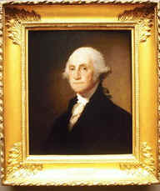
38.Who discovered America?(A.Fleming, Columbus, Nelson)
39.Who planned and built St.Paul’s Cathedral?(R. Chancellor, C. Wren, I. Newton)
40.Whо was the first President of the USA?(Jefferson, Washington, Clinton)
41Who was the first woman prime-minister of GB?(Tussaud, Thatcher, Tereshkova)
42Who was the author of the gravitation theory?(Darwin, Newton, Fleming)
43.This writer wrote 75 detective stories .The main character of the stories is Miss Marpel.(Agata Christy, Sherlock Holmes, Jack London)
44.What is the nickname of Samuel Clemens? He wrote stories about American boy Tom Soyer.(J. London, M. Twain, Dickens)
45.Who created the best animated cartoons in the USA?(Disney, Wrights, London)
46.Who was the 43rd President of the USA?(Bush, Clinton, Kennedy)
47.Who discovered penicillin?(Darvin, Fleming, Hogarth)
48.He was a famous rock-n-roll singer. People call him «The King of rock-n-roll.»(Presley, Jackson, Sting)
49.This English pop- group consisted of 4 men. They song sings such as «Yellow Submarine», «Yesterday».(Bonny M, Beatles, Abba)
50.He was a great English writer, actor, wrote «The Twelfth Night», «Romeo and Julia». (J.London, W. Shakespeare, W.Scott)
51.He was born in 1859.He was a writer ,wrote stories about Sherlock Holmes .(Jack London, Sherlock Holmes, Agata Christy)
52.He was born in 1847 in Scotland. He invented the telephone. (Newton, Bell, Fleming)

