Внеклассное мероприятие в 11 классе

Тема: WILLIAM SHAKESPEARE (1564 – 1616)
Цель: Формирование социокультурных компетенций учащихся, повышение мотивации изучения английского языка в средней школе.
Задачи: 1. Познакомить учащихся с творчеством Шекспира более детально;
2. Привить учащимся интерес к литературе страны изучаемого языка;
3. Воспитать трепетное и уважительное отношение к проявлению ранней влюблённости у подростков;
4. Развивать познавательную деятельность и расширять кругозор подростков.

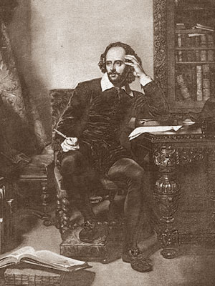
SPEAKER I and II: Good evening, Ladies and Gentlemen.
SPEAKER I: We are very glad to see you on the opening of our literary club by William Shakespeare.
We'll talk about one of the greatest writer and poet of the16-th century William Shakespeare.
SPEAKER II: Shakespeare is often called by English people «Our national bard», «The bard of Avon», «The immortal poet of Nature», «The Swan of Avon». We'll remember his biography, his creative-work some of his sonnets and tragedies.
SPEAKER I: Now we open the first page of our journal – Biography of William Shakespeare. Our friends will tell you something about the life of young William.

BIOGRAPHY OF WILLIAM SHAKESPEARE

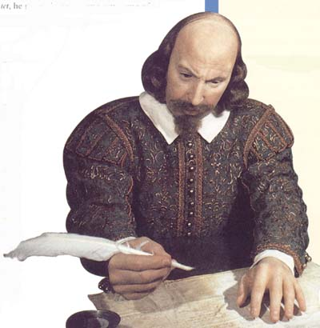
Pupil I: The great poet and dramatist William Shakespeare is often called by people «Our National Bard. Shakespeare was born on April 23, 1564 in Stratford-on-Avon – a small town in the centre of Great Britain. Young Shakespeare studied at the Grammar School where boys learned Latin, Greek, and other subjects.
Pupil II: At that time there were no theatres in England. Groups of actors travelled from town to town and played in different places, usually out-of-doors. Young William went to see all their shows and liked them very much. He wanted to become an actor. Shakespeare was twenty-one he went to London. In London he joined a group of actors. William Shakespeare played in Glode Theatre and wrote plays for this theatre.
SPEAKER II: Thank you, dear friends.
Now, let’s open next page of our journal “William Shakespeare” – Sonnets of Shakespeare. Our classmates will read you some of his great sonnets. (ученики читают сонеты Шекспира
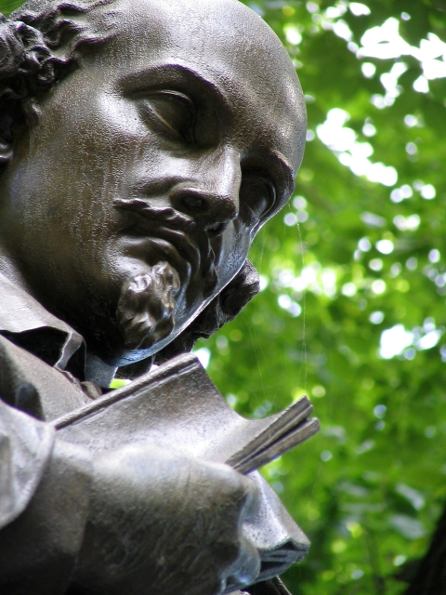

SONNETS OF SHAKESPEARE
Sonnet 18 Shall I compare thee to a Summer's day?
Shall I compare thee to a summer's day?
Thou art more lovely and more temperate:
Rough winds do shake the darling buds of May,
And summer's lease hath all too short a date:
Sometime too hot the eye of heaven shines,
And often is his gold complexion dimm'd;
And every fair from fair sometime declines,
By chance or nature's changing course untrimm'd;
But thy eternal summer shall not fade
Nor lose possession of that fair thou owest;
Nor shall Death brag thou wander'st in his shade,
When in eternal lines to time thou growest:
So long as men can breathe or eyes can see,
So long lives this and this gives life to thee.
Sonnet 10 For shame deny that thou bear'st love to any
For shame! deny that thou bear'st love to any,
Who for thyself art so unprovident.
Grant, if thou wilt, thou art beloved of many,
But that thou none lovest is most evident;
For thou art so possess'd with murderous hate
That 'gainst thyself thou stick'st not to conspire.
Seeking that beauteous roof to ruinate
Which to repair should be thy chief desire.
O, change thy thought, that I may change my mind!
Shall hate be fairer lodged than gentle love?
Be, as thy presence is, gracious and kind,
Or to thyself at least kind-hearted prove:
Make thee another self, for love of me,
That beauty still may live in thine or thee.
Sonnet 22 My glass shall not persuade me I am old
My glass shall not persuade me I am old,
So long as youth and thou are of one date;
But when in thee time's furrows I behold,
Then look I death my days should expiate.
For all that beauty that doth cover thee
Is but the seemly raiment of my heart,
Which in thy breast doth live, as thine in me:
How can I then be elder than thou art?
O, therefore, love, be of thyself so wary
As I, not for myself, but for thee will;
Bearing thy heart, which I will keep so chary
As tender nurse her babe from faring ill.
Presume not on thy heart when mine is slain;
Thou gavest me thine, not to give back again.

Sonnet 116 Let me not to the marriage of true minds
Let me not to the marriage of true minds
Admit impediments. Love is not love
Which alters when it alteration finds,
Or bends with the remover to remove:
O no! it is an ever-fixed mark
That looks on tempests and is never shaken;
It is the star to every wandering bark,
Whose worth's unknown, although his height be taken.
Love's not Time's fool, though rosy lips and cheeks
Within his bending sickle's compass come:
Love alters not with his brief hours and weeks,
But bears it out even to the edge of doom.
If this be error and upon me proved,
I never writ, nor no man ever loved.

Sonnet 130 My mistress' eyes are nothing like the sun
My mistress' eyes are nothing like the sun;
Coral is far more red than her lips' red;
If snow be white, why then her breasts are dun;
If hairs be wires, black wires grow on her head.
I have seen roses damask'd, red and white,
But no such roses see I in her cheeks;
And in some perfumes is there more delight
Than in the breath that from my mistress reeks.
I love to hear her speak, yet well I know
That music hath a far more pleasing sound;
I grant I never saw a goddess go;
My mistress, when she walks, treads on the ground:
And yet, by heaven, I think my love as rare
As any she belied with false compare.

SPEAKER I: Don’t you think that it was great? It was like a melody of love. Each girl wants to hear such words to her address, and I am not an exception…
SPEAKER II: Oh ... my mistress eyes are nothing like the sun... My mistress, when she walks, treads on the ground...
SPEAKER I: Oh, thank you dear! (smiling)
Let’s continue. At the end of our little performance we’d like to show you next page of our journal, that is “Shakespeare’s work”. Our friends are going to tell you something about his great works.

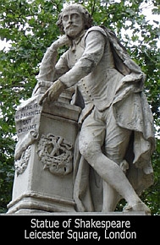

SHAKESPEARE’S WORK
Pupil III: The first period (1590-1600) of his creative work consists of comedies and histories. In this period William Shakespeare wrote such histories as «King Henry IV», “King Henry V”, «Kind Richard II», «King Henry III» and others. Here the author showed historical events and dramatic characters.
Pupil IV: All of Shakespeare's famous tragedies appeared between 1600 and 1608. This was the second period of his literary work. He presents great human problems. This period began with the tragedy «Hamlet», which was a great success.
SPEAKER I: Romeo and Juliet …This is the best Shakespeare’s play. This play is full of love, youth and humanism. «Romeo and Juliet». (сцена балконе)

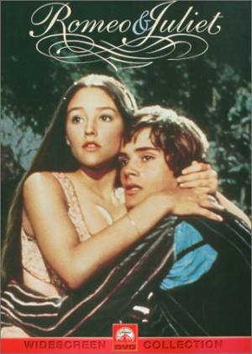
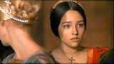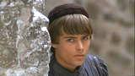

ACT I

PROLOGUE
Two households, both alike in dignity,
In fair Verona, where we lay our scene,
From ancient grudge break to new mutiny,
Where civil blood makes civil hands unclean.
From forth the fatal loins of these two foes
A pair of star-crossed lovers take their life;
Whole misadventured piteous overthrows
Do with their death bury their parents' strife.

SCENE II. Capulet's orchard.
Enter ROMEO

ROMEO
But, soft! what light through yonder window breaks?
JULIET appears above at a window
It is the east, and Juliet is the sun.
It is my lady, O, it is my love!
O, that she knew she were!
She speaks yet she says nothing: what of that?
Her eye discourses; I will answer it.
The brightness of her cheek would shame those stars,
See, how she leans her cheek upon her hand!
O, that I were a glove upon that hand,
That I might touch that cheek!

JULIET
Ay me!

ROMEO
She speaks:
O, speak again, bright angel!

JULIET
O Romeo, Romeo! wherefore are you Romeo?
Deny thy father and refuse thy name;
Or, if thou wilt not, be but sworn my love,
And I'll no longer be a Capulet.

ROMEO
Shall I hear more, or shall I speak at this?

JULIET
What's Montague? it is nor hand, nor foot,
Nor arm, nor face, nor any other part
Belonging to a man. O, be some other name!
What's in a name? that which we call a rose
By any other name would smell as sweet;
Oh, Romeo, doff thy name and
Take all myself.

ROMEO
I take thee at thy word:
Henceforth I never will be Romeo.

JULIET
What man art thou that thus bescreen'd in night
So stumblest on my counsel?

ROMEO
By a name
I know not how to tell thee who I am:
My name, dear saint, is hateful to myself,
Because it is an enemy to thee;
Had I it written, I would tear the word.
JULIET
My ears have not yet drunk a hundred words
Of that tongue's utterance, yet I know the sound:
Art thou not Romeo and a Montague?

ROMEO
Neither, fair saint, if either thee dislike.

JULIET
How camest thou hither, tell me, and wherefore?
The orchard walls are high and hard to climb,
And the place death, considering who thou art,
If any of my kinsmen find thee here.

ROMEO
With love's light wings did I o'er-perch these walls;
For stony limits cannot hold love out,
JULIET
If they do see thee, they will murder thee.

ROMEO
Alack, there lies more peril in your eyes
Than twenty of their swords: look thou but sweet,
And I am proof against their enmity.

JULIET
I would not for the world they saw thee here.

ROMEO
I have night's cloak to hide me from their sight;
And but thou love me, let them find me here:
My life were better ended by their hate,
Than death prorogued, wanting of thy love.

JULIET
My true love's passion: therefore pardon me,
And not impute this yielding to light love,
Which the dark night hath so discovered.

ROMEO
Lady, by yonder blessed moon I swear
JULIET
O, swear not by the moon, the inconstant moon

ROMEO
What shall I swear by?

JULIET
Do not swear at all;
Or, if thou wilt, swear by thy gracious self,
And I'll believe thee.

ROMEO
If my heart's dear love—I swear, I swear

JULIET
Oh, It’s too late, I must go, Sweet, good night!
ROMEO
O, wilt thou leave me so unsatisfied?

JULIET
What satisfaction canst thou have to-night?

ROMEO
The exchange of thy love's faithful vow for mine.

JULIET
I gave thee mine before thou did request it:
And yet I would it were to give again.

ROMEO
Would thou withdraw it? for what purpose, love?

JULIET
My bounty is as boundless as the sea,
My love as deep; the more I give to thee,
The more I have, for both are infinite.
Nurse calls within – Madame!
I’m coming, good nurse!
Stay but a little, I will come again.
Exit, above
ROMEO
O blessed, blessed night! I am afeard.
Being in night, all this is but a dream,

Re-enter JULIET, above

JULIET

Three words, dear Romeo, and good night indeed.
Thy purpose marriage, send me word to-morrow,
Where and what time thou wilt perform the rite;
And I follow thee my lord throughout the world.

Nurse
Madam!

JULIET
I come, I come.--But if thou mean'st not well,
I do beseech thee—

Nurse
Madam!

JULIET
By and by, I come:--
To cease thy suit, and leave me to my grief:
To-morrow will I send.
A thousand times good night!
Exit, above
ROMEO
A thousand times the worse, to want thy light.
Love goes toward love, as schoolboys from
their books,
But love from love, toward school with heavy looks.

Retiring. Re-enter JULIET, above

JULIET
Hist! Romeo, hist!

ROMEO
It is my soul that calls upon my name:
How silver-sweet sound lovers' tongues by night,
Like softest music to attending ears!

JULIET
Romeo!

ROMEO
My dear?

JULIET
At what o'clock to-morrow
Shall I send to thee?

ROMEO
At the hour of nine.

JULIET
I will not fail:

ROMEO
Let me stand here till thou remember it.

JULIET
I shall forget, to have thee still stand there,
Remembering how I love thy company.

ROMEO
And I'll still stay, to have thee still forget,
Forgetting any other home but this.

JULIET
Sweet, Good night, good night! parting is such
sweet sorrow,
That I shall say good night till it be morrow.

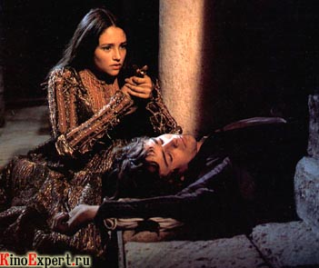

SPEAKER II:
Unfortunately, our time is up. We hope you’ve enjoyed our performance and we’d like to see you soon with us.
SPEAKER I:
Thank you for your coming! Thank you for your attention!
