Внеклассное мероприятие
по английскому языку
‘ St. Patrick’s Day ’
( 4-5 классы )

Подготовила учитель английского языка
МКОУ СОШ №2 г. Беслана
Тогоева Фатима Романовна

18.03.2013 г.

Ход праздника.

Учитель: Good morning dear children, good morning dear guests. Today we are gathered to celebrate the feast of St.Patrick’s.
First of all, let’s devide into two groups. So, dear guests, you are welcome to Ireland.
( Ученики получают листочки зелёного цвета с номером своей команды и садятся за два стола, согласно командам. Звучит ирландская музыка.)

Учащиеся исполняют популярную песню, ставшую символом Ирландии:
« Мо́лли Мало́ун»

In Dublin’s fair city, where the girls are so pretty,
I first set my eyes on sweet Molly Malone,
As she wheeled her wheel-barrow, through streets broad and narrow,
Crying, "Cockles and mussels, alive, alive, oh!"
Припев:
«Alive, alive, oh, Alive, alive, oh»,
Crying "Cockles and mussels, alive, alive, oh".
She was a fishmonger, and sure 'twas no wonder,
For so were her father and mother before,
And they both wheeled their barrow, through streets broad and narrow,
Crying, "Cockles and mussels, alive, alive, oh!"
She died of a fever, And no one could save her,
And that was the end of sweet Molly Malone.
Now her ghost wheels her barrow, through streets broad and narrow,
Crying, "Cockles and mussels, alive, alive, oh!"

Ведущий 1:
Сегодня мы собрались с вами, чтобы узнать об одном из праздников, который празднуют в Ирландии, в США и во многих других странах.

The 17 of March is St. Patrick's Day. It's a national Irish holiday. Many people who immigrated to the United States have come from Ireland. Every year on the 17 of March cities with large population of Irish Americans have parades.

An Irish Blessing (Ирландское благословение. Читает учащийся, одетый в костюм Святого Патрика).

May the road rise up to meet you.
May the wind be always at your back.
May the rains fall soft upon your fields.
And until we meet again,
May God hold you in the palm of his hand.

Hail, Glorious St. Patrick! (ответ на благословение Св. Патрика читают учащиеся)

Hail, Glorious St. Patrick,
Dear Saint of our Isle,
On us thy poor children
Bestow a sweet smile.
And now thou art high
In thy mansion above,
On Erin’s green valleys
Look down with thy love.

Ведущий 2: Вы, наверно заметили, что листочки с номерами ваших команд зелёного цвета, зелёный – это цвет Дня Святого Патрика. Но кто же такой Святой Патрик?
St. Patrick
The person who was to become St. Patrick, the patron saint of Ireland, was born in Wales . When he was 16, he was sold into slavery to Ireland where he was a shepherd for 6 years. While in captivity he studied and turned to religion. He escaped slavery and later returned to Ireland as a missionary, determined to convert Ireland to Christianity. He used the shamrock to explain the Holy Trinity.
Patrick was quite successful at winning converts. And this fact upset the Celtic Druids. Patrick was arrested several times, but escaped each time. He traveled throughout Ireland, establishing monasteries across the country. He also set up schools and churches which would aid him in his conversion of the Irish country to Christianity.
His mission in Ireland lasted for thirty years. After that time, Patrick retired to County Down. He died on the 17 of March . That day has been commemorated as St. Patrick's Day ever since.
Ведущий 1: У Дня святого Патрика есть и языческие мотивы. Так, одним из его непременных героев являются лепреконы - сказочные башмачники, владеющие спрятанным горшком с золотом.
( Учащиеся читают стихотворение о лепреконах)

Leprechaun.
I'm looking for a leprechaun,
Leprechaun, leprechaun.
I'm looking for a leprechaun,
Do you know where he's gone?
He wears a suit that's made of green,
Made of green, made of green,
He wears a suit that's made of green,
Do you know where he's gone?
He lives by a rainbow and hides his gold,
Hides his gold, hides his gold,
He lives by a rainbow and hides his gold,
Do you know where he's gone?
If you see a leprechaun,
Leprechaun, leprechaun,
If you see a leprechaun,
Please tell me where he's gone!

Учитель: And now, dear children, your task is to paint a leprechaun.
So, let’s call him in.
( Конкурс « Разукрасить лепрекона»)

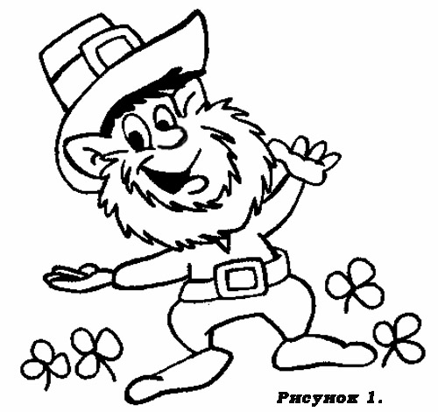
Учитель: Shamrock is one of the emblems of the holiday.

I’m looking over a four leaf clover.

I’m looking over a four leaf clover
That I overlooked before.
One leaf is sunshine,
The second is rain,
Third is the rose
That grows in the lane.
No need explaining
The one remaining
Is somebody I adoure.
I’m looking over a four leaf clover
That I overlooked before.

St. Patrick's Day
St. Patrick's Day is here, you see.
We'll pick some shamrocks, one, two, and three.
We'll count the leaves and look them over,
And maybe find a four-leafed clover.
I'll sew green buttons on my vest;
Green for St. Patrick is the best.
I'll wear a green hat, very high.

Учитель: The next task is to find your way through the maze to get one of the lucky shamrocks for St. Patrick’s Day. There are two ways to get there.
( Учащиеся проходят лабиринт ).

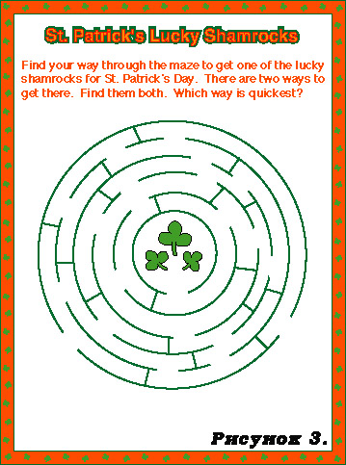

Учитель: Green is one of the national colours of Ireland and also one of the signs of spring.

Green, Green and more Green
There is green everywhere,
even in peoples' hair. Some
on hands, some on shirts.
There is green everywhere!
Green, green, and more green.
I think I'm going crazy over green.
If you don't wear green you get pinched,
then you'll start to itch.
So many people are obsessed with green.
Green Spring, green air.Green feet, green wheat, green meat.
Green isn't very neat!

What About Green?
Green is the color of my shirt.
Green is the color of my favorite toy.
I see a piece of green paper by me.
I see a green pencil by me.
I see green books.
I see a green frog.
I have a green chair.
I have green pajamas.
I see green grass at school.

What Is Green ?
Green is the small, little
Leprechaun that sees some gold.
Green is the grass that's between
My toes and the moss between my
Fingers.
Green are the buds that are
On the trees
So that in the spring they will
Bloom
Green leaves.
Green is the jumpy frog that
Jumps from lily pad to
Lily pad.
Green is for the juicy grapes that
Explode with juice in my mouth.
In the rain
I use my green umbrella.

Учитель: Well, and now I want you to solve a crossword puzzle.
(Учащиеся решают кроссворд).

Учитель: Everything has a beginning and an end. Here is the end of our holiday. Thank you very much, we have received great pleasure.

