Конспект открытого урока по английскому языку

Дата: 9 февраля 2015 года
Учитель: Карева К.С.
Класс: 9 «Г»
Тема: Путешествие
Учебное пособие: Exam Activator (Longman), Английский язык «Письмо» Е.С.Музланова

Цель: обобщить усвоенный материал по теме «Путешествия»

Задачи:
Образовательные – познакомить учащихся с современным путешественником,
совершенствовать навыки аудирования с общим и полным пониманием услышанного, чтения с извлечением информации, а так же умения подбирать аналогичные фразы с одинаковым смыслом на материале изученной темы , описывать изображения и высказываться на тему о достоинствах и недостатках видов транспорта.

Развивающие– совершенствовать умение говорить про известных путешественников, составлять маршрут по описанию.

Оборудование:
Смарт доска, запись для аудирования на диске, подключение к интернету

Ход урока:
- Greeting
Hello everyone! How are you today? I hope you are well!
Let me introduce the plan of our lesson. – 1 слайд
It connected with the topic ‘Travelling’ and the first part will be ‘Speaking’ where you’ll be able to tell us something about the meaning of the travelling as well.
The second part will be ‘Listening’ where you’ll learn something interesting.
The next part will be ‘Reading’ and you’ll work with the map.
At ‘Grammar’ part you’ll train you grammar skills, of course. Can you predict
what part of our lesson would be the most interesting for you?
- Warming up
T: I think you know something about the great travellers who investigated our planet past times. Could you match their names with their portraits? - 2 слайд

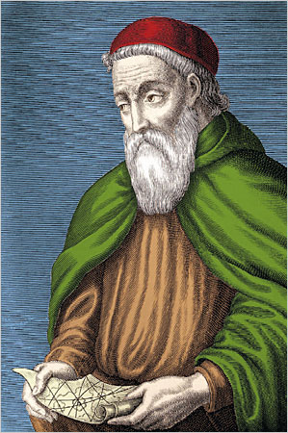
P 1: Amerigo Vespucci the first has floated along coast of the South America, and the first, has communicated to radical Americans. He is the great Italian researcher, the seafarer and the cartographer who has laid a path for expeditions to the New world.

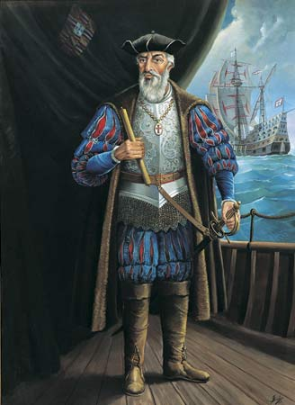
P2: Vasco da Gama was definitely resolute person, which knew how to survive and achieve the objective for the sake of the country. Its first expedition has opened a direct marine trading route of the country.

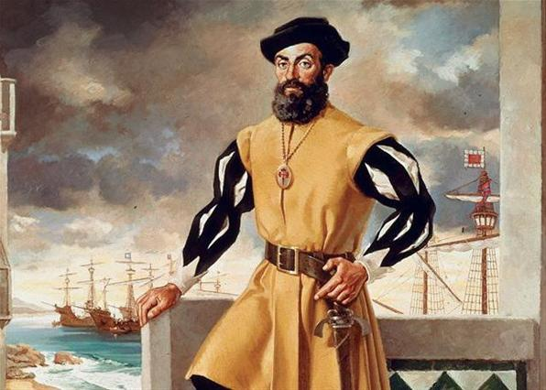
P3:Magellan has headed the first round-the-world expedition, for the first time crossing Pacific ocean.

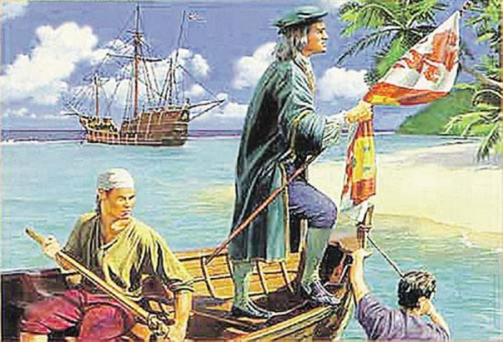
P4: Christopher Columbus was the great traveller and the perfect seaman. He has convinced governor of that time that they can fast cross Atlantic, get to India and return with spices which at that time were very much appreciated.

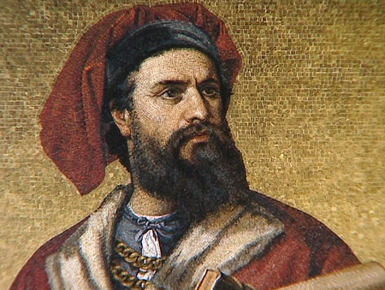
P5: Marco Polo was the great traveller and investigated more than 15000 miles for 24 years. Travelling mainly to Asia he understood culture of China.

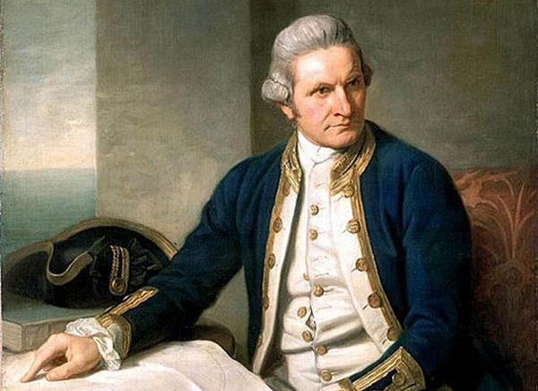
P6: Captain James Cook , the excellent navigator and the cartographer was one of the most known British researchers. On the expeditions he has made a map of a part of coast of Australia.

T: I see, that’s interesting. And do you know some modern travellers?
P: Unfortunately, no.
T: That’s why today we are going to listen and read some information about one Englishman who likes to travel round the world in our days.

Let’s move on! Who can answer my question: what do people travel for? Do you agree that travelling broadens the mind? Why?

P1: In my opinion travelling lets you know more about cultures of different folks.
P2: If you ask me travelling gives you an opportunity to see the difference between lifestyles.
P3: I believe that travelling teaching you how to be more tolerant.
P4: Let me explain my point of view: travelling also gives you an opportunity to make friends with new people, etc

- Speaking
That’s true! It’s very exciting to travel indeed and now look at the first picture and describe it. Remember to answer the questions:
- Who is in the picture?
-Where are they?
- What are they doing?

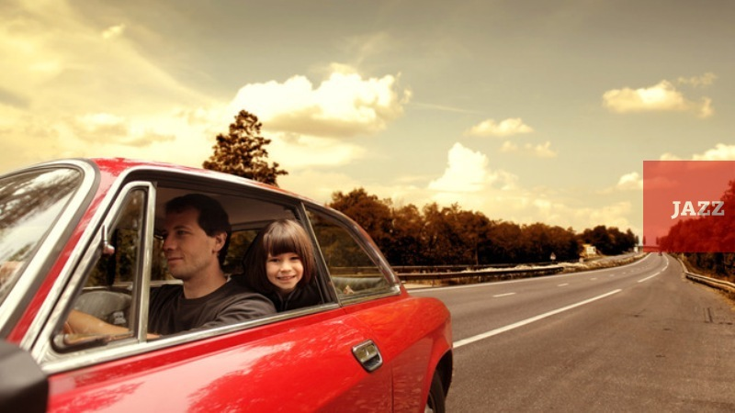 - 3 слайд

P1: In the picture I can see... The day is...
On the right there is ...

T: Right! And who can tell us about advantages and disadvantages of travelling by car?
P2: As for me there is nothing better than travelling by a fast car. You can stop whenever you want and wherever you want just to admire the beauty of nature.
P3: However, there are certain disadvantages. For example, cars are considered to be the most dangerous means of transport.

T: Thank you very much! Here is another picture.
P1: The picture shows...
In the foreground...
In the background...
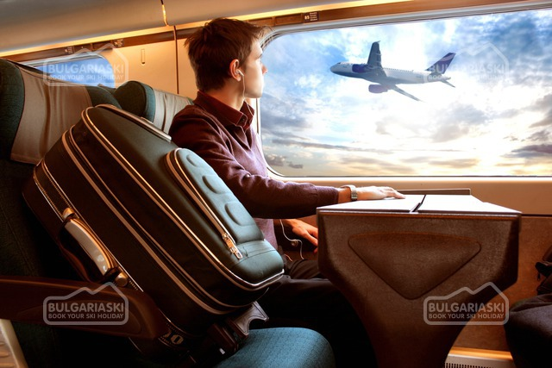
- 4 слайд
T: That’s amazing! In your opinion, what is the best way of travelling? Do you suffer from air-sickness?
P2: ...

T: Good! That’s the last picture

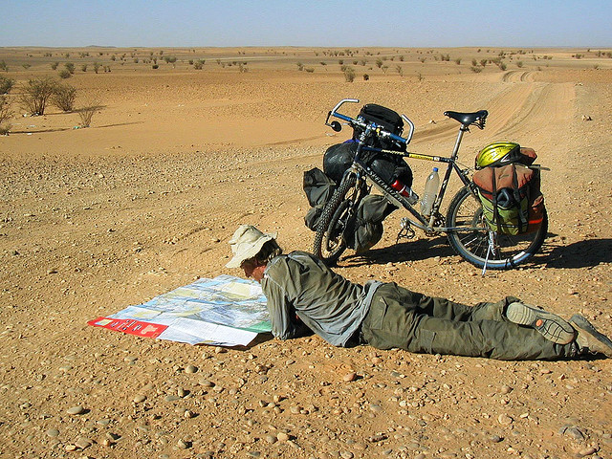 - 5 слайд
P3: There is ....... in the picture.
The picture was taken in...
The weather is...
The general atmosphere in the picture is positive because...

T: Marvelous!
And this is a person who has cycled around the world.
Think of two things that could be enjoyable on a journey like that.
P4:...
T: Now think of two possible bad experiences
P5:...

- Listening – 6 слайд
T: Marvelous! Do you want to know the name of this man? His name’s Alastair Humphreys. Alastair Humphreys is an adventurer, explorer, author and blogger.
You are going to hear his story and answer my question:
How old was Alastair when he started his journey?
http://www.youtube.com/watch?v=MsD4cpLCnv0

(Просмотр видео по ссылке около 1 минуты)
P: He was 24.

T: Go on! Let’s listen an interview about Alastair and choose the correct answer
(Exam Activator p.121 ex.3 CD 2.19)

T: The people in some of the countries Alastair visited thought he was rich. When is a person considered ‘rich’ in your country?

- Reading
T: Read the tapescript and try to draw Alastair route around the world.
7 слайд – карта мира
One person should do it on the board.

8 слайд
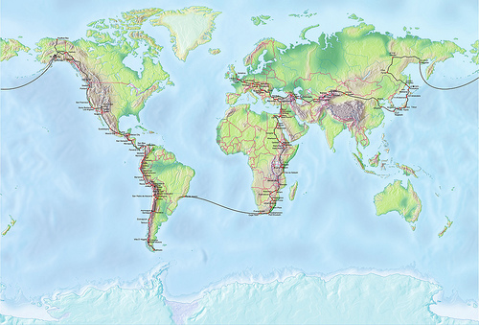
T: Let’s check up and compare!

- Now close your eyes and imagine, you are riding your bike on a very high hill. What do you feel? Are you tired? Then have a rest and do some exercises! – 9 слайд

- Grammar – 10-15 слайды
Our rest is over and we are going to ride in Egypt.
(Exam Activator p.123 ex.2)

- Writing - 16 слайд
Now our world tour is over and you can have a look at your home task.
(Е. С.Музланова. Английский язык. Письмо. стр.12 Task 1)

- Summary – 17 слайд
The lesson is coming to the end. What part of our lesson was the most interesting for you? Why?

