Сценарий урока к неделе иностранного языка в 7 классе «Конкурс грамматиков»
Цели:
- повторение и обобщение изученного грамматического материала;
- активизация лексических навыков;
- поддержание интереса к изучению английского языка.
Оборудование:
- картинки с изображением различных предметов для выполнения третьего задания;
- карточки для выполнения первого и второго задания;
- кроссворд для выполнения пятого задания;
- листы бумаги для записи предложений.

I. Начало урока: приветствие, сообщение темы урока.
Teacher: Good morning, boys and girls! We are glad to see you. How are you today? Today we have unusual lesson. We shall play and do different tasks and find out who knows English grammar very well. Divide into two teams, please. …, you are the first team, …-you are the second team. Are you ready to start?

II.Основная часть.
- Игра «Лото».
Teacher: Do you want to play with me? Let’s remember some English adjectives. I shall name the Russian word, and you should find the English word. .

умный |  | красивый |  | удачливый
 | усталый |  | сильный
честный |  | одинокий
независимый |  | испуганный |  | злой
 | несчастливый |  | подавленный | расстроенный

smart |  | nice |  | lucky
 | tired |  | strong
honest | pleased | lonely |  | surprised
independent |  | frightened |  | angry
sure | unhappy |  | depressed | upset

2) Задание «Заполни пропуски».
Teacher: The second task for you is to open the brackets using the Passive Voice. You will have …minutes to do this task.

Задание на карточке: Use the Present Indefinite Passive, the Past Indefinite Passive and Future Indefinite Passive.
- Mickey Mouse (to create)_______________________________ by Walt Disney.
- The letters (to send) ______________________________every day.
- The story (to translate)______________________tomorrow.
- Rice (to eat)_______________________________with chopsticks in China.
- Roses (to grow) ______________________in greenhouses in winter?
- America (not to discover)___________________________in 1942.
- Disneyland (to open)_______________________________in California in 1955.
- This film still (to show)____________________________ regularly at the cinema.
- This papers (not to look) ______________________________through in two hours.
- The problem (to discuss) _________________________next week?

Ключи:
Mickey Mouse was created by Walt Disney.
The letters are sent every day.
The story will be translated tomorrow.
Rice is eaten with chopsticks in China.
Are roses grown in greenhouses in winter?
America was not discovered in 1942.
Disneyland was opened in California in 1955.
This film is still shown regularly at the cinema.
This papers won’t be looked through in two hours.
Will the problem be discussed next week?

3) Игра «Расшифруй пословицу»
The next task for you is to make up the proverb. You can see some numbers, and you must read the proverb using the code.

Запись на доске:
21 25 93,436 188 7013 18 73, 069
Учащимся раздаются коды для расшифровки пословицы:
I-2; t-1; s-5; n-9; e-3; v-4; r-6; o-8; 1-7; a-0.
Ключ: It is never too late to learn.

4) I want you to look at the blackboard. You can 5 pictures on it. You will make up the sentences using the Passive Voice and describe the pictures.
На доске развешаны картинки (5 штук). Каждая картинка сопровождается словом-обстоятельством времени:
1-yesterday
2-every evening
3-tomorrow
4-last week
5-every day
Примерные предложения:
The book was read yesterday. Предложения учащиеся записывают на лист бумаги.

5) The last task for you is to try the crossword on the topic “Transport”.

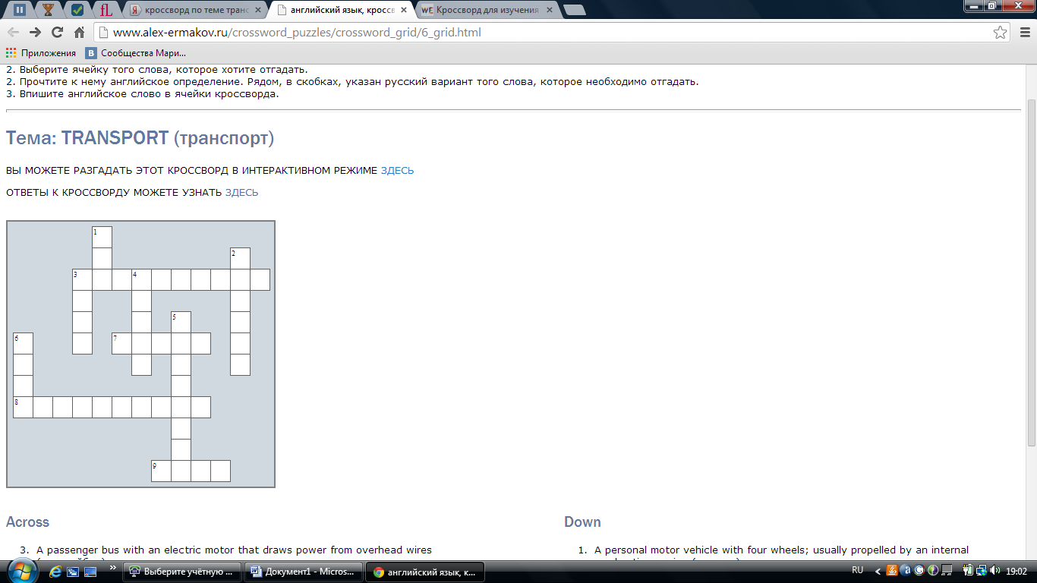

Across
- A passenger bus with an electric motor that draws power from overhead wires (троллейбус)
- Public transport provided by a line of railway cars coupled together and drawn by a locomotive (поезд)
- A motor vehicle with two wheels and a strong frame (мотоцикл)
- A car suitable for travelling over rough terrain (джип)
Down
- A personal motor vehicle with four wheels; usually propelled by an internal combustion engine (машина)
- An electric railway operating below the surface of the ground (usually in a city) (метро)
- A car driven by a person whose job is to take passengers where they want to go in exchange for money (такси)
- A large truck designed to carry heavy loads; usually without sides (грузовик)
- An aircraft that has a fixed wing and is powered by propellers or jets (самолет)
- A wheeled vehicle that runs on rails and is propelled by electricity (трамвай)
III. Заключительная часть. Подведение итогов.
Thank you for your work. I can see you are good at grammar. Now it is tome to finish our work.
После этого учитель или приглашенное жюри подводит итоги, подсчитывает результаты и награждает команды-победители.

