1. Выражения и преобразования.
1.3. Логарифмы.
Задания с выбором ответа.
- Какое из указанных ниже чисел является значением выражения ${\text{log}}_{\frac{1}{3}}^{3}\frac{1}{9}$?
1. 6 2. -27 3. -8 4. 8
- Упростить выражение ${\text{log}}_{3}\frac{1}{9}$+${\text{log}}_{9}\frac{1}{9}$$−\frac{1}{3}{\text{log}}_{\text{27}}\frac{1}{9}$.
1. $−2\frac{7}{9}$ 2. $4\frac{5}{9}$ 3. $−2$ 4. $−4$

- Вычислить ${\text{log}}_{2}\text{1024}+{\text{log}}_{3}\sqrt{3}⋅{\text{log}}_{2}\sqrt{2}$.
1. 11 2. 9 3. 10,25 4. 10,5

- Найдите значение выражения ${\text{log}}_{3}{\text{log}}_{5}\text{125}−{\text{log}}_{5}{\text{log}}_{3}\text{243}$.
1. ${\text{log}}_{\text{15}}\frac{\text{125}}{\text{243}}$ 2. 1 3. -1 4. 0

- Упростить выражение ${\text{log}}_{2}{\text{log}}_{3}9−{\text{log}}_{3}{\text{log}}_{2}8$.
1. 1 2. -1 3. 0 4. ${\text{log}}_{6}\frac{9}{8}$

- Вычислите ${\text{log}}_{3}\frac{1}{2}+{\text{log}}_{3}6$.
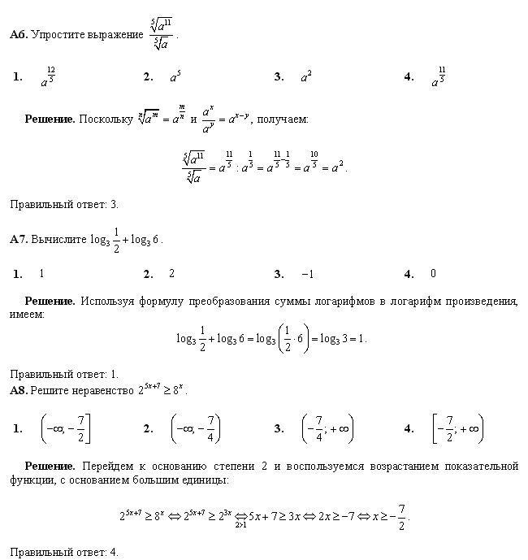

- Укажите значение выражения ${\text{log}}_{5}\text{250}−2{\text{log}}_{5}\text{10}$.
1. | $$5+8{\text{log}}_{5}2$$ | 2. | 2 | 3. | $$1−{\text{log}}_{5}2$$ | 4. | 0

- Укажите значение выражения $2{\text{log}}_{2}3+{\text{log}}_{2}\frac{1}{3}$.
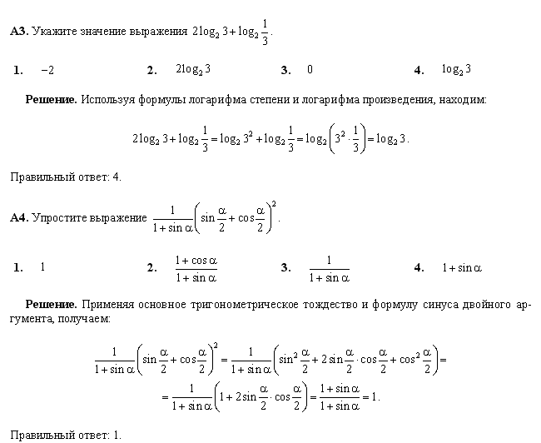
- При каких значениях $a$ верно равенство ${\text{log}}_{2}\left({\text{log}}_{3}\text{sin}\frac{π}{3}−{\text{log}}_{3}\text{cos}\frac{π}{3}\right)=a$?
1. $a=1$ 2. $a=\sqrt{3}$ 3. $a=−1$ 4. $a=−\sqrt{3}$

- Найдите значение выражения 2с-3, если $с={\text{10}}^{0,5\text{lg}9}$.
1. | -1 | 2. | 15 | 3. | 3 | 4. | 6

- Вычислить ${\text{27}}^{\frac{1}{{\text{log}}_{4}3}}$.

1. 3 2. -3 3. 64 4. 9

- Вычислить $3^{{\text{log}}_{6}\text{18}}⋅2^{{\text{log}}_{6}3}$.

1. 54 2. 9 3. 18 4. 21

- Вычислить ${\text{10}}^{−\text{lg}2}+2^{−{\text{log}}_{2}\text{10}}$.

1. -0,99 2. -22 3. 0,51 4. 0,6

- Найдите значение выражения если
1. | – 6,5 | 2. | – 0,5 | 3. | – 10,5 | 4. | – 67,5

- При каких значениях $a$ верно равенство $\left(1+\text{lg}3\right){\text{log}}_{\text{30}}\text{10}+3\text{lg}0,1=a$?

1. $a=3$ 2. $a=4$ 3. $a=−2$ 4. $a=0$

- Упростить $\frac{2{\text{log}}_{7}6−{\text{log}}_{7}3}{{\text{log}}_{7}\text{144}}$.
1. $−2$ 2. $2{\text{log}}_{\text{144}}7$ 3. $0,5$ 4. $\frac{1}{2}{\text{log}}_{7}\text{12}$
- При каких значениях $a$ верно равенство ${\text{log}}_{5}4⋅{\text{log}}_{6}5⋅{\text{log}}_{7}6⋅\text{.}\text{.}\text{.}⋅{\text{log}}_{\text{16}}\text{15}=a$?
1. $a=\frac{1}{2}{\text{log}}_{5}4$ 2. $a=\frac{1}{2}$ 3. $a=\frac{1}{2}{\text{log}}_{\text{16}}\text{15}$ 4. $a=−\frac{1}{2}$
- Упростить ${\text{27}}^{{\text{log}}_{\sqrt{3}}\sqrt[6]{3}}+4⋅5^{{\text{log}}_{5}^{2}2}−2^{{\text{log}}_{5}2}{\text{log}}_{2}\text{16}$.
1. 1 2. $2^{{\text{log}}_{5}2}$ 3. ${\text{log}}_{5}2$ 4. 3

Задания с кратким ответом.
Определение логарифма.
1. Вычислите:
1. ${\text{log}}_{2}\text{16}−{\text{log}}_{3}\frac{1}{\text{81}}+{\text{log}}_{\text{17}}1$; 4. $\frac{1}{5}{\text{log}}_{2}\text{16}+\frac{1}{2}{\text{log}}_{0,1}\text{10}−3\text{ln}e^{2}−\text{lg}\text{100}$;
2. ${\text{log}}_{7}{\text{log}}_{7}\sqrt[7]{\sqrt[7]{7}}$; 5. ${\text{log}}_{\frac{1}{2}}{\text{log}}_{4}\text{256}+{\text{log}}_{5}{\text{log}}_{6}\sqrt[\text{25}]{6}$;
3. $\text{10}{\text{log}}_{\sqrt{2}}{\text{log}}_{\sqrt{2}}\sqrt{\sqrt{\sqrt{2}}}$; 6. ${\text{log}}_{2}^{2}{\text{log}}_{\sqrt{7}}\text{49}⋅{\text{log}}_{\frac{1}{5}}^{3}{\text{log}}_{2}\text{32}$.

Свойства логарифмов.
2. Вычислите:
1. ${\text{log}}_{2}5−{\text{log}}_{2}\text{35}+{\text{log}}_{2}\text{56}$; 2. ${\text{log}}_{5}8−{\text{log}}_{5}2+{\text{log}}_{5}\frac{\text{25}}{4}$;
3. ${\text{log}}_{2}\left({\text{log}}_{2}5+{\text{log}}_{2}3,2\right)$; 4. ${\text{log}}_{2}\sqrt{3}+\frac{1}{2}{\text{log}}_{2}\frac{4}{3}$;
5.${\text{log}}_{5^{7}⋅\sqrt{5}}\sqrt[4]{\text{125}}$; 6. $\frac{2{\text{log}}_{7}6}{{\text{log}}_{7}\text{12}+{\text{log}}_{7}3}$;
7. $\frac{2{\text{log}}_{7}6−{\text{log}}_{7}3}{{\text{log}}_{7}\text{144}}$; 8. $\frac{2{\text{log}}_{3}\text{12}−4{\text{log}}_{3}^{2}2+{\text{log}}_{3}^{2}\text{12}+4{\text{log}}_{3}2}{3{\text{log}}_{3}\text{12}+6{\text{log}}_{3}2}$.

Формулы перехода к новому основанию.
3. Вычислите:
1. $\frac{3{\text{log}}_{7}2−{\text{log}}_{7}\text{24}}{{\text{log}}_{7}3+{\text{log}}_{7}9}+\frac{{\text{log}}_{4}\text{45}+2{\text{log}}_{4}\frac{1}{3}}{{\text{log}}_{4}\text{75}−{\text{log}}_{4}3}$; 2. $\frac{{\text{log}}_{5}\text{12}−{\text{log}}_{5}4}{{\text{log}}_{5}\text{18}+{\text{log}}_{5}0,5}−\frac{\text{lg}\text{64}+\text{lg}0,5}{\text{lg}7−\text{lg}\text{14}}$;
3. $\frac{{\text{log}}_{\text{144}}\text{49}−2{\text{log}}_{\text{12}}3}{1−{\text{log}}_{\sqrt{\text{12}}}2}−\frac{{\text{log}}_{2}6−1}{{\text{log}}_{4}6−0,5}+\frac{3{\text{log}}_{\sqrt{\text{15}}}\sqrt{3}−2{\text{log}}_{\text{225}}\text{49}}{2−{\text{log}}_{\text{15}}\text{25}}$;
4. $6{\text{log}}_{3}2⋅{\text{log}}_{4}3⋅{\text{log}}_{5}4⋅{\text{log}}_{6}5⋅{\text{log}}_{7}6⋅{\text{log}}_{8}7$.

Основное логарифмическое тождество.
4. Вычислите:
1. ${\text{25}}^{{\text{log}}_{5}3}+0,{\text{04}}^{{\text{log}}_{0\text{.}2}8}−9^{{\text{log}}_{\text{81}}4}$; 2. $\sqrt[6]{{\text{27}}^{\frac{1}{{\text{log}}_{4}3}}}$;
3. $3^{2+{\text{log}}_{3}5}+{\left(\frac{1}{3}\right)}^{{\text{log}}_{3}5}$; 4. $9^{3−{\text{log}}_{3}\text{54}}+7^{−{\text{log}}_{7}2}$;
5. $3^{{\text{log}}_{3\sqrt{3}}8}+7⋅4^{{\text{log}}_{2}\sqrt{7}}−8⋅2^{{\text{log}}_{4}9}$; 6. $3^{{\text{log}}_{\sqrt{3}}7}+5^{{\text{log}}_{\frac{1}{\sqrt{5}}}3}−2^{{\text{log}}_{4}9}$;
7. $e^{\frac{2}{{\text{log}}_{5}e}}−4^{\frac{2}{\text{lg}\text{16}}}$; 8. ${\left(7^{{\text{log}}_{\text{100}}\text{81}}\right)}^{{\text{log}}_{3}\text{10}}$; 9. $\sqrt{5^{2{\text{log}}_{5}3}}−7^{2{\text{log}}_{\text{49}}2}+8^{4{\text{log}}_{\text{16}}3}$; 10. ${\text{25}}^{2−{\text{log}}_{5}\text{75}}+7^{−{\text{log}}_{7}3}$;
11. $3^{2+\frac{{\text{log}}_{3}4}{{\text{log}}_{4}3}}−9⋅4^{\frac{1}{{\text{log}}_{4}3}}+4^{1+{\text{log}}_{4}\text{25}}$; 12. ${\left(1+4^{{\text{log}}_{2}\sqrt{2}}\right)}^{\frac{1}{2}}\text{cos}\frac{\text{13}π}{6}$;
13. $3^{\frac{1}{2{\text{log}}_{7}3}}⋅3^{{\text{log}}_{3}^{2}8}−\sqrt{7}⋅8^{{\text{log}}_{3}8}−\sqrt{3^{{\text{log}}_{3}\text{25}}}$; 14.${\left({\left(\frac{3}{2}\right)}^{−0\text{.}5}⋅3^{0,5{\text{log}}_{3}6}+1\right)}^{\frac{1}{2}}\text{sin}\frac{7π}{3}$; 15. $\text{cos}\frac{π}{3}⋅{\left(0,\text{025}\right)}^{\text{lg}\frac{1}{2}}⋅{\left(0,\text{04}\right)}^{\text{lg}\frac{1}{2}}$; 16.$\sqrt{1+3^{1+0,5{\text{log}}_{4}^{−1}3}+2^{2{\text{log}}_{9}^{−1}4}}$.

Смешанные задачи.
5. Найдите значение выражения:
1. $3{\text{log}}_{\text{12}}\sqrt[3]{a}$, если ${\text{log}}_{\text{12}}a=−2$; 2. ${\text{log}}_{8}a$, если ${\text{log}}_{2}a=6$;
3. $4^{b}$, если $b={\text{log}}_{2}5+{\text{log}}_{14}\text{10}$; 4. ${\text{log}}_{\text{36}}9$, если ${\text{log}}_{\text{36}}8=a$;
5. ${\text{log}}_{5}a^{8}$, если $a=\sqrt{5\sqrt{5\sqrt{5}}}$; 6. ${\text{log}}_{2}\text{360}$, если ${\text{log}}_{3}\text{20}=a$, ${\text{log}}_{3}\text{15}=b$;
7. $\text{lg}\left(\frac{b}{\text{100}a}\right)$, если $\text{lg}b=5$, $\text{lg}a=1$; 8. $\text{lg}a+\text{lg}\left(\frac{1}{a^{2}}\right)$, если ${\text{log}}_{\text{100}}a=4$;
9. $5^{b}+6^{c}$, если $b=\frac{3}{{\text{log}}_{2}5}$, $c={\left({\text{log}}_{5}6\right)}^{−1}$; 10. ${\text{log}}_{\text{30}}8$, если $\text{lg}5=a$, $\text{lg}3=b$;
11.${\text{log}}_{π^{2}}\frac{π^{3}}{{\text{ab}}^{2}}$, если ${\text{log}}_{π^{3}}a={\text{log}}_{π^{3}}b=1$; 12. $3^{{\text{log}}_{9}a}$, если $a^{4}=\text{36}$;
13. ${\text{log}}_{a\sqrt{b}}\frac{\sqrt{b}}{a^{2}}+{\text{log}}_{b\sqrt{a}}\left(a\sqrt{b}\right)+\frac{1}{4}{\text{log}}_{\sqrt[3]{a}}\sqrt[5]{a}$, если ${\text{log}}_{a}b=2$.

6. Упростите:
1. $a^{1+2{\left({\text{log}}_{b}a\right)}^{−1}}⋅b−2⋅a^{{\text{log}}_{a}b+1}b^{{\text{log}}_{b}a+1}+a⋅b^{1+2{\left({\text{log}}_{a}b\right)}^{−1}}$;
2. $\frac{{\text{log}}_{a}\sqrt{a^{2}−1}⋅{\left({\text{log}}_{\frac{1}{a}}\sqrt{a^{2}−1}\right)}^{2}}{{\text{log}}_{a^{2}}\left(a^{2}−1\right)⋅{\text{log}}_{\sqrt[3]{a}}\sqrt[6]{a^{2}−1}}$ 3.$\left({\text{log}}_{a}c+{\text{log}}_{b}c\right){\text{log}}_{\text{ab}}c−\left({\text{log}}_{a}c\right)\left({\text{log}}_{b}c\right)$;
4. $\sqrt{{\text{log}}_{a}^{2}3}$; 5. $\left(x^{\text{lg}y}+y^{\text{lg}x}\right):x^{\text{lg}y}$.
6. $\left(9⋅2^{5{\text{log}}_{2}a}−{\left(\frac{1}{\text{32}}\right)}^{−{\text{log}}_{2}a}\right)3^{1−\frac{1}{{\text{log}}_{a}3}}$, $a>0$, $a≠1$.

7. Сравните значения:
1. $\text{lg}\left(\sqrt{3}−1\right)$ и $\text{lg}\left(\sqrt{5}−2\right)$; 2. ${\text{log}}_{0,7}^{3}\frac{3}{4}$ и ${\text{log}}_{0,7}^{3}\frac{5}{6}$;
3. $3,\text{76}⋅{\text{log}}_{3}2$ и $3,\text{76}{\text{:log}}_{3}2$; 4. $\text{23},\text{76}+{\text{log}}_{0,3}2$ и $\text{23},\text{76}−{\text{log}}_{0,3}2$;
5. $0,\text{75}+{\text{log}}_{0,3}2$ и $0,\text{75}+{\text{log}}_{0,3}3$; 6. ${\text{log}}_{\text{48}}7$ и ${\text{log}}_{\text{37}}6$;
7. ${\text{log}}_{8}\text{63}$ и ${\text{log}}_{5}\text{26}$; 8. ${\text{log}}_{\text{37}}6$ и $\sqrt{\frac{2}{7}}$.

8. Сравните с нулем значения указанных выражений:
1. ${\text{log}}_{\frac{3}{2}}\left(\sqrt{3}−\frac{3}{2}\right)$; 2. ${\text{log}}_{0,3}\left(x^{2}−6x+\text{11}\right)$;
3. ${\text{log}}_{\frac{2}{3}}\left(6{\text{log}}_{\frac{3}{7}}0,6\right)$; 4. ${\text{log}}_{{\frac{2}{3}}^{2}}6+{\text{log}}_{\frac{2}{3}}6⋅{\text{log}}_{\frac{3}{7}}5+{\text{log}}_{{\frac{3}{7}}^{2}}5$;
5. ${\text{log}}_{2^{2}}3−3{\text{log}}_{2}3⋅{\text{log}}_{3}\text{10}+2{\text{log}}_{3^{2}}\text{10}$.

