ДИАГНОСТИЧЕСКАЯ РАБОТА ПО АНГЛИЙСКОМУ ЯЗЫКУ В 3 КЛАССЕ
Name: _________________________________ Class: ________ Date: __________
- Вычеркни лишнее слово
- rocking horse, aeroplane, bed, tea set c) Music, Art, History, John
- lamp, rabbit, seahorse, parrot d) eleven, five, apple, sixteen

- Впиши some или any
- I have got _________ pencils in my pencil case.  - Has she got ________ toys in her room?  - Larry hasn’t got ________ books in his bag. | - Can I have ________ pasta?  - Mark has got _________ milk in his glass.  - We haven’t got _________ desks in our class.
- Подчеркни правильное слово
а) A dog has/can a long tail.  b) Birds can/can’t fly.  c) It is/are a ballerina.  d) Do/Does you like sausages? | e) My train is/are red.  f) I like/likes fruit.  g) I have/has got a computer in my room.  h) Can/Have you swim?

- Напиши предложения во множественном числе
- That is my child. __________________________________
- That is an apple. __________________________________
- This is my fish. __________________________________
- This is a man. __________________________________

- Поставь предложения в правильном порядке и запиши их.
- food/ your/ favourite/ is/ What ? _________________________________________
- you/ Can/ swim/ a fish/ like ? _________________________________________
- are/ 9/ years old/ We _________________________________________
- Look/ my/ at/ radio/ funny ! _________________________________________

- Прочитайте текст, раскрасьте картинку, заполните анкету.

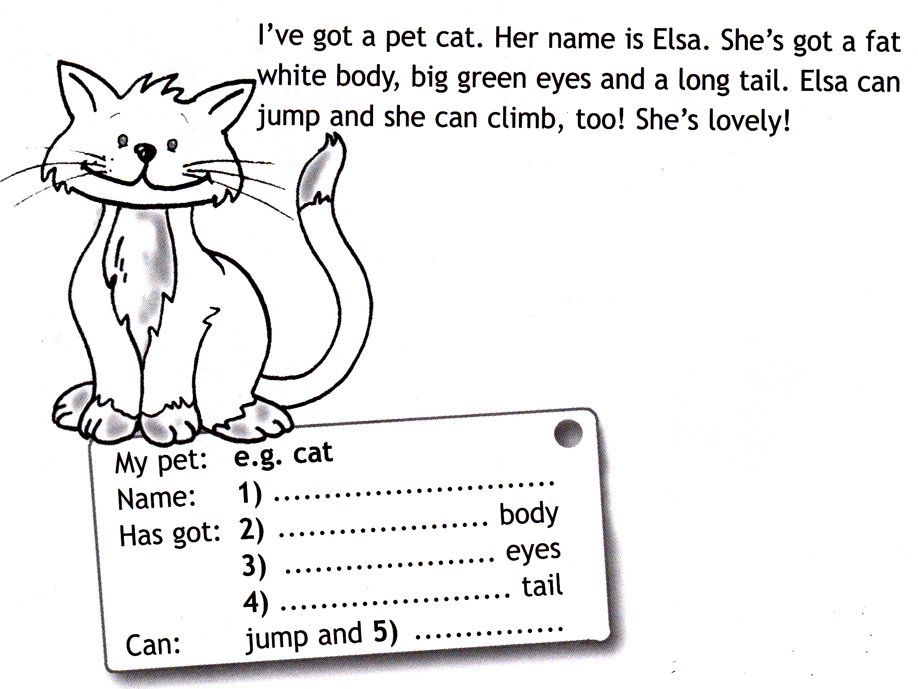
- * Напиши письмо своему другу о своем любимом домашнем питомце. Закончи предложения.
Dear _____________ ,
Thank you for your letter.
I’ve got a pet ___________. Its name is _________________. It has got _______________________________.
Its favourite food is _____________________________ . It can _____________________________________ .
Write back soon.
Love,
______________________
Mark:

