ГБОУ СОШ 1011

Разработка тренировочных упражнений с ответами по грамматике английского языка к теме «Формы настоящего времени (Present Tenses)»
для учеников 10-х классов общеобразовательных школ

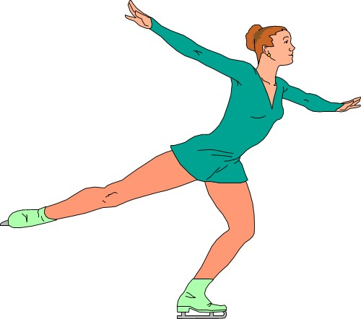

Подготовила
учитель английского языка:
Коренева Юлия Михайловна

г. Москва
2014

- Choose a time expression from the list to complete each sentence.
Never for 3 hours everyday tonight now always yet on Fridays at the moment ever

- Mother is reading the paper now.
- She ________ eats meat. She’s a vegetarian.
- He drives to work__________.
- They are going to a party ______.
- John goes to the gym ___________.
- Nick _______ goes out on Sundays.
- Dad is watching TV right _______.
- Have you caught anything _____?
- Have you ______seen a kangaroo?
- I have been fishing __________ already.

- Fill in the gaps with the proper forms of the verbs: Present Simple/ Progressive/ Perfect/ Perfect Progressive:
- – What … Ann … (do)?
- She is a journalist. She … (interview) interesting people and … (write) reports in a popular women’s magazine.
- What … she … (do) now?
- It … (snow) since early morning.
- It … (snow) today. Be careful on the road!
- – What … Ella … (do)?
- She is a student. She … (study) at a linguistic university.
- What … she … (do) now?
- She … (hang out) with her friends.
- I … (lose) my key. I can’t enter my flat now.
- He … (read) six textbooks by the history exam.
- - How long ….you … (play) the piano?
- I … (play) the piano since I was five.
- – What … David … (do) now?
- He … (jog) in the park.
- How long … he … (jog)?
- He … (jog) for ten minutes without a rest.

- ЕГЭ. Complete the dialogue with the correct form of the verbs in capital letters.

1. Martha: Bill, I __________my English-Spanish dictionary. | LOOK FOR
2. (you) ____________it? | SEE
3. Bill: No, but ask Dad. He ________emails in Spanish in his room. | WRITE
4. Martha: I __________ (already) him. | ASK
5. He ________ where it is. | NOT KNOW
6. I think you _______it. | TAKE
7. Bill: Martha, you know I __________your books without asking. | NOT TAKE
8. (you) __________ in the living room? | LOOK
9. May be you _______ it there? | LEAVE
10.Martha: Okay, I will check the living room. And what (you) ________________? | DO
11. Bill: Can leave me alone, Martha? I _____on a project about Barcelona. | WORK
12. Martha: Barcelona _________ in Spain. | BE
13. Oh, no, what (you) _________ there? This is my dictionary! | HODE
14. Bill: I’m sorry, Martha but I really ____it.  Please, let me finish! | NEED
15. Martha: You’re impossible, Bill! You can keep it for half an hour and then I _____it back. | WANT

CHECK YOURSELF

- Choose a time expression from the list to complete each sentence.
Never for 3 hours everyday tonight now always yet on Fridays at the moment ever

- Mother is reading the paper now.
- She never eats meat. She’s a vegetarian.
- He drives to work every day.
- They are going to a party tonight.
- John goes to the gym on Fridays.
- Nick always goes out on Sundays.
- Dad is watching TV right now.
- Have you caught anything yet?
- Have you ever seen a kangaroo?
- I have been fishing for three hours already.

- Fill in the gaps with the proper forms of the verbs: Present Simple/ Present Progressive/ Present Perfect/ Present Perfect Progressive:
- - What …does Ann … do?
- She is a journalist. She … interviews interesting people and … writes reports in a popular women’s magazine.
- What …is she … doing now?
- It … has been snowing since early morning.
- It … is snowing today. Be careful on the road!
- - What …does Ella … do?
- She is a student. She … studies at a linguistic university.
- What …is she … doing now?
- She … is hanging out with her friends.
- I … have lost my key. I can’t enter my flat now.
- He … has read six textbooks by the history exam.
- - How long ….have you … been playing the piano?
- I …have been playing the piano since I was five.
- - What …is David … doing now?
- He …is jogging in the park.
- How long …has he … been jogging?
- He … has been jogging for ten minutes without a rest.

- ЕГЭ. Complete the dialogue with the correct form of the verbs in capital letters.

- I’M LOOKING FOR
- HAVE YOU SEEN
- ‘S WRITING
- ‘VE ALREADY ASKED
- DOESN’T KNOW
- HAVE TAKEN
- DON’T TAKE
- HAVE YOU LOOKED
- ‘VE LEFT
- ARE YOU DOING
- ‘M WORKING
- IS
- ARE YOU HIDING
- NEED
- WANT

Использованные материалы и Интернет-ресурсы
- Фурсенко С.В. Английский язык. Тесты. 9 класс. Москва: Дрофа, 2002.
- Virginia Evans, Jenny Dooly. New Round up 5. Pearson/ Longman, 2011.
- http://www.native-english.ru/exercises/present
- http://www.study.ru/test/test.php?id=373

