Муниципальное бюджетное общеобразовательное учреждение
основная общеобразовательная школа №27 х. Западного
муниципального образования
Ленинградский район

Контрольная работа
по английскому языку
для учащихся 5 класса
(УМК М. З. Биболетовой.
Enjoy English 5 – 6 кл.)
3 четверть

Составлена
учителем английского языка
Гура Ириной Николаевной

Задание 1. Match the pictures and captions (подписи):

1) 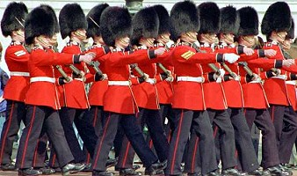 2) 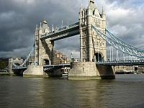

___________________________ _____________________

3) 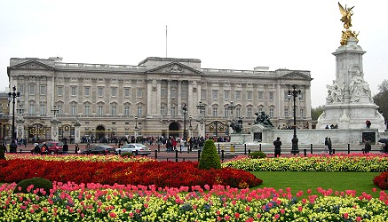 4) 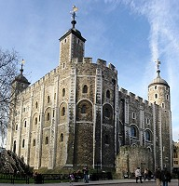
__________________________ ________________________

5) 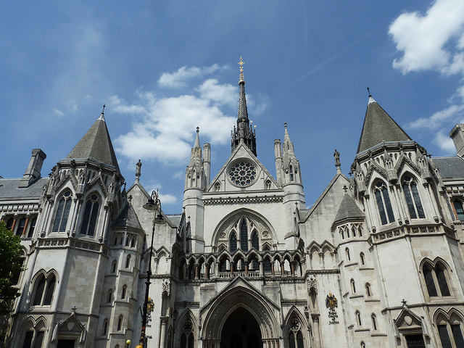 6) 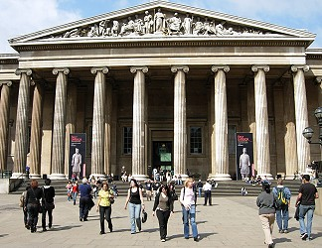
___________________________ ________________________

A. Changing the Guard at Buckingham Palace

B. Tower Bridge

C. The Tower of London

D. Buckingham Palace

E. Westminster Abbey

F. British Museum

Задание 2. Make up the dialogue.

- You are welcome. Have a nice day.
___Excuse me, am I far from Trafalgar Square?
___How can I get there?
___I'm afraid you are.
___It's very easy. Take bus No 64 and you'll be there in ten minutes.
___ Thank you very much.

Задание 3. Choose the right verb:

- Listen! Somebody _________ the violin.
a) is playing b) plays c) played

- __________ you ___________ to drink some coffee?
a)do, want b) is, wanting c) are wanting

- The Queen ____________ in Buckingham Palace, doesn’t she?
a) is living b) live c) lives

- Now he _____________ lunch in a cafe not far from Trafalgar Square.
a) is having b) haves c) has

- You ____________ many interesting places in London.
a) is seeing b) can see c) sees

Задание 4. Make up sentences:

- visit, a, lot, tourists, of, Palace, famous, Buckingham.
____________________________________________________________
- built, Bridge, 1894, in, Tower, was.
_____________________________________________________________
- Abbey, is, a, Westminster, of, London, symbol.
_____________________________________________________________
- history, of, Bloody, blood, Tower, has, the, a.
_____________________________________________________________
- interesting, most, the, London, is, one, of, famous, and, cities.
______________________________________________________________

Задание 5. Choose the suitable word:
1). There are so many . . . to visit in London!
a) music b) places c) a museum d) information

2). Can you see that . . . palace there?
a) bridge b) interesting c) front d) beautiful

3). Buckingham Palace is the place where British . . . live when they are in London
a) people b) tourists c) kings and queens d) guards
Список использованной литературы

1. Учебник «Enjoy English-5». М.З.Биболетова, О.А. Денисенко, Н.Н. Трубанёва, Обнинск: Титул 2013;
2. Рабочая тетрадь «Епjоу English-5». М.З.Биболетова,О.А. Денисенко, Н.Н.Трубанёва, Обнинск: Титул 2013;
3. Книга для учителя «Enjoy English-5». М.З.Биболетова, Н.Н.Трубанёва, Обнинск: Титул 2012.

Использованные Интернет-ресурсы
- http://www.webturism.ru
- http://www.tourister.ru

