Муниципальное общеобразовательное учреждение
«Многопрофильная гимназия №12» города Твери

My room
Слова
Упражнения
Тексты

подготовила
учитель английского языка
Гордеева Наталья Филипповна

Тверь
2014

Everyday objects
a picture (a painting) картина a chandelier люстра
a carpet ковёр a lamp лампа
a TV-set телевизор a standard lamp торшер
a remote control пульт a wall lamp бра
Hi-Fi аудиоаппаратура a lampshade абажур
a DVD(video) – player DVD(видео)-плейер an iron утюг
a tape-recorder магнитофон a vase ваза
a computer компьютер a mirror зеркало
a mobile phone мобильный телефон a console-mirror трюмо
a telephone телефон an aquarium аквариум
a (digital) camera (цифровой)фотоаппарат a magazine журнал
a printer(a scanner) принтер (сканер) a newspaper газета
a computer компьютер a poster постер
a vacuum cleaner пылесос a curtain занавеска
a washing machine стиральная машина a blind штора
an electric heater электрический нагреватель a key ключ
a humidifier увлажнитель воздуха a key ring брелок
a hair- drier фен an alarm-clock будильник
a hall stand вешалка в прихожей
a hanger вешалка

Kitchen

a refrigerator(a fridge) холодильник a towel полотенце
a gas-stove(cooker) газовая плита a teapot заварной чайник
an oven духовка a kettle чайник
a microwave oven микроволновая печь a saucepan кастрюля
a cupboard буфет a tray поднос
a sink раковина a glass стакан
dishes посуда a jug (a jar) кувшин
a plate тарелка a table-cloth скатерть
a saucer блюдце a napkin салфетка
a bowl миска a bread box хлебница
a cup (a mug) чашка (кружка) a broom метла,веник
a fork вилка a dustpan совок
a knife нож a dustbin мусорное ведро
a spoon ложка (a garbage can )
a teaspoon чайная ложка a mop швабра
a frying pan сковорода
an electric teapot электрический чайник a mixer миксер
a dishwasher посудомоечная машина a kitchen unit кухонный комбайн
a coffee machine (maker) кофеварка a plate rack подставка для
сушки посуды
a thermos flask термос

Bathroom

shower душ a towel полотенце
a bath ванна a basin таз
a washbasin раковина a powder порошок
soup мыло shampoo шампунь
a brush зубная щётка shower gel гель для душа
toothpaste зубная паста a toilet туалет
a sponge мочалка

Amenities

central heating центральное отопление
electricity электричество
running water вода
telephone телефон
gas газ
shower душ
a refuse/rubbish chute мусоропровод
lift лифт
air-conditioning кондиционер

Building materials
Cement цемент
Concrete бетон
Stone камень
Brick кирпич
Wood дерево
Timber бревно
Sand песок
Bamboo бамбук
Paper обои
Tile кафель, плитка

При описании квартиры или комнаты часто используют конструкцию there is\are.
There is – находится There is + сущ. в ед.ч +обстоятельство места
There are – находятся There are + сущ. во мн.ч +обстоятельство места
Example:
There is a table in my bedroom. – В моей комнате находится стол.
There are two tables in my bedroom. - В моей комнате находятся два стола.
There is a kitchen and three rooms in our flat. – В нашей квартире – кухня и три комнаты.
There are three rooms and a kitchen in our flat. – В нашей квартире – три комнаты и кухня.

Перевод предложения с данной конструкцией начинается с конца предложения.
Конструкция в некоторых предложениях может не переводится, вместо неё можно поставить знак «-»
Отрицание:
There is not a table in my bedroom. (=There is no table in my bedroom. – Обратите внимание, что определённый артикль перед существительным отсутствует)
There are not two tables in my bedroom. (=There are no two tables in my bedroom.)
Вопрос-ответ:
Is there a table in my bedroom? – В моей комнате находится стол?
- Yes, there is.
- No, there isn’t.
Are there two tables in my bedroom? - В моей комнате находятся два стола?
- Yes, there are.
- No, there aren’t.
При описании квартиры или комнаты в некоторых предложениях можно не использовать данные конструкции, тогда они выглядят следующим образом:
A table is in my bedroom. (Вместо There is a table in my bedroom.)
В данном предложении перевод дословный, с начала предложения : Стол – в моей комнате.
Two tables are in my bedrooms. – Два стола – в моей комнате.
Упражнения на закрепления слов.
- Read and guess what it is:
- A place we live in ______________
- A place where we cook food______________________
- A place where we take a shower____________________________
- A place where we wash the dishes____________________________
- A place where we wash our face and hands_____________________
- A place where we can sit and read before the fire____________________
- A room where we can have dinner_________________________
- A thing we can lock the door with___________________
- A thing where we keep our clothes_________________________
- A thing in the kitchen to cook our food_________________________
- A thing in the kitchen where we can wash up______________________
- A thing that we can see our faces in_____________________
- A thing that helps us to read when it is dark in the room__________________
- Things which are usually on the windows and makes the room lovely__________________
- Complete the sentences:
- We cook in the__________________________.
- We sleep in the _________________________.
- We watch TV in the ______________________.
- We eat in the ___________________________.
- We read books in the _____________________.
- We wash face and hands in the ______________________.
- We take off our overcoats in the ______________________.
- We keep old things in the ____________________________.
- Write the word:
- Iilgcen____________
- kenthci_________________
- yparnt_______________
- ewdrorab _____________
- uoardbpc ________________
- cipuetr___________________
- riormr_____________________
- iumqaura_________________
- taicnur__________________
- tletke________________
- dsehsi ___________________
- cytriileect __________________
- bsindut ________________
- tnvieceonn _________________

- Найти названия комнат и выписать:
W P A N T R Y O N L
A O C E O K H I L J
L L V K I I N A K P
L D W E L T H E D S
O Q R S E C V W O P
U X B A T H R O O M
D R T S M E E T R I
Y G H K A N D R Y N
L I V I N G R O O M
W I N D O W N N Y O

_____________________________________________________________________________
_____________________________________________________________________________
_____________________________________________________________________________
_____________________________________________________________________________

Углубленный уровень.
Текст 1
My flat.
We have a nice flat in a new block of flats. Our flat is on the fourth floor. It has all modern conveniences: central heating, gas, electricity, cold and hot water, a lift and a chute to carry rubbish down.
There are three rooms, a kitchen, a bathroom and a hall in our flat.
The living-room is the largest and most comfortable room in the flat. In the middle of the room we have a square-table with six chairs round it. To the right of the dinner-table there is a wall-unit which has several sections: a sideboard, a wardrobe and some shelves. At the opposite wall there is a piano and stool before it. Between the two large windows there is a little table with a colour TV set on it. Near the TV set there are two cosy armchairs. A small round table, a divan-bed and a standard lamp are in the left-hand corner. This small table is for newspapers and magazines. My father is used to having a rest sitting on this divan-bed reading books, newspapers, magazines or watching TV.
The bedroom is smaller than the living-room and not so light as there is only one window in it. In this room there are two beds with a bedside-table between them. An alarm-clock and a small lamp are on the table. In the left-hand corner there is a dressing-table with a big mirror. In this room we have a built-in wardrobe with coat-hangers to hang clothes on. There is a thick carpet on the floor and plain light-brown curtains on the window.
The third room is my study. It is not large but very cosy. There isn't much furniture in it, only the most necessary. It has a writing-table and an armchair before it. In the right-hand corner there is a bookcase full of books, magazines and newspapers. A small table with a radio is standing in the left-hand corner. Near it there is a sofa with some cushions. In my opinion, the study is the best room in our flat. My friends used to come to my place to have a chat or to play chess in the evening, and they say my room is very comfortable. I share their opinion. But the warmest place in our flat is the kitchen, I think - the place where the whole family gathers every evening not only to have supper together, but also to speak and rest. I like the English proverb: "My home is my castle" because my flat is, indeed, my castle.
Questions:
1. Have you a house or a flat?
2. How many rooms are there in your flat?
3. Has your flat all modern conveniences? What are they?
4. What room is the largest in your flat?
5. What is there in the middle of the room?
6. Is there a piano in the living-room?
7. What is there near the TV set?
8. How many windows are there in the bedroom?
9. What is on the bedside-table?
10. What colour curtains are there on the window?
11. What room is very cosy?
12. Is there much furniture in the study?
13. What is there in the right-hand corner of the study?
14. What is standing in the left-hand corner?

Углубленный уровень
Текст 2
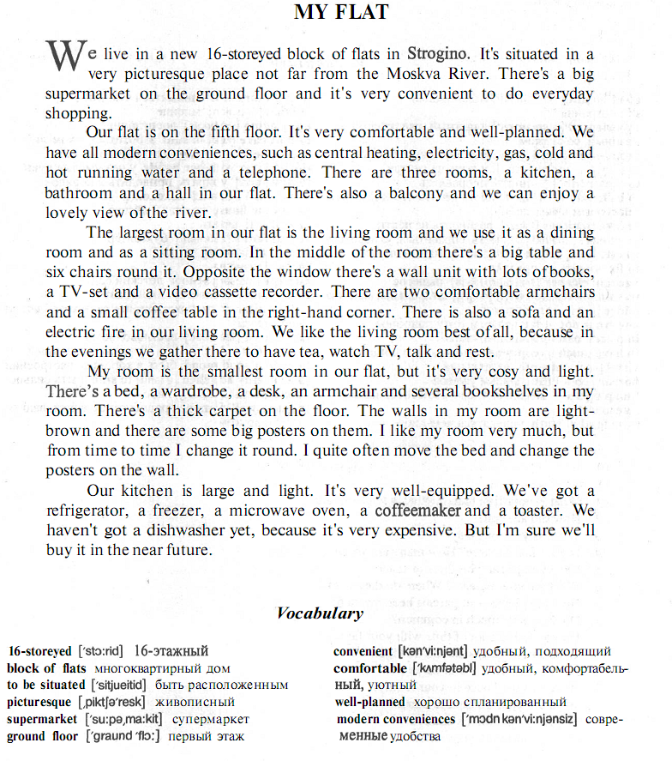

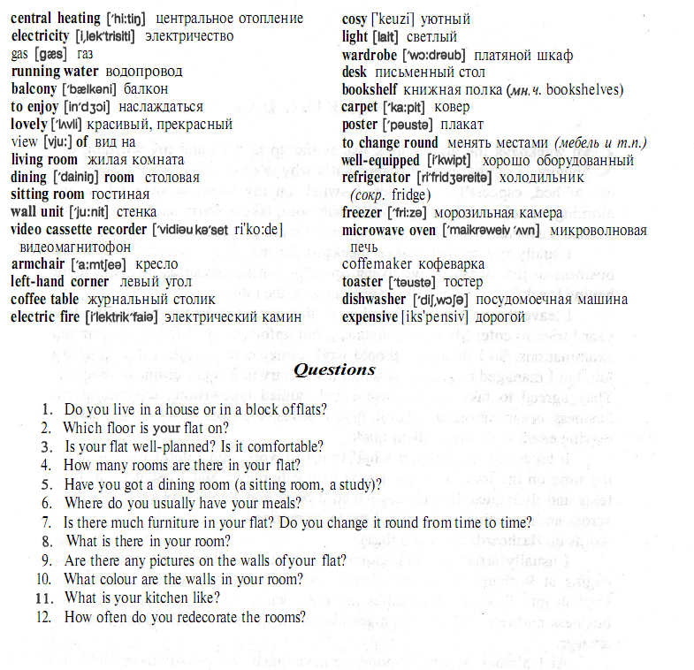

Текст 3

My room

We live in a four-room flat. My favourite place in the flat is my room. My room is not very big. My room is a bedroom and a study at the same time. But it is a very nice, comfortable and cozy. There isn't much furniture in it, only the things that I need most of all. The furniture is built-in. So it doesn’t take much space.
There is a small window in my room but it faces the park, so the view is really wonderful!
The walls of my room are papered in a white colour and the white and green curtains on the window match the wallpaper perfectly.
Besides, there are a lot of flowers in my room. I love taking care of the flowers and water them regularly.
On the right there is my bed and a built-in wardrobe. In the right corner there is a comfortable armchair. There is a standard lamp near it. I love reading in this comfortable arm-chair.
In the left corner of the room there is my desk. There are shelves above the desk. I keep my books, text-books, note-books, CD’s, DVD’s there. As for pens, pencils and other necessary things, I keep them in table drawers. On the table there is a computer, a printer and a scanner.
There is a small light brown carpet on the floor.
There are some posters with my favourite singers on the walls and on the door. I change the posters in my room from time to time.
I like my room very much. My room is a nice place for both rest and work.
My friends love coming to my place and I invite them into my room. We like spending time there.

Текст 4
My home.

There is no place more delightful than home. We connect many pleasant things with our home, our dearest people, parents, friends, nature, gentle flowers, the trees in the yard, the native language and music, the first book read in the childhood, lively and noisy games. That’s why we miss our home badly when we are away. In such moments we feel loneliness and homesickness. You always look forward to homecoming and are delighted to meet your friends and relatives. There are so many poems about the native home. They arose much excitement, much warmness and tenderness.
I would like to tell you about my home. We live in a new flat in one of the largest newly built residential areas. We moved into this flat 7 years ago. It is a three- room flat on the fifth floor of an eight-storeyed building. It consists of a living room, a study, a bedroom, a kitchen and a bathroom. There are two balconies in the flat. Our flat has all modern conveniences: central heating, telephone, electricity, running water, gas. Besides there is a lift and a garage disposal in our building. The layout is perfect! The rooms are light, though not very large. To my opinion it’s quite a modern-looking flat. The windows face the park in front of the building and the view is really wonderful.
Our living room is 19 square meters .It is the largest room in our flat. As my parents don’t like much furniture in the house so in the living room there are two comfortable armchairs and a sofa, coffee-table and a nice thick carpet on the floor. Opposite the window there is a wall unit, but it doesn’t make much space in the room . Here we are fond of entertaining our guests.
Now I’d like to describe our study. At first it was my daddy’s room, but as I grew up ,it has become mine. To tell you the truth I am very happy to have a room for myself, that’s why I always try to keep it tidy and cozy. There is a single-bed, a writing table, a bookcase and a wardrobe in my room. There is a little rug on the floor. I have two pictures in my room. They are nice copies of my favourite paintings by Savrasov.
But the most popular and favorite place with all of us is the kitchen, as we spend most of our time there. We are not big-caters, but for us the kitchen as a place where we can have a chat about our problems. Our kitchen is comparatively large and looks the usual modem kitchen you can see in many other homes. There is a gas-cooker, a fridge, a kitchen table and some cupboards in it. We have regular meals in the kitchen.
Список использованной литературы
- Цветкова И.В. Английский язык для школьников и поступающих в ВУЗы. Устный экзамен.М.,2004,с 54

Использованные Интернет-ресурсы
- http://www.english-easy.info/topics/topics_my_flat1.php#axzz1g2sI5dKr
- http://www.licey.net/english/compositions/room
- http://englishclub.narod.ru/topics/topics_12.htm

