Do you know the place you live in?
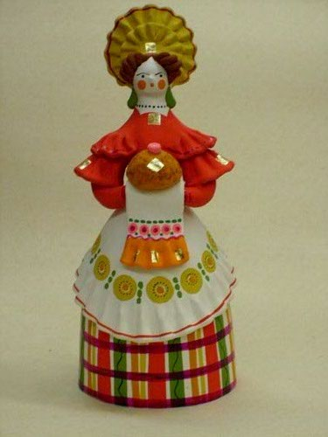

Образовательное учреждение:
Кировское областное государственное вечернее (сменное) общеобразовательное казенное учреждение вечерняя (сменная) общеобразовательная школа при федеральном казенном учреждении «Исправительная колония № 1 Управления Федеральной службы исполнений наказания России по Кировской области» п. Котчиха Омутнинского района

Автор: Сенатская Галина Михайловна

Должность: Учитель английского языка

Номинация: Сборник практических заданий и упражнений

Название работы: «Ты знаешь край, в котором ты живёшь?»

СОДЕРЖАНИЕ

- Пояснительная записка |  | с. 4
- Part A.
 | 1. Kirov Region | с. 5
 | 2. Kirov. | с. 7
 | 3. Dymkovo toys. | с. 8
 | 4. Some facts about the Kirov Region towns. | с. 9
- Part В.
 | Tasks for fun and profit  Grammar exercises. Some proper names  1. Fill in “the” where necessary. | с. 10
 | Famous people  2. Fill in the prepositions | с. 10
 | Writing tasks. Questionnaire | с. 11
 | It’s never too late to learn  2A. Choose the true sentences and then write a composition. | с. 12
 | 2B. Complete the sentences. | с. 12
 | A story about Kirov and Omutninsk  3. Write a story about Kirov or Omutninsk. Use this word web to help you. | с. 13
 | The weather in Kirov Region  4. Describe the weather in Kirov Region. These words can help you. | с. 13
 | A talk with a foreigner  5. Translate and complete the dialogue in English. Act it out. | с. 13
 | About the museum  6. Role-play the situation. | с. 14
 | Сrossword. Towns of Kirov Region  1. Find all the towns of Kirov Region. | с. 15
 | Famous people of Kirov Region  2. Mach the names of famous people with their occupations. | с. 16
 | The symbols of our region  3. Choose only the Kirov Region’s symbols. | с. 16
 | 4. Odd one out. | с. 18
- Keys |  | с. 19
- Источники информации |  | с. 19
ПОЯСНИТЕЛЬНАЯ ЗАПИСКА

Сборник практических заданий и упражнений по региональному культуроведению для учащихся 5-9 классов общеобразовательных школ “Do you know the place you live in?»
Региональный компонент играет большую роль в обучении иностранным языкам. Практические задания“ Do you know the place you live in? “ предназначены для обучающихся 5-9 классов общеобразовательных школ, изучающих английский язык. Задания направлены на развитие навыков чтения, устной и письменной речи.
В сборнике 2 раздела.
В первый раздел” Do you know the region you live in? “ включены тексты по региональному культуроведению. К текстам разработаны коммуникативные задания, побуждающие учеников к беседе по темам» Кировская область», «Дымковская игрушка».
Во второй раздел вошли задания грамматические, коммуникативные, письменные, также предлагаются кроссворды.
Задания снабжены иллюстрациями и многочисленными фотографиями, что делает их более привлекательными.
Актуальность данных заданий определяются неразработанностью по данной теме.
Значимость заданий состоит в том, что они могут использованы учителями средних школ при работе с разными категориями детей, поскольку в основе лежат общедидактические принципы обучения иностранным языкам:
- воспитывающего обучения;
- сознательности;
- активности;
- наглядности;
- доступности и посильности;
- прочности;
- индивидуализации.
Данные задания прошли апробацию в 5-9 классах МКОУ ООШ д. Ежово Омутнинского района Кировской области. Дети с
интересом и увлечением работали с заданиями и даже составляли собственные кроссворды, предлагали вопросы.

Part А.

Do you know the region you live in?

1. Kirov Region
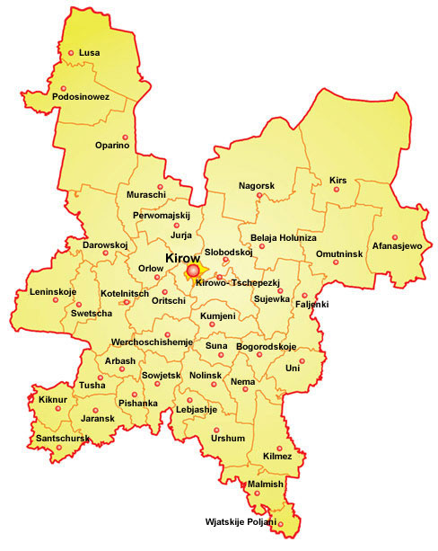

Kirov Region was founded on December 5 in 1936. It covers 120,8 sguare kilometers. It is one of the central regions in Russia. Nizhniy Novgorod, Kostroma, Arkhangelsk, Vologda, Izhevsk are very close to Kirov Region. Kirov Region’s population is about 1634,5 00 people.
Our region is famous for plants and factories. But most of all we are proud of the famous people who were born here.
Everyone knows the name of one of the greatest writers in the world A.S. Grin. He was born not far from Kirov in Slobodskoy. Now his house has become a museum and many people visit it every year.
Another world-wide known person is V. M. Vasnetsov. The talented artist comes from Kirov Region, too.The poet N.A. Zabolotskiy, the writer A. Likhanov , politicians, sportsmen were born here. Besides, 219 people from Kirov Region have been awarded the titles of the heroes of the Soviet Union.
There are plenty of places to visit here .For example, the museum of the artists V.M. and A.M. Vasnetsovs ,literature museum of Saltykov-Shchedrin , national history museum in Kotelnich , Shaitan -Lake is the most unique in Kirov Region. If you ‘re fond of literature, history, nature you should visit these places.
There are 20 towns in Kirov Region. They are big and small, old and young, but all of them are nice and interesting in there own way.
The symbol of Kirov Region is Dymkovo toy.
I’m very proud of living in Kirov Region

Let’s talk.
Ask your friends questions about the size, population and location of Kirov Region .
Where can a visitor of our region go to learn about the history and culture of Russia?
Which symbol of Kirov Region is unique?

2. Kirov.

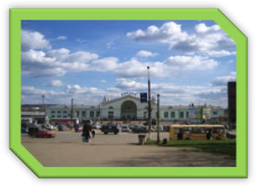
Let’s talk.
If you were in Kirov , what would you like most of all there?

Kirov is the main city of my region. It has the population of about 491,4 thousand people, who work at various plants and factories. Kirov is a beautiful city with lots of parks and museums. There are the City Drama Theatre , the City Philarmonia Hall, the Children Theatre , restaurants where you can spend an evening. If you are in Kirov, you should visit Teatralnaya Square, Gagarin Park or Victory Park. A lot of children and grown-ups from the region have visited Kirov circus, where wonderful performances are staged. Have you ever been there? If you haven’t , you should do it as soon as possible! Besides, there are a lot of cafes and cinemas, so you may have wonderful time in Kirov!

Let’s talk.
If you were in Kirov , what would you like most of all there?

3. Dymkovo toys.

The visiting card of Kirov Region is Dymkovo toys.

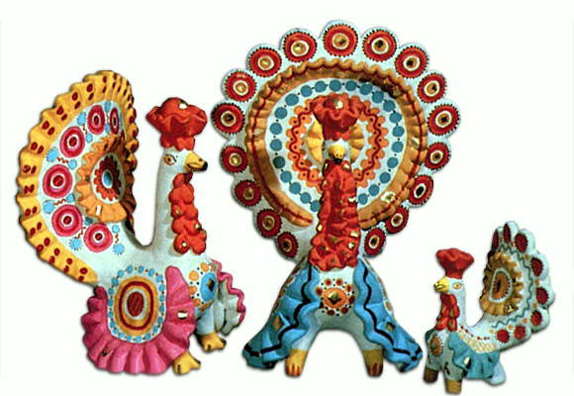

This name comes from Dymkovo settlement. First Dymkovo masters made clay whistles. Then they started manufacturing clay toys, which were brightly painted.
More often Dymkovo toys depict people and animals. I especially like the toys-dogs that always cause a smile-they are funny, cheerful and beautiful. Dymkovo toys are masterpieces. Artists who make them are talented and good people, and those man-made products are the bearers of spiritual values .Today you can see these cute toys not only on counters of shops of folk crafts, but also on the sheves in our apartments. Such toys make us feel happy.
If you are in Kirov, you should visit Dymkovo masters. You will really like it.
Let’s talk.
What would you tell your friends about Dymkovo toys?

4. Some facts about the Kirov Region towns.

Town | The year of foundation | Population
1.Kirov | 1374 | 491,4
2.Kirovo-Chepetsk | 15 century | 99,4
3.Omutninsk | 1773 | 29,6
4.Slobodskoy | 1489 | 43,4
5.Malmyzh | 1584 | 10,5
6.Vyatskie Polyany | 16 century | 45,9
7.Kotel’nich | 1459 | 37,4
8.Yaransk | 1584 | 20,9
9.Orlov | 1459 | 10,4
10.Urzhum | 1554 | 12,0
11.Nolinsk | 1780 | 16,3
12.Luza | 1897 | 13,7
13.Sosnovka | 17 century | 15,9
14.Kirs | 1729 | 14,1
15.Murashi | 1898 | 9,4
16.Sovetsk | 1939 | 18,8
17.Sanchursk | 1584 | 6,3
18.Belaya Kholunitsa | 1764 | 13,3
19.Zuevka | 1898 | 16,0
20.Lal’sk | 16 century | 5,4

Let’s talk.
Which towns of our region have you visited?
Do your relatives live in the towns of our region?

Part B.

Tasks for fun and profit
Grammar exercises
Some proper names

1. Fill in “the” where necessary.
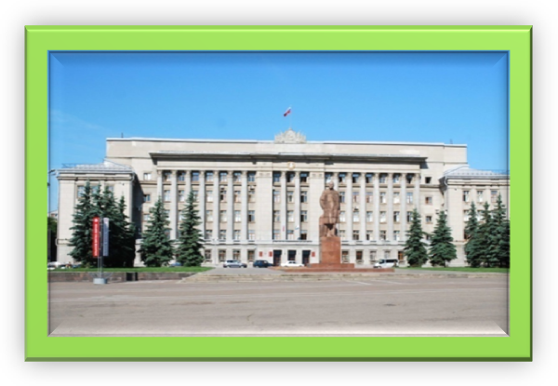
1. _Wyatka
2. _ Slobodskoy
3._ Teatralnaya Square
4. _Moskovskaya Street
5. _ Gagarin Park
6._Shaitan-Lake
7._”Kolizey”

Famous people
2. Fill in the prepositions
A. It is a monument ____Kirov
B. It is a monument____ V.M. and A.M. Vasnetsovs
C. It is a monument_____Lenin
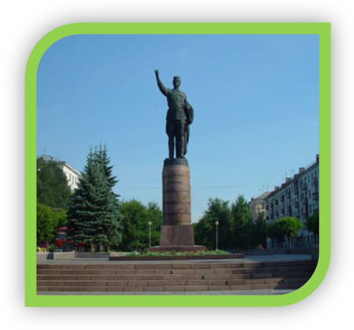  А | 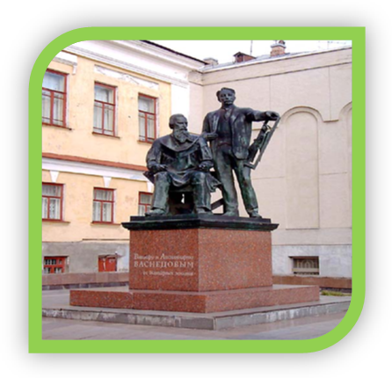  В
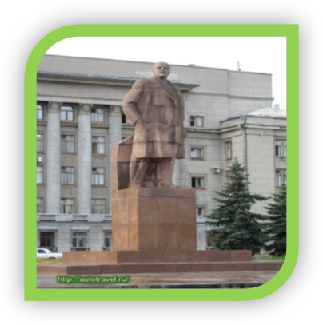
С

Writing tasks
Questionnaire
- Complete the following sentences.
I think our town is ______________
The most beautiful place is_________________________________
The town needs_____________________
I wish we had______________________
In future it will become_______________

It’s never too late to learn
2A. Choose the true sentences and then write a composition.
1. I study at an ordinary school .or I study at gymnasium.
2. My school is big and always clean. or My school is small and always dirty.
3. A lot of pupils come here every day.or Nobody comes here.
4. There are many teachers in my school .or There are few teachers in my school.
5. Nobody teaches us. or We learn to count, to read and write correctly.
6. They are kind and clever. or Unfortunately , they are not kind and clever.
7. The teachers do not teach us .or The teachers know a lot of interesting facts and teach us to be nice and polite.
8. I like some of my teachers . or l like all my teachers.
9. There are many classrooms , a computer room , a gym and a library. or There is no library in my school.
10. Our classrooms are not comfortable. or Our classrooms are comfortable.
11. We have many wonderful lessons. or We have only boring lessons.
12. I like my school very much and I am happy to be here .or I don’t want to study here.
2B. Complete the sentences.
In our timetable there are many lessons. They are…..
My favourite subjects are……..
I don’t like ……I think it’s difficult.
My favourite teacher is ……..
I want to be a …… That’s why I must study……

A story about Kirov and Omutninsk
3. Write a story about Kirov or Omutninsk. Use this word web to help you.

is has

Kirov

is situated is famous for

There’re…in

The weather in Kirov Region
4. Describe the weather in Kirov Region . These words can help you.
clear, chilly ,cloudy ,cool, foggy ,lightning , frosty , hot , ice , windy , rainy , snowy , thunder , warm , wet
It is frosty and snowy in January.
… in February.
… in March.
… etc.

A talk with a foreigner
5. Translate and complete the dialogue in English. Act it out.
Ann: Привет.
You:_______________
Ann: Я англичанка. А ты?
You: _________________
Ann: Где ты живёшь в России?
You:______________________
Ann: Это большой город?
You: _____________________
Ann: Какой твой адрес и телефон?
You:____________
Ann: Мой адрес :г. Лондон, Ул. Грин Парк, 18. Мой телефон 888-12-57.

About the museum
6. Role-play the situation.
Поздоровайся
Ответь на приветствие
Предложи сходить в музей

Скажи, что тебе нравится бывать в музеях. Спроси, что там за выставка.Ксссссссссссссс

Ответь, что ты не знаешь, но уверен, что будет интересно

Предложи встретиться в 3 часа
Скажи о встрече у музея. Попрощайся

Согласись. Уточни место встречи

Попрощайся

Сrossword
Towns of Kirov Region

1. Find all the towns of Kirov Region.

W | R | O | T | O | V | Y | A | T | S | K | I | E | P | O | L | Y | A | N | Y
K | K | R | D | M | U | D | K | D | C | O | D | A | B | W | Q | A | J | O | A
F | L | S | P | U | M | A | I | S | O | V | E | T | S | K | K | D | A | B | W
P | W | O | S | T | G | O | D | E | V | M | U | R | A | S | H | I | N | G | Y
M | E | H | Z | N | A | N | O | L | I | N | S | K | H | X | W | A | E | V | O
J | S | O | X | I | D | O | H | W | P | O | S | O | K | I | R | S | G | O | K
O | E | S | K | N | S | R | L | O | A | L | Y | T | G | L | L | U | Z | A | I
G | L | D | E | S | A | L | A | L | P | I | A | E | F | A | D | E | R | O | R
O | G | A | U | K | T | O | D | R | W | N | R | L | Z | L | S | V | A | T | O
D | H | K | P | A | K | V | E | K | M | S | A | N | L | S | O | K | O | O | V
A | H | D | L | Q | A | H | O | L | O | K | N | I | P | K | P | A | D | P | A
O | F | P | S | A | K | V | O | N | S | O | S | C | A | Z | K | R | R | O | R
M | I | R | S | A | N | C | H | U | R | S | K | H | O | L | U | N | T | E | S
U | R | K | A | B | E | L | A | Y | A | K | H | O | L | U | N | I | T | S | A
H | J | O | P | E | R | O | S | T | W | A | H | T | A | M | O | R | I | A | G
Z | K | I | R | O | V | O | C | H | E | P | E | T | S | K | T | A | K | V | Y
R | F | A | P | V | S | L | O | B | O | D | S | K | O | Y | Z | I | Y | H | E
U | T | I | W | E | Y | S | A | N | F | O | R | I | T | A | G | O | K | I | T

1. Kirov
2. Kirovо-Chepetsk
3 .Omutninsk
4. Slobodskoy
5. Malmyzh
6. Vyatskie Polyany
7. Kotelnich
8. Yaransk
9. Orlov
10. Urzhum
11. Nolinsk
12. Luza
13. Sosnovka
14. Kirs
15. Murashi
16. Sovetsk
17. Sanchursk
18. Belaya Kholunitsa
19. Zuevka
20. Lalsk

Famous people of Kirov Region
2. Mach the names of famous people with their occupations.

1.Chebysheva M.  2.Vasnetsov V.  3.Domnina O.  4.Savinykh V.  5.Krupin V.  6.Agalakova Zh.  7.Konev  8.Maltsev A. | A. a cosmonaut  B. a writer  C. an artist  D. a hockey-player  E. a poetess  F. a world-wide known figure skater  G. a popular TV presenter  H. a military leader

The symbols of our region
3. Choose only the Kirov Region’s symbols.

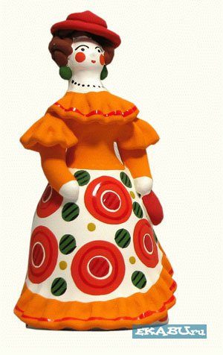 | 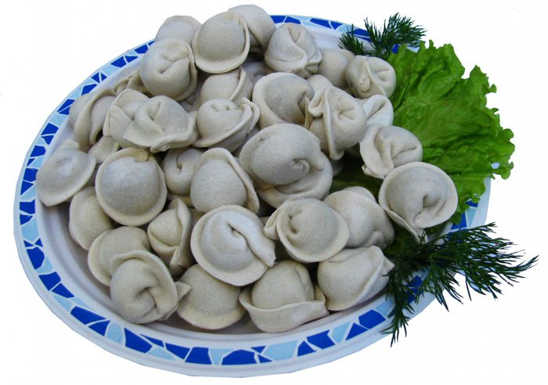
1. Dymkovo toys | 2. Pelmeni
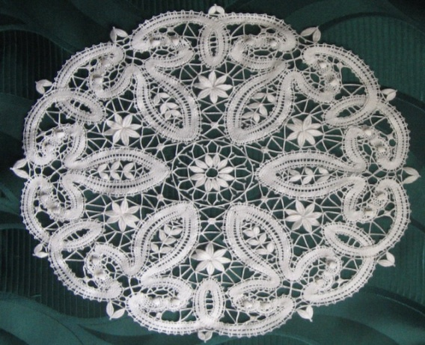 | 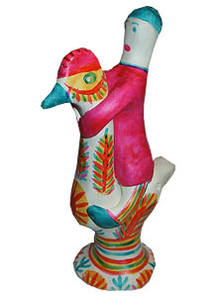
3. Kukarskie Kruzheva | 4. Philimonov toy
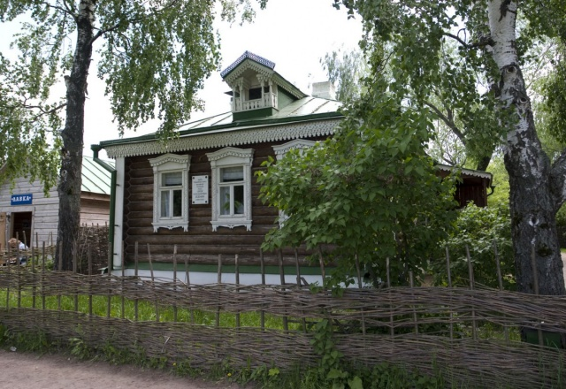
5. Konstantinovo

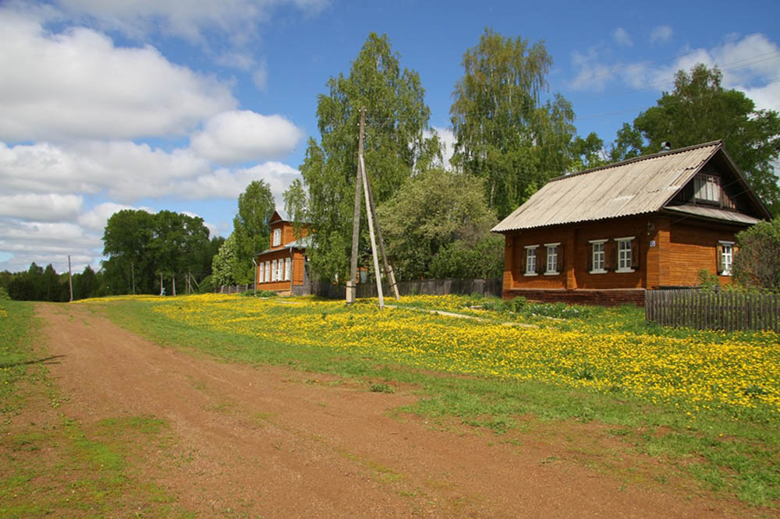
6. Ryabovo

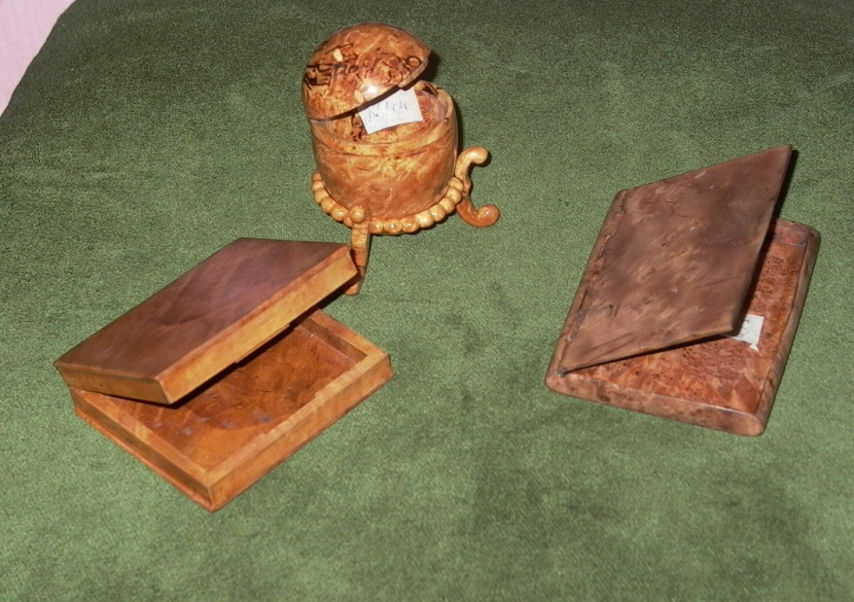 | 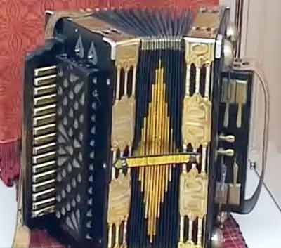
7. Kap | 8. Wyatskaya garmon

4. Odd one out.
1.Kirov, Omutninsk, Izhevsk
2.the Vyatka, the Volga ,Shaitan- Lake
3.Krupin, Gorky,Grin
4. Konstantinovo , Ryabovo, Ezhovo
5. Khokhloma toy, Dymkovo toy, Kap

Keys
Grammar exercises
Ex.1
1. the 7. the

Ex.2
1-B, 2-C, 3-F, 4-A , 5-B , 6-G , 7-H , 8-D

Ex.3
1, 3, 6, 7, 8

Ex.4
1. Izhevsk
2. the Volga
3. Gorky
4. Ezhovo
5. Khokhloma toy

Источники информации:

- Учебно-методический журнал «Английский язык в школе №2(38)2012 Н.В. Маслова «Учебное пособие по региональному культуроведению для учащихся 5-7-х классов общеобразовательных школ и гимназий- Do you know the place you live in?
- http://Kirov-v-mire.ru/novosti
- http:// images.yandex.ru

