Сайфуллина Евгения Сергеевна
Учитель иностранного языка
МАОУ СОШ №2 УИИЯ
Г. Ноябрьск, ЯНАО
Crossword
(the geography and political outlook of the UK)

Do this crossword and you’ll know the name of the British Queen
Down Across
- It has a real power in the country. 10. The cross to this Saint is on the flag
- The UK is washed by this ocean. of the UK.
- The strait of … is the nearest point to Europe. 11. The capital of England.
- England, Wales, Scotland and Northern 12. The English Channel links the UK
Ireland form this kind of state. with …
5. One of the biggest industrial cities. 13. The Commonwealth was formed by
6. She is the symbol of the country, of its history them in 1949.
and traditions. 14. The word “Great” concerns the …
- This sea separates 2 islands (Great Britain and of this country.
Ireland) from each other. 15. Everyone who was born in Britain is
- This House of the British Parliament can …
discuss and change laws.
- The British people elect the members of the
House of … every 5 years.

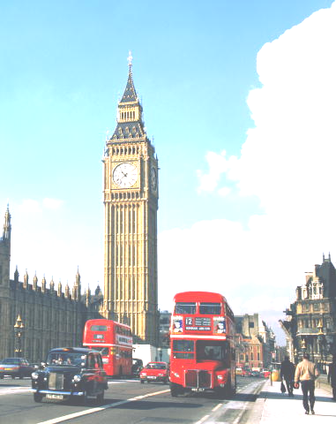
7
6

114
3
4
5
10
1
13
8
9
15
11
2
12

Литература
1. Верещагина И.Н., Афанасьева О.В. Английский язык. 5 класс: учеб. для общеобразоват. учреждений и школ с углубл. изуч. англ. яз.- М.: Просвещение, 2011.

