ГБОУ СОШ 1011г. МОСКВЫ

Методическая разработка внеклассного мероприятия
По английскому языку
«ST. Valentines Day»
Для учащихся 5-11 классов

подготовила
учитель английского языка
Фоминых Светлана Ивановна

г. Москва
2014

Пояснительная записка.
Я предлагаю вашему вниманию два варианта проведения внеклассного мероприятия по английскому языку, посвященного Дню Святого Валентина. Первый – это веселые соревнования для команд 5-6 классов, так как школьники этого возраста любят работать в группах и соперничать друг с другом. И второй для учеников 7-9 классов - это и праздник, и небольшой концерт, и конкурсы. А ученикам 10-11 классов можно предложить конкурс на лучшую валентинку в электронном варианте. Они делают потрясающие презентации.
Цели и задачи проведения данных мероприятий:
1.Формировать коммуникативные компетенции обучающихся.
2.Развивать информационные и социокультурные компетенции
3.Формировать творческие способности школьников.
4.Повысить интерес к изучению английского языка.

Час веселых соревнований.
День Святого Валентина.
5-6 классы.
Ведущий 1. Valentine’s Day is one of the most favorite holidays in the UK and the USA. They celebrate this holiday on February 14. It is a day of love and friendship. People send greeting cards to their sweethearts and friends and ask them to “Be MY Valentine”. This means “be my friend or love”. People also decorate their homes with big red hearts and give red roses and chocolate to their sweethearts, friends and family.
Ведущий 2. This holiday is popular in our country too. And now we have merry St. Valentine’s party and competition between two teams. Happy Valentine’s Day!
Участники команд рассказывают стихотворения.
- I dream about you  Every night  Be my Valentine  And hold me tight. | Someone to love  Somebody new,  Someone to love,  Someone like you.
2.Roses are red,  Violets are blue,  Honey’s sweet  And so are you. | I hope that St. Valentine’s Day  Will bring you lots of fun!  He thinks you’re nice,  And so does everyone.

- Задания командам. Кто быстрее справиться с заданиями:
1. How many hearts are there in this picture?


2. Find the 10 differences between these two pictures

3. Find the two cupids that are exactly alike. 4. Crossword.
. | 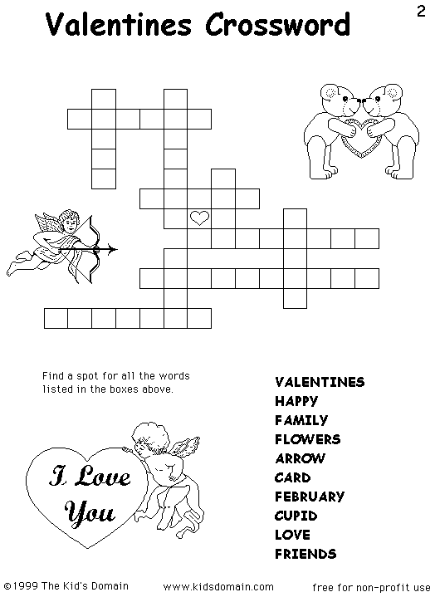
5. 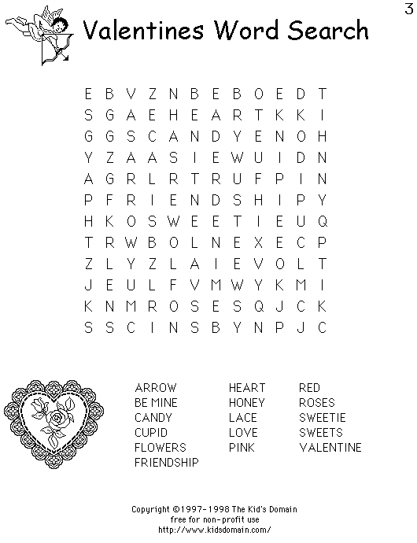 | 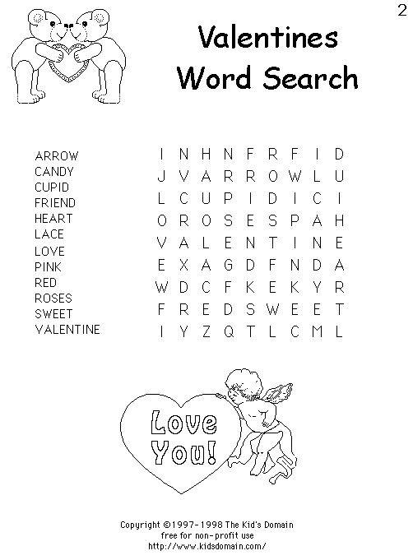

6. And now some more tasks:
- В коробке картинки, вырезанные из цветного картона. Надо с закрытыми глазами достать картинку и сказать что это. Картинки: роза, сердечко, ленточка, голубь, купидон. Кто догадается, почему именно эти картинки? Символы дня святого Валентина.
- Let’s say compliments to each other. You must say good and kind words and go to each other.
- Valentine’s Day is a day of love and friendship. And now let’s play the game “Do you know your friend well?”
Один человек выходит из класса и командам по очереди задаются вопросы об этом человеке, например по 5 вопросов:
1. What is his mother’s name?  2. Does he like tea or coffee?  3. He is a good football player, isn’t he?  4. What does he like to do after school?  5. Where did he go last summer? | 1. Does he have a pet?  2. What is his favorite food?  3. What is his father’s name?  4. What is his favorite holiday?  5. Does he like playing computer games?

Те же вопросы задают тому, кто выходил. Та команда, которая ответила правильно на все вопросы, выигрывает
7. Команды рисуют друг другу валентинки и подписывают на английском языке.

Праздник День Святого Валентина . 7-9 классы.
Ведущий 1 Love! Happiness! Beauty! There are not so many days in a year, when we pronounce these pleasant words. Today you have an excellent chance to plunge into atmosphere of love and friendship, to take part in party games, to practice the use of some pleasant words and expressions on this special occasion. Happy Valentine’s Day.
Here’s a special valentine
With lots of love for you
And since you’re very special
Here are hugs and kisses too.

Ведущий 2 Ladies and gentlemen! Good evening! It’s lovely to meet you here at St’Valentine’s party.
Just a little note to say
Have a happy, happy Valentine’s Day.
Ведущий 1 Valentine! You’ve turned my world upside down!
Love, love me do,
You know I love you,
I’ll always be true,
So please, love me do.

Ведущий 3 One of the most favorite holidays is Valentine’s Day. We celebrate this holiday on February 14. It isn’t national holiday, but it’s a happy festival, especially for children and young people. It is time to say words of love to your sweethearts and friends and ask them to “Be my Valentine”.
Ведущий 1 This is the legend of how St.Valentine’s Day began. When the Roman Emperor Claudius the second needed soldiers, he made a law against marrying because he felt that marriage made men want to stay at home instead of fighting wars. But at that time there was a kind priest named Valentine. He couldn’t agree with the emperor’s decision and when he saw that young couples were truly in love, he married them secretly.
Ведущий 2 And now some tasks for you:
- What are the most popular presents on St.Valentine’s Day? Of course, roses! Different Rose colors have been assigned different meanings by the society.
Guess please.
(Red Roses - Love and passion
Yellow Roses - Friendship
White Roses - True love and purity of the mind
Pink Roses - Friendship or Sweetheart
Black Roses – Farewell)
- What does it mean? E-valentines:
WUBMY (Will you be my Valentine?”)
ILU (I love you)
LUWAM<3(Love you with all my heart)
Xoxox (Hugs and kisses).
BK (Big kiss)
- Give the Russian equivalents of the proverbs:
You can take the horse to the water, but you cannot make him drink (Насильно мил не будешь)
Like father like son (Яблоко от яблони…)
A friend in need is a friend indeed.
Tastes differ.
- Ведущий 3 And now a poem for you (Инсценировка стихотворения: мальчик и девочка)
“Where are you going, my pretty maid?”
“I’m going a-milking, sir,” she said.
“May I go with you, my pretty maid?”
“You’re kindly welcome, sir,” she said.
“What is your father, my pretty maid?”
“My father’s a farmer, sir,” she said.
“What is your fortune, my pretty maid?”
“My face is my fortune, sir,” she said.
“Then I can’t marry you, my pretty maid?”
“Nobody asked you, sir,” she said.
- Ведущий 1 Well, different people like different things. Let’s see what our friends like. (ученики 7 класса рассказывают стихотворения)
- I love learning English.
I can read, I can write,
I can speak English too.
I love learning English
And what about you?
- I like my cat
It’s warm and fat.
My cat is grey
It likes to play.
- I don’t like your peaches,
They are full of stones,
I like bananas, because they haven’t bones.
Don’t give me tomatoes,
Can’t stand ice-cream cones,
I like bananas, because they haven’t bones.
- Ведущий 2 Let’s play a game “Snowball”. Do you know pleasant and kind English words?
Dear
Dear and love
Dear, love and honey and so on.
- Ведущий 3 And now a beautiful song for you(вокальная группа поет песню)
1. Let me call you sweetheart.
I am in love with you.
Let me hear your whisper
That you love me too.
2. Keep the love light glowing
In your eyes so true.
Let me call you sweetheart.
I am in love with you.
- Ведущий 1 Finish the sentence, please. Who is more creative?
Love is…

- Ученики 9 класса инсценируют шуточное стихотворение:
“Soldier, soldier, won’t you marry me,
With your trumpet, fife and drum?”
“Oh no, sweet maid, I cannot marry you,
For I have no hat to put on”.
So up she went to her father’s chest,
And she got him a hat of the very, very best,
And the soldier put it on!

“Soldier, soldier, won’t you marry me,
With your trumpet, fife and drum?”
“Oh no, sweet maid, I cannot marry you,
For I have no coat to put on”.
So up she went to her father’s chest,
And she got him a coat of the very, very best,
And the soldier put it on!

“Soldier, soldier, won’t you marry me,
With your trumpet, fife and drum?”
“Oh no, sweet maid, I cannot marry you,
For I have no boots to put on”.
So up she went to her father’s chest,
And she got him a pair of the very, very best,
And the soldier put them on!

“Soldier, soldier, won’t you marry me,
With your trumpet, fife and drum?”
“Oh no, sweet maid, I cannot marry you,
For I have a wife of my own!”

- Ведущий 2
Thank you very much! You were clever, active creative and attentive. We wish you great love, now and forever, because
Love is wonderful
Thing though it’s sad.
Love makes you happy
And goes to your head.
Love keeps you warm
On a cold winter night.
Love makes you day-dream
Makes things seem alright.

Литература и информационные ресурсы:
- Е.В. Дзюина « Игровые уроки и внеклассные мероприятия на английском языке» Москва 2007
- Журнал”Speak Out”
- http://www.stvalentinesday.org/
- http://www.englishforkids.ru/
http://www.hotvalentinesday.com/

