Муниципальное бюджетное общеобразовательное учреждение
«Средняя общеобразовательная школа №77»

Конспект урока по английскому языку в 5 классе

«Интересные факты о погоде»
«Weather facts»

Подготовила:
учитель английского языка
Алексеева Нина Георгиевна

г. Ижевск
2014
Тема урока «Интересные факты о погоде»
Weather facts
Unit 9 Lesson 2
Тип урока: урок открытия нового знания
Цель: совершенствование лексических навыков говорения по теме.
Задачи:
образовательные:
- совершенствование коммуникативных умений учащихся в говорении, аудировании;
- развитие лексико-грамматических навыков говорения;
- расширение общего кругозора учащихся о климатическом разнообразии Земли;
развивающие:
- развитие психических функций связанных с речевой деятельностью (мышление, память, внимание, восприятие);
- развитие логического и творческого мышления;
- развитие языковых и творческих способностей;
воспитательные:
- формирование культурной компетентности: знакомство с климатическим разнообразием Земли;
- воспитание культуры общения.

Оснащение: компьютер, проектор, наглядный раздаточный материал, видеосюжет, аудиозапись, карта мира.

Ход урока
- Good morning children! Nice to see you!
How do you do? How do you do?
I hope you are well. I hope you are too.
- Look at the blackboard. You can see a poem. Let’s read it after me.
Whether the weather is fine,
Or whether the weather is not,
Whether the weather is cold,
Or whether the weather is hot,
We’ll weather the weather
Whatever the weather,
Whether we like it or not.
Do you know what is it about? You are right, it’s about the weather.
- So, what can be the weather? Let’s describe the pictures.
And now let’s make a rhythm. I’ll show you the symbols and you will name the word.
Sunny, dry and hot,
Windy, snowy and cold,
Cloudy, foggy and wet,
Rainy, stormy and dirt.
- What can you say about today’s weather? Is it typical of our region?

Australia?
Russia?
What weather is typical of Britain?
Scotland?

And what weather is typical of Cherrapunji? Do you know what is it?
So, today at the lesson we’ll talk about extreme geographical places and the weather in different regions.
- Now let’s read the new geographical names: Atacama desert, The South Pole, The North Pole, El Azizia desert and Cherrapungi.

Which place is hot and dry in summer?
Which place is cold in winter?
Which place is damp in autumn and humid in summer?
Which place is the coldest in the World?

- Now we come to the grammar exercise.
Make the superlative form of the words:
hot – hotter – the hottest
cold – colder – the coldest
dry – drier – the driest
wet – wetter – the wettest
Please describe the new geographical places using this words. The El Azizia is the hottest place on Earth. The South Pole is the coldest place in the World. The Atacama is the driest place on Earth. And which is the wettest place on Earth?
To answer this question let’s listen to the tape.
What did you learn from the text? What is it about? Is the life easy in that city? What’s the temperature in winter? And in summer? What season does it rain every day? How do people survive in that region in winter?

- Now, let’s make a mental card of this text.
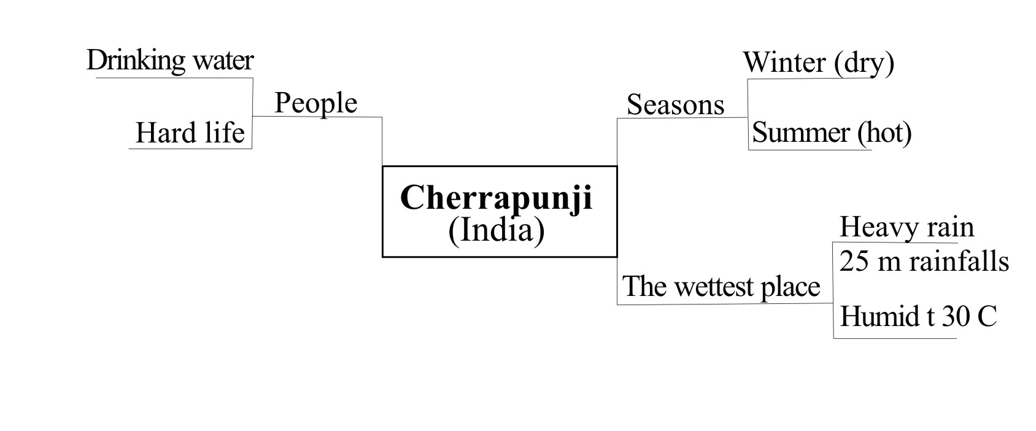
- Now, let’s watch the video film. Be very attentive. Try to understand more facts about Cherrapunji.
So, what did you learn from the film? Let’s complete our mental card.
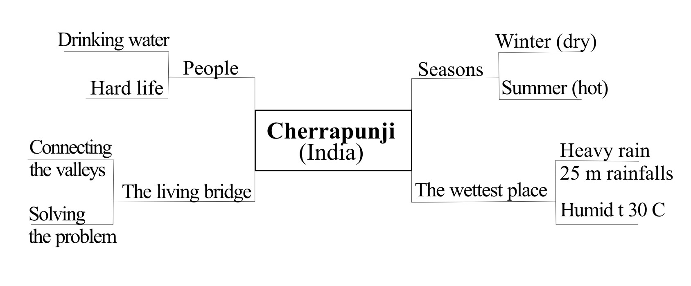
Imagine that you are the news reporter. Tell us everything about the life and extremely weather in Cherrapunji. You can use our map.
The people who live in this part of the World travel on foot every day for 7 km to get drinking water. Winter is the dry season when there is no rains for weeks. The temperature is about 20°C in summer from May to September it’s cloudy and wet. It rains almost every day. July is the hottest month. The temperature is above 30°C.
Would you like to go to Cherrapunji?
When would you like to go there?
Could you survive living there?
- Let’s play the guessing game. One of you will describe any geographical place and we should guess it.
P1: It’s windy and dry in summer. The temperature is 14..27°C. it’s cool, cloudy and dry in winter. The temperature is between 0..25°C. It’s the driest place on earth.
P2: Is it the Atacama desert?
P1: Yes, it is.
P3: It’s very cold and windy in winter. The temperature is between -30..-45°C. It’s cloudy and warm in summer. The temperature is between 0..25°C. It’s wet and cool in autumn.
P4: Is it the North Pole?
P3: Yes, it is.

- Well, but we live in Russia and we have different climate and landscape.
What is the hottest/coldest month where you live?
Is there wet/dry season in our region?
When does winter/summer begin?
- Let’s divide into three groups and make a project about different seasons and weather (winter, summer and autumn). Be ready to present your ideas using different pictures.
Thank you for your active work in groups. You were really creative.
Which presentation did you like best? Who was the best of the pupils? What marks will you put?
- Homework
Write about the climate and seasons where you live. You can use some pictures and make a project.
- So, what did you learn at the lesson? What is it Cherrapunji? What weather is typical of the North Pole? Where do penguins live?
- Thank you for the lesson. Your marks are…for… Our time is up.
Good bye!
Список использованной литературы:
- Аникеева Н. Н. Воспитание игрой. – М., 1987.
- Гальскова Н. Д., Никитенко З. П. О взаимодействии учителя и учащихся на уроке иностранного языка / Иностр. языки в школе. – 1991. N 1.
- Выготский Л. С. Воображение и творчество в детском возрасте. – М., 1991.
- Дьяченко В. К. Сотрудничество в обучении: О коллективном способе учебной работы. – М., 1991.
- Зимняя И. А. Психология обучения иностранным языкам в школе. – М., 1991.
- Коростелев В. С. Обучение иноязычному общению на начальном этапе, Иностр. языки в школе. - 1992 – N 1.

Использованные материалы и ресурсы интернет:

Видеосюжет « Cherrapunji Rain» http://www.youtube.com/watch?v=VUCPi55lpF0

Аудиозапись к учебнику Деревянко Н. Н. и др. New millennium English 5 класс, Unit 9 Lesson 2.

