МУНИЦИПАЛЬНОЕ ОБРАЗОВАНИЕ БУЛУНСКИЙ УЛУС (РАЙОН)
МУНИЦИПАЛЬНОЕ ОБЩЕОБРАЗОВАТЕЛЬНОЕ УЧРЕЖДЕНИЕ
«КЮСЮРСКАЯ СРЕДНЯЯ ОБЩЕОБРАЗОВАТЕЛЬНАЯ ШКОЛА»

«CHILDREN’S CULTURAL EDUCATION THROUGH DANCES»

Выполнила: Бочарова О.С.
учитель английского языка
II категории

2010 г.
I have chosen the item about children’s education in school. Teaching children to dance, to be in group, know how to reveal their own talents and, finally, be active in public deal; I probably bring up the children in some measure of morality and aesthetic. In dance, to teach signifies love, to respect and to value their culture, traditions of their nation and other people, as well as to respect their own friends on dance, help to each other. Aesthetic ally teaching is to understand dance’s beauty, feel it, to learn to take care of them, be neat and beautiful.
The submersion children in traditional folk ambience are one of the factors of the education. It not only introduces the child with surrounding world, but also inspires moral rules, rates of the behavior.
The public traditions sent from generation to generations create in itself various facilities and forms of the education.
There is a task before modern education of joining the most latest generations to historical memory of folk, and it means – the conservation its in our children. The knowledge of the heritage is necessary for each folk. Our past is - a foundation of stable, full-blooded life in reality and a guarantee of the development in the future. We address to public pedagogies not only that this is the well of wisdom, reserve of pedagogical thought and moral health, but also this is our headwaters and so, our task now:
- to help the child to recall his national and generic memory;
- to value his old root;
- to honour and respect the memory of his ancestors;
- systematic and goal-directed joining children to headwaters of public culture.
The Yakut Traditional dance art does not lose its importance in our days. It is necessary newly to comprehend, realize, brought through ages spiritual values, spiritual wealth of folk. There are deep sense and rich contents in folk dance art. We must perceive it as profound art, which carries in itself the highest sense - beauty and good.
Dance culture of Sakha folk is - an integral part of spiritual universal meaning - and it has deep ancient headwaters. The complex vicissitudes of the historical fate of Sakha with their transmigration during long period, by the contacts with other adjacent peoples, by the mutual understanding and interacted cultures have influenced upon the shaping of specific characteristics of different types of art and also dance.
One of the facilities of the issue to traditions is a dance. Public dances have absorbed in themselves national values of folk. The Main purpose of folk dances – is to graft love to beauty, interest to culture, traditions and customs of folk.
The traditions as if organize the relationship of the generations, spiritual-moral life of folk. This held on them receivership senior’s and younger’s receivership is founded concretely on traditions. Man is spiritually rich than essential traditions. Folk dances graphically show, as our ancestors valid and venerably pertained to their customs and traditions, what huge educational importance they had from different peoples.
In our Republic there are many dance groups. They propagandize the art of Yakut dance, and try to develop it. Young it is necessary to acquaint the children with deep, ancient creation of Yakut people since young years.
We have a young dance group "Bulunchaana" at our school. In spite of that we are only 6 year; we have a good deal of luggage of dance repertoire.
For instance, such dances are put deliver in our dance group:
The Dance "Dance of little deer" is intended for 2-3 classes. The Deer is the most famous beast of our pupils. Feelings, themselves as little deer in dance children try to imitate this deer. Many pupils may participate in this dance. It is Necessary the children themselves to obtain, synchronous and clear performing of motions in dance performing.
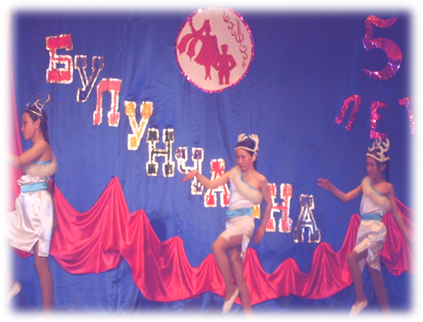
In senior group we have put delivered the dance "Algys". During the rite "Yhyakh yhyy", Yakut made the ritual in honour of aju the deities of the Upper world. They addressed to honoured deities, spirits «ichi» with requests to send them happiness, profusion and welfare. Algysies were made not only in spoken and written forms, in plastic dance elements were also included.
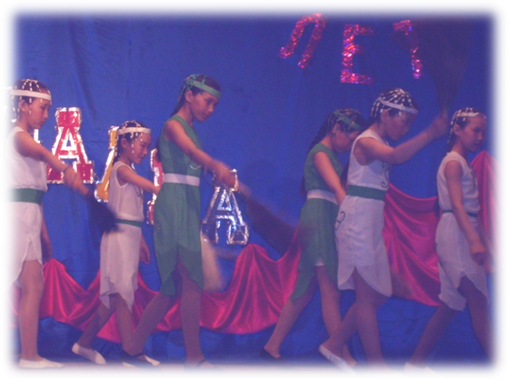
"Choroonnookh dance". Regales road of the guests by kumuss is the most solemn, excited moment of the traditional Yakut holiday «Yhyakh", conducted at the beginning of summer. Choroon is a wooden cup with whimsical ornament, from people drink kumuss from it. Choroon presented by girls is a symbol of hospitality and respect and regard.
The Dance "In sterkh’s valley". The Yakut from ancient times honoured and regarded to this bird. Sterkh was a holy bird for them, some tribes considered it as their totem. Sterkh is a symbol of the purity, beauty and nobility. The girls were compared with this bird.
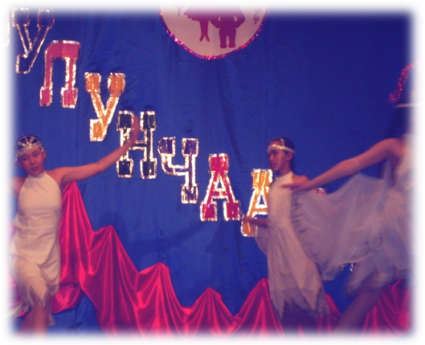
The Dance "Youth". In ancient times Yakut wandered with their live-stock to summer camps. The young people helped to look after live-stock, milked cows. The time conducted on summer camps the happiest one in spite of tough hard work, was considered. White nights, heat, wakened nature, green wood’s garb disposed to marry and dances.
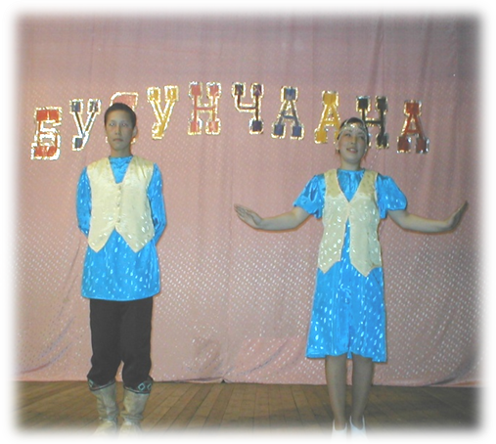

By means of Yakut dance we introduce to children with nature, animal’s world, folk, traditions and customs of Yakut people.
We in dance try to obtain harmonies, wholeness of folk bases and its scenic entailment in dance, certainly, it promotes creation of really folk dance, reflecting shower and nature of people.
Multiform various and some times strangely unexpected combinations of real life and plastic are figurative vision of people, established during the ages, were shown in whimsical, original forms of folk dance.
Motions of ritual dance were, on essences, the signs, carrying information from depths of the ages. The art lives on traditions. But today it is necessary the combination of traditions and researches. Each new generation contributes their vision and understanding in dance creation.
We come and leave. So the world is made. But there is something, which does not yield to destruction, and the time is never powerful. That which deserves the right to be continued in the future, that finds the second wind in creative activity of the followers, in which the longing to good, to humanities live.
We see this in whimsical choroon’s ornament, breathing of the epic folk legends - olonkho, pattern of hitching post, natty festive raiment a khomus excited resounding, pierced verse of the poet, folk melodic, eternal beauty of оsuokai and folk dance - in all that is created by man that is warmed by his heart that carries power and wisdom of the wit in himself, wealth of his fantasies. There are so much senses and contented in the spiritual wealth of people, which headwaters rise in deep antiquity.
And in conclusion want to say about the role of folklore in education growing generations – as the result of long and deep creative functioning working of the teacher. Such education forms interest in person to folk dances, traditions and customs of his native people, creative attitude to labour, and surrounding world. The efficient way of the education remains as well as way the of self-education and self-upbringing.
Revealing the role of the folklore, traditions in education of growing generations, we take as starting point public wisdom: "Tree can’t be without enormous root".
РЕЦЕНЗИЯ
на статью "Children’s cultural education through dances" учителя английского языка МОУ «Кюсюрской средней общеобразовательной школы» Бочаровой Оксаны Столетовны.
Статья Бочаровой О.С. посвящена организацию ученических танцевальных групп для общения культурного наследия, традиций, обычаев и фольклора своего народа через народные танцы.
Актуальность данной статьи без сомнения помогает подрастающему поколению понять и уважать глубокие исторические корни якутского фольклора, его связей с культурами других народов. Статья является очень важной и необходимой частью воспитания подрастающего поколения одной из важнейших и проблемных задач стоящих перед преподавателем.
Автором проведена серьезная работа по воспитанию эстетического и нравственного воспитания учащихся. Немаловажным является и то, что О. С. Бочарова пишет о необходимости включения культурного воспитания через народные танцы, так как сегодня теряются значение и связь культурного наследия и языка якутского народа, его традиций и обычаев. Преподаватель танцевального кружка является источником общения учащихся с корнями своего народа.
Статья Бочаровой О.С. " Children’s cultural education through dances " соответствует всем требованиям, предъявляемым к работам такого рода. Данная статья может быть рекомендована к публикации.
Надеемся, что представленная статья окажется полезной и вызовет интересные отклики со стороны преподавателей иностранных языков.

Преподаватель английского языка
высшей категории МОУ «КСОШ»
Старостина Галина Егоровна.

