План урока английского языка
в 10 классе по теме
“HOW DIFFERENT THE WORLD IS!”
(защита проектов)

Составила
Гумерова Гульнур Шангараевна,
учитель английского языка ОБУ СОШ № 5
г. Благовещенска Республики Башкортостан

Aims:
- Teach the students to present projects (advertisements);
- check the knowledge about the political systems in the UK, USA and Russian
Federation;
- teach to compare the known information and transfer it to a new situation;
- develop creative activity;
- maintain the feeling of patriotism and respect of other people's traditions.
Equipment:
Maps of the English-speaking countries, photos, poster “Welcome to Russia”
PLAN
I Greeting and introduction into the lesson.

Teacher: Good morning, students! I’m glad to see you at our unusual lesson. Sit down, please!
Today we are going to speak about English-speaking countries and about Russia.
And first let's look up in the Travel Agency "Round The World".
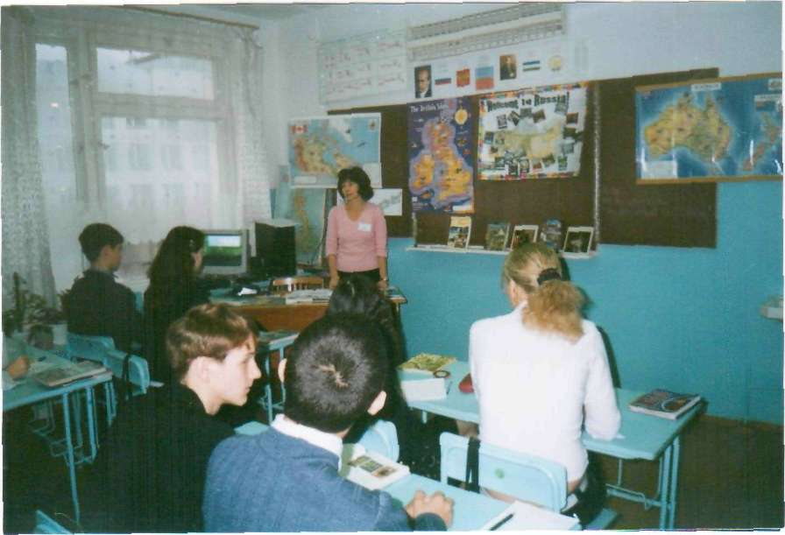
AT THE TRAVEL AGENCY
Main characters: the Chief of the agency, guides and students.
(In the office. The chief is looking through the pictures of New-York. Two young men are coming into the room)
Boys: Hello! My name is Aidar! And I am Insaf.
Chief: Hello! Glad to see you in our Travel Agency "Round the World!" What can I do for you?
Boys: We'd like to spend our holidays in some beautiful place, but we haven't decided
yet where. Can you help us?
Chief: Sure, it's our duty.
(the telephone is ringing).
- Sorry, wait a minute, please.
(speaking on the phone) - Hello. Travel agency. (a pause) Yes. I'm sorry, hold on, please.
- (to the clients): Sorry again. An urgent call. Do you mind my consultant's assistance?
Boys: Certainly. Never mind.
Chief: Miss Lucky, will you be so kind to help our clients, please?
Ms.Lucky: Good morning. Glad to meet you. My name is Liza Lucky. Do you need a hand?
Boys: We are looking forward to our holidays. They are rather long and we don't want to stay all the time at home
Ms.Lucky: Oh, I understand you. It's so boring to spend vacation in the same place every year.
Boys: We'd like to see something unusual and tremendous.
Ms.Lucky: You can have a look at our projects and the agents will describe you some places of interests in details. They are experienced guides.
Ms. Swazy: How do you do? I'm Miss Swazy. Nice to meet you. Are you active holiday makers?
(the clients are nodding)
- Have you ever been to Altay? Do you like climbing, swimming in mountain rivers, sleeping in fresh air under the dark star sky? (the clients are becoming interested).
-Then it's for you. Just look how wonderful the nature is there. It's seems the air is becoming cleaner and fresher even in this room.
(the girls are telling about Altay and showing pictures taken during their trip. The clients are looking them through)
At this time the chief's office is shown. Chief is going on her talk over telephone.
Chief: Is our project ready? When will you be able to show it? Today, in an hour? OK, I'll be waiting for you. See you. Bye.
(returning back to the first stage)
Ms. Swazy: We constantly organize hiking tours there every season. This place is charming in summer as well as in winter when you can enjoy skiing, toboganning and horse riding excursions.
One of the boys: I'm afraid, my friend is a great coach potato. He is lazy enough for such kind of traveling. Is there anything else?

Ms.Swazy: Sure. We have a great variety of trip programs in many countries, Great Britain, for example. I'll ask Alice to describe its main sightseeing.
Alice: (Alice presents her project about Great Britain.)

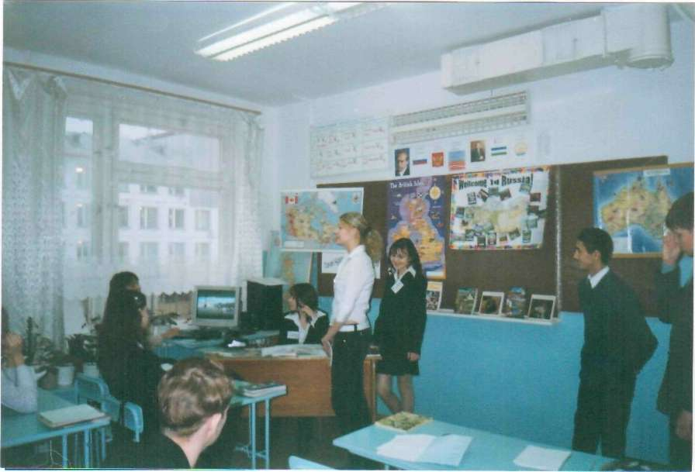
(The second stage. In the chief's office two girls comes with their adverts and leaflets)

Girls: Good morning! Glad to see you, Elin. You look wonderful today!
Chief: Thank you. You're always so attentive. And how about the ads? Will you show them?
Girls: Choose any you like. Here is a computer version and the ads for newspapers.
(they show the slides "Wellcome to Russia", the leaflets, photos)
Chief: Great! You've worked very well and I want you to continue it and prepare some projects about Sochi. You see, we're going to represent this city as the host of the Olympic Games 2014. That's why you should think how to promote Sochi well to outadvertise other candidates for this place. Is it clear? The project should be done in the shortest term. When can you show us your esquisses?
Girls: We'll think they will be ready in half a month.
Chief: All right then. Let's meet after Christmas holidays.
(they say "Good-bye " to each other. Elin goes to her partners and Alin runs into the office, very emotional and happy.)
Alina: Hi, my dears! Hello, everybody! Don't forget me? How I've missed you in St. Petersburg! If you were only with me! I've seen another world! Hello, boys! Searching for a trip? I advise you to go to the most beautiful and splendid city in the world! Sorry, Alice, but to my mind London is a bit boring and not so solemn as St. Petersburg. Just have a look at these photos and you'll, perhaps, understand me. (Slide show)
After visiting this city I've made my mind to move there. I can't live here any more. Girls, will you come to me in my new flat on the banks of the Neva-river? (everybody is smiling and laughing)
All togethers: Of course, we will.Are you moving just now? (again laughter).
Boys: You are so happy and impressed by the northern capital that we'll think about it. And are there any places we haven't seen yet not so far from here?
Ms. Luck: Why not? We've forgotten to offer you the places of interest in our region. I am a citizen of a very marvelous country and I am proud of it. It is very rich because here the industry and agriculture are highly developing. As for the people they are very industrious and hospitable.There are a lot of worth seeing, Shulgantash cave, for example, lakes Aslykul, Kandrykul, the rivers Inzer, Ufa, Belaya or Agidel as we call it here. As for the nature, in my opinion East or West - home is best. You won't be disappointed seeing the Ural Mountains or the cities of Ufa, Sterlitamak, though it's better to see once than to hear many times. My advise is to examine own country first. Besides it's cheaper and that fact suits students, doesn't it?
Boys: Thank you, girls. There are as many ideas as many people. Speaking honestly we've come here only to look and speak with pretty girls. Bye, girls.Hope to see again.
(both friends run out of the office)

II. Teacher: Thank you, girls and boys, for your short performance and beautiful projects.
CULTURAL AWARENESS
Teacher: While traveling people should know many things such as the weather, the time difference, the peculiarities of some traditions. I want you to compare some of the British and Russian habits and customs and say what is usual in our country and different from Great Britain (taken from Jimmie Hill, Michael Lewis. “Welcome to Britain. Language and informatin for the foreign visitor” г.Обнинск, издательство «Титул», 1997)

Customs | Usual in Creat Britain | Usual in your country
Take your shoes off as soon as you enter someone’s home | No
Shake hands the first time you meet someone | Yes
Shake hands when you meet a friend you last saw yesterday | No
Kiss when you meet a friend you last met six months ago | No
Kiss on one cheek | Yes
Kiss on both cheeks | No
Queue in a line if you are waiting for a bus or a ticket | Yes
Hold the door open for a woman if you are a man | Yes
Touch someone several times during a conversation | No
Take a present if you are invited to visit someone for dinner | No
Give flowers to a man | Yes
Take a present a bottle of wine for someone you don’t know well | Yes
Write to say thank you when you get home after you have stayed with someone | Yes
Arrive early for the party | No
Arrive at exact time you were invited | Yes
Arrive at a party one hour later the time you were invited | No

Teacher: And, now, can you tell me if a traveller should know the political system of the country s/he'd like to visit?
-Then let's see if you know well some details of ruling in the USA, UK and Russia. Please, answer the questions of the test. (3 minutes)
Test “Cultural awareness” (1 variant)
Choose the right version:
1 The US Government has ... branches of power.
a) three b) four c) five
2. The highest law in the USA which describes the powers of the national government and the powers of the state government is ... .
a) the Congress b) the Constitution c) the President
3. The Congess meets in ... Washington D.C.
a) the White House b) the Pentagon c) the US Capitol
4. The official head of the state in the UK is ... .
a) the Queen b) the Prime Minister c) Parliament
5. The Queen ... the bills.
a) signs b) votes on c) passes
6. The government of the UK represents the ... brunch of power.
a) legislative b) representative c) executive
7. ... guarantees the basic rights of the people in Russia.
a) The President b) The Duma c) The Federal Assembly.
8. ... elect the members of the Federal Assembly.
a) The Government b) The people c) the President
9. The chairman in Russia is ... .
a) elected b) invited c) appointed.
10. In Russia ... can declare laws unconstituitional.
a) the President b) the Supreme Court c) the Constituonal Court
Test “Cultural awareness” (II variant)
Choose the right version:
1. People who work in the US Senate are called senators and people who work in the House of Representatives are called...
a) housemen b) congressmen c) members of Parliament
2.There are ... senators than congessmen in the US Congress
a) more b) a lot more c) fewer
3. The US President’s term is ...
a) 2 years b) 4 years c) 6 years
4. The British Prime Minister is the leader of the party with the majority seats in ...
a) the House of Lords b) the House of Commons
5. ... makes laws in the UK
a) the House of Commons b) the House of Lords c) the Cabinet
6. The Cabinet of the British Government consists of ...
a) the members of Parliament b) about twenty ministers
7. The Russian President is elected by...
a) the people b) the Supreme Court c) the Duma
8. The Duma consists of ...deputies.
a) 540 b) 450 c) 400
9. In Russia ... can declare laws unconstituional.
a) the President b) the Supreme Court c) the Constituional Court.
10. The House of Commons ...the government
a) appoints b) controls c) chooses
KEYS:
1 variant: 1a, 2b, 3c, 4a, 5a, 6c, 7a, 8b, 9c,10c
2 variant:1b, 2c,3b, 4b, 5a, 6b, 7a, 8b, 9c, 10b
III. Studying of a new topic via the known one.
Teacher: Now let's think and determine what kind of the state our republic is.
- What institutions exercise the legislative/executive branches of power?
(While answering, the students fill in the scheme of the political system of Bashkortostan. One student is working at the blackboard, others – in their copybooks.). Use the words from the wordbox.
Wordbox: The Chamber of Representatives
State Assembly/ The Kurultai
The Cabinet of Ministers
The President
The Legislative Chamber

The scheme of the political structure of Bashkotostan

The head of the state
The President

The Cabinet of Ministers

The legislative brunch
State Assembly/ The Kurultai

The Chamber of Representatives

The Legislative chamber

Then someone can describe the political system in Bashkortostan.

IV. Homework:
Write the essay "The President We Choose".
Try to touch upon the following questions:

- Does the Russian President appoint the President of Bashkortostan?
- Who can take part in election?
- Can you be the President of the country? Why?
- What term is the President elected for?
- When will the next election of the President of Russia take place?
- Is it easy to be a president?
- What traits of character should he possess?
- What sciences should he know? What knowledge should he possess?

V. Conclusion: commenting the activity at the lesson and giving marks.

СПИСОК ИСПОЛЬЗОВАННОЙ ЛИТЕРАТУРЫ
1. Jimmie Hill, Michael Lewis. “Welcome to Britain. Language and information for the foreign visitor” г.Обнинск, издательство «Титул», 1997 с.60, 65.
2. Учебник издательство «Просвещение», г.Москва, 2005год под редакцией В.П. Кузовлева, И.П.Лапа, Э.Ш.Перегудова. Unit 3 стр. 70)
3. О.В.Наговицына. Поурочные разработки уроков английского языка к учебнику В.П. Кузовлева “English.10—11”. Издательство «Просвещение», Москва, 2004

