РАЗРАБОТКА
Праздника на английском языке по теме
«St. Valentine’s Day»

с использованием
ресурсов Интернет
и презентации.



Праздник Святого Валентина на английском языке для 9 классов
Ladies and gentlemen! Good evening!
It's lovely to meet you here, at Valentine's party!
Love! Happiness! Beauty! There are not so many days in a year, when we pronounce these pleasant words. Today you have an excellent chance to plunge into atmosphere of love and friendship, to take part in party games, and now we have merry St. Valentine’s party and competition between 4 teams представление команд
Our judge’s today-
Valentine's Day is a day of love
Where love is as bright as the sun
We share kisses, and even a hug
With people we call our loved ones

Keep love in your heart. A life without it is like a sunless garden when the flowers are dead. The consciousness of loving and being loved brings a warmth and richness to life that nothing else can bring.”
3 look at the statements of famous people about love
- Love is…Loving is not just looking at each other; it's looking in the same direction.
- Where there is love, there is life.
- True love stories never have endings.
Read small children’s answers and think of your own
- Love is when a girl puts on perfume and a boy puts on shaving cologne and they go out and smell each other.
- Love is when you kiss all the time. Then when you get tired of kissing, you talk and want to be together.
- Love is when you go out to eat and give somebody most of your French fries.
What does love mean? You’re right you get a point
The next task is to find and match words with similar meanings.
- A part of your body
- Chocolates
- Lace
- Arrow
- Bouquet
- Smile
- Rose
- Valentine
- Heart
- A heart-shaped card
- A kind of a flower
- A bunch of flowers
- A friendly look
- A kind of material
- Sweets
Used with a bow
Ok good thank you
Another game on Valentine’s Party is Scrambled words. Try to read them correctly! The letters in words connected with St. Valentine’s Day are mixed.
Make the words. Heart February chocolate holiday rose love
The idea of paper time valentines spread thought Europe. They began to take the place of Valentine’s gifts. Dear boys and girls! Your home task was to make a Valentine Card we invite the team 9th form to show your card for Valentine's Day

In our world there are a lot famous couples match the famous couples
Father Frost | Juliet
Mickey Mouse | Crocodile Gena
Ruslan | Snegurochka
Winnie-the-Pooh | Minnie
Tom | Jerry
Ivan | Gerda
Romeo | Lyudmila
Cheburashka | Princess Frog
Kay | Piglet

Mend these broken hearts to figure out the hidden message.
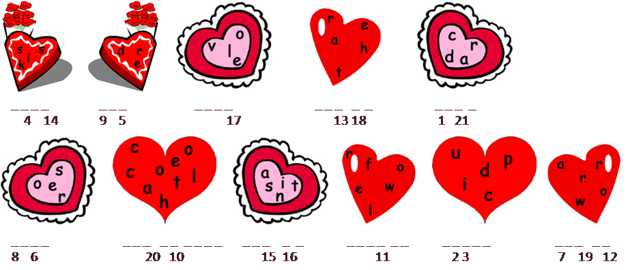

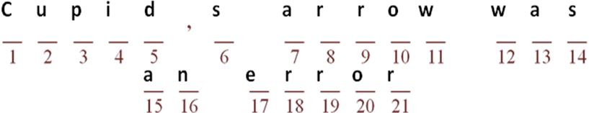

Key
- Kiss
- Red
- Love
- Card
- Rose
- Chocolate
- Saint
- Flower
- Cupid
- Arrow

The next contest - guess the melody Listen to the music and say who singing, name the author of the song is.
1Stevie_Wonder_I_Just_Called_To_Say_I_Love_You.
2Elvis_Presley_Only_You
3Bilan_Dima_-_Believe_Me
4celine_dion_-_my_heart_will_go_on
5Beatles_Yesterday
6Toni_Braxton_UnBreak_My_Heart.
7 Whitney Houston I Will Always Love You
8 muse_-_i_love_you_baby
9limp_bizkit_-_behind_blue_eyes
10Bilan_Dima_-_Never_Let_You_Go
11Listen To Your Heart
12natalia_oreiro_me_muero_de_amor
Look at this picture and tell me how many hearts you can see the right answer-50
The next contest is a riddle-contest. Try and guess what are they about?
1. It has no wings, but it can fly away. A balloon
2. What is it that everybody saw, but can never see again? Yesterday
3. Why are teeth like verbs? They can be regular, irregular and defective
4. In what month do people talk the least? In February
5. It never asks questions, but one has always to answer it. What is it? a telephone
6. What letter is a drink? Tea
7. What is the difference between here and there? The letter «T»
8. What is the end of everything? The letter «G»
Different games are very popular at Valentine parties. Now let’s play special games!Are you tired? Do you want to play with us?
The first game is to make a supermodel using a toilet paper. We need five pairs to play this game. The boys will try to be the models and the girls will roll the paper round their bodies. The Unusual supermodel will be the winner!
The second game crazy dances!! We need a boy and a girl. You must dance with each other so that would not drop the balloon.
The third game is to bump the balloons. We need a boy and a girl. They will try to bump the balloons with their backs.
Dear boys and girls! Your home task was to prepare some music show. Now let’s listen your songs about Love.
Well, our traditional Valentine party has come to the end. What a lovely holiday it was!
Thank you for all your compliments, smiles, presents & songs!
Thank you very much! You were clever, active creative and attentive. We wish you great love, now and forever, because
Love is wonderful
Thing though it’s sad.
Love makes you happy
And goes to your head.
Love keeps you warm
On a cold winter night.
Love makes you day-dream
Makes things seem alright.
Listen to the results, please. 9th grade team won
Все: Happy Valentine’s Day!See you!Bye!

Информационные ресурсы
- http://ru.wikipedia.org/wiki/День_Святого_Валентина
- http://www.mes-english.com/flashcards/holidays.php
- http://bogglesworldesl.com/valentines_day_worksheets.htm
- http://www.abcteach.com/directory/seasonalholidays/valentines_day/
- http://images.yandex.ru/
- http://chevaliersduweb.com/WEBMASTERS/GIFT/GIFT_ANIMES.html

