Municipal Comprehensive Boarding- School
of the Village Samburg

Research Project in English

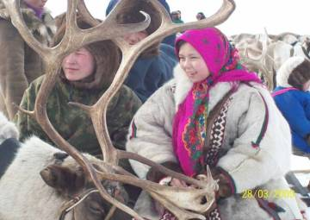

Salinder Necheyko,
Form 8b
Project supervisor:
Osipova G.G.,
English teacher

Samburg, 2010

Dear guests! Have you ever seen a national holiday of the northern people? Then I invite you to our great annual holiday- the Day of the reindeer breeders. It takes place in spring. There are a lot of fun, games and songs on this day. The festive walking starts in the morning. Well-dressed people gather at the club square. Families show their beautiful national clothes. The reindeers have smart harness, too.
You can see chums near the club. Every guest is invited into the chum. The hospitable hostess entertains to their guests with hot tee and offer them fish or meat.
On this holiday people sing national songs, tell poems and dance. Everywhere one can see many people from other settlements and towns. They celebrate the reindeer breeders, talk to the aborigines and visit their relatives.
If you go into the club you can see some exhibits. There are toys of the reindeer pelts, different things from beads and wood. You will be impressed by the handmade wares.

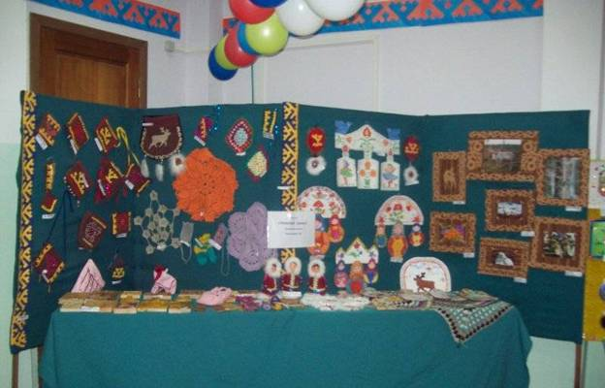
At the exhibition

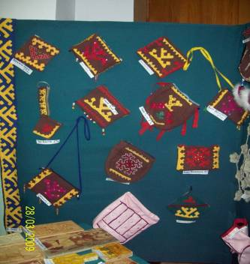
Knitted napkins

Nenets bags “Tuchan”

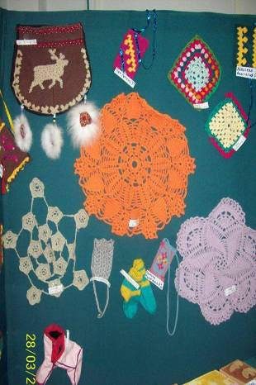

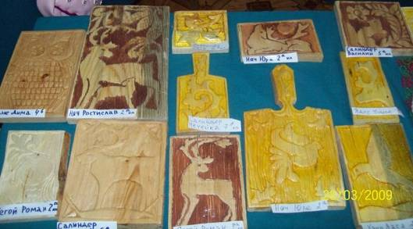

Wood threading
Beads wares
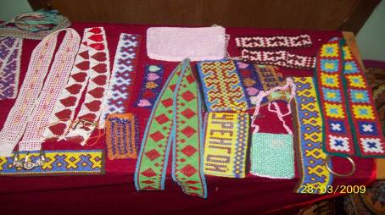

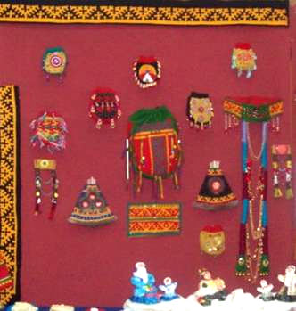
Exhibition on the reindeer breeders’ day

The most interesting competitions are the races on reindeer harnesses. This show is worth seeing. The important kind of competitions is throwing of an axe at a distance. The tundra men can demonstrate their smartness, force and skill.
Races on reindeer harnesses. Before the competition the participants greet each other. They all are in a good mood. Everybody hope to win. The people support all the participants. I can only say – these races are unforgettable!
Another kind of competition is jumping through the dog sledge. Multidiscipline event attracts many people too.
.
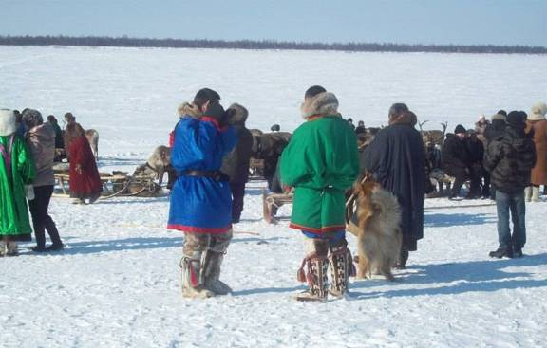

Our reindeer breeders
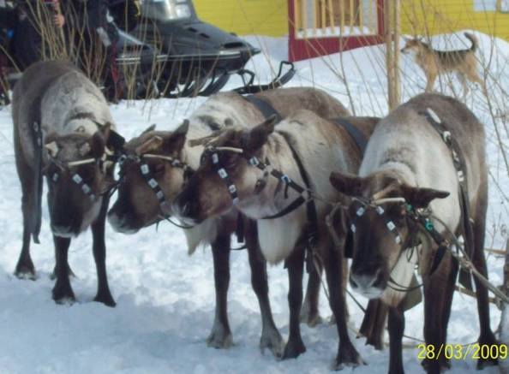 О The reindeer-participants
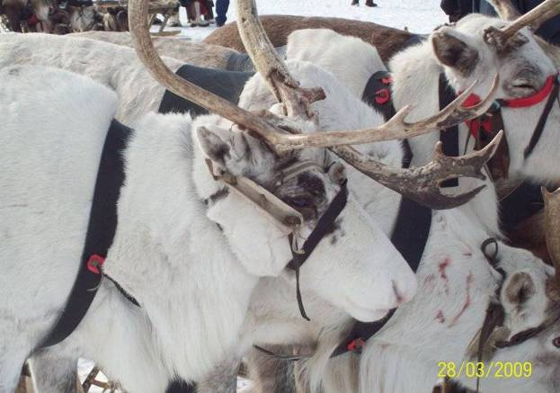
The white beauties
Reindeers
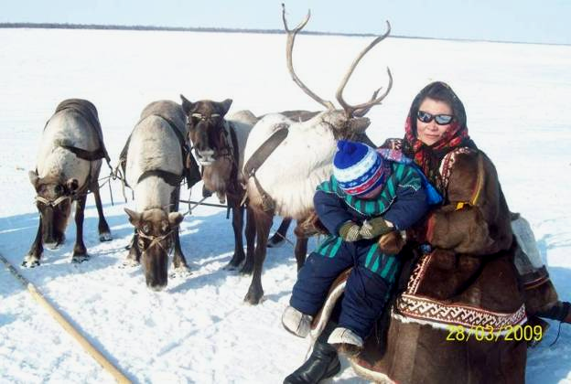
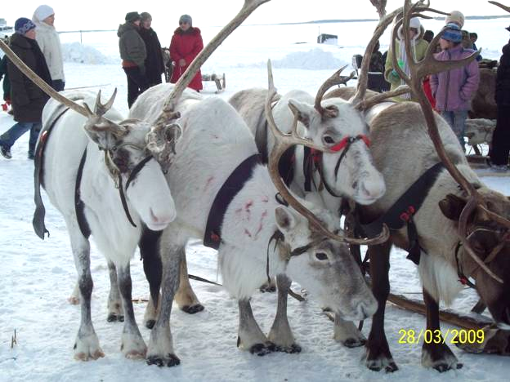

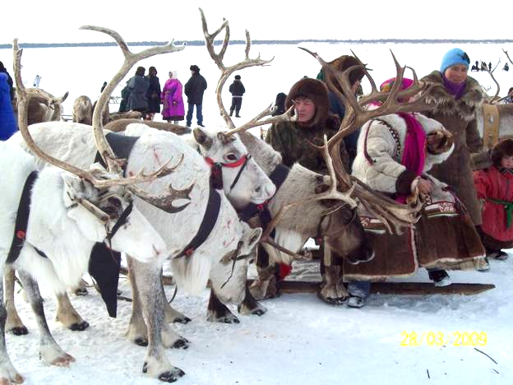

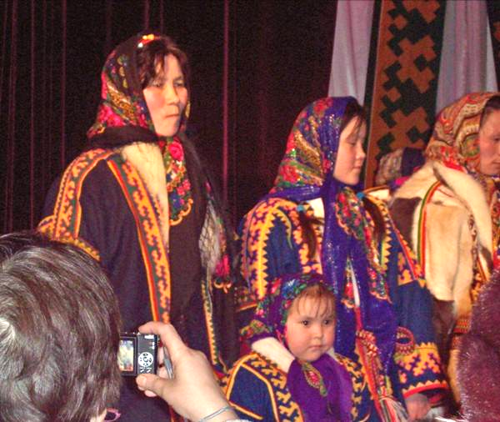
All the members of the family – mother, father and a child- take place at the contest. Every person shows his smart dress. The national clothes are decorated with breads, ornaments and other decorating. All the participants will be awarded.
National nenets wearing
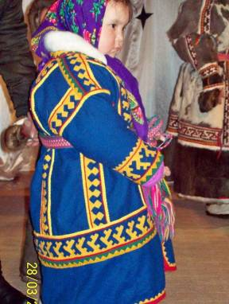

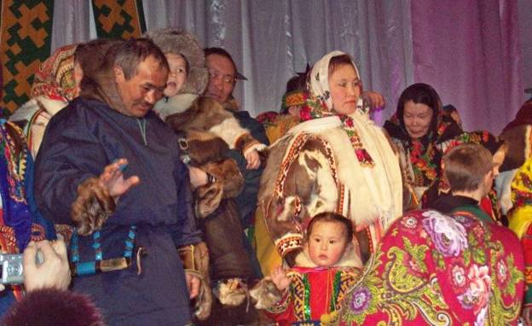
In the evening everybody goes to the concert. The reindeer breeders will get a lot of prices and presents.
The Day of the reindeer breeders comes to the end. Late in the evening we go out and enjoy the fireworks.

