Английский язык
Урок в 7 классе

Учитель: Кравченко Е. Г.
Тема урока: Food, glorious food.
Цели урока: - знакомить с новой лексикой по теме и отработать её в речи учащихся;
- тренировать учащихся в чтении текста с целью извлечения нужной информации;
- развивать умения аудирования текста по теме с извлечением выборочной информации;
- прививать понятия о здоровой и вредной еде, расширять кругозор учащихся.
Лексика урока : freshly - squeezed carrot juice; lettuce; fried chicken; lamb and mashed potatoes; melon; cucumber; watermelon; mushrooms; peaches; wholemeal bread; apple juice; fried egg, sausages, French toast; grilled chicken, Basmati rice, brussels sprouts, carrots; fruit salad; steak, jacket potato, broccoli; chocolate cake; nuts; spaghetti bolognese, garlic bread; doughnut; bacon and cheese sandwich; bread rolls; prawns; green beans; mussels; peas; olive oil; vinegar; club sandwich, chips;
Учебник: Enterprise 2, Express Publishing
Ход урока:
I Greeting. - What is your favourite food?
- What do the people usually eat in summer?
- What is your favourite drink?
- What can you cook?

I think you understand that our topic today is "Food."

1. Let's open your books at p.40 and look at the pictures. Let’s read the labels after me.
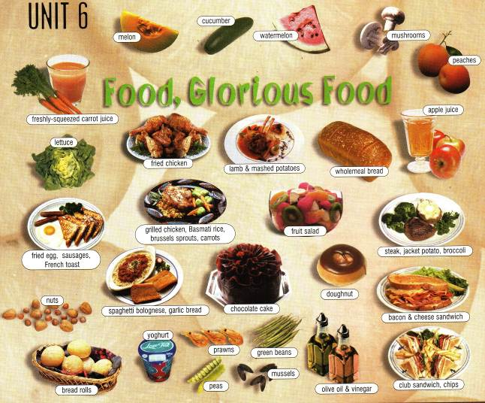

The title of the unit is the title of a song and the word glorious is a synonym of wonderful.
Healthy - здоровый
Low-fat foods - низкокалорийные продукты
Fatty foods - жирная еда
Junk food = fast food

2. on the blackboard:
Pictures Labels

The pupils should match the pictures with their labels (without books).

3. Write the headings on the blackboard:
Healthy Fatty food Junk food
Each item from the picture should go under one of these headings on the blackboard.
(Write down these headings in your exercise – books and finish this task at home.)
Suggested answers:
Healthy foods: freshly – squeezed carrot juice, melon, cucumber, watermelon, mushrooms, peaches, lettuce, mashed potatoes, wholemeal bread, apple juice, grilled chicken, Basmati rice, brussels sprouts, carrots, fruit salad, jacket potato, broccoli, bread rolls, yoghurt, peas, green beans, mussels, olive oil.

Fatty foods: fried chicken, lamb, sausages, fried egg, French toast, steak, spaghetti Bolognese, garlic bread, chocolate cake, doughnut, bacon and cheese sandwich, club sandwich, chips.

Junk food: fried chicken, bacon and cheese sandwich, club sandwich, chips.

II
1. Let’s look again at the blackboard and try to answer the question: What food and drink would be suitable for:
A vegetarian; somebody who is on a diet?
(Suggested answers)
A vegetarian: freshly – squeezed carrot juice, melon, cucumber, watermelon, mushrooms, peaches, lettuce, mashed potatoes, wholemeal bread, apple juice, French toast, Basmati rice, brussels sprouts, carrots, fruit salad, jacket potato, broccoli, nuts, garlic bread, chocolate cake, doughnut, bread rolls, yoghurt, peas, green beans, olive oil, vinegar, chips.

Smb. who is on a diet: freshly – squeezed carrot juice, cucumber, (melon, watermelon), mushrooms, (peaches, apple - juice), lettuce, wholemeal bread, grilled chicken, Basmati rice, brussels sprouts, carrots, jacket potato, broccoli, yoghurt, peas, green beans, mussels.

2. Pupils discuss and answer the questions in groups.
- What do you usually eat and drink:
At work/school ; on a picnic; at a fast – food restaurant; at expensive restaurant?
(Suggested answers)
At work/school: sandwiches, crisps, chocolate bars, fruit, milk, coke, coffee, tea …
On a picnic: sandwiches , fried chicken, boiled eggs, pies, fruit, salad, lemonade, coffee, etc.
At a fast-food restaurant: chips, hamburgers, salad, fried chicken, coke, milkshakes, etc.
At an expensive restaurant: steak, roast chicken, lamb and mashed potatoes, spaghetti bolognese, soup, salad, chocolate cake, wine, fruit salad, coffee, etc.
Do you often: eat junk food; have a snack between meals?
Do you worry about how healthy your diet is?
Are you a fussy eater?
Which foods: contain a lot of calories; contain protein; are rich in vitamins?
Contain a lot of calories: chocolate, crisps, nuts, chips, fried chicken, butter, cheese, etc.
Contain protein: bacon, steak, chicken, cheese, etc.
Rich in vitamins: apples, peaches, carrots, broccoli, etc.
III
Listening. It’s not a secret that we like to read different interesting things about famous people. We want to know where they live, what they wear, where they spend their holidays. And today we are going to listen and to read a magazine article about some film stars’ favourite foods.

Film stars are everyone's favourite subject. People love to talk about what they're wearing, who they're dating, and how much money they make. But have you ever wondered about what they eat?
Chefs and caterers on film sets have the answers. "Every actor has different eating habits," says chef John Sharp. "Some stars love meat, while others are strict vegetarians who don't eat meat, eggs, or fish. Some stars love junk food, while others are constantly on a diet and eat only healthy foods."
Ninety-nine per cent of the time, actresses are on a diet and insist on eating only low-fat foods. During the filming of Now and Then, Demi Moore ate nothing but Basmati rice, steamed baby spinach, green beans with lemon, and turkey sandwiches on wholemeal bread. During the filming of Twister, Helen Hunt only ate low-calorie foods, including poached eggs, dry toast, and steamed brown rice with vegetables.
Other stars love to eat junk food, and never count calories during their meals. Eddie Murphy's favourite food is Kentucky Fried Chicken. Whoopi Goldberg doesn't worry about how healthy her diet is, and loves fatty bacon sandwiches with lettuce, mayonnaise and lots of butter.
One thing for sure is that cooking for the stars is never easy, because they are often fussy eaters. "They want food fixed exactly the way they like it and always have something to complain about," says caterer Susan Tate. Bill Murray won't eat watermelon with seeds in it, and Mickey Rourke insists on freshly-squeezed carrot juice twice a day, but he won't drink it if it sits for more than six minutes.
Cooking for the stars is hard work, but few of these caterers ever think about changing jobs. "I love my work," says Susan Tate. "Where else can I see what Michelle Pfeiffer eats for breakfast or what Al Pacino has for a snack?"

Let’s read the names of the famous film stars, then listen and match the stars to the things they like to eat or drink.
1 Demi Moore a. bacon sandwiches
2 Helen Hunt b. fried chicken
3 Eddie Murphy c. watermelons (without seeds)
4 Whoopi Goldberg d. turkey sandwiches
5 Bill Murray e. carrot juice
6 Mickey Rourke f. poached eggs

IV Reading.
Read the article and five questions. We have four variants – you should choose the right one.

1. Vegetarians don’t eat …
A. junk food
B. vegetables
C. meat
D. healthy foods
2. Most actresses don't eat …
A. low - fat foods
B. sandwiches
C. fatty foods
D. steamed vegetarians
3. Who likes junk food?
A. Eddie Murphy
B. Demi Moore
C. Susan Tate
D. Bill Murray
4. Cooking for the stars is …
A. boring
B. difficult
C. easy
D. scary
5. Caterers on film sets should …
A. be fussy eaters
B. prepare only healthy food
C. change their jobs often
D. fix food the way each star likes it

V Now you have 2 - 3 minutes to skin the text and do the following tasks:
1. Fill in the words from the list then make sentences using the completed phrases:
Dry, foods, eating, junk, freshly - squeezed, calories, poached, steamed, strict.

1 ……. habits 6 ……. toast
2 ……. brown rice 7 to count …….
3 ……. food 8 ……. carrot
4 low - fat ……. 9 ……. Vegetarians
5 ……. eggs

2. Fill in the correct preposition, then make sentences using the completed phrases.
1 … film sets; 2 … a diet; 3 ninety - nine per cent … the time; 4 to insist...
sth; 5 to worry … sth; 6 to cook … sb; 7 to complain …sth; 8 to think …sth.

VI Home - task. Read the article again, and make notes about the stars and their eating habits under these headings:
dieters junk - food lovers fussy eaters

Then, use your notes to talk about what the stars like to eat. Start like this:
Some actors only eat low - fat foods. For example, Demi Moore enjoys Basmati rice…..

