The Tarnogsky District. A Tourist Guide for Foreigners”.
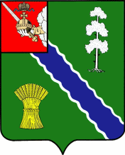
Tarnoga is many things. Tarnoga is history.
Tarnoga is festivals.
Tarnoga is hospitality.
You are welcome to Tarnoga!

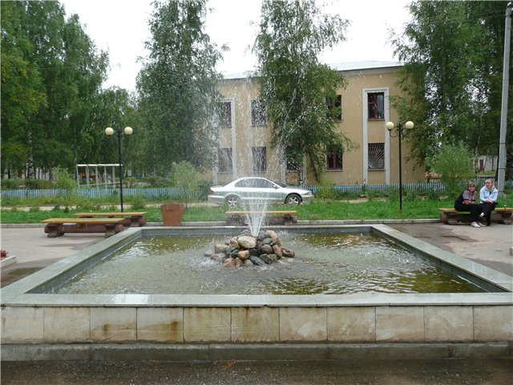
Attractions.

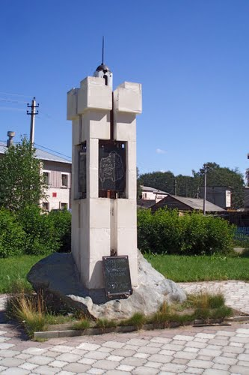

Central Square. Stele in honour of 550- th anniversary of Tarnoga.

Every year the tourists enjoy the holiday devoted to the honey feast .

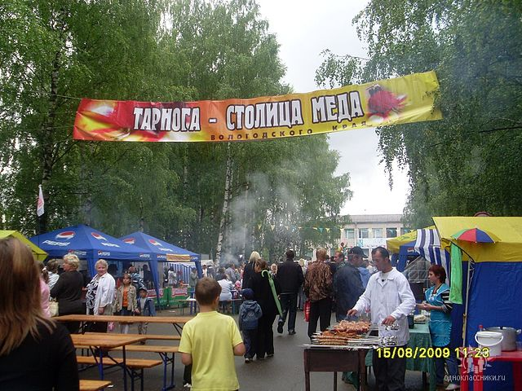

Tarnogsky Gorodishche.

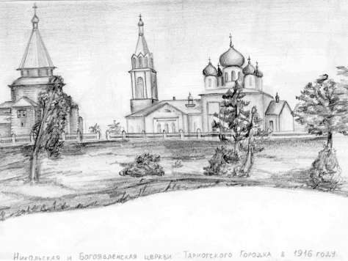

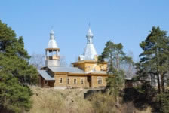

The construction was begun in 1453 to protect the residents from raiding tribes
Here you can see the remains of a fortress moat and the shaft.

The house of Merchant Shabanov.

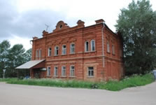

The Village of Krasnoye. The house was founded in 1905.
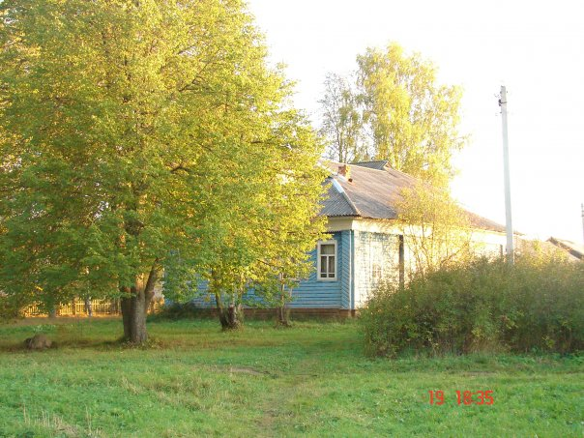

The Museum in the Village of Zarechye.

The Village of Pershinskaya.

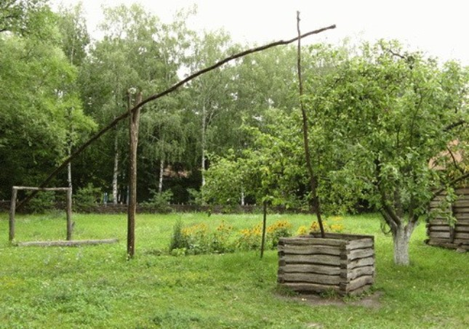

A monument of wooden architecture of 19 - 20 – th centures.
The village retained the old peasant houses and wells - “Cranes”.

The Ugryumov’s House.

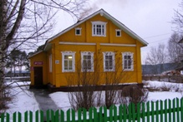
It is a small house in the centre of Tarnoga.
The honoured teacher and the honoured citizen of Tarnoga lived here.
The Museum of Traditional Folk Culture.

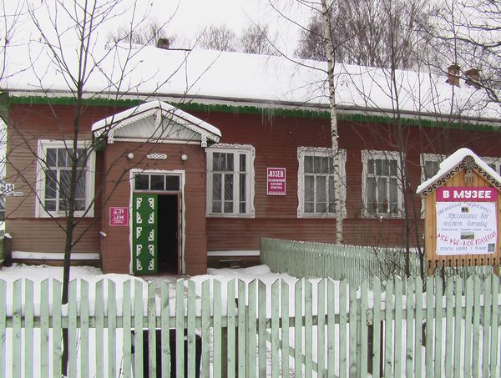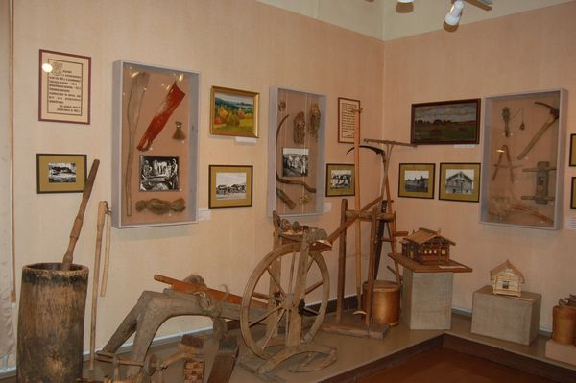

It includes different halls and departments.

- Hall of Traditional Folk Culture and Nature.

- Historical Memorial Department.
The museum has rich material and keeps memory of the last generation. In the exhibition hall you can see the works of the famous artist D. T. Tutundzhan.
The House of Children’s Creativity.

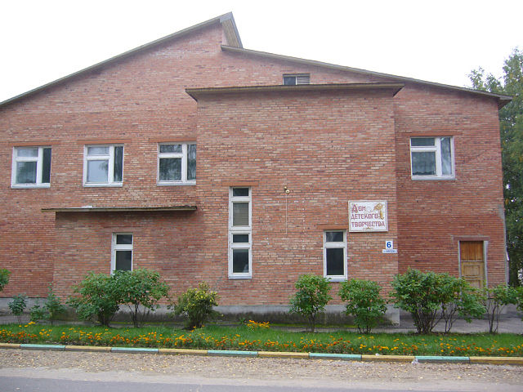



Enjoy making dolls, various souveniers. Attend different clubs here!
The Traditional Folk Culture Centre.

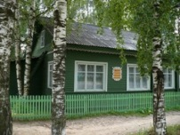

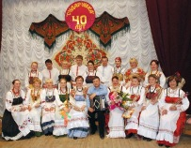

You are sure to enjoy old Russian posidelki ( gatherings) where the members of the local folk group “ Sudarushka” sing and dance , introduce to traditional Kokshengskaya embroidery

Saint and Cult Places.
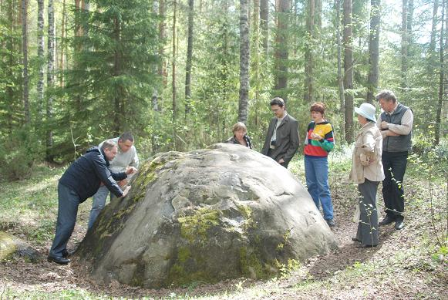
The Tiunovsky Sunctuary ( 14-th- 15-th centuries). Shebengsky settlement. Pay attention to this monument of archeology. Sanctuary represents two big stones. Next to the stones the traces of rituals have been founded.

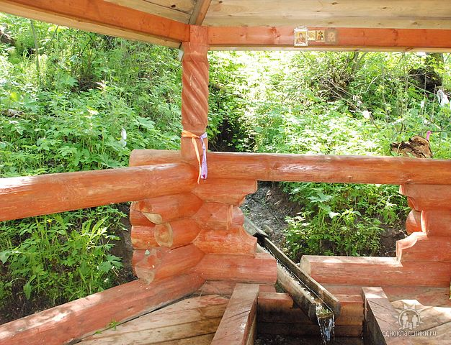 The Holy Markushevsky
Spring. It was founded by Monk An old villagers the source was considered as holy. Monks went to the spring to bring water. They washed their children in the water, learned about their illnesses.
The Orthodox Churches and Springs.
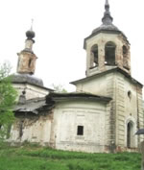 The Church of Proishhozhdeniya in Lokhta. It was founded in 1725. The temple is inactive.

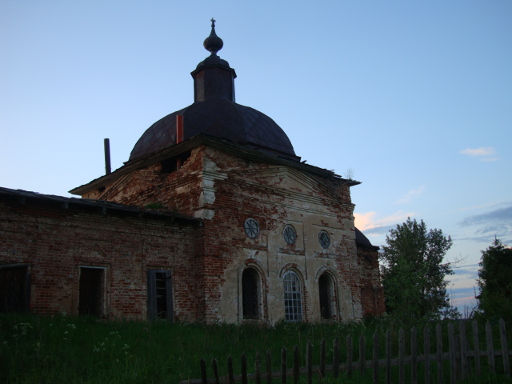 The Church of Eliya the Prophet. The Village of Potsky Churchyard. It was constructed in 1818. The temple is inactive, frescoes are saved.

St. Nicholas Church in Tarnoga.

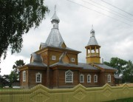

Church – going has become more frequent nowadays.
The first swallow among temples is a new building of the 21- st century- St. Nicholas Church in Tarnoga. It was constructed in June, 2009. The temple is active.

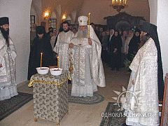
Hotels.

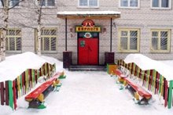 The Berloga Hotel

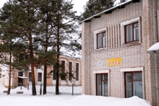 The Rus Hotel

You may stay and have a rest in these hotels.

Tarnogsky Gorodok today.

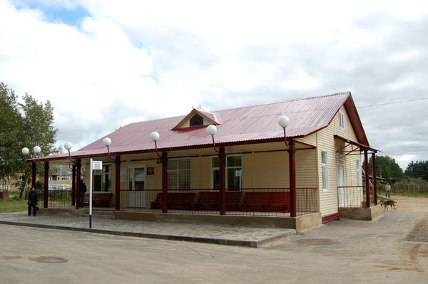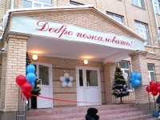

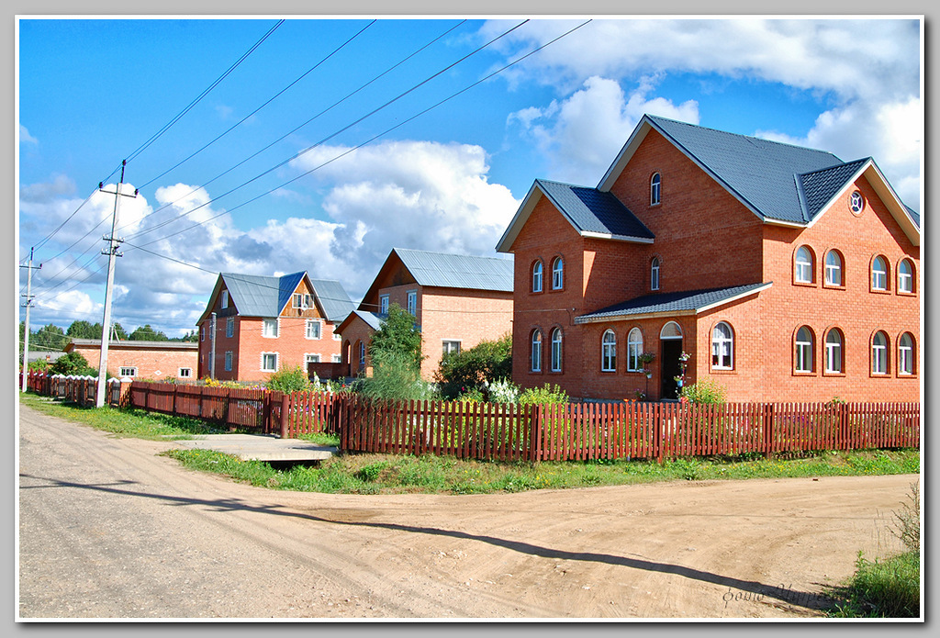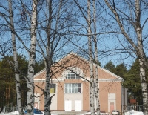

The New School Building, The New Modern Bus Station.
Private Houses. The Tarnogsky House of Culture

Tarnoga- Visit Us and Fall in Love with One of Little Places of Great Russia!

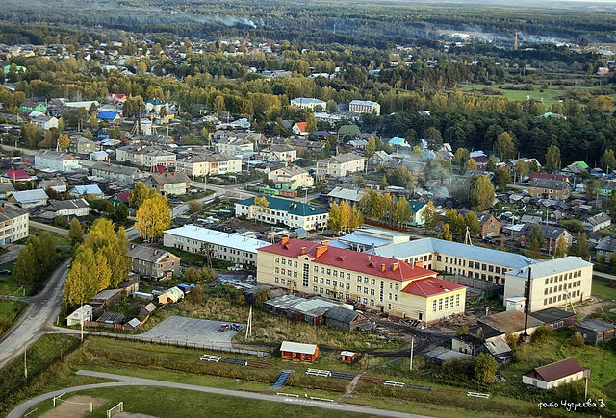
St. George’ s Church . The Village of Ileza.
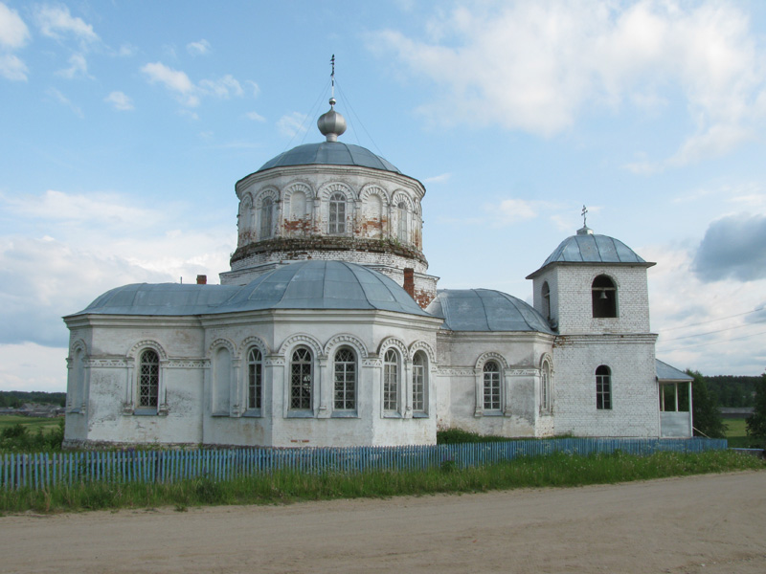
It was founded in 908. The temple is inactive.
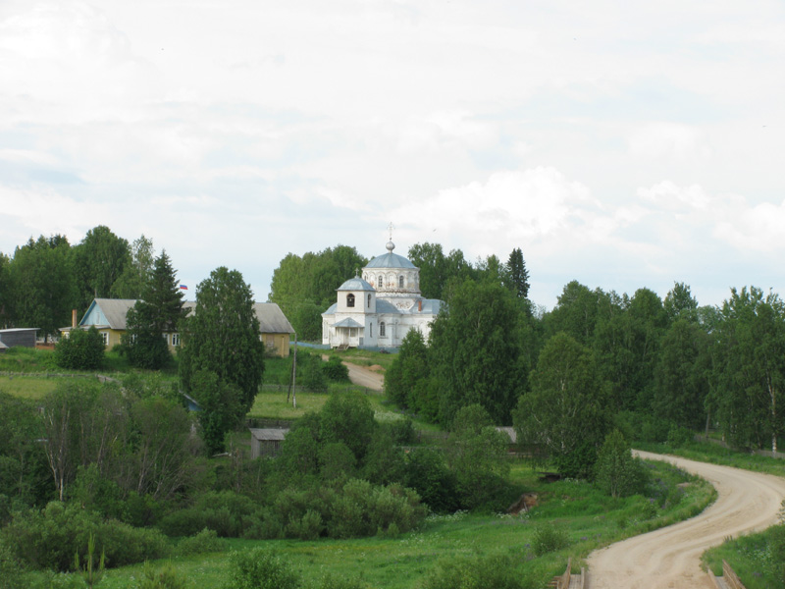

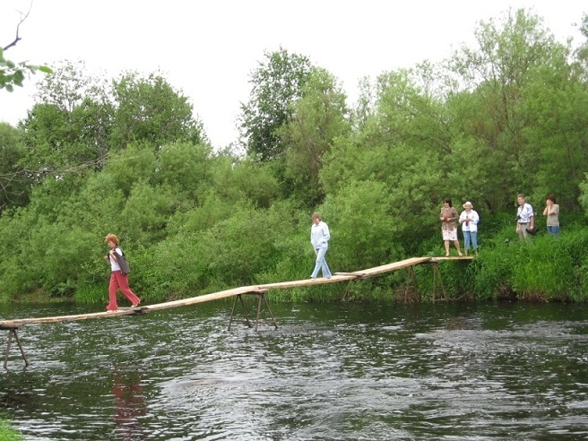
“ The Face of Perun”- Cult Stone on the River Uftyuga.

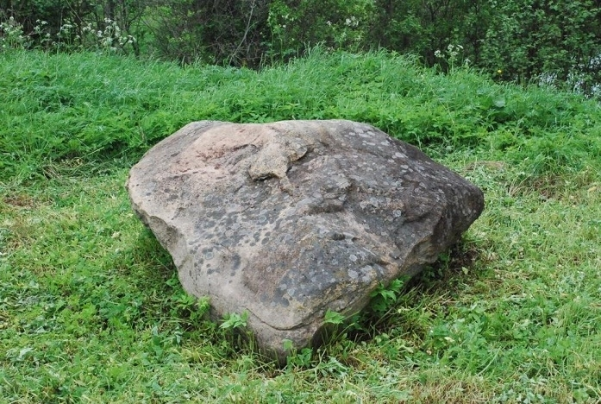
Eleven Arguments for Visiting Tarnogsky District.
Tarnogsky Gorodok is located 34 kilometres away from the highway Vologda-Veliky Ustyug.
Our area is famous for its specific crafts, culture and traditions.
- The level of pollution is very low.
It is rich in berries and mushrooms, herbs. In our district live the bear, wolf, fox, lynx, elk a lot of birds. There are large rivers and lakes.
- The Tarnoga District has five unique forest reserves.
- Tarnogsky Gorodok is a historical place.
Pagan “ sacred places and groves” have remained in this territory.
There is a unique pagan Tiunovsky Sanctuary with pictures, symbols and inscriptions. There is nothing like this place in the world.
Tarnogsky District has got many centres of culture, libraries, museums, sports objects, shops.
- Tarnoga is the “Capital of honey” of the Vologda Region. Beekeeping is developed. And last, but certainly not least,
- And last, but certainly not least Tarnoga is hospitality.

Nature

Tarnoga – The Perfect Place to Relax!
The Malakhovsky pine – forest is a magnificent place to have a rest. It is areal gift of nature. It is under the protection of the state.

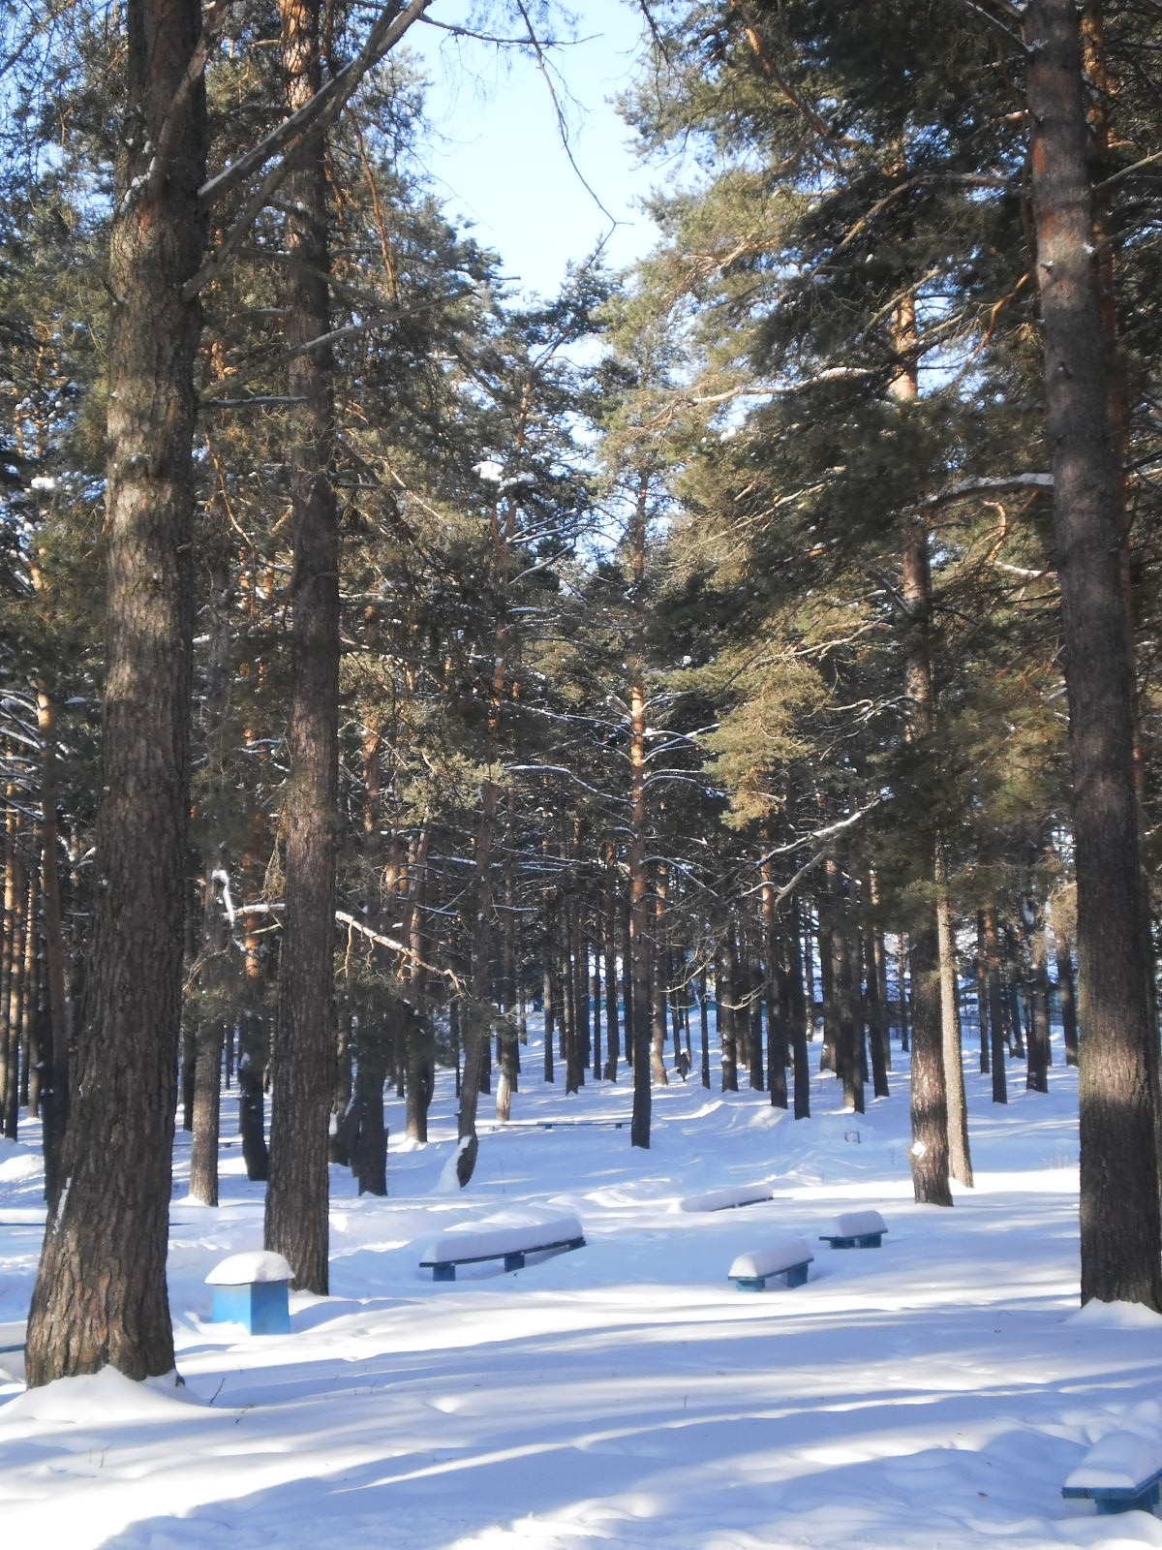

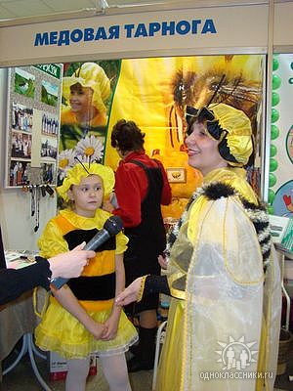

Tarnoga has become the ‘ Capital of Honey “ of the Vologda Region”.
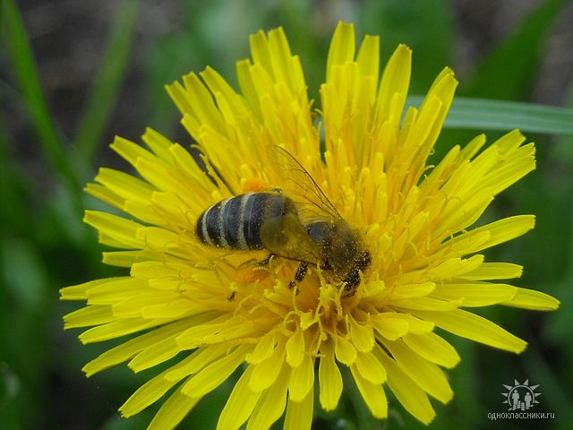
Surrounding meadows are the perfect base for beekeeping.

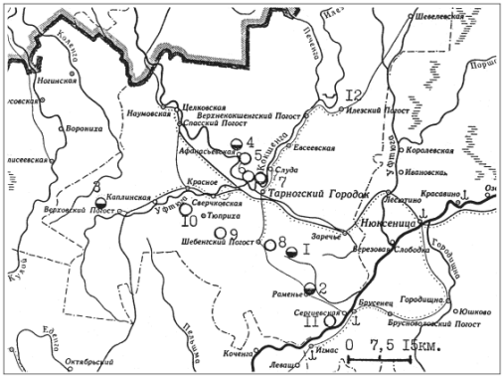

Cult Trees and Groves – Bushes in the Tarnogsky District.

