Английский язык
Урок в 5 классе

Учитель: Кравченко Е. Г.

Тема урока: Времена года. Моё любимое время года.
Цели урока: - практиковать учащихся в использовании изученной лексики по теме;
- формировать навыки работы в группах;
- тренировать в составлении монологических высказываний по теме
- проверить знание Present Progressive Tense;
- воспитывать любовь к природе;
Ход урока:
I Greeting. Day, date, season, weather.
- How are you today?
- What is your favourite season?
- What do you like to eat in autumn?
- What do you like to drink in summer?
- What do you like to wear in winter?
- What do you like to do in spring?

1. Today we are having the summarizing lesson on the topic "The weather.
The seasons." and I'd like to know what you have remembered.
Firstly, I'll read different statements about seasons and you'll match them to the right season.
- The weather is hot.
- The sky is blue.
- The weather is cold.
- The birds return from the hot countries.
- We can swim in the river.
- We celebrate the New Year.
- We don't go to school.
- The weather is warm.
- There are green trees in the parks.
- It usually snows.
- It sometimes rains.
- The birds fly away.
- The children go to school.
- The children go swimming.
- The birds sing merrily.
- The leaves are yellow and red.
- There are a lot of vegetables.
- We eat melons and watermelons.
- We like to eat ice - cream.
- We pick up mushrooms.
- It's quite windy.
- It's freezing cold.
- We wear jackets and warm trousers.
- We wear sundresses and sandals.
- We take umbrellas.

2. Now, look at the blackboard: there are some pictures and the sentences describing the weather. But there are some mistakes. Can you match them in the right way?
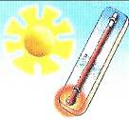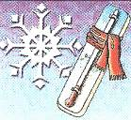
- It's raining. - It's sunny. - It's hot. - It's cold.

II The work in groups.
Each group has a number of sentences about different seasons. Your task is to discuss these sentences in groups and match them to the right seasons on the blackboard.
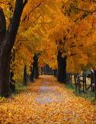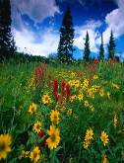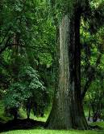

1. Match the cards with the sentences to the seasons.
2. The leaders of the groups choose their season (cards), then they correct the mistakes on the blackboard if there are some and put the sentences in the right order.
3. The pupils read the sentences about their season.

III The pupils get cards with the short texts about summer or winter. Their task is to put in the right words.
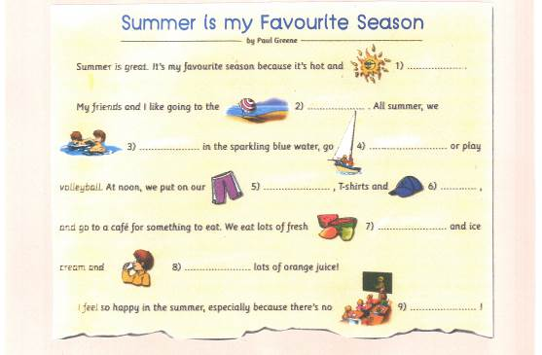
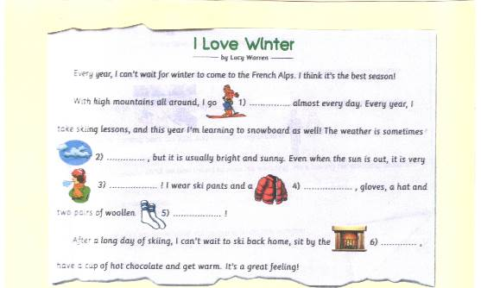
IV Then the pupils tell the stories about their favourite seasons using their
projects which they have prepared at home.
- Physical exercises.

V Now children, let's look at the blackboard once mote. Look at the pictures
describing the weather. What tense is used in the sentences
"It's raining." "It's snowing?"
You are right. It's the Present Progressive Tense. And now we'll do some
Training exercises to improve your knowledge of grammar.
(On the blackboard - the table "Present Tense")

 | am
+ | is |  | + V ing
 | are
 | am
- | is | + not | + V ing
 | are
 | am
? | is | + Subject | + V ing
 | are

1. The first task is to make sentences about yourself. I'll give you the pictures
with the actions to help you.
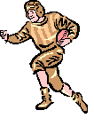
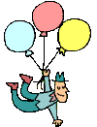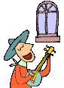
2. The next task is to ask your classmates what they are doing now.
- What are you doing, Dima?
- I am reading.
3. Now, we'll dramatize the short dialogues on the telephone.
The pupils have card with the examples and word - combinations. They
Answer the neibough's question using the prompts.
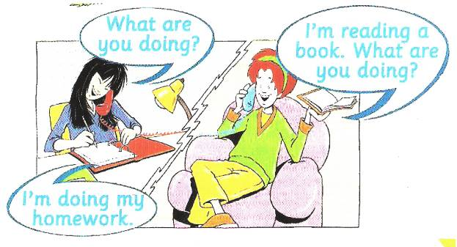
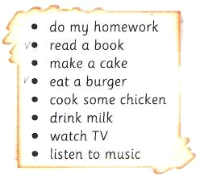

4. If the pupils have time, they write the sentences in their exercise - books
using the cards with the prompts.
Home - task: to finish the task at home.

