План-конспект урока по английскому языку по теме "My room"
Цель урока: систематизация знаний учащихся по теме “Моя комната”.
Задачи урока:
Учебные:
- обобщение лексического материала по теме;
- активизация употребления конструкций there is/ there are;
- развитие коммуникативной компетенции через проектную деятельность.
Развивающие:
- развитие произносительных навыков;
- развитие памяти и внимания;
- развитие творческих способностей детей.
Воспитательные:
- воспитывать умение работать в парах и группе;
- прививать любовь и интерес к иностранному языку.
Оснащение урока:
- тематические картинки;
- картинки с различиями;
- плакат, карандаши, фломастеры, клей.

Ход урока

1. Приветствие.
- Good morning, children! (Good morning!)
- Nice to see you again. (Nice to see you too.)
- What day is it today?
- What day was yesterday?
- What day will be tomorrow?

2. Вступительное слово учителя: сообщение темы и задач урока.

Look around. What can you see in the room? Today at the lesson we are going to revise everything we know about the house. We’ll also revise the grammatical rule with the construction ‘There is/ there are’, read the words, play and speak about our topic. Let’s start!

3. Отработка лексики. Bedroom, living room, bathroom, kitchen, hall..
- Boys and girls answer my questions. What is it? – It’s a …
- Let’s remember our poem
This is my house
It’s number two
There is a bedroom, a bathroom and a kitchen too.
In my house
There is a living room
And in the garden
All the flowers bloom.
(some pupils will tell the poem). While telling the poem, you should work with the picture of the house.
Thank you for your telling. I really liked it.

4. Закрепление грамматической конструкции there is/there are в устной речи (парная работа).
- Now boys and girls look at the picture and find at least 5 differences between two pictures. Write the sentences.

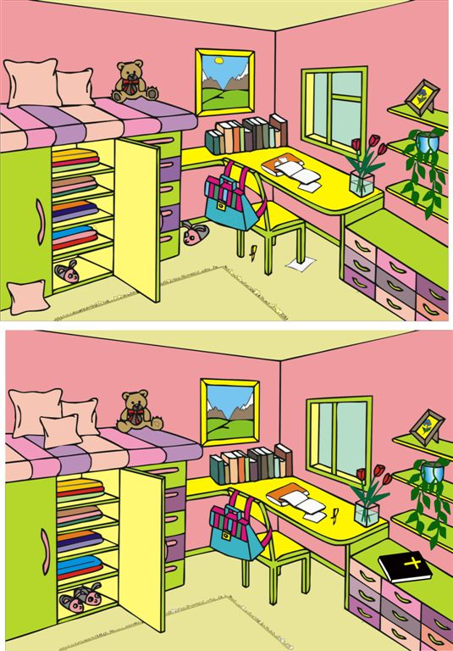

5. ФР.
Now I think it’s high time to have a break.
- Stand up.
Hands up.
Hands down.
Hands on hips.
Sit down.
Stand up.
Bent left, bent right.

6. Проектная работа.
Ok boys and girls. Now let’s start our projects. You are sitting in the groups. Each group has posters, an envelope with the furniture, coloured pencils, markers and glue. Your task is to create your dream room. You should use all the cards. And if you want, you can draw. Then you should describe your room. You have 15 minutes to do this task. Let’s start.
7. Защита проекта

8. Now the lesson is coming up to the end. Write down your home task.
To draw your dream house and describe it.

9. Marks for today. Lesson is over. Goodbye.

There is/There are
 | + | ? | -
Ед.ч. | There is …….  There is a book on the table. | Is there …..?  Is there a book on the table? | There is not=isn’t  There isn’t a book on the table.
Мн.ч. | There are ……..  There are books on the table. | Are there ……?  Are there books on the table? | There are not=aren’t  There aren’t books on the table.

