Викторина «London’s places of interest »

Составитель:
Прокопьева Марина Геннадьевна.
учитель английского языка
МОБУ СОШ №21 г.Якутска

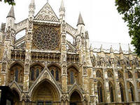 | 1. It is the oldest and most important church in England and the official church of the British Monarch. It was built in 1065.  _ _ _ _ _ _ _ _ _ _ _ A_ _ _ _
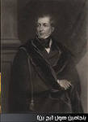 | 2. He was a member of English Parliament (1804-1880). He built tower, symbol of London.  B_ _ _ _ _ _ _ H_ _ _
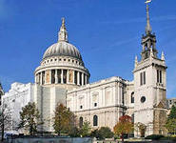 | 3. It is one of the symbols of London. It is 175m long and 111m high.  St. _ _ _ _’_ C_ _ _ _ _ _ _ _
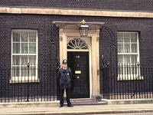 | 4. It is the most famous front door in the world. On the second floor there is a private apartment of the Prime minister.  10, D_ _ _ _ _ _ S_ _ _ _ _
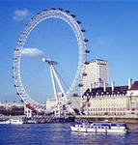 | 5. It is the biggest wheel in Britain. It was opened on the 1st of February in 2000.  _ _ _ _ _ _ E_ _
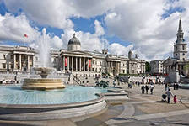 | 6. It is the largest square in central London.  _ _ _ f_ _ _ _ _ _ _ _ _ _ _
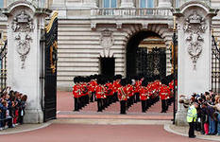 | 7. It is one of the most beautiful tradition in London. You can see it every day at 11.30 from April to August.  _ _ _ _g _ _ g _ _ _ _ _ G_ _ _ _
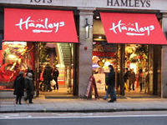 | 8. It is the biggest toy shop in London. There are 6 floors with millions of toys.  H_ _ _ _ _ _
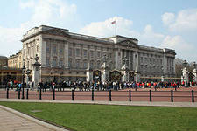 | 9. It is the most famous place in London. It is the home of the Queen.  _ _ _ _i _ _ _ _ _ _ _ _ _ _ _
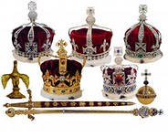 | 10. The biggest diamond in the world – the “Star of Africa” is situated there.  The _ _ _ _ _ J_ _ _ _ _
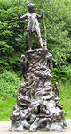 | 11. It is the last park in London that was opened to the public. The bronze statue of Peter Pen is situated there.  K_ _ _ _ _ _ _ _ _ G_ _ _ _ _
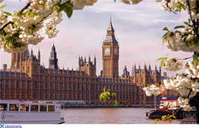 | 12. The first name of the capital of the UK.  L_ _ _ _ _ _ _ _
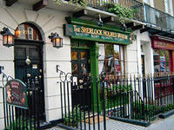 | 13. This address: 221, Baker Street, is well- known in the world.  _ _ _ _ _ _ _ _ _ _ _ m _ _ M_ _ _ _ m
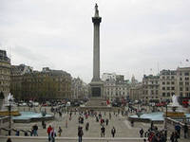 | 14. This column, 51m high, is situated on the Trafalgar Square.  N_ _ _ _ n _ _ _ _ _ n
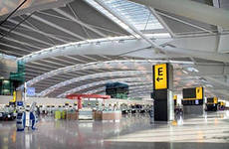 | 15. It is the biggest airport in the UK. It is situated 24km from London.  _ _ _ _ _ _ o _
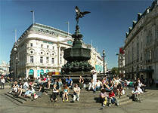 | 16. It is one of the main street in London. It is the meet point of the sweethearts.  P_ _ _ _ _ _ _ _ _
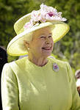 | 17. It is her majesty  Q_ _ _ _ _ _ _ _ _ _ _ _ _ II
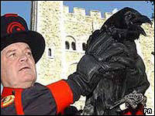 | 18. Harley, Thor, Odin, Gwyllum, Cedric, Hugine and Munin huard the Tower of London. The legend says: “Without them the Tower will fall”.  R_ _ _ _ _
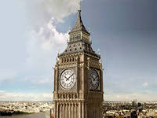 | 19. It is known by its nickname The proper name of the tower is …  St. S_ _ _ _ _ _’ _ _ _ _ _ _
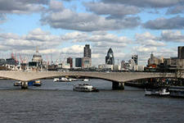 | 20. It is the deepest and most beautiful river in Britain.  T_ _ _ _ _
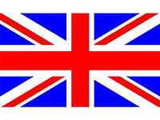 | 21. It is the state flag of the UK and Northern Ireland. It was established in 1801.  U_ _ _ _ J_ _ _
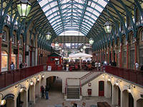 | 22. It is the biggest market-place in London for 300 years. It was officially established by King Charles II in 1670.  _ _v _ _ _ _ _ _ _ _ _
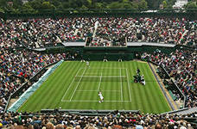 | 23. It is the suburb of London where the famous tennis-court is situated.  W_ _ _ _ _ _ _ _
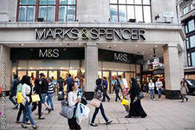 | 24. One of the most popular and reasonable prices department store Marks & Spensers is situated 448,  _x _ _ _ _ street in London
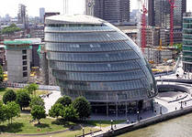 | 25. It is the financial and business centre of London.  _ _ _y
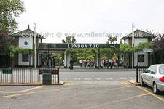 | 26. It is one of the sightseeing in London. It was founded on the 27th of April in 1828.  _ _ _ _ _ _ z_ _

Ответы на вопросы викторины «London’s places of interest »
1. Westminster Abbey
2. Benjamin Hall
3. St. Paul’s Cathedral
4. Downing Street, 10
5. London Eye
6. Trafalgar Square
7. Changing of the Guard
8. Hamleys
9. Buckingham Palace
10. The Crown Jewels
11. Kensington Garden
12. Londinium
13. Sherlock Holmes Museum
14. Nelson Column
15. Heathrow
16. Piccadilly
17. Queen Elizabeth II
18. Ravens
19. St. Stephen’s Tower
20. Thames
21. Union Jack
22. Covent Garden
23. Wimbledon
24. Oxford Street
25. City
26. London zoo
Использованная литература:
- Ошуркова И.М. Школьный англо-русский страноведческий словарь М; 2002
- Васильев М.В. Достопримечательности Лондона М; 2008
- Кузнецова Е. Лондон гид М;2011
- Баканова И.Ю. Великобритания М;1997
- Деревянко Н.Н. New Millennium English 5 класс Титул, 2009

