Unit 1

Match a special language with a meaning: Variant 1
2B great
BTW later
f2f I have a question for you
L8R face to face
U as soon as possible
gr8 to be
?4u you
asap by the way

Match a special language with a meaning: Variant 2
PEOPLE | X
BECAUSE | STR8
BY THE WAY | KNO
ALL MY LOVE | WD
PLEASE WRITE BACK | PWB
IN MY OPINION | TY
STRAIGHT | BCZ
WELL DONE | AML
THANK YOU | IMO
THANKS | MSG
PLEASE | PLZ
Cross or a KISS¹ | PPL
MESSAGE | THX
KNOW | BTW

Unit 1 Read the text and complete the gaps with appropriate words:

In years 7, 8 and 9 of (1)____________ school pupils study a lot of subjects. In years 10 and 11, the last two years of (2)______________ education all pupils continue with the (3)_____________ subjects: English, Mathematics, Science and Technology. All pupils study at least one (4) __________language and at least one (5)_______________ subject chosen from History, Geography and Religious Studies. Pupils also have the opportunity to study Russian as an (6)________________ subject. Most pupils study ten (7)___________ subjects. The majority of pupils continue into the Sixth Form and they take three main subjects at (8)___________ level, though some may take more, according to their individual (9)______________ and timetable. Twenty subjects are taught at Advanced level and it is possible to take further subjects at other (10)____________ schools. | Advanced  comprehensive  core  foreign  GCSE  humanities  local  needs  optional  secondary

Unit 2 Контрольная работа

You want to join the sport centre. Fill in the application forn.
Southhend Sports Center
Long Lane, Coalport
HP 4 7 NL
UK
Applicaton for Membership

Full Name_(1)___________________________________________________________
Age(2)_________________________________________________________________
Sex (3)_________________________________________________________________
Nationality (4)____________________________________________________________
What sports do you take in at present?(5)______________________________________
Please describe how well you do your favourite sport. (6)_________________________
How often do you do sport? (7)_____________________________________________
at what time of day and which days of thr week do you prefer to do sport?(8)________________
What new sport would you like to start?
Home address (including coountry). (10)________________________________________.

Unit 2
1.Name the pictures and describe them:
2. Write about your favourite sport (70-100 words)
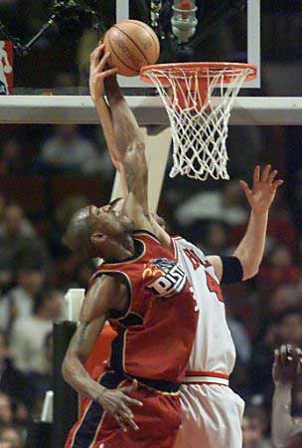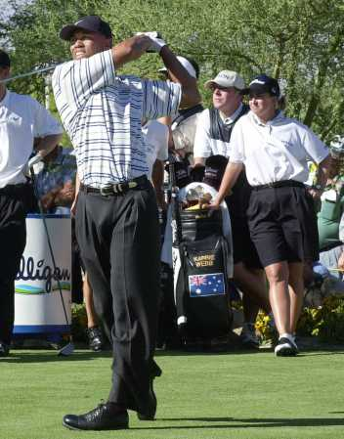

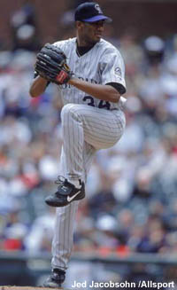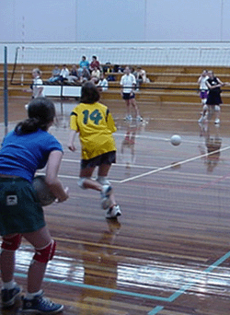

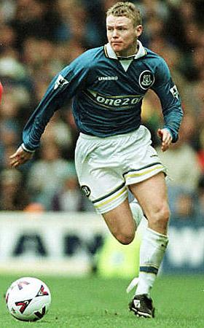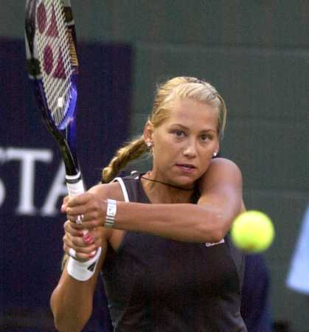

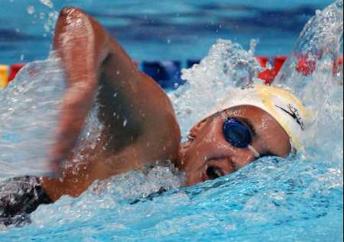

Unit 3

Read the text and answer to the following questions:

1) What was Vedran Smailovic’s job before the war?_____________________________________________________________

2) What did Vedran Smailovic do when he heard the news?____________________________________________________________

3) What piece of music did he play?____________________________________

4) Why did he play his cello?_________________________________________

5) Was he ever hurt?________________________________________________

Before the war, Vedran Smailovic had been a cellist with the Sarajevo Opera. When he heard about an explosion that had killed men, women and children in a bread queue in Sarajevo, he decided to do something about it. And so he did what he did best. He played his cello.

For the next twenty-two days at exactly four o’clock in the afternoon he put on his concert clothes, took his cello and a plastic chair into the empty streets and played a piece of music by the composer Albioni –his Adagio in G minor, one of the saddest pieces of music ever. Around him there was fighting and death. Shells fell and bullets flew while he played, but he was never hurt. With the world collapsing around him he played for compassion and peace, to ease the pain of loss and to preserve the dignity of the human race.

Unit 4
1.Write down everything about the American flag
1.Colour:_____________________________________________________
2. Name:______________________________________________________
3. Number of stars:______________________________________________
4. Number of stripes:_____________________________________________
5. Colour of stripes: ______________________________________________
6. Stripes stand for: ______________________________________________
7. Stars stand for: ________________________________________________
8. Time of the day it is displayed:____________________________________
9. Places to see the flag:____________________________________________
2. Choose the right date:
Holiday | Date
1. New Year’s Day | A. June, 14th
2. St. Valentine’s day | B. October, 31st
3. April Fool’s Day | C. December, 25th
4. Flag Day | D. January,1st
5. Independence Day | E. February,14th
6. Halloween | F. December, 31st
7. Thanksgiving Day | G. April, 1st
8. Christmas Day | H. July, 4th
9. New Year’s Eve | I. November, fourth Thursday

3. Make up the correct statement:

1. Statue/ given/ was/ The/ to/ United/ the/ States/ the/ by/ France/ of / people/ Liberty________________________________________________________________________
2. by/ signed/ Congress/ was/ The/ Declaration/ Independence/ of____________________________________________________________________________
3. was/ The/ American / flag/ first/ made/ Betsy Ross/ by___________________________________________________________________________
4. put up/ in/ The/Liberty/ was/ Statue/ of/ 1886_______________________________________
5. made/ An/ Independence/ was/ Day/ holiday/ official_________________________

4. Mach the pictures with the words:

a)Worn-looking jeans with holes at the knees e) Punk style jeans

b) Painted hippy jeans f) Flared jeans
c) Baggy jeans g) Frayed jeans

d) Bleached jeans h) Black jeans
1.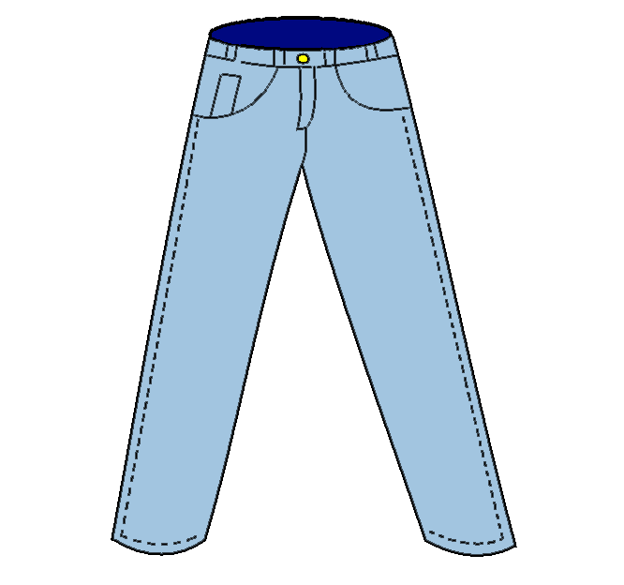 2 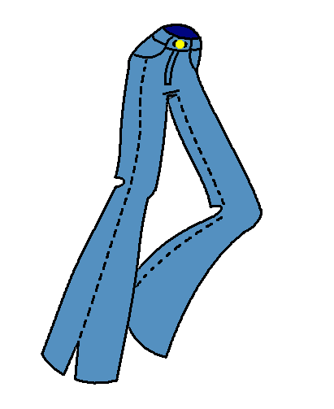

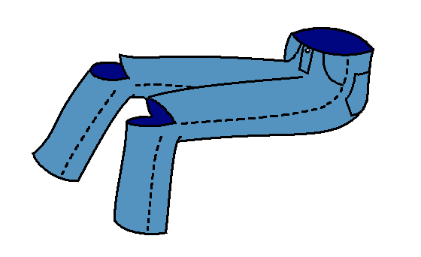 4. 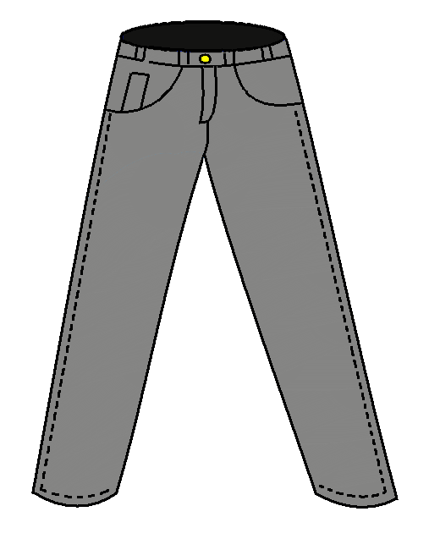
3.
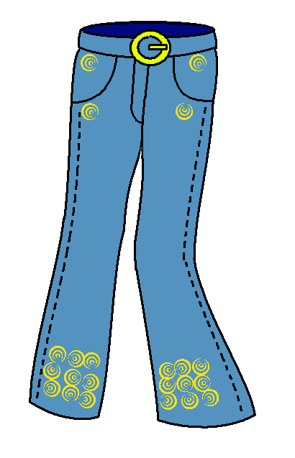 6. 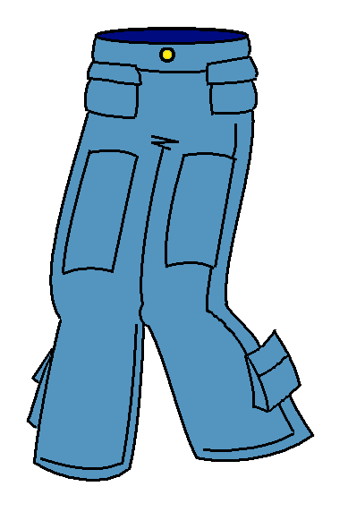
5.

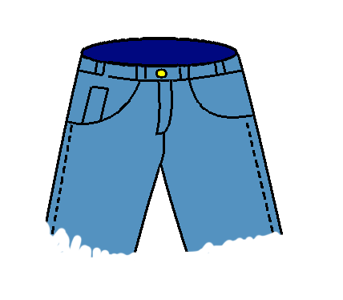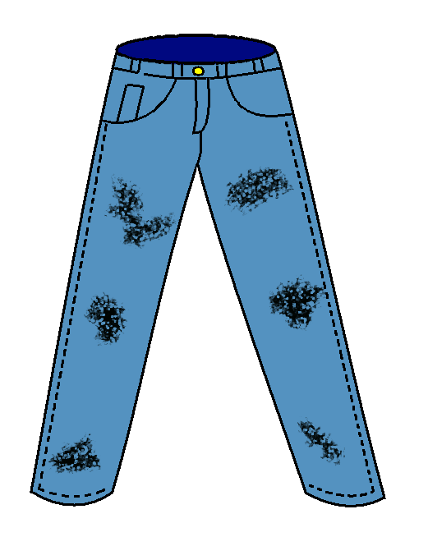

7) 8)

Unit 5

1. Complete the following sentences with the correct word or phrase.

blockbuster record-breaking budget director producer

- The ________________ finds the money to pay for the film to be made.
- The________________ tells the actors and actresses what to do.
- A _________________ film is a successful film that costs a lot of money to make.
- The _______________ for a film is the amount(количество) of money spent making film.
- Ben Hur was a _______________________film in the 1950s because it was the most expensive film ever before made.

2. Letter Madness. Can you sort out this letter?
dearjohnivejustseentitanicitsbrillia
ntillsendyouthevideoitstouchingan
dimpressiveitsdirectedbyafamous
filmdirectorbutidontrememberhisn
ameillcallyouattheweekendloveka
te
__________________________________________________________________________________________________________________________________________________________________________________________________________________________________________________________________________________________________________________________________________

3. Match the pictures and the titles of the films
Write a short film review (choose one of these films):

- Gladiator
- Lord of the rings
- Matrix
- Harry potter and the Philosopher’s stone
- Pirates of the Caribbean
- Rossomaha

a)  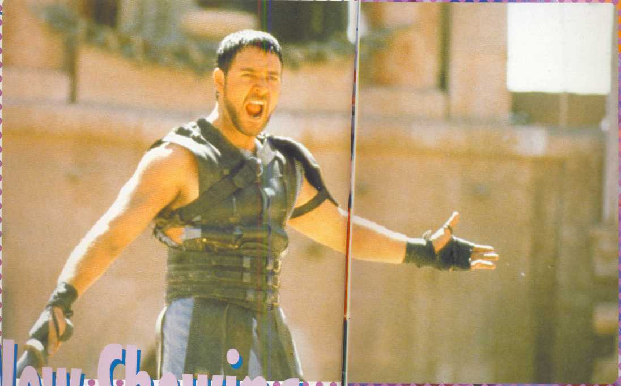  b)  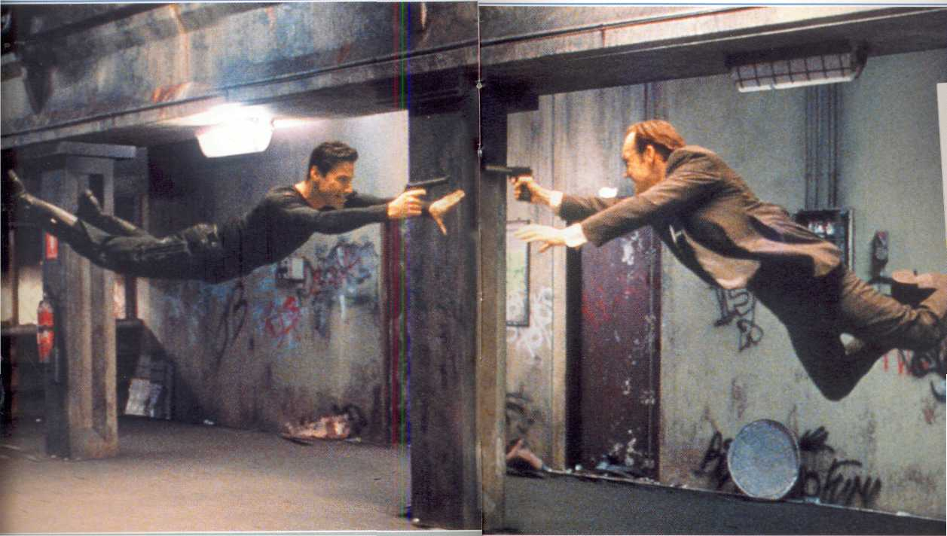  c)  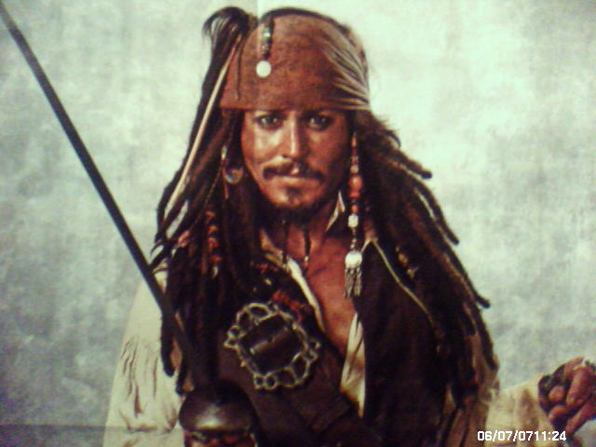 |  d)  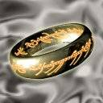 e)   f)

NM 7
Unit 6 Lesson 8

Карточки для оценки проектов товарищей
Name of the project | Is the project original?  1………………..5 | Is the story well-organised?  1………………5 | Are the photos \ pictures interesting?  1…………………5 | Would I like to have such a friend?  1………………..5
1
2
3
4

Unit 6

Read the text and complete the gaps with appropriate words:
Bill’s big (1)_________ is clothes and bags. Besides he’s helpful and very (2)____________ to his friends. He loves partying and having fun and he’s always cheerful in the morning. He’s got a good head on his (3)____________ and he’s very (4)____________.  (5)____________ is one of John’s strength. He never lets his friends (6)____________ and he always tries to (7)____________ his promises. He likes Maths and Physics and he (8)______________ extra classes in these subjects. But he also loves dancing and listening to good music. John is pretty easy to get (9)____________ and he enjoys (10)______________. | along with  down  keep  love  loyal  reliability  shoulders  socialising  takes  witty

Unit 7

Report what the girl an the boy said:
"I think the future will be cool. When the weather is not good, all you need to do is push a button and your house would be up above the clouds. All the schools would have computers. And whenever you want to go somewhere you'll have a flying board to take you there. Also, when your house is messy, you just call your maid, Rose." Rose, 6 years old
____________________________________________________________________________________________________________________________________________________________________________________________________________________________________________________________________________________________________________________________________________________________________________________________________________
"Computers and CD Roms will change the future of education because the CDRom will be like a textbook stored on a disk. So instead of carrying loads of heavy textbooks, you carry a couple of disks that you can read the material from. Learning would be made easier and less of a burden." Mark, 8 years old
__________________________________________________________________________________________________________________________________________________________________________________________________________________________________________________________________________________________________________________________________________

Unit 8

1. Read the witness statement. It was written by the police officer who interviewed John Burney. The police officer wrote the statement in the first person ( I = John Burney ). John Burney will be asked to sign the statement. Answer the questions.

a What crime took place?
b How many people were involved?

WITNESS STATEMENT FORM
NAME: John Burney
ADDRESS: 32 Albert Close, Glasgow, GL2 1BT

STATEMENT
I was in the bank at 12.30. I saw two men and a girl run into the bank. A tall, white man with a gun ran up to the window and shouted something like “Give me all your money”. He had short, dark hair. A second man, with a suitcase, went up to the window and helped the first man to put money into it. He was a 30-year-old, black man wearing jeans and a black sweater. He was very tall . the girl was about 25 with long blonde hair, wearing red trousers and a white shirt. When the suitcase was full I saw all three of them run out of the bank.

Signed _______________________ Date:_____________________

2. Read the following information about the Great Pyramid and underline the passive verbs:

The Great Pyramid was built in Egypt about 5,000 years ago. It was constructed to the west of the River Nile. This area was called “The Land of the Dead”. The Great Pyramid was made from huge blocks of limestone*. The wheel hadn’t yet been invented, so the blocks of stone were pulled from the quarry* by hundreds of men on a path of wooden logs. The pyramid was designed with the solid core* of limestone with four sides, and gaps were left for corridors and various rooms. It is not known exactly what the pyramids were used for, but burial* chambers (where the bodies of dead pharaohs and their families and servants were placed) have been found deep inside the pyramids. It is thought that the pyramids were designed to help the pharaoh’s spirit rise up to the sun after death. The pyramids are visited by millions of people each year.
* limestone- [‘laim stǝun]-известняк
* quarry-[kwɔri]- каменоломня
* solid core-[‘sɔlid kɔ:]- цельная часть
* burial-[beriǝl]- похороны

3. Read the information about the famous ship the Titanic and write the correct passive form of the verb in brackets in each gap:

The Titanic (a build)__________________ in 1912. it (b design)____________ in a new way and it was (c think) _____________to be unsinkable. Because of this, it (d not/ give)___________________ enough lifeboats for the passenger and crew. The hull (e damage)________________ by a collision with a huge iceberg and it sank very fast. A total of 1, 513 people (f drown)_____________ that day. Because of this disaster, new international safety laws (g pass)______ and the Ice Patrol (h establish)_____________. In 1985 the wreck (i locate) ______________ on the sea bed and the ship (j explore) _______________. Several successful films (k make)_____________ about the Titanic since then, and the most recent (l release) ______________ in 1997.

Unit 9

Put the paragraphs in order and do the task below:
____Scientists believe that the Solar System appeared from a giant cloud of dust and gas. They believe that this dust and gas began to collapse under the weight of its own gravity. As it did so, the matter contained within this could begin moving in a giant circle, much like the water in a drain moves around the center of the drain in a circle.

_____At the center of this spinning cloud, a small star began to form. This star grew larger and larger as it collected more and more of the dust and gas that collapsed into it.

_____The creation of our Solar System took place billions of years before there were any people around to witness it. Our own evolution is tied closely to the evolution of the Solar System. Thus, without understanding from where the Solar System came from, it is difficult to comprehend how mankind came to be.
_____Further away from the center of this mass where the star was forming, there were smaller clumps of dust and gas that were also collapsing. The star in the center eventually ignited forming our Sun, while the smaller clumps became the planets, minor planets, moons, comets, and asteroids.

True or false:
  - The creation of our Solar System took place billions of years before there were any Russian people to witness it.__________
  - Scientists believe that the Solar System appeared from a giant cloud of dust and water.__________
  - At the center of the spinning cloud, thousands of small stars began to form._____
  - The star in the center of the cloud formed our Sun______

Unit 9
1. Look at the table and answer the following questions:

- Which planet has a longer day than year?___________________________________________________________________
- Which planet has the most moons?__________________________________________
- Which is the hottest planet? Why?__________________________________________
- Which planet has the longest year?__________________________________________
- Which planet has the closest length of day to the Earth’s?________________________________________________________________
- Which planet has the shortest day?__________________________________________
- Which is the smallest planet?_______________________________________________
- Which planet is nearly as large as the Earth?_________________________________

Appendix 1:
Name | Moons | Average temperature (⁰C) | Rotation | Orbit | Diameter (kilometres)
Mercury | 0 | -167⁰C to 427⁰ | 58.6 days | 88 days | 4,880
Venus | 0 | 472⁰ | 243.3 days | 224.70 days | 12,100
Earth | 1 | -51⁰ to 48⁰ | 23.9 hrs | 365.26 days | 12.800
Mars | 2 | -123⁰ to -30⁰ | 24.6 hrs | 686.98 days | 6,780
Jupiter | 16 | -117⁰ | 9.8 hrs | 11.9 years | 142,600
Saturn | 24 | -180⁰ | 10.2 hrs | 29.46 years | 120,000
Uranus | 17 | -221⁰ | 10.8 hrs | 84.01 years | 50,800
Neptune | 7 | -216⁰ | 15.7 hrs | 165 years | 49,500
Pluto | 2 | -230⁰ | 6.3 days | 248 years | 2,300

2. Write what planet you would go to if you were an astronaut:
Example:
If I were an astranaut I would go to Mars because it’s the closest planet to the Earth.
If I WERE … I WOULD GO TO … BECAUSE…

A) Mercury B) Venus

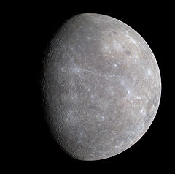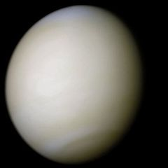

C) Earth D) Mars

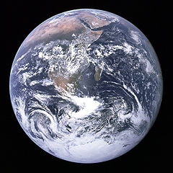

E) Jupiter F) Saturn

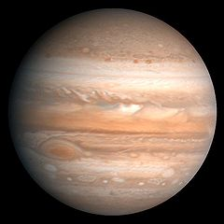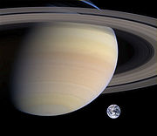

G) Uranus H) Neptune

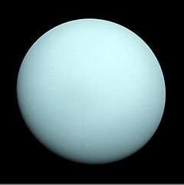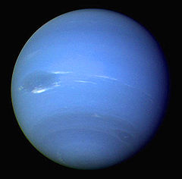

- Pluto J) Mercury

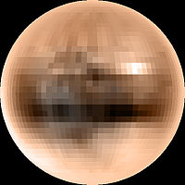

3.Read the text and say which planet it is about:

This planet is the most mysterious planet in our solar system. It is the smallest and the coldest of all the nine planets. It takes 248 years to orbit the Sun, so its year is the longest. A day on this planet is longer than on Earth but shorter than on Mercury. It has as many moons as Mars. It is nearly as cold as Uranus.
There is no water or air on it, so there is no life there. This planet is the most distant planet from the Sun.
Answer :

4. Translate the sentences:

- Юпитер почти такой же холодный, как и Марс.______________________________________________________
- День на Сатурне почти такой же длинный, как и на Уране.______________________________________________________
- У Юпитера почти столько же лун, как и у Урана._____________________________________________________

5.Сompare the planets (use appendix 1):
Neptune and the Earth ________________________________________________________________
Pluto and the Earth________________________________________________

Jupiter and the Earth_______________________________________________

Mars and the Earth________________________________________________

Saturn and the Earth_______________________________________________

Uranus and the Earth_______________________________________________

Unit 10

Lisa is on holiday in St.Petersburg. Read her letter and fill in the gaps with the correct sentences. There is one extra sentence.
Dear Sandra,
(1)___________________. My mum and I are in St.Petersburg now. It’s the north-west of Russia. I think it’s one of the most beautiful cities in the world.
(2)________________. We’ve visited the Hermitage and the Russian Museum and some beautiful cathedrals. Then we’ve taken a boat trip along the canalsand enjoyed the sights of the city from the Neva River. We’ve also visited Petrodvorets and seen it’s famous fountains and the park.
(3)________________. And Nevsky Prospect is the busiest street. You can see lots of people here in the daytime and late at night. There are a lot of modern shops and lovely small cafes where you can eat cakes and delicious ice-cream. You know, it’s my favourite place here.
(4)____________________. I’m taking lots of photographs. I wish you were with us. See you soon.
Love,
Lisa

1.
A I’m having a fantastic time
B There are many places to see and things to do in St.Petersburg
C Can you guess where I’m writing to you from?
D St.Petersburg’s streets are always full of life
E St.Petersburg is on the Neva River

2. Read the sentences and say if they are true (T) or false (F):
1. Lisa is going to visit the Russian Museum
2. Lisa has tasted St.Petersburg’s ice-cream
3. Lisa likes being in St.Petersburg
4. She is making a film about her trip

Тесты NM 7 (конец 1 полугодия)
1. Образуйте новое слово: :goal:
A. ball; B. ground; C. keeper; D. case.
2. Дополните предложение.
A. wrestling; B. chess; C. baseball; D. boxing.
3. Weight training, karate, aerobics are all : sports.
A. team; B. outdoor; C. indoor; D. interesting.
4. Do you : karate?
A. do; B. play; C. go; D. like;
5. This is my brother Tom and that`s his wife Betty with : children.
A. our; B. your; C. their; D. her.
6. Какое предложение передает смысл русского предложения?
Я видела, как дельфины прыгают в воду.
A. I saw dolphins jump in the water.
B. I saw dolphins to jump in the water.
C. I watch dolphins jump in the water.
D. I watch dolphins to jump in the water.
7. What is the capital of USA?
A. Washington, D.C; B. Washington; C. Los Angeles; D. New York.
8. Where is the USA?
A. In North America; B. In South America; C. In Africa; D. In Europe.
9. Which state in the USA is closest to Russia?
A. California; B. Montana; C. Alaska; D. Florida.
10. Допишите правило поведения в школе.
You : be late for school.
A. can; B. can`t; C. should; D. must.
Выберите правильный ответ.
11. The first jeans : by Levi Strauss.
A. was made; B. were made; C. be made; D. made.
12. The name 'jeans' : to them after sailors from Genoa.
A. give; B. given; C. was given; B. were given.
13. Many US cars are made in : .
A. Chicago; B. Detroit; C. New York; D. Los Angeles.
14. The : river is the greatest river in the USA.
A. Neva; B. Mississippi; C. Avon; D. Colorado.
15. Дайте совет другу.
You : do regular exercise..
A. must; B. should; C. can`t; D. can.
16. Выберите нужное.
I don`t play ping pong. - : do I. I find it boring.
A. So; B. Neither; C. Will; D. Can.
Скажите, что вы делали / не делали раньше. Дополните предложение, употребив глаголы в скобках в нужной форме. В ответе запишите только слова.
George (17 use to live) : in the country but now he lives in a town.
Melen (18 use to listen) : to pop but now she enjoys jazz concerts.
Скажите, как бы вы поступили на месте другого человека. В ответы запишите только слова.
If I were you, : (19 join) a sports club.
If I were you, : ( 20 not ask) your father to repair your bike.
Допишите предложения, употребив глагол в скобках в нужной форме.
21. Four school friends (sing) : together since 1976.
22. My sister (write) : New Year cards for half an hour.
Задайте вопрос к предложению. Начните со слов, данных в скобках.
23. I have been playing the violin for two years. (How long :?)
Выберите правильное прилагательное. В ответ запишите только слово.
24. Horror movies are exciting/excited.

