Открытый урок в 10 классе по учебнику Английский язык с удовольствием, авторы Биболетова М. З., Снежко Н. Д. по теме «Семья»

Цель урока:
- Развивать творческую активность детей;
- Разнообразить и внедрить новые методы работы при обучении английскому языку;

Задачи:
- Расширить и закрепить языковые знания и навыки, а именно: лексическую сторону речи, коммуникативные умения
- Воспитывать любовь к семье, к обществу

Оборудования:
  - медиапроектор,
  - раздаточный материал,
  - компьютер.

Ход урока.

- Организационный момент. Вступительное слово учителя.
Good morning, my dears.
T: Are you ready for the lesson?
S: Yes, we are.
T: Have you done your hometask?
S: Yes, we have.

T: Would you like to start?
S: Yes, we would.
Today some guests are present at our lesson. I am happy to great you on behalf off my students.
Dear boys and girls, during our lessons, we have been talking and exploring your family past. These discoveries gave you a sense of knowing who you are. That’s why the topic for our discussion is «Family», what makes a family happy and family disagreements.
But first what does every letter mean for you in a word «Family»
F - father
A - and
M - mother
I - I
L - love
Y - you
- Фонетическая зарядка. Ex.3p.54
Listen to the world and repeat them. Put them into the following categories according to their pronunciation pattern. Use your Workbook.
- Речевая разминка. Ex2.p.54
Отработка английских пословиц
Match the proverbs with their explanations and give the Russian equivalents. Then interpret the proverbs.
1. It runs in the family
2. Your own flesh and blood
3. Blood is thicker than water.
a) a member of your family, no matter what
b) an ability or talent that is passed on through the generation.
c) family ties are stronger than any others, despite arguments.
IV.Актуализация лексики по теме семья Ex.49 p 66
Look at the pictures and say which shows an extended / nuclear family. Which picture reminds you…
- Of your own family?
- Of your friend's family?
- How so?
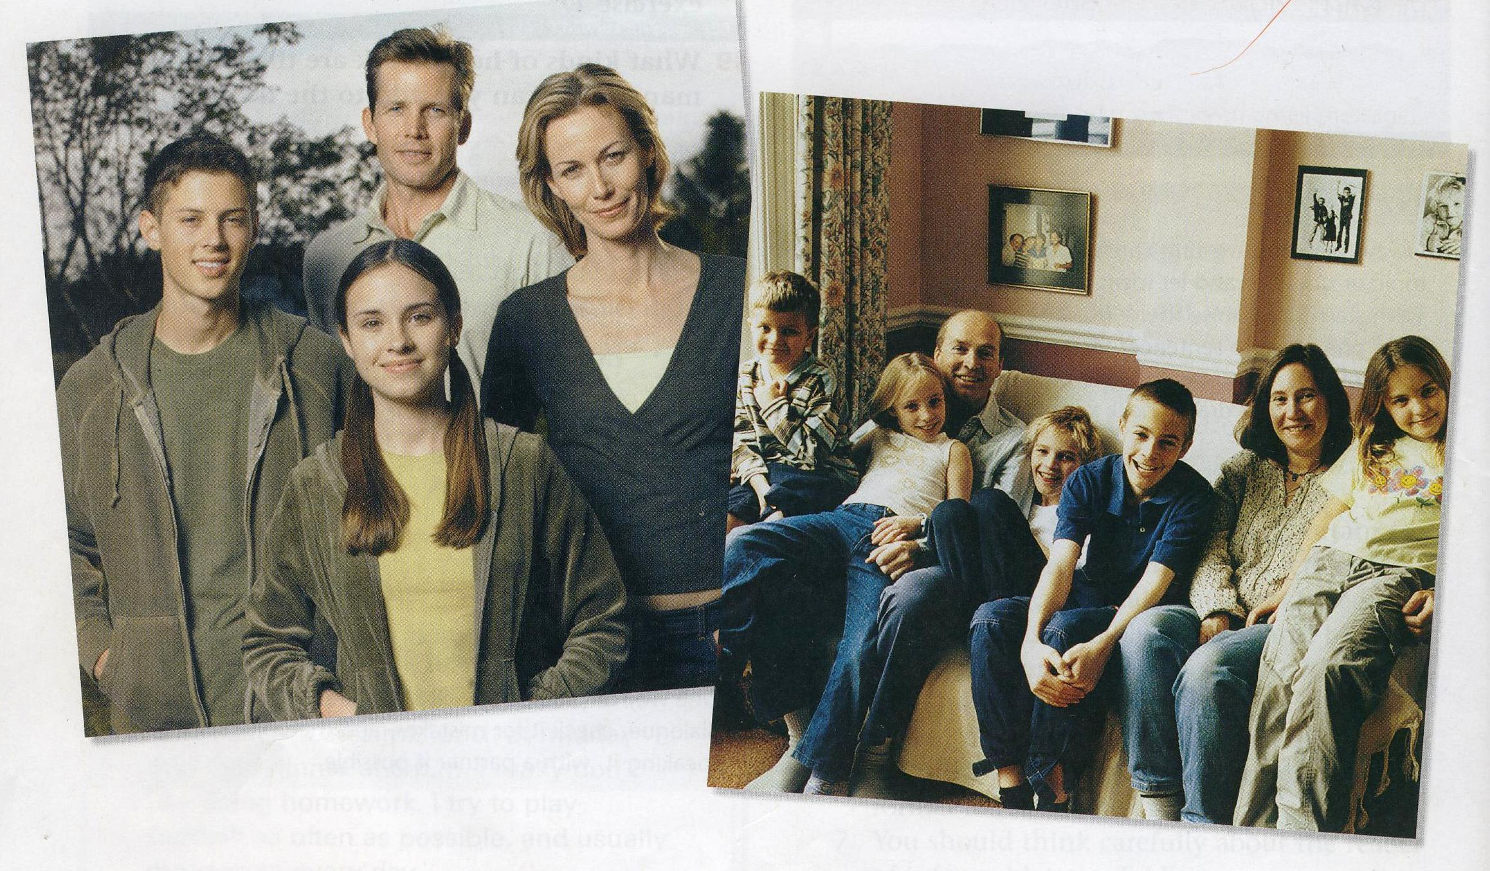

V. Проверка домашнего задания. Контроль понимания почитанного текста, и извлечение информации. Ex.51 p.67, W.B. Ex.4 p.34
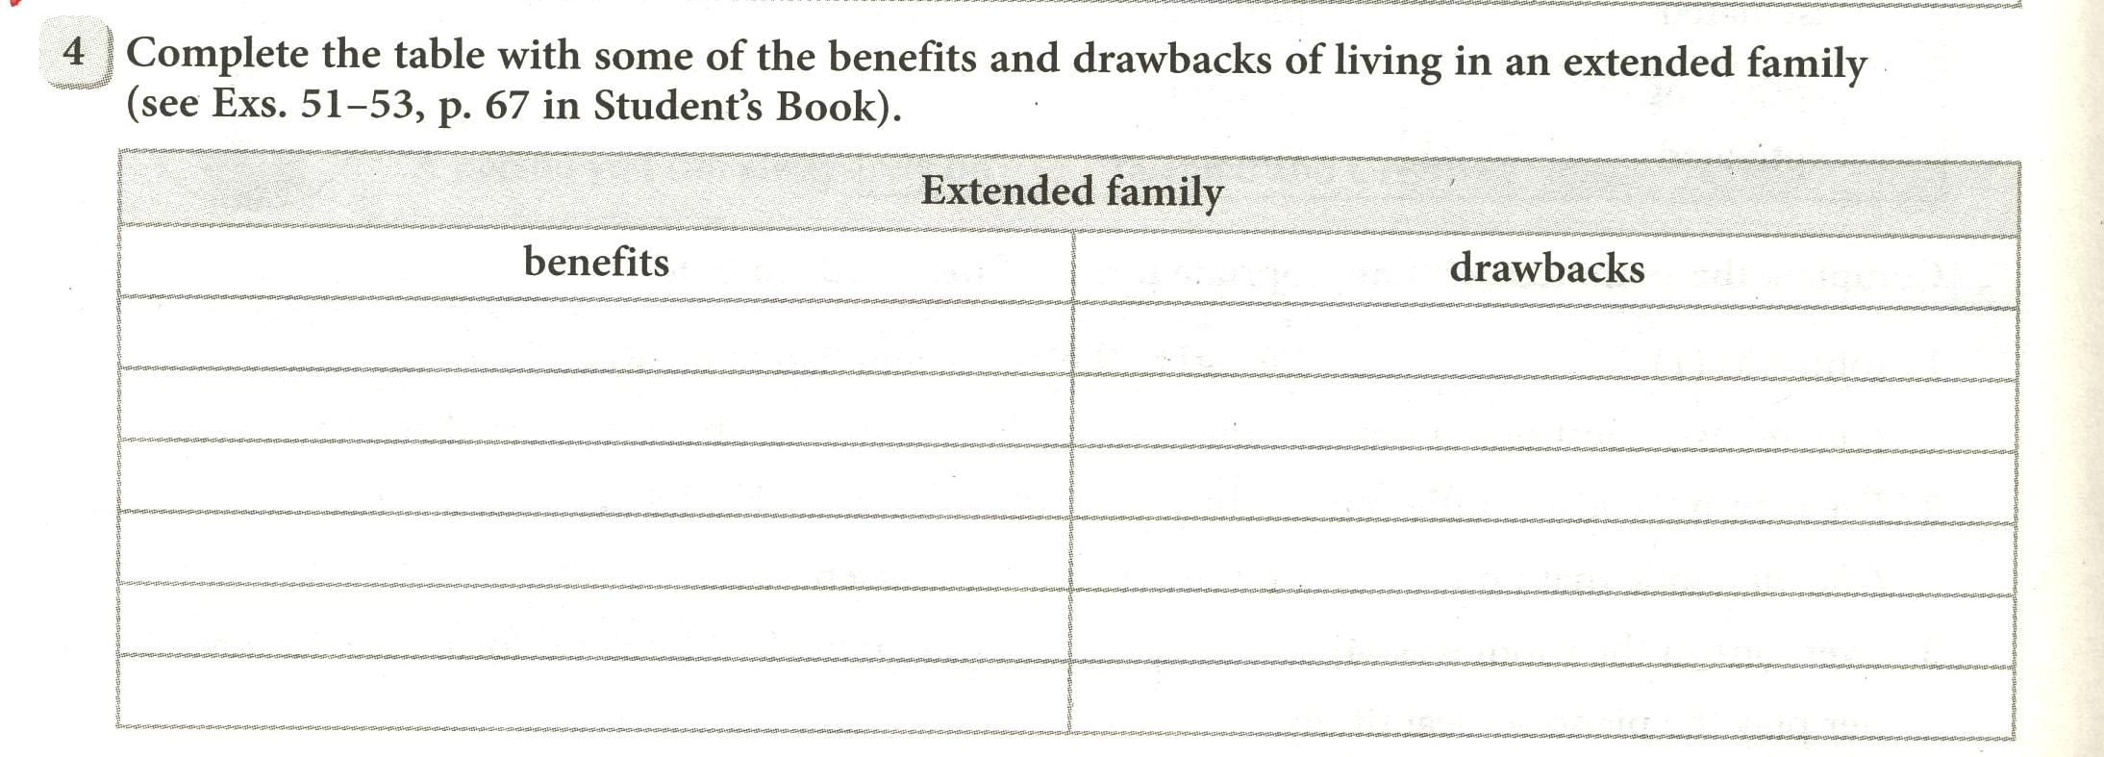
VI. Групповая работа. Дебаты. Ex.54 p.68.
Work in groups. Compare your lists, combine your ideas. Then discuss the following question.
- If you could choose, which of family (nuclear or extended) would you prefer to have? Why?
And then the leader of your group will make a conclusion and express your group's opinion.
VII. Аудирование с пониманием основного содержания текста. Ex.3.03 p.13.из учебника OXFORD Exam Excellence (Preparation for secondary school exams.)

VIII. Физкульт-минутка.
Now, let's have a break. Open your hearts to this song. I think you will enjoy it. «Imagine».

IX. Развитие говорения (Монологическая речь). Описывание фотографий из семейного альбома детей о запоминающихся событиях. Собственные исследования.
What makes our family happy?

  - Диалогическая речь. Умение вести беседу по заданной теме.Section 4 Family disagreements. Описание рисунков:
- Диалог между мамой и дочкой о её друге.
- Диалог межу сестрой и братом о планировании комнаты.
- Диалог между мужем и женой кто глава в доме.
XI. Заключительная часть. Итоги урока. Отметки. Домашнее задание: написать статью «A family story»,РТ упр. 3, стр. 43.
Заключительное слово учителя:
No matter how much you argue your family never let you down. They will always stay with you. No matter what happens in the world there are at least 3,4,5 persons who you can rely on.
Try to avoid conflicts as far as you could but if you get into a conflict try to be the first to pronounce:
I am terribly sorry
I beg your pardon
It is my fault
I am so blame for it all
Forgive me
I am really sorry
And you will hear in response:
No harm done
Never mind
It doesn’t matter
That’s OK.
Forget it
Let bygones by bygones.

The lesson is over. Good-bye.

