Ашинова-Грозаву Рузана Нальбиевна
учитель английского языка
МБОУ гимназия № 40 г. Краснодара
План-конспект урока: «Life stories»
Учебник английского языка для 10 класса “Up & Up 10” под редакцией: Тимофеева В.Г.

Тема: | «Life story»
Цель: | развивать речевые умения и навыки учащихся
Задачи: | - введение новой лексики по теме и ее актуализация на уровне предложения;  - введение новой грамматической темы  - развитие учебных умений: умений обобщать, выделять главное, анализировать, сопоставлять, находить сходное и различное, устанавливать взаимосвязи
Оборудование: | - Текст из Интернет источника: http://www.rapwiseman.com/eminem/  - Отрывок из сериала “Extra”  englishfull.ru/videoangl/3-extra-english.html  - Презентация
 | Ход урока:
Приветствие: | Good morning, children.  Good morning, teacher.
Орг.момент: | What is the day today?  - Today is ....  What is the date today?  - Today is …  Thank you.  Our topic for today is “Life story”  But before we shall start, let’s train our tongues.
Фон. зарядка: | The kitten  The trouble with the kitten is that, eventually it becomes  the cat
Речевая разминка: | Do you remember the best day in your life?  Can you tell us about that day?
Проверка д/з: | Well done!  Now let’s check your home task  Ex. 10, p. 59
Просмотр сериала Extra | Просмотр 3 серии сериала Extra
Работа с текстом: | What did you understand from the extract? Answer the questions, please.  Who are the main characters? etc.  Now have a look at the board. Do you know this person?  Who is he?  What is he?  What is he famous for? etc.  (на мультимедийной доске в виде презентации представлены фотографии певца)
Чтение статьи: Eminem  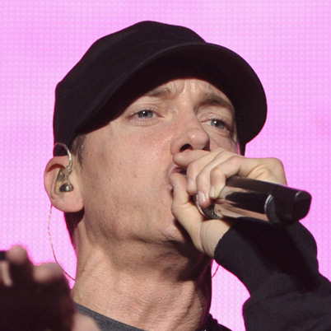 |  | American rapper, record producer, and actor Eminem was born October 17, 1972 in St. Joseph, MO. Mathers had a turbulent childhood. Eminem released The Slim Shady LP early in 1999. The album went multiplatinum, and he won two Grammy Awards and four MTV Video Music Awards. In 2000 Eminem released The Marshall Mathers LP-the fastest-selling album in the world.

Early Life
Rapper. Eminem was born as Marshall Bruce Mathers III on October 17, 1972 in St. Joseph, Missouri. He never knew his father, Marshall Mathers Jr., who abandoned the family when Eminem was still an infant and rebuffed all of his son's many attempts to contact him during his childhood. As a result, Eminem was raised by his mother, Deborah Mathers. She never managed to hold down a job for more than several months at a time, so they moved frequently between Missouri and Detroit, Michigan, spending large chunks of time in public housing projects. "I would change schools two, three times a year," Eminem later recalled. "That was probably the roughest part about it all."
Работа с текстом: | Find in the text and translate from English into English:  The album went multiplatinum, and he won two Grammy Awards and four MTV Video Music Awards  He never knew his father  I would change schools two, three times a year
Подведение итогов урока: | You did a good job. Thank you. Your marks for the lesson…
Домашнее задание: | Your home task for the next time is: Ex. 25, p. 77  Look it through. Is everything clear?
Завершение урока: | You may be free, good bye.

