План открытого урока английского языка в 4 классе.
Валиева Рузиля Рафиковна

Тема: Festivals (повторение и закрепление темы «Festivals»
Цели : 1) образовательная – развитие познавательных сил учащихся: мышления, воображения и памяти; формирование коммуникативной компетентности учащихся;
2) развивающая – развитие фонетических и лексических навыков, а также умений письма и говорения;
3) воспитательная – расширение кругозора, развитие культуры речи;
Задачи:
1) активизация изученной лексики по главе №3 «Festivals»в разговорной речи и в тренировочных упражнениях;
2) проверить усвоение пройденного материала;

Наглядный материал:
1) учебник:
2) магнитофон, аудиокассета
3) интерактивная доска

Ход урока :
- Орг. момент : приветствие (Stand up! Good morning, children! I am glad to see you! Take your seats, please!)
- Формирование речевых навыков.
T: How are you?
Where are you from?
How old are you?
What day is it today?
What date is it now?
What season is it now?
What weather is it now?
How many lessons have you got today?
What lessons have you got today?

- Актуализация знаний.
T: Doing the puzzle.
Well, friends, to begin with, have a look at the blackboard, please. Here is a puzzle for you to do. Name all the words in the pictures, take only the first letter of each word and you will read the topic of today’s lesson. For example, a hat- letter- H

Orange, lizard, ice-cream, dog, apple, yellow, sweets

T: So, what key word have we got?
P: Holidays
T: Right. I am sure you know much about holidays because we already read some information about celebrations in different countries of the world. Today we shall revise some material and speak about some other popular holidays.
T: Well, let’s play a bit. Catch the toy and answer my questions.
- By the way, do you like holidays? (Yes Ido)
What holidays do you know?
- ( New year, Happy birthday, Mather’s day, Easter, Christmas,)
(Father’s day, Halloween,…)
Ok, thank you, so tell me please What is your favourite festival? Why?

4 Фон. зарядка.
Listen to the tape recorder, than sing to the music.
Are you ready?
Yes!
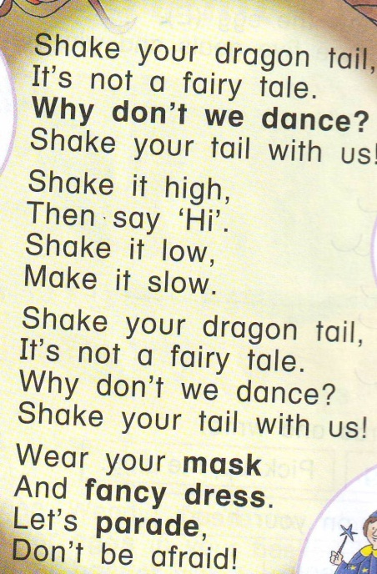

5. Закрепление изученного материала
And now I want to know how do you know festivals. So, look at board and answer my questions,(появляется слайд шоу)
- What holiday is it? (New year, Happy birthday, Mather’s day, Easter, Christmas, Halloween)
Now you get the papers and do exercises. (the task to complete the sentences)
Do you understand?(Yes, No)
Упр. из раб .тетр.

6. Итоги
- Did you like our lesson?
-Was it interesting?

7. Задание на дом.
-Open your dairies, and write down your home task:
Write about your favourite festivals.(10 sentences)

