Presentation:

Урок английского языка по теме «The harm of smoking».
Учитель английского языка 2 квалификационной категории – Хузина Эльза Айратовна.
Учебное заведение: МБОУ СОШ №9 города Альметьевска, Республики Татарстан.
Тип урока – урок обобщения и систематизации знаний

Цели:
Обучающие: сформировать знания и умения учащихся по использованию новых слов по теме;
Развивать навыков монологической речи по теме «Вред курения».
Воспитательные: Создание условий для формирования ясных представлений школьников о здоровом образе жизни, о вреде курения на здоровье подрастающего поколения, умения работать в парах.
Развивающие: развивать у учащихся умения сравнивать, выделять главное, логически излагать свои мысли, анализировать;
Методическая: показать различные виды контроля на уроке.
Задачи:
-ознакомить с лексикой;
-формирование навыков письма, сочинение с элементами сочинения;
-организовать чтение текста с полным пониманием;
-создать условия для высказываний по теме «What measures should be taken in the future»
Оснащение: мультимедийное приложение «The harm of smoking», карточки с упражнениями.

Методическое описание урока.
Актуальность выбора темы определяется современными требованиями к уроку и личности ребенка. Состояние здоровья подрастающего поколения - важнейший показатель благополучия общества и государства. Ухудшение здоровья детей школьного возраста в России, распространение вредных привычек стало не только медицинской, но и серьезной педагогической проблемой. Здоровье сберегающие технологии являются составной частью и отличительной особенностью всей образовательной системы. Это совокупность всех используемых принципов, методов и приёмов обучения и воспитания, которые, дополняя традиционные технологии, наделяют их признаками здоровье сбережения, цель которого - не только оберегать здоровье учащегося и учителей от неблагоприятных факторов образовательной среды, но и способствовать воспитанию у учащихся культуры здоровья, борьбе с вредными привычками, в том числе и с курением.
Тип урока выбран, исходя из его цели. Для реализации всех типов задач применялись следующие методы обучения: словесный, наглядно-иллюстративный, проблемный.
Подбор учебного материала соответствует уровню подготовки обучающихся и их возрастным особенностям.
На уроке использованы технологии личностно-ориентированного обучения, здоровье сберегающие технологии, коммуникативный подход в обучении иностранным языкам, ИКТ.
Использование ИКТ позволяет:
-использовать многочисленные и разнообразные приемы, задания и упражнения;
- сделать урок более информативным, зрелищным и динамичным;
- регулировать объём и скорость выводимой информации с помощью компьютерного моделирования;
-способствует эффективному запоминанию информации;
В подготовке к уроку использовались Интернет-ресурсы: тексы о вреде курения и фотографии.
Ход урока.
1.Приветствие и организационный момент.
Good morning, boys and girls! Sit down, please. I am glad to see you. Who is on duty today? What is the date today? What is the day of the week today? Who is absent today?
2.I’d like to start our lesson with the proverbs. Look at the screen and match the beginnings and the endings of the proverbs.
An apple a day/ is above wealth.
Good health/ keeps a man healthy, wealthy and wise.
Early to get up and early to rise/ keeps the doctor away.
3. Объявление целей урока.
As you see all the proverbs concern one topic and that is the topic of our lesson. Also we’ll talk about smoking and it’s negative effect to health of a man. At the end of the lesson you’ll offer the ways of solution.
As you know, there are a lot of problems of young people. Do you agree smoking is a problem? Do many people around you smoke? Do your relatives smoke? Do you try to help them to stop smoking?
4.Введение темы. Express your point of view to the following facts.
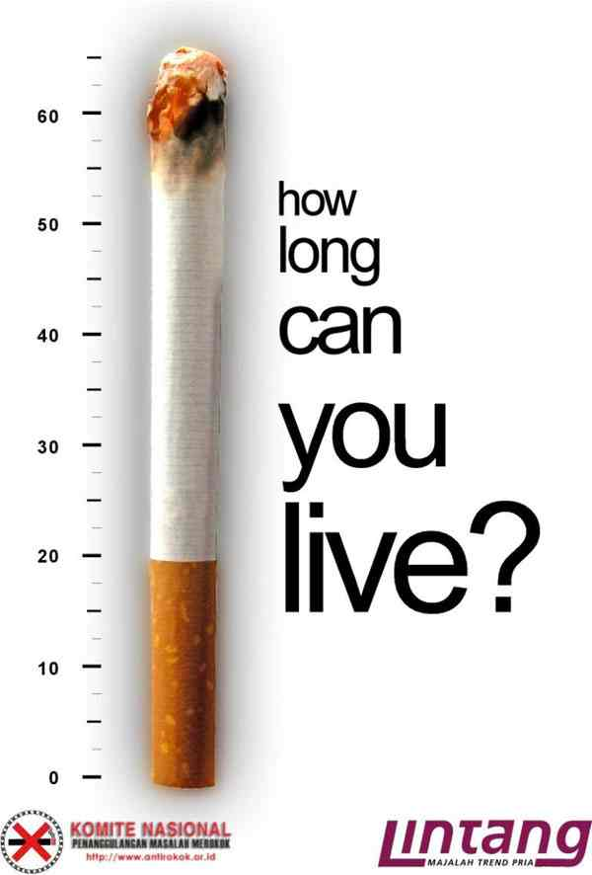-Many teenagers become really addictive from smoking since school.
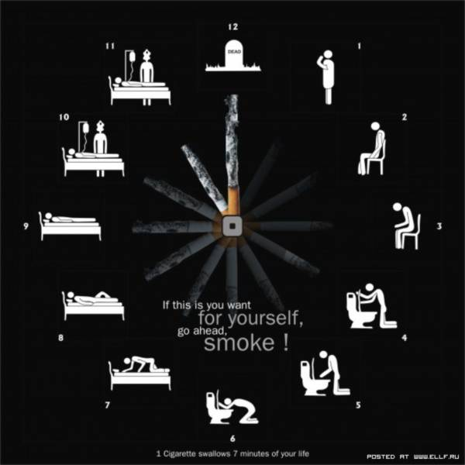In Russia smoking kills 332 thousand people a year, or 15% of all deaths.
-240 thousand (231 thousand males + 9 thousand females) or 72% of them are still in middle age when they die.
-Men in Russia smoke more and are more severely affected by smoking hazard than women.
-One fourth of all deaths at all ages and one third at middle age are associated with tobacco smoking.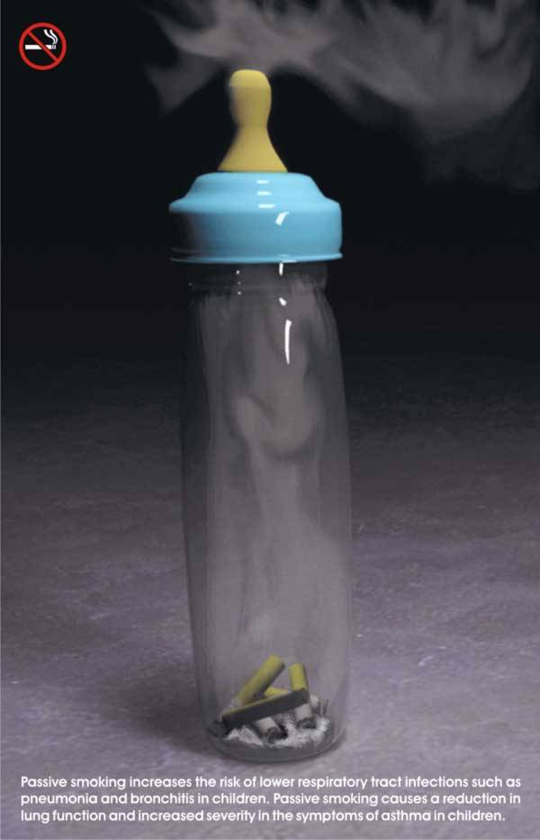
-For women, smoking causes 3% of all annual deaths.
-Significantly less – 3.5 thousand women vs. 47 thousand men (by a factor of 13) yearly die from lung cancer caused by smoking.

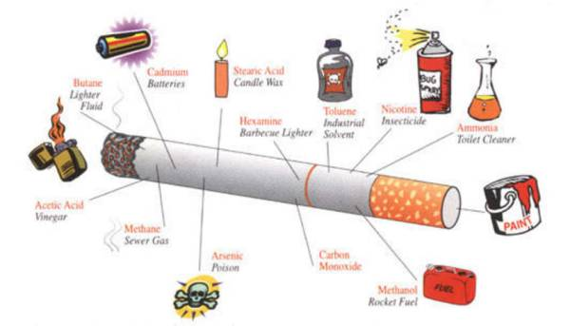

Now answer to my questions. What is your attitude to smokers? Do women realize a great risk of smoking when they expect a baby? Unfortunately, many teenagers have been smoking when they are at the age of 13 or 14. What measures could help to decrease the number of smokers especially among teenagers? Should the prohibition be taken in the public places?
Предполагаемые ответы учащихся.
P1: I’d like to add that smoking is badly injurious to health and adverse effects on passive smokers is well established. Therefore, I strongly favor the ban imposed in many public places and office buildings in various countries.

P2: I totally agree with you . Smoking in public places irritates and causes discomfort to non- smokers. Moreover, the passive smokers are also highly susceptible to various diseases like cancer and other ailments based on the findings of various researches.

P3: As public places are open to all people, no individual has any right to knowingly cause harm , injure to others health.

P4: Also it would be better if advertising in different ways stops offering a cigarette from posters and screen.
P5: In spite of the law, that forbidden to sell cigarettes to teenagers, shop assistances frequently offend against law. That’s why it would be wisely if our government increase fine to these offenders.
T: What do you think why many teenagers start smoking since early age?
P6: Maybe, the image of smoking hero convince adolescents that it will increase their personality among others.

P7: In my opinion, first of all family and school must be responsible for harmful habits. If children learn to appreciate a healthy way of life since very early age, they will appreciate it for the rest of their life. Schools must have strict rules and family must lead by example.

P8: Moreover, teenagers should be provided with adequate recreational facilities to put an end to the boredom that drives them to smoking.

5. Развитие навыков чтения с извлечением основной информации.
The Harm Of Smoking
The problem of smoking is very acute in modern society. You can see lots of men, women and even teenagers smoking in the streets. It is, of course, the shortest way to bad health. There are many other harmful waste gases in the air nowadays. They come from industrial or automobile manufacturing. However, smoking is the worst of all fumes. Even if we don’t smoke ourselves but simply inhale these fumes from other smokers’ cigarettes, it is harmful. Those who don’t smoke but sit next to smoking people are called passive smokers. In the past few years measures have been taken to reduce smoking. In a number of countries the anti-smoking campaigns were launched. As a result smoking was banned in public places in some cities. Our country is also on its way to struggling with smoking. Not a long time ago a new law was introduced that all restaurants should have separate areas for non-smokers. Many schools run a series of lectures on the harm of smoking and it has a positive effect on children. Apart from breathing problems and bad smell, smoking leads to heart attacks and strokes at an early age. Other than that many people suffered from cancer because of smoking. Appearance also suffers: the teeth become yellow, the skin and hair look unhealthy and pale, the immune system become weak. The harm of cigarettes for women should be especially highlighted. They give birth to children and it’s difficult to have a healthy child being a smoker. Above all, cigarettes are costly and they worsen the personal budget. As you can see, there are no advantages of smoking at all, only harm and danger.
The pack of cigarets in day is nearby 500 X-ray of an irradiation for a year! Temperature of a decaying cigaret of 700-900 degrees! Lungs of the smoker with the experience – black, decaying weight. After an inhaling nicotine gets to a brain in 7 seconds. Nicotine causes an angiospasm, from here infringement of a food of fabrics by oxygen. The spasm of small vessels does a skin withering. Harm of smoking also that there is an unpleasant smell from a mouth, teeth turns yellow, the throat inflames, eyes from constant irritation of a smoke redden
Harm of smoking that it causes three basic diseases: a cancer of lungs, a chronic bronchitis, coronary illness. For a long time already it is proved that tobacco is at the bottom of death rate from a lung cancer in 90 % of all cases, from a bronchitis and an emphysema in 75 % and from a heart trouble in approximately 25 % of all cases. Approximately 25 % of regular smokers of cigarets will die prematurely because of smoking. Many of this number could live for 10, 20 or 30 years longer. Died owing to smoking on the average will lose 15 years of the life.
Smoking does terrible harm so smokers in 13 times fall ill with a stenocardia is more often, in 12 – a myocardium heart attack, in 10 times – a stomach ulcer and in 30 times — a cancer of lungs.
6. NOW please discuss with your partners the harmful effects of a cigarette . But first of all we’ll revise the new words.

Decaying cigarette-

Inhaling nicotine-вдыхаемый никотин
get to a brain- проникнуть в мозг

infringement - нарушение
constant irritation- постоянное раздражение
cancer of lungs- рак легких
a chronic bronchitis- хронический бронхит
emphysema- эмфизема
approximately- приблизительно
7. Итог урока. Оценивание учащихся. Our lesson is coming to the end. Thank you for your active participation. Your homework will be: to write an article about advantages and disadvantages of smoking to the school newspaper.

