Разработка урока английского языка по теме
Проблемы окружающей среды

Цели:
познавательный аспект – продолжение знакомства с проблемами окружающей среды;
развивающий аспект – развитие способности к выявлению причинно-следственных связей;
воспитательный аспект – формирование экологического сознания;
учебный аспект – обучение чтению с извлечением информации, активизация лексики в процессе чтения и обсуждения прочитанного, повторение грамматического материала – the Present Perfect Tense.
Речевой материал: саrbon dioxide, oxygen, pollution, the ozone layer, the greenhouse effect, environment etc.(см. предыдущий урок)

Ход урока

- Организационный момент
- Фонетическая зарядка: - ture [t∫ə], nature, future, picture, temperature;
-tion [∫n], pollution, radiation, information

III. Речевая разминка:
- фронтальный опрос лексики предыдущего урока;
- построение word web

air

environment
Учащиеся составляют свой вариант ассоциаций, затем работают в парах, сравнивая свои идеи.

3. ответы на вопросы учителя:
What is environment?
How is the environment changing?
What problems are there in the environment today?
Are there environmental problems where you live?

IV. Работа со статьей People and Planet Earth (статья распечатана на каждого ученика).
1. Предтекстовая подготовка:
Do you know what these words mean?
the ozone layer the greenhouse effect carbon dioxide ultraviolet

2. Знакомство с видеорядом текста (высказывание предположений о представленных на картинках проблемах (слайды презентации));
Речевое клише: I think picture one shows...

3. Аудирование с опорой на текст;
Listen to the text and say what problem each picture illustrates. Match the problem and the picture.

( В тексте, с которым работают учащиеся, иллюстрации отсутствуют. Слайды будут появляются на экране последовательно во время ответов. Презентация)

PEOPLE AND PLANET EARTH

Problems for the environment
The Earth is 4,600 million years old. Modern man has lived on the Earth for only 35,000 years but, in that time, we have changed our planet in many ways. Many of the things we have done are good, but many many more are bad for the Earth.

(Картинки в таблице не соответствуют расположению текста. Учащиеся определяют их соответствие с использованием слайда презентации)

Traffic pollution  In big cities cars and buses have polluted the air. Many people in cities now have very bad health problems. | 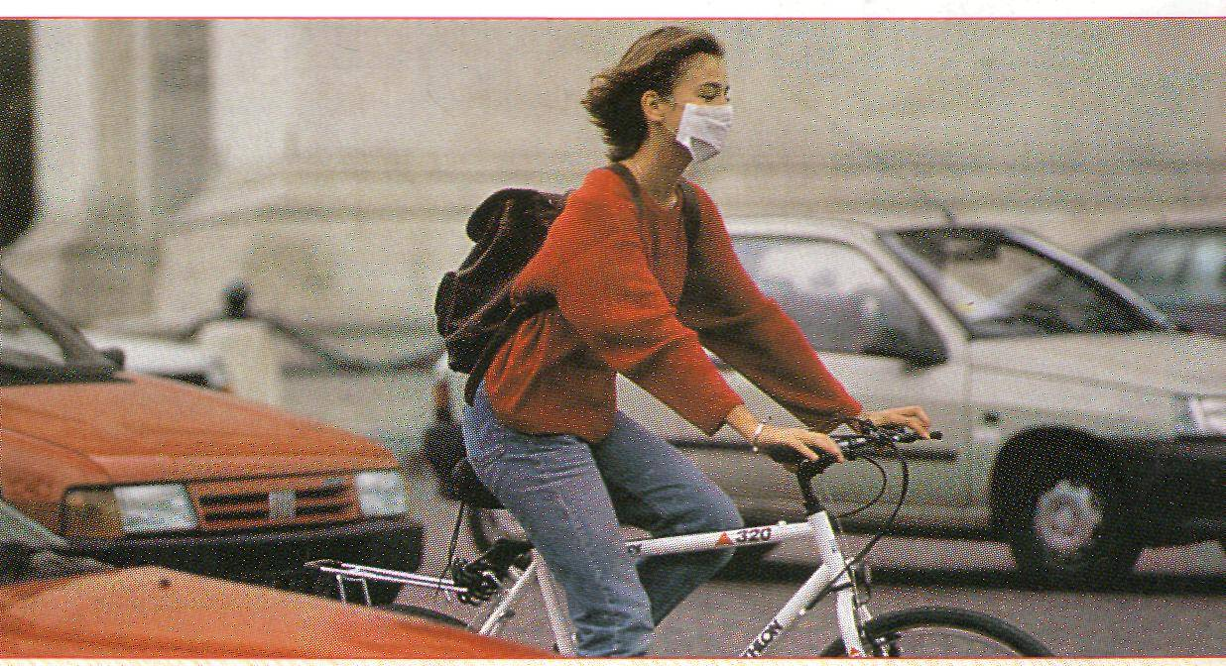
Factory pollution  Factories have also polluted the air, the land and the water. As a result, many rivers and lakes are now dead. | 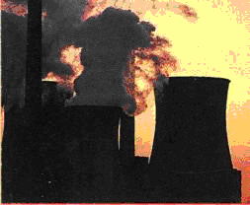
The ozone layer  Around the Earth, there is a special type of oxygen called ‘ozone’ (O₃). Ozone is important because it stops ultraviolet radiation from the sun. Many aerosol sprays and factories destroy ozone and they have made a very big hole in the ozone layer. This means that too much ultraviolet radiation now enters the Earth. This is very dangerous because it can cause cancer. | 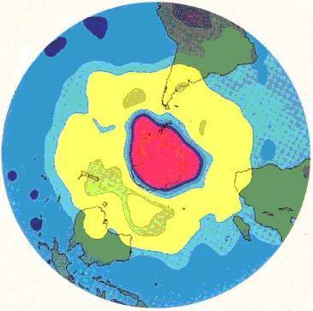
More carbon dioxide  Carbon dioxide (CO₂) in the air has increased a lot. (CO2 comes from burning oil, coal and wood.) This has formed ‘a blanket’ around the Earth. The heat from the sun cannot escape and so the temperature is rising (the ‘greenhouse effect’). This means that the level of the sea is rising and the climate is changing. | 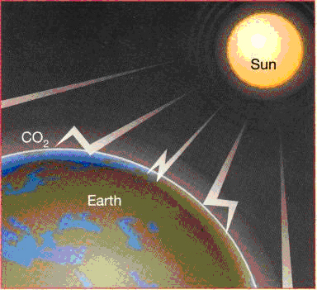
Fewer trees  All over the world, people have cut down millions and millions of trees. As a result many types of animals and plants are now disappearing. Trees are also important because they help to produce oxygen and control climate. | 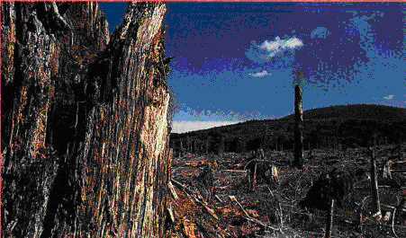

4.Беседа по тексту:
а) Answer the questions
1. Why are the trees important?
2. What is ozone?
3. What is the greenhouse effect?

b) Find these phrases in the article and say what the words like this link to (с использованием презентации):
- This means that too much ultraviolet radiation…
- This is very dangerous…
- This has formed the blanket…
- This means that the level of the sea…
- …they help to produce…
- These problems are very serious…
5. Составление таблицы причинно-следственной связи на основе текста
(у каждого учащегося бланки для заполнения таблицы в электронном виде)

WHAT HAVE WE DONE

What has happened? | What is the result?
Cars and buses have polluted the air. | Many people now have health problems.

Предполагаемый результат (проверка с использованием презентации):

WHAT HAVE WE DONЕ

What has happened? | What is the result?
Cars and buses have polluted the air. | Many people now have health problems.
Factories have polluted the land and the water. | Many rivers and lakes are dead.
Aerosol sprays and factories have made a very big hole in the ozone layer. | Too much radiation now enters the Earth.
Carbon dioxide in the air has increased. | So the temperature is rising.
People have cut down millions of trees. | Many types of animals and plants are disappearing.

6. Грамматический анализ текста:
a) найти сказуемое в каждом предложении правой колонки, назвать, определить видовременную форму глаголов. ( По мере называния, при правильном варианте, сказуемые выделяются на экране. Презентация.)
в) повторить правила образования The Present Perfect Tense

HAVE/HAS + PAST PARTICIPLE (V₃)

-ed III ст.
polluted made
increased cut

с) вывод: мы можем использовать the Present Perfect Tense когда говорим о действии, случившемся в прошлом, но имеющем результат в настоящем.
V.Закрепление лексики путем самостоятельной работы с кроссвордом в электронном виде.(Проверка выполнения осуществляется с использованием презентации)

A |  | CROSSWORD |  |  |  |  |  | PUZZLE
 |  |  |  |  | e
 |  | 1 |  |  | n
2 |  |  |  |  | v
 | 3 |  |  |  | i
 |  |  | 4 |  | r
 |  |  |  | 5 | o
 |  |  | 6 |  | n
 |  | 7 |  |  | m
 | 8 |  |  |  | e
 | 9 |  |  |  | n
 |  |  |  |  | t
1. A special type of oxygen around the Earth is called o .
2. Too much u radiation is dangerous.
3. Every day we produce millions of tons of r .
4. Concentration of c dioxide in the air is increasing.
5. In most big cities, there is a lot of p .
6. Water pollution is d for health.
7, The temperature is rising and the c is changing.
8. Ozone is a type of o .
9. Global warming is also called g effect.
10.The t of the Earth is rising.

VI. Домашнее задание: детальная проработка текста, выписать и выучить новые слова.
VII. Подведение итогов урока.

