Внеклассное мероприятие «Хэллоуин»

Учитель: Берсенева Анастасия Викторовна
Школа: МАОУ Лицей 97
Тема: Halloween

Данное мероприятие разработано для 5-7 классов с целью расширить знания учащихся о культуре страны изучаемого языка, развить познавательный интерес к традициям страны изучаемого языка, артистические качества детей, навыки речевой деятельности на английском языке. Мероприятие можно провести как на уроке, так и вне урока.

Задачи мероприятия:
1) Расширять знания учащихся о культуре страны изучаемого языка.
2) Развивать познавательный интерес детей к традициям и обычаям страны изучаемого языка.
3) Расширять словарный запас учащихся.
4) Развивать умение работать в команде.
5) Воспитывать ответственность у учащихся.
6) Развивать артистические способности детей.

Оборудование:
Музыкальное сопровождение.
Презентация
Туалетная бумага.
Листочки с ручками
Гуашь, помада, тушь, тени, кисточки, баночки с водой.
Грамоты
Призы (Чеснок и конфеты)
Кроссворд
Ход мероприятия

№ п/п | Этапы урока | Содержание
1 | Орг. Момент | Hello boys and girls. I’m glad to see you! Sit down please. Today we have an unusual lesson! We shall celebrate HALLOWEEN!!!!! Are you ready? Let’s begin.
2 | Просмотр презентации (слайды 1-11) | Ghosts and witches, ghosts and witches!  Gather here! Gather here!  Halloween is coming! Halloween is coming!  Can’t you hear? Can’t you hear?  Look at the board! (Учащиеся смотрят презентацию)  Now you know the history of this holiday, its traditions and symbols!
3 | Деление на две команды Конкурс "Страшное заклинание" | First of all you shall divide into 2 teams. Think of some scary name of your team, and then you should say the most frightful spell and explain the meaning of it. Begin!  (Учащиеся делятся на команды, придумывают название командам, придумывают жуткое заклятие. Причем, это заклинание не обязательно должно содержать осмысленные слова или фразы, это может быть любой набор букв, главное, чтобы оно жутко и пугающе звучало. И, затем учащиеся объяснят значение своего заклинания. Названия команд записываются на доске)
5 | Конкурс "Страшный макияж" | The next competition is a scary makeup. Each team will get necessary things and your task is to do a frightful makeup on your partner.  Now let’s look at you! I think that your makeup is more frightful!  Для конкурса понадобятся белая пудра, черная подводка, черная тушь, красная помада, гуашь черная и красная, кисточки. В конкурсе участвуют 2 члена от каждой команды. Каждой команде выдается набор вышеприведенных реквизитов. За 5 минут 1 участник должен раскрасить второго  (победившей команде вручаем дольку чеснока, чтобы отпугивать нечисть)
4 | Конкурс "Страшилки" | Children, Can you continue the following phrase «In the black black wood there is a ……….»  Begin!  Now let’s listen to your scary stories.  (Героями страшилок становятся самые необычные вещи, предметы и герои, например, черные перчатки, красные глаза, красное пятно, черная рука. Можно раздать игрокам листочки и ручки для записи страшилок.)  (победившей команде вручаем дольку чеснока)
6 | Конкурс "Мумия" | Let`s have some fun and play a bit. We need 2 players from each team. One of you is an Egyptian and your task is to make a mummy from your classmate with the help of a toilet paper.  The winner will be the fastest and the most careful team.  Понадобится: по 2 участника от каждой команды, 2 рулона туалетной бумаги. Один будет исполнять роль Мумии, другой будет Египтянином. По сигналу Египтянин должен как можно быстрее замотать Мумию туалетной бумагой с ног до головы). Побеждает тот, кто сделал Мумию быстрее.  (победившей команде вручаем дольку чеснока)

7 | Конкурс "Кроссворд"  Слайд № 11 | Look at the board and guess the crossword. The winner will be the team that will guess the words quicker.  Игроки могут разгадывать кроссворд прямо со слайда, или можно раздать напечатанный кроссворд. (См приложение № 1)  (победившей команде вручаем дольку чеснока)
8 | Конкурс "Найди слова"  Слайд № 12 | Look at the board and find out so many words as possible. The winner will be the team that will find more words connected with Halloween.  Каждой команде вручается листок и ручка. (См. приложение № 2)  (победившей команде вручаем дольку чеснока)
9 | Конкурс "Загадки" | Next competition is to guess the riddles. The winner will be the team that will guess more riddles about Halloween. (См. приложение № 3)  (победившей команде вручаем дольку чеснока)
10 | Подведение итогов  Песня «This is Halloween»  Слайд № 16 | Let` s know who is the winner!!! Let’s count the cloves of garlic  The winner is …. And I will give you a treat!!!  Команда победителей получает конфеты, проигравшая команда получает поощрительные призы. Можно подарить грамоты по следующим номинациям:  Самый хеллоуинский makeup  Самая страшная мумия и т.д. (См. приложение № 5)  In the end of our holiday we will sing a song « This is Halloween » (См. Приложение №4)  I hope you liked the lesson and had a lot of fun. See you, goodbye!!!!

Приложение 1 Halloween crossword

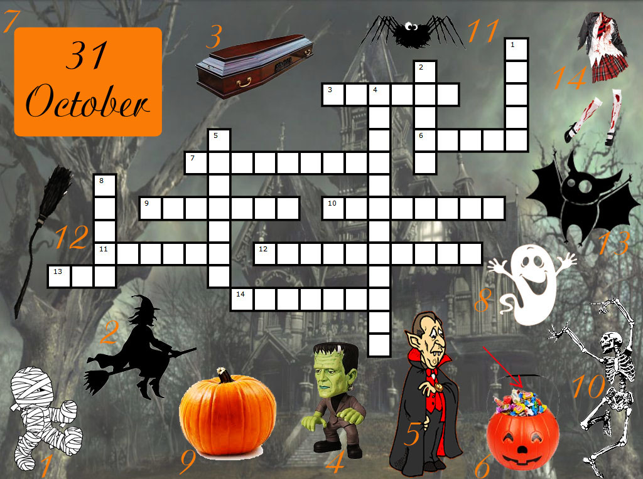
Приложение 2 Word Search

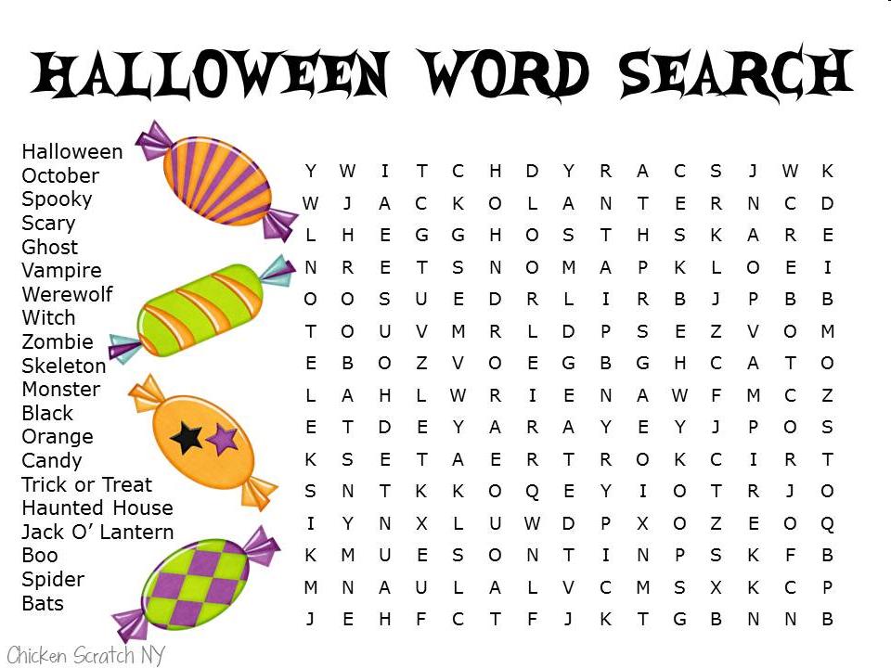
Приложение 3 Halloween Riddles

She always flies on her magic broom,
She always flies around the moon
With a black hat on her head
And what do you think, who is that?
(a witch)

It means bad luck, don’t look at it
If it crosses your path
And what do you think we call it?
(a black cat)

In masks and gouns we haunt the street
And knock on doors for trick or treat
Tonight we are the king and queen
For all tonight is ………..
(Halloween)

Sometimes big and sometimes small
But always round and yellow
When the children make my famous grin
Then I’m a scary fellow
(Jack – O’ – Lantern)

I am a big and round
Once upon a time I grew on the ground
Now I have a mouth, 2 eyes and a nose
Who am I do you suppose?
(pumpkin)

I see a friendly shining moon
As big and round as a balloon
Soon I will go out on the street
With my friend for our ………….
(trick – or – treat)

Приложение 4
Song «This is Halloween»
Boys and girls of every age
Wouldn't you like to see something strange?
Come with us and you will see
This, our town of Halloween
This is Halloween, this is Halloween
Pumpkins scream in the dead of night
This is Halloween, everybody make a scene
Trick or treat till the neighbors gonna die of fright
It's our town, everybody scream
In this town of Halloween

I am the one hiding under your bed
Teeth ground sharp and eyes glowing red
I am the one hiding under yours stairs
Fingers like snakes and spiders in my hair
This is Halloween, this is Halloween
Halloween! Halloween! Halloween! Halloween!

In this town we call home
Everyone hail to the pumpkin song
In this town, don't we love it now?
Everybody's waiting for the next surprise
Round that corner, man hiding in the trash can
Something's waiting now to pounce, and how you'll...

Scream! This is Halloween
Red 'n' black, slimy green
Aren't you scared?
Well, that's just fine
Say it once, say it twice
Take a chance and roll the dice
Ride with the moon in the dead of night

Everybody scream! Everybody scream!
In our town of Halloween!
I am the clown with the tear-away face
Here in a flash and gone without a trace
I am the "who" when you call, "Who's there?"
I am the wind blowing through your hair
I am the shadow on the moonlit night
Filling your dreams to the brim with fright
This is Halloween, this is Halloween
Halloween! Halloween! Halloween! Halloween!
Halloween! Halloween!
Tender lumpings everywhere
Life's no fun without a good scare
That's our job, but we're not mean
In our town of Halloween

In this town
Don't we love it now?
Everyone’s waiting for the next surprise
Skeleton Jack might catch you in the back
And scream like a banshee
Make you jump out of your skin
This is Halloween, everybody scream
Won’t ya please make way for a very special guy
Our man jack is King of the Pumpkin patch
Everyone hail to the Pumpkin King
This is Halloween, this is Halloween
Halloween! Halloween! Halloween! Halloween!
In this town we call home
Everyone hail to the pumpkin song
La lala la, la la la la...

Song «This is Halloween»
Boys and girls of every age
Wouldn't you like to see something strange?
Come with us and you will see
This, our town of Halloween
This is Halloween, this is Halloween
Pumpkins scream in the dead of night
This is Halloween, everybody make a scene
Trick or treat till the neighbors gonna die of fright
It's our town, everybody scream
In this town of Halloween

I am the one hiding under your bed
Teeth ground sharp and eyes glowing red
I am the one hiding under yours stairs
Fingers like snakes and spiders in my hair
This is Halloween, this is Halloween
Halloween! Halloween! Halloween! Halloween!

In this town we call home
Everyone hail to the pumpkin song
In this town, don't we love it now?
Everybody's waiting for the next surprise
Round that corner, man hiding in the trash can
Something's waiting now to pounce, and how you'll...

Scream! This is Halloween
Red 'n' black, slimy green
Aren't you scared?
Well, that's just fine
Say it once, say it twice
Take a chance and roll the dice
Ride with the moon in the dead of night

Everybody scream! Everybody scream!
In our town of Halloween!
I am the clown with the tear-away face
Here in a flash and gone without a trace
I am the "who" when you call, "Who's there?"
I am the wind blowing through your hair
I am the shadow on the moonlit night
Filling your dreams to the brim with fright
This is Halloween, this is Halloween
Halloween! Halloween! Halloween! Halloween!
Halloween! Halloween!
Tender lumpings everywhere
Life's no fun without a good scare
That's our job, but we're not mean
In our town of Halloween

In this town
Don't we love it now?
Everyone’s waiting for the next surprise
Skeleton Jack might catch you in the back
And scream like a banshee
Make you jump out of your skin
This is Halloween, everybody scream
Won’t ya please make way for a very special guy
Our man jack is King of the Pumpkin patch
Everyone hail to the Pumpkin King
This is Halloween, this is Halloween
Halloween! Halloween! Halloween! Halloween!
In this town we call home
Everyone hail to the pumpkin song
La lala la, la la la la...
Приложение 5

Грамота

Награждается_______________________________
В номинации___________________________

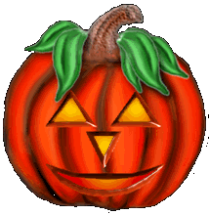
HAPPY HALLOWEEN

31.10.13

